Delivering Better Value in SEND Communications Working Group
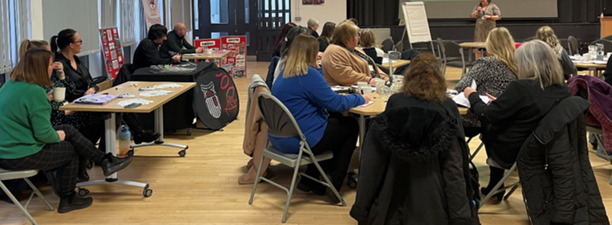
Terms of Reference

Background: What is the DBV programme?
The Delivering Better Value programme (DBV) is a national programme led by the Department for Education (DfE). The focus is Special Educational Needs and Disabilities (SEND).
The purpose of the programme: to work with local authorities with SEND responsibilities to look at ways of improving local services, making the most effective use of resources and, most importantly, improving outcomes for children.
The programme includes considering how data and insights can be used to better inform trend analysis, planning, decision making and service design, working with and alongside children and families; and how schools can work together more effectively to support an inclusive approach to education provision and support.
The purpose of the Delivering Better Value in SEND Communications Working Group is:
To share the work of the DBV programme in North East Lincolnshire among young people with SEND and their families, key stakeholders and the wider community so all have involvement in meaningfully working together (co-production) to collectively ensure children and young people with SEND are at the centre of the Delivering Better Value in SEND Programme .
The main aims:
- To develop a communication work plan for DBV.
- To keep up to date with the latest DBV development in our local area and nationally.
- To feedback to the DBV steering group regarding views of young people, parent carers, proffesionals and wider SEND stakeholders.
- To ensure relevant and correct information is being shared on Local Offer, social media and by other relevant communication means.

Organisation
- The group has representation from: Young people, NE Lincs PCF, SENDIASS, Education, Health, Social Care and other SEND providers.
- The group will meet half termly during term time, Thursdays at 1pm for one hour via Microsoft Teams or in person as appropriate for individuals.
- The meetings will be chaired by NE Lincs SEND Services manager or SEND Local Offer and communications officer.
- Each meeting will have an agenda and a note taker and the notes and actions will be shared and agreed.
- Use of jargon and acronyms will be kept to a minimum and if used will be clearly explained.
- The group will report to the NE Lincs DBV programme steering group.

Membership
- Members will attend all meetings or if necessary, nominate a proxy member in their absence or send apologies.
- Members understand that sometimes highly sensitive information may be raised as part of the discussion and all members agree to maintain the strictest of confidentiality both within and outside of this group.
- If any member feels uncomfortable during a meeting, they should either raise their concerns via the raise hand button, use the chat facility or leave the meeting and communicate their concerns via email or phone call with the SEND Services manager or SENDIASS manager.
Review
This Terms of Reference document will be reviewed once a year.
The legal stuff: The focus of the group’s activity will be wide-ranging, but will keep in mind the framework SEND guidance as set out on the 2015 SEN Code of Practice; the Special Educational Needs and Disability Regulations 2014; Equality Act 2010; and The Child and Families Act 2014.
(If you would like help to understand this, please ask the group.)
Last review 11/05/2023

