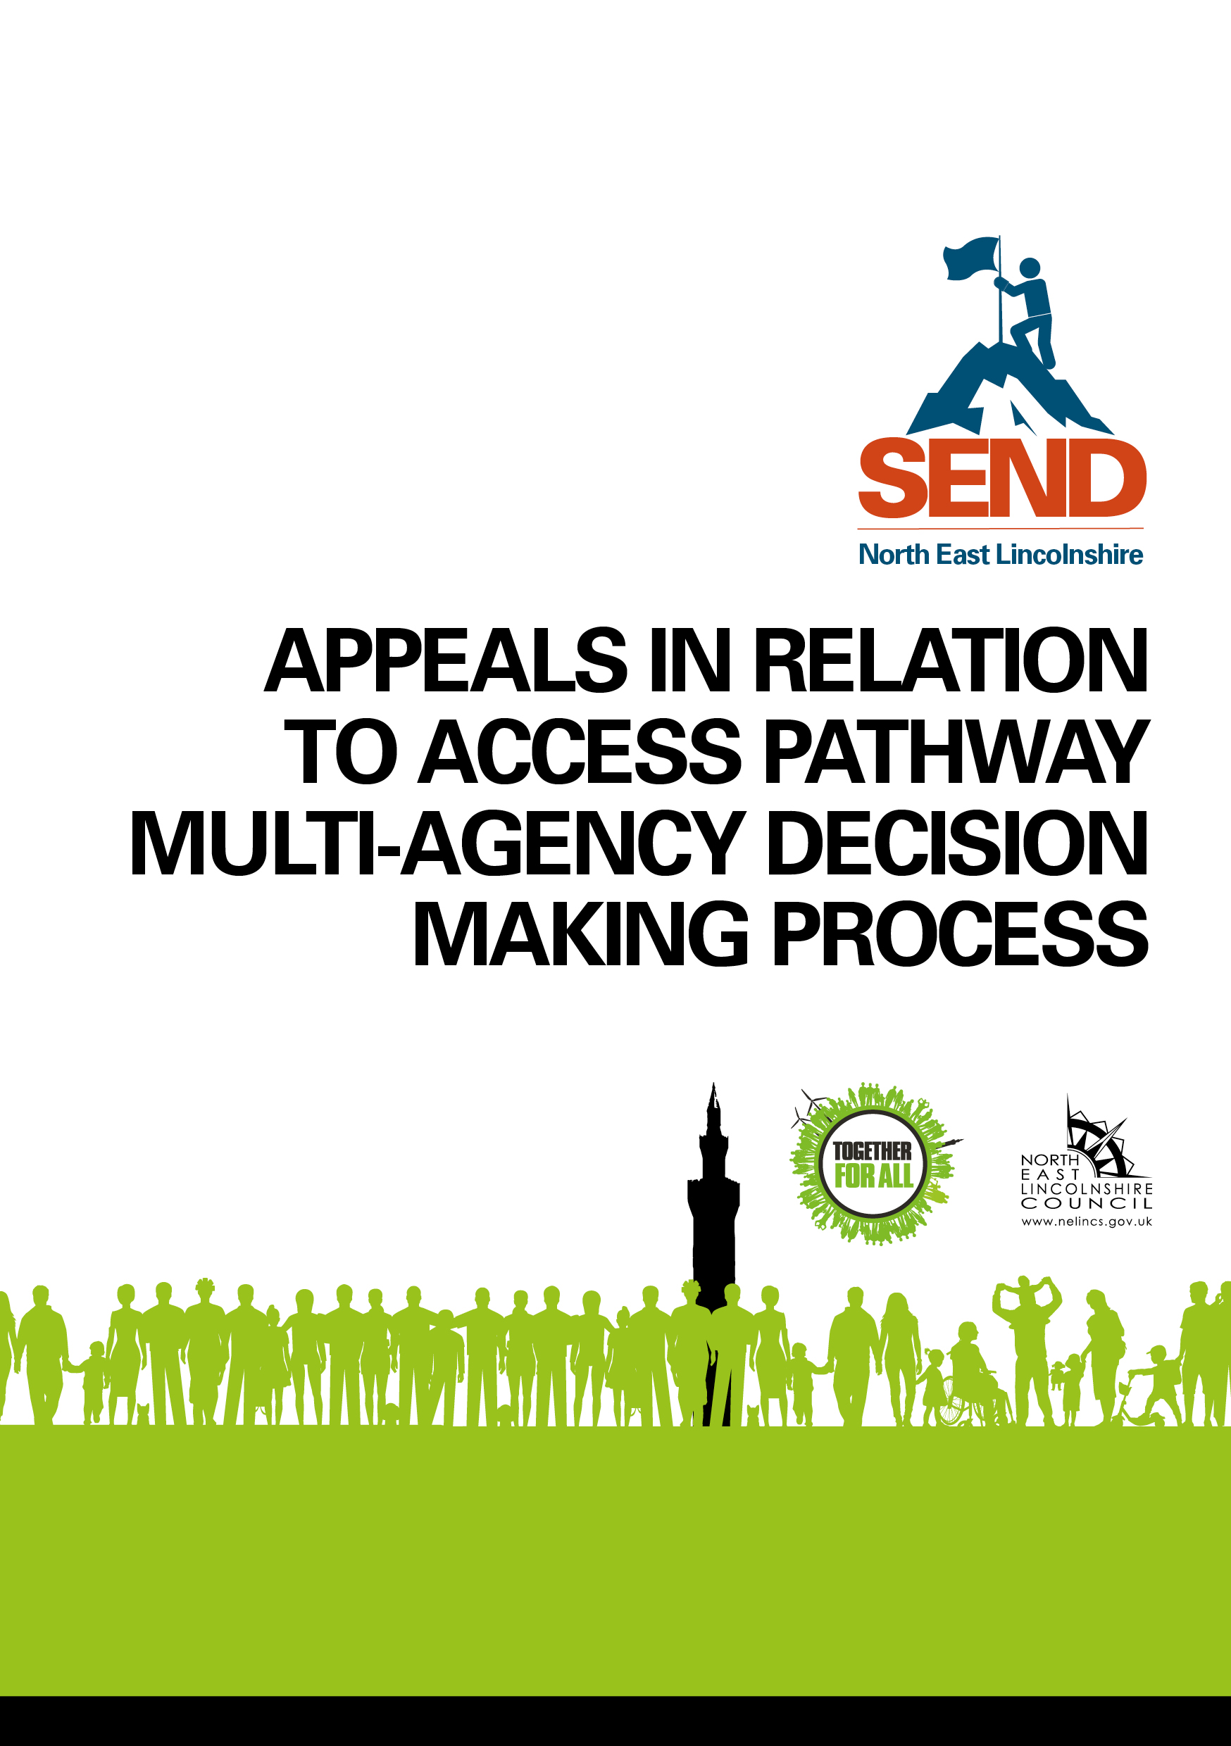

ASD & ADHD Screening Assessment & Diagnosis Rates (Over 5’s)

Introduction

The data included in this document regarding ASD and ADHD assessments and diagnoses comes from data reported as part of the Young Minds Matter contract. Locally, Young Minds Matter undertake assessments for both ASD and ADHD following an onward referral from the Access Pathway or ASD Screening Clinic.

For more information on the Access Pathway please visit the SEND Local Offer webpage.

The following data regarding ASD and ADHD assessments and referrals is presented quarterly based on financial years (April – March). Please note, data is always 1 quarter (3 months) behind, this is due to reporting and contracting arrangements. Additionally, specialist assessments take time, therefore figures assessed will not align with figures referred per quarter.

ASD screening, assessment and diagnostic pathway for the over 5s

This data shows the total number of children and young people (5-18) who have accessed the ASD screening, assessment and diagnostic pathway in North East Lincolnshire.

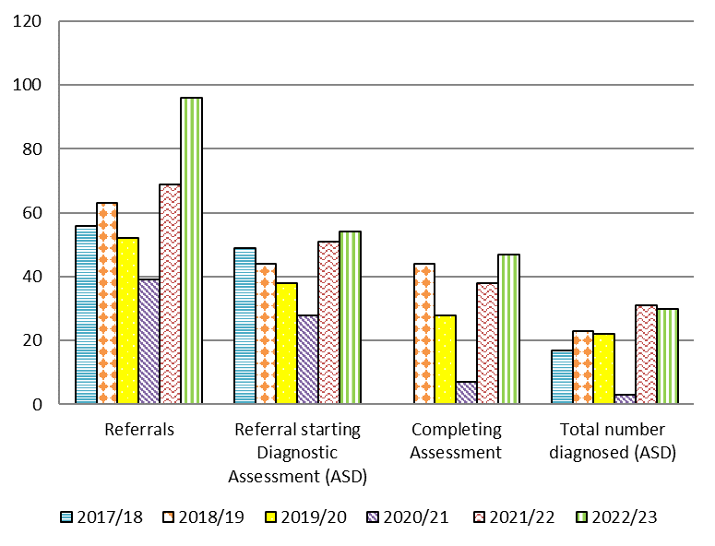

Figures for the full year 2017/18, 2018/19, 2019/20, 2020/21, 2021/22 & 2022/23
Year | Referrals | Diagnostic Assessment (ASD) | Completing Assessment | Total number diagnosed (ASD)
2017/18 | 56 | 49 | Not reported | 17
2018/19 | 63 | 44 | 44 | 23
2019/20 | 52 | 38 | 28 | 22
2020/21 | 39 | 28 | 7 | 3
2021/22 | 69 | 51 | 38 | 31
2022/23 | 96 | 54 | 47 | 30

ADHD referrals and diagnostic pathway

This data shows the total number of children and young people (5-18) who have accessed the ADHD assessment and diagnostic pathway in North East Lincolnshire.
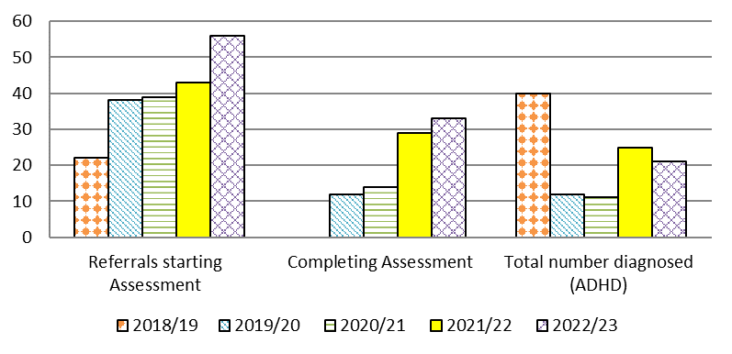

Figures for the full year 2018/19, 2019/20, 2020/21, 2021/22, & 2022/23
Year | Referrals (Starting Assessment) | Completing Assessment | Total number diagnosed (ADHD)
2018/19 | 22 | Not reported | 40
2019/20 | 38 | 12 | 12
2020/21 | 39 | 14 | 11
2021/22 | 43 | 29 | 25
2022/23 | 56 | 33 | 21

