North East Lincolnshire
Autism Strategy
2023-2028
Summary Version

Making a difference together.
Improving outcomes, support and services for autistic people.

Contents

- Acknowledgements
- Introduction and the vision
- Priorities for the National Autism Strategy, the national context
- Priorities for the Humber and North Yorkshire Health and Care Partnership - Mental Health, Learning Disabilities and Autism Collaborative Programme
- The North East Lincolnshire Health and Care Partnership
- Understanding autism in North East Lincolnshire (adults/young people/children)
- How are autistic people supported in North East Lincolnshire (adults/young people/children)
- The outcome of engagement with autistic people in North East Lincolnshire
- Themes and priorities for North East Lincolnshire
- North East Lincolnshire’s Action Plan
- Appendix 1 - Additional services and support that may be of interest to autistic people

The language of autism
In line with the National Autism Strategy, this strategy uses the word ‘autism’ as an umbrella term to include all the terms for conditions on the autistic spectrum. These include autism, autistic spectrum disorder, autistic spectrum condition, Kanner’s syndrome, Asperger syndrome, high functioning autism, Rett syndrome, childhood disintegrative disorder, Pervasive Development Disorder Not Otherwise Specified (PDD-NOS), Pathological Demand Avoidance (PDA) and associated neurodivergent conditions.
Some sources of information and data use the words “Autistic Spectrum Disorder” the majority of autistic people reject the idea that autism is a “disorder”; indeed, many consider it offensive, and the NHS language guidance rejects use of ASD or Autism Spectrum Disorder. A short film has been made about this and can been seen here.
Asperger’s Syndrome has not been used as a diagnostic term since 2013, and “functioning” labels are recognised to be harmful to all autistic people and rejected by the autistic community. “Autistic people with learning disabilities,” “autistic people with no learning disabilities” and “additional support needs” are generally considered more acceptable among autistic people; these terms have been used throughout this strategy in respect for the autistic community’s stance.
1. Acknowledgements

We are grateful to the following people, services and organisations that have helped us to write this Strategy.
The North East Lincolnshire Adult Autism Partnership Board
Faraway Community Interest Company (CIC)
The North East Lincolnshire Health and Care Partnership (NEL HCP) - Voluntary and Community Sector Enterprises (VCSE) organisations and groups that support health and care in North East Lincolnshire

Care Plus Group | NAViGO Health and Care CIC
Focus | Lincolnshire Partnership Foundation Trust
Apollo Primary Care Network | Northern Lincolnshire and Goole Hospitals NHS Foundation Trust
Freshney Primary Care Network | North East Lincolnshire Council
Genesis Primary Care Network | North East Lincolnshire Voluntary Sector and Social Enterprises
Meridian Primary Care Network | St Andrew’s Hospice
Panacea Primary Care Network | St Hugh’s Hospice

The Special Educational Needs and /or Disability (SEND) Executive Board
Humberside Police
Jobcentre Plus
INSERT LOGOS OF ALL PARTNERS HERE WHEN
ENDORSED AND FINALISED

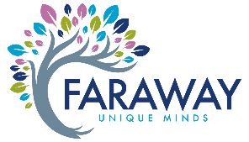

2. Introduction and the vision

As a person who has lived with autism, having been diagnosed over 20 years ago, I am honoured to be able to participate in writing the Autism Strategy for North East Lincolnshire (NEL).
As Co- Chair of the Adult Autism Board for NEL I have seen how much this strategy has been needed. It has been co-produced with autistic people who have had their say on what is needed locally.
The strategy’s aim is to ask: “how we can make NEL a great place for autistic people to live, and what can we do to support and help improve their outcomes?”
It will tell you about the priorities of the autistic community and how it links to support the delivery of the national Autism Strategy, the NHS Long Term Plan, the Humber and North Yorkshire Health and Care Partnership (HNYHCP) Mental Health, Learning Disabilities and Autism Collaborative Programme and the ambitions of the North East Lincolnshire Health and Care Partnership.
The strategy has adopted the HNYHCP strategic vision (below), focussing on the things that we know will make a difference to the autistic population in NEL over the next five years.
I would like to say a big thank you to everyone who has contributed to the strategy, particularly Amber Petchey. If it were not for peoples help, we would not have got this far, and their contributions enable our future progress so by implementing this strategy we hope to see better outcomes for all autistic people in NEL.
Thank you
Thomas Jones
Co-chair North East Lincolnshire Adult Autism Board
Associate Director - Faraway Community Interest Company (CIC)
The vision
We have adopted the vision of the Humber and North Yorkshire Health and Care Partnership (HNY) - Mental Health, Learning Disabilities and Autism Collaborative Programme to:
“Start Well, Live Well, Age Well”
Locally, “We want people of all ages who experience mental health conditions, have learning disabilities and/or autism to live healthy lives, be able to achieve their goals and be accepted and supported in the communities they live in.”
3. Priorities for the National Autism Strategy, the national context

The National Autism Strategy reflects on the years since the last review, where there have been improvements, and looks at how the government will support people in the future. The national strategy focuses on these key areas:
- Improving understanding and acceptance of autism within society
Acceptance rather than awareness is important to the NEL autistic community as it supports inclusion. This strategy will support the development a “public understanding and acceptance of autism” initiative, working with autistic people, their families and the voluntary sector. Organisations, businesses and public sector services will become autism-inclusive, so that autistic people can engage in their communities, like everyone else.

- Improving autistic children and young people’s access to education, and supporting positive transitions into adulthood
This strategy will support the development of autism-inclusive cultures, systems, and institutions, improve early identification of children and young people’s needs, enabling autistic children and young people to access the right support, both within and outside of education. It will strengthen and promote preparing for adulthood pathways so that more autistic young people are able to live well in their communities, find work or take up higher education opportunities.
- Supporting more people into employment

Providing information, advice and guidance is key to improving the support autistic people can access to find and stay in work. This strategy aims to show through data and improvements that can or should be made that existing services and work programmes are autism-inclusive and better able to help autistic people find the right employment opportunity; that employers support them to remain in work and autistic people’s experience of being in work has improved.

- Tackling health and care inequalities for autistic people
This strategy aims to have made demonstrable progress on reducing diagnosis waiting times and improving diagnostic pathways for children, young people and adults.

- Building the right support in the community and supporting people in inpatient care
This will be achieved through this strategy’s link with the Transforming Care Partnership strategy to enable strong and robust community services to support autistic people and actively prevent unnecessary admission to inpatient mental health settings.

- Improving support within the criminal and youth justice systems
Improving support for autistic people at risk of being affected by criminal activity is a key priority identified by the NEL autistic community in this strategy’s actions. Ensuring, through the training programme, all staff understand autism and how to support autistic people will improve their experience of services (e.g., Police, Advocacy Services, Youth Offenders Service, Forensic Services) and ensure reasonable adjustments are put in place.

4. Priorities for the Humber and North Yorkshire Health and Care Partnership (HNYHCP) - Mental Health, Learning Disabilities and Autism Collaborative Programme

“For a number of years now, health and care organisations working in the Humber and North Yorkshire area to deliver Mental Health, Learning Disabilities and Autism services have been working increasingly closer together, through the development of our partnership arrangement and our collaborative programme or work.” (Source: HNY MH, LDA Collaborative Programme) This plan has adopted and will support the delivery of the HNYHCP strategic vision, illustrated below; the key outcomes are included in our action plans on the following pages.

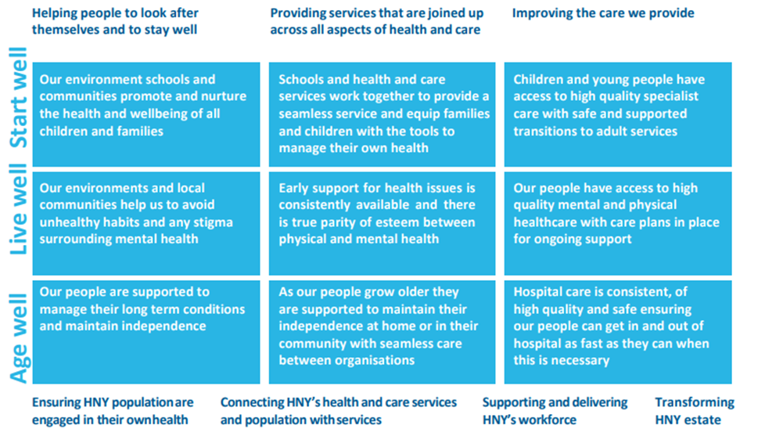
5. The North East Lincolnshire Health and Care Partnership

These new partnerships will lead the detailed design and delivery of integrated services across the NEL localities and neighbourhoods. The partnerships will involve the NHS, local councils, community and voluntary organisations, local residents, people who use services, their carers and representatives and other community partners with a role in supporting the health and wellbeing of the population.
The NEL vision is:
“To deliver health and care which optimises the health, wellbeing and treatment for people of all ages living in our area.”
What achieving our ambitions will mean
- There will be one team, no referrals, no waits.
This means that a person experiencing Health and Care Services in NEL should experience their care or support as though it is organised, arranged, and delivered by one team. The person’s journey between agencies should feel smooth and ‘hurdle free.’ The Health and Care Partnership aims to make sure there will be no waiting for assessments and treatments – where this is unavoidable, the person should be informed of how long they are expected to wait and have access to support whilst they wait for their assessment or treatment. The Adult Autism service operates as a partnership between Navigo, Care Plus Group, and is symbiotic with Faraway CIC. These organisations work as one team for autistic people.
- Individuals are informed about their care or treatment journey and are therefore more in control. An informed wait is a better wait.
The relationship with Faraway, a peer-led organisation, enables good quality information throughout the person’s journey. The strategy seeks to enable wider services to be more informed about the needs of autistic people.
- Services will be joined up and will support the individual, their carer, those who matter to them and who work for them.
This strategy supports care and support wrapped around the individual according to their needs and enabling people to develop skills to live as independently as possible.
- Services will be digitally enabled and supported when possible.
Digital modes of communication are often preferred by autistic people and can help other people with communication difficulties – for example, d/Deaf people to access services – reducing inequalities for people accessing and gaining support. The strategy supports this and further development of digital solutions in the context of ensuring autistic people gain skills to successfully interact with real life scenarios to achieve their goals in life.
- Health and care services will link in with broader services where it is needed to support an individual. For example, housing or education.
The action priorities of the strategy support people to access education, higher education, work and employment opportunities, their local communities and with ‘getting a place to call a home.’
- If you need diagnostic tests, you will be able to have these in the community.
The strategy supports continuation of high standard diagnostic pathways.
- Our approach will apply no matter what age you are – from birth through to the end of life
This strategy is an all-age strategy that, consistent with regional strategy, aims to support autistic people to ‘Start Well, Live Well and Age Well’ It focuses on working together better to improve co-ordinated, timely access to the right care and support with the aspiration to ensure everyone can live a happy, healthy, meaningful life.
- Your mental health is as important as your physical health
Autistic people generally experience a higher rate of co-occurring mental health issues, and often find greater obstacles in seeking help with them. The close partner working of Care Plus Group and Navigo in North East Lincolnshire further demonstrates the priority of the Autism Strategy in the wider Health and Care agenda.
- Hospital will not be the first point of care. Other options will be explored first.
The focus of this strategy is very much about empowering people by providing skills and opportunities with which to support themselves. It links with the Transforming Care Partnership strategy to enable strong and robust community services to support people with Autism and to actively prevent unnecessary admission to Assessment & Treatment units or other mental health units, reducing seclusion and restraint practices across all settings, and supporting the STAMP/STOMP children’s and adults’ agenda in community and in-patient settings.
6. Understanding autism in North East Lincolnshire

What is autism?
An autistic researcher in North East Lincolnshire (NEL) stated that autism is a socially defined neurodevelopmental condition that can be viewed as either a disability, a difference or both.
Autism varies widely and is often referred to as a spectrum condition, because of the range of ways it can impact on people and the different level of support they need. Some autistic people will need very little or no support in their everyday lives while others may need high levels of care.
The National Autistic Society (NAS) defines autism as a lifelong developmental disability which affects how people communicate and interact with the world, and estimates 700,000 autistic adults and children in the UK, equating to approximately 1% of the population. With an estimated 3 million carers/family members supporting those autistic people. Latest figures suggest there are about 332,600 autistic adults in the UK (https://i-am-autism.org.uk/ 2021) and it is estimated that 75% of these autistic adults still live at home with their parents (autism.org.uk 2020).
The themes and priorities in NEL strategy are aligned to the national strategy for autistic children, young people and adults: 2021-2026. They are focused on improving the public’s understanding and acceptance of autism, improving autistic children and young people’s access to education, and supporting positive transitions into adulthood and into employment. We aim to build the right support within in the community and support people during inpatient care. We want to reduce diagnostic waiting times and tackle health and care, which includes when preparing for adulthood, obtaining and maintaining employment, around the justice system, addressing health inequalities, and reducing diagnosis waiting times.
NEL agrees that there must be no limit to the ambitions of autistic people, and that they should not only have the same opportunities as everyone else in society, but also have the ability to make use of those opportunities: equity, not just equality. We need to continue to raise awareness and liberate services to ensure they are diverse and inclusive.
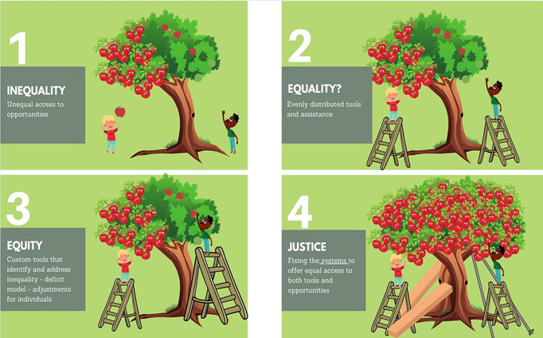
“Equality is always evolving in terms of how it relates to Equality, Diversity and Inclusion.”
The above graphic is from Inclusive leadership (bath.ac.uk)

Achieving these ambitions will help us demonstrate that North East Lincolnshire is a great place to live, where all autistic people can “Start Well, Live Well, Age Well.”
Autism prevalence
Understanding the prevalence of autism in NEL
This “autism prevalence” is an estimate of how many autistic people there are in the UK. It is not the number of people who have a diagnosis of autism as many autistic people might not have been identified or even know yet themselves.
January 2022 school census
All pupils with SEN have an assessment of their primary need. In January 2022, 103,400 (31.3%) pupils with education, health and care (EHC) plans, had autism recorded as their primary need, ‘autism’ was the most common primary need recorded for pupils with an EHCP nationally.
In NEL’s January 2022 school census there were 253 school pupils recorded with a primary need autism, 180 (71%) of these children were recorded as having an EHC plan, and 73 (29%) were recorded as SEN support. There were an additional 80 pupils with autism recorded as a secondary need.
The table below shows there are almost five times the number of males with a primary SEN of autism than there are females.
Number of pupils with an EHCP or SEN support with a primary SEN of autism, by gender, January 2022

 | EHC plan | SEN support | Total
Male | 152 | 58 | 210
Female | 28 | 15 | 43
Total | 180 | 73 | 253
Male: Female ratio | 5.4:1 | 3.9:1 | 4.9:1
Source: NELC January 2022 school census
The 253 pupils with a primary SEN of autism, equates to 6.2% of all pupils with SEN. Of pupils with a EHC plan, autism is the most common primary need and is recorded as the primary need for 22% of all plans.
Based on the National Autistic Society’s (NAS) assumptions above, we estimate there are 1,700 autistic adults and children in NEL (1% of our population) and an estimated 7,300 family members and carers of autistic people.
Regarding adult estimates, the Projecting Adult Needs and Service Information (PANSI) and Projecting Older People Population Information (POPPI) systems, include a range of population projections.
Predicted autistic adults aged 18-64, by gender, projected to 2035 this is work in progress and needs more research)

 | 2020 | 2022 | 2025 | 2030 | 2035
Males | 821 | 810 | 799 | 774 | 761
Females | 93 | 92 | 89 | 87 | 85
Source: PANSI Crown copyright 2020
Predicted autistic adults aged 65, by gender, projected to 2035 this is work in progress and needs more research)

 | 2020 | 2022 | 2025 | 2030 | 2035
Males | 272 | 283 | 297 | 331 | 355
Females | 36 | 37 | 39 | 43 | 47
Source: POPPI Crown copyright 2020
The prevalence rates, based on a previous study have been applied to ONS population projections for NEL to give estimated numbers predicted to have autism to 2035.
Autism related referrals to adult services
Navigo is the lead provider for Adult Neurodiversity Services (ANDS) in NEL, which is sub-contract to Care Plus Group.
Care Plus Group (CPG) is a social enterprise working across NEL, providing adult health and social care services to improve health and wellbeing, and helping people to help themselves. Alongside providing crisis support, community networks, and general healthcare and treatments, CPG are NEL’s main community provider offering support for learning disability and/or autism.
Latest data available shows:
The total number of referrals for diagnosis to the Adult Autism Service (April 2021 – March 2022) was 252
The total number of referrals for support to the Adult Autism Service (April 2021 – March 2022) was 102
Focus Independent Adult Social Work – adult social care
Adult social care in NEL is provided by Focus independent adult social work.
Adult social care provide help and support with mental health, social care, community health or GP out of hours needs / concerns or safeguarding issues (e.g., home care or residential care) in NEL. They are contactable through NEL’s Single Point of Access, and available 24 hours a day, all year round, including bank holidays.
Latest data available shows:
The total number of people assessed by focus (Jan 2021- April 2022) with a recorded outcome of “autistic people with learning disabilities” is 21.
The total number of people assessed by focus (Jan 2021 – April 2022) with a recorded outcome of “autistic people with no learning disabilities”” is 5.
Over the next 5 years, the NEL Health and Care Partnership (tbc)want to work with autistic people to improve the collection and quality of data to be able to measure progress, address gaps in the knowledge base (particularly those that autistic people feel are important), and drive improvements around supports and services for autistic people and their families.

7. How are autistic people supported in North East Lincolnshire

Each autistic person may need different levels of support, and this may vary over time and by situation; some may need assistance with challenging situations and accessing education and services, others access local services daily such as day support/opportunities, supported living, lifelong learning opportunities, sports and activities providers, services that on a day-to-day basis make all the difference to a person’s life. Some people may just want support in socialising and accessing hobby groups. Support is not just from services but also includes individuals’ social networks.
The organisations delivering support and services for autistic people in NEL are part of the Humber and North Yorkshire Health and Care Partnership
The following services and support frameworks are available locally (criteria may apply):
Support for children, young people and parent/carers
Special educational needs and/or disabilities information, advice and support service (young people aged 14-25, parent/carers)
Special educational needs and/or disabilities information, advice and support service (SENDIASS) Provide free, impartial, confidential and accurate advice and support to parent carers of young people with SEND. This service is also offered directly to young people.
Children and Young People’s Neurodiversity Pathway – the current work programme
There has been a greater focus in national strategy, outlined in the NHS Long Term Plan for improving access to the right care and timely support for children and young people with learning disabilities and/ or autism, so they can live happier, healthier, longer lives.

The COVID-19 mental health and wellbeing recovery action plan also included a focus on learning disability and autism and had specific actions to prevent, mitigate and respond to the mental health impacts of the pandemic during 2021/ 22. As a result, Young Minds Matter (YMM) has benefitted from investment to recruit additional psychology support to increase capacity for specialist assessment for autism/ ADHD.

NEL is connected into these national programmes through our NEL CYP Mental Health commissioners and as part of the Humber Coast and Vale Integrated Care System and Humber Transforming Care Partnership.

It is important that local services understand the needs of people with a learning disability, autism or both in NEL, so that they can make sure people receive the right support. Integrated care boards (ICBs) are required to develop and maintain registers to identify people with a learning disability, autism or both who display, or are at risk of developing, behaviour that challenges or mental health conditions who were most likely to be at risk of admission. By understanding people’s needs and recognising early signs that might lead to a crisis, extra support can be put in place quickly, so the person does not end up going into hospital unnecessarily. NEL is unique in the region, in having an all-age Dynamic Support Register.

We continue to work together as a system to respond to the key actions identified by NHSe and by our local areas. This partnership is proving effective as we have been successful in three funding bids which specifically support this programme of work and include:

- Key Worker Programme – designated keyworker for CYP with learning disabilities, autism or both for those who are inpatients or at risk of being admitted to hospital
- Diagnostic pathway support for young people aged 14-25 - a collaborative approach across the Humber Transforming Care Partnership to provide pre and post diagnostic and peer/ family support, through an online diagnostic platform and providing Sleep support practitioner training

- Autism in Schools project for ages 5-18 (25) years, has been a pilot in partnership with NHSe and ten local mainstream schools since March 2021. It has 4 key areas of delivery, these are, Parents Supporting Parents Forums (school-based), Understanding Myself engagement work with children, young people and Young Carers, and the Autism/ Neuro training offer.

It aims to provide an uplift in support across the academic year, by creating a more autism-friendly ethos and changing the approach to autism across the entire school system with coordinated funding, specialist practitioners and awareness raising.
The programme area has improved support and access for those children and young people who display neurodiverse traits (e.g., Autism and ADHD). This is to reflect changes in national priorities and supports the delivery of our local SEND strategy and Early Help strategy.
Going forward the autism lead from a local special school, will work collaboratively with Compass Go and our schools to regenerate the Autism Education Trust Offer.
Compass go (Mental Health Support Team) provides support, help and advice for pupils, students and schools for issues related to emotional and mental health wellbeing across NEL.
Key impacts have been:
- 10 schools committed to implementing ‘small changes, big impact’, working in collaboration with parent carers, in their schools
- Attitudes have changed, positive collaborations between parent carers and school staff.
The feedback from parent carers and practitioners:
“Like being heard and listened to”
“Like being able to speak open and honestly in a safe group”
“I like the fact that parents can voice their own personal experience and get feedback or advice from other professionals and from other parents too”
Learnt: “How important the use of language is when speaking and interacting with parent carers and the CYP”
“Safe space to express experiences which can improve services/help others in a similar position”
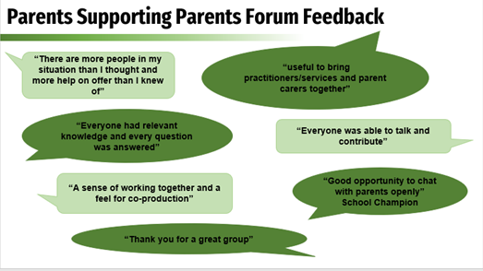
The above graphic has been collated as part of the autism in school’s project.

Young Minds Matter undertake assessments for both autism and ADHD following an onward referral from the Access Pathway or the autism Screening Clinic.
Young Minds Matter - autism screening, assessment and diagnostic pathway for ages 5 – 18 years
This data below shows the total number of children and young people (5-18) who have accessed the autism screening, assessment and diagnostic pathway in NEL. The data regarding autism and ADHD assessments and referrals is presented quarterly based on financial years (April – March).
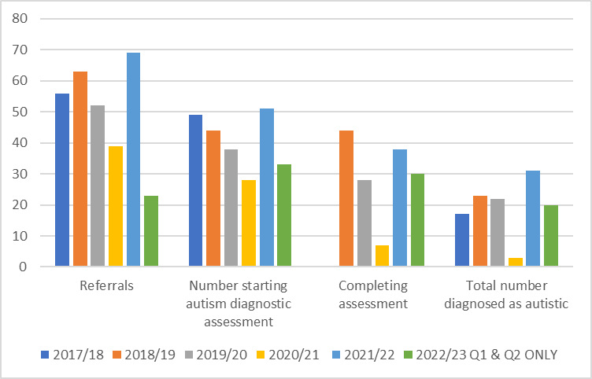

YMM do not offer support for autism but anyone with an autism diagnosis who has mental health problems can access the service just like any other young person.
YMM also deliver online training. In 201-22 the YMM autism online training course was delivered to 44 people.
INSERT FURTHER INFORMATION
Children’s disability service Children Looked after
Early Years Portage Key Stage Team (SAS)

Preparing for Adulthood (transitions – (young people aged 14-25, parent/carers)
The Government’s vision for young people with special educational needs and/or disabilities (SEND), is called Preparing for Adulthood (PfA), a process previously referred to as “transition.” The vision challenges NEL to ensure the aspirations, views, wishes and feelings of young people (and their parents or carers) are at the centre of our assessment, planning and review processes, and that the outcomes they are seeking form a golden thread throughout. To ensure the vision is realised, young people need to receive consistent information, be listened to, participate in decisions and have increased choice, autonomy and control which will prepare them for adulthood and a future that includes a pathway to employment, independent living, friends, relationships, participation in their local communities and being as healthy as possible in adult life.
The North East Lincolnshire Preparing for Adulthood Protocol is a practice guide for NEL’s multi-agency transition planning process to support preparation for adulthood (PfA) for young people (aged 13-25) with special educational needs and/or disabilities (SEND), complex physical or mental health needs, those with care needs, as well as for their parents/carers and young carers. The guide details what should happen, when how and who will do it - so young people and their parents or carers will know what they can expect, when, and receive the support they need to live the lives they choose in adulthood. Further information on PfA and other services and support for children and young people with SEND in NEL can be found here: Local Offer
The National Careers Service (all adults aged 19+)
The National Careers Service provides comprehensive careers information advice and guidance on employability (training advice, CV help, interview support etc) to support decision making. Further information can be provided via weekly sessions in NEL at various locations and 1-1 appointments with Careers Advisors can be requested, where needed. Contact IAG-NEL@nelincs.gov.uk
Young Peoples’ Support Services (young people aged 13-19 (or 25 for those with additional needs)
Young People’s Support Services (YPSS) mainly work in secondary schools/colleges providing information, advice and guidance (IAG) to support decision making on careers, further education, training and employment. Further information here.
Employability Services
This service works with businesses and employees to support people into work.
Employability Services supports people across NEL aged 14 years up to retirement, to develop their employability skills and support them on a pathway to sustainable employment.
Health Lead, North East Lincolnshire (adults/children) (expand when governance is clear)
The Humber and North Yorkshire Integrated Care Board’s (ICB) Health Lead is responsible for developing, maintaining and promoting a diagnostic treatment pathway, and offers local planning and leadership in relation to the provision of services for autistic adults.
Learning Disability Annual Health Checks (adults/transition)
Autistica state that whilst autism is not a learning disability, it is estimated that around 4 in 10 autistic people have a learning disability. People with a learning disability often have poorer physical and mental health than other people. This should not be the case. The NHS offers free annual NHS Learning Disability Health Checks to those aged 14 or over from a local GP Practice. You do not need to be ill to access a health check, and it is important that everyone on their GPs learning disability register has a routine assessment to discuss, review and/or identify health conditions, support requirements, and health action plans.
Going forward the NHS Long Term Plan has a commitment to pilot the introduction of a specific health check for autistic people, and if successful, extend it more widely. This is included in this strategy.
Carers Support Service (carers)
Carers Support Service makes life better for carers. They give telephone advice, support, information and the chance to talk about caring. They help – connect – campaign and innovate. There is further information at Carers UK and Carers Trust.
Support for young people and adults
Navigo is NEL’s mental health provider, people can access mental health support from Navigo’s community services as well as from their crisis team.
Navigo is the lead provider for Adult Neurodiversity Services (ANDS), which they sub-contract to Care Plus Group. Navigo and Care Plus Group work in partnership with other local health and social care providers, including the Faraway to deliver co-produced, statutory, user-led and peer-to-peer support adult neurodiversity services to NEL residents and across the Humber Transforming Care Partnership (TCP) area. The TCP comprises four areas: Hull, East Riding of Yorkshire, North Lincolnshire and NEL.
The Adult Neurodiversity Services based at Neurospace and Queen Street Centre in Grimsby include various specialist community teams, including the:
- Learning Disability (LD) Psychological Therapy Service to support the mental health needs of learning-disabled individuals.
- Intensive Support Team (IST) to support individuals with complex needs and behaviours of concern.
- Community Learning Disability Team (CLDT) to support the physical health of learning-disabled adults and Carer’s Support needs.
- Adult Autism (no-LD) Service (AAS) and ADHD Service, which provides both diagnostic assessments and a full range of post-diagnostic support for autistic adults.
- Forensic Outreach Liaison Service (FOLS) to support autistic and/or learning-disabled adults who are at risk of offending.
The Adult Neurodiversity Services deliver support to individuals, their families, carers, supporters and other services and professionals involved in their care.
The Adult Autism and Adult Attention Deficit Hyperactivity Disorder (ADHD) Service (adults)
Provide an open referral system for specialist Autism Diagnostic Assessments; this includes self-referral.
The AAS multi-disciplinary pathways and multi-disciplinary teams (MDTs) consist of Clinical Psychologists, Assistant Psychologists and Trainee Clinical Psychologists, Mental Health Practitioners, Autism Support Workers, and Psychiatrists.
This data charts below shows the total number of adults that have been referred for an autism assessment, the number assessed within 12 weeks of referral and the number of diagnoses in NEL.
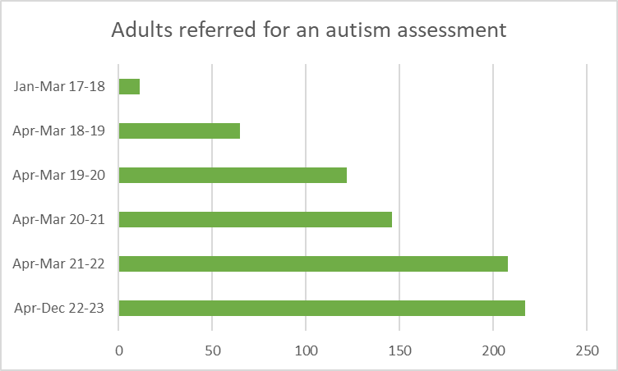
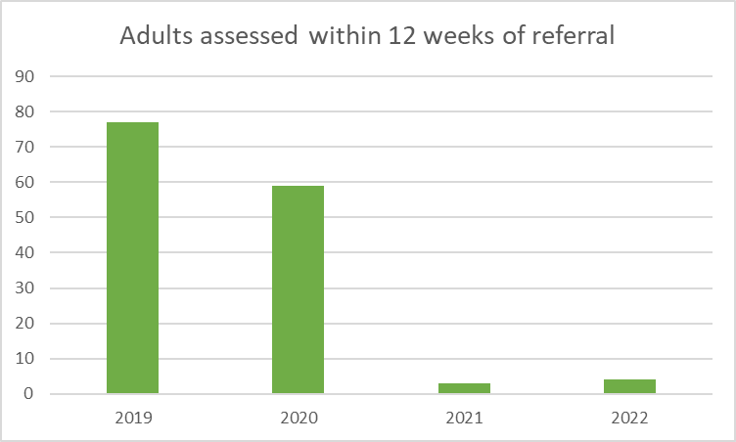
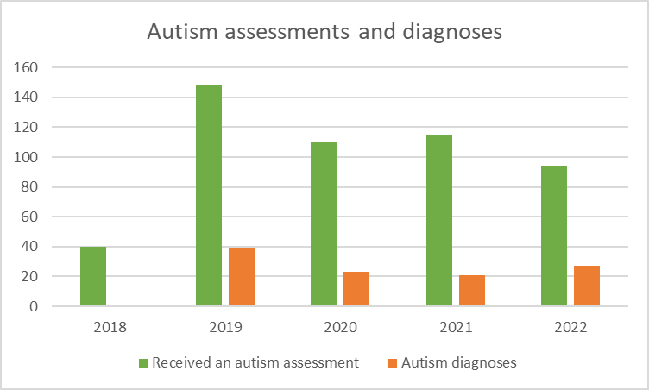
Source: Care Plus Group

The Adult Attention Deficit Hyperactivity Disorder (ADHD) Service (adults)
The Adult ADHD Service offers diagnoses, medication, support groups, and can be accessed via referral from GPs or other professional.
Among its services Care Plus Group includes:
The Adult Learning Disability Service (ALDS) (adults)
The ALDS supports adults and young people in transition who have learning disabilities, autism and/or complex needs, as well as their families, carers and supporters. Their services include the Community Learning Disability Team (CLDT), Intensive Support Team (IST), Adult Learning Disability (ALD) Psychology Service and the Carers Support Service, and they aim to improve and maintain service users’ health and wellbeing.
The ALDS are proud to have signed up to the STOMP pledge. STOMP stands for stopping over medication of people with a learning disability, autism or both with psychotropic medicines.
The Forensic Outreach Liaison Service (FOLS) (adults)
In partnership with the wider team across the Humber, FOLS work with those over the age of 18 with learning disabilities, autism diagnoses and/or complex needs, who have been or are at risk of becoming involved in the criminal justice system. The team includes a wide range of skilled clinical staff who ensure the care and support received is appropriate to their individual needs, delivering offence-specific interventions and specialist forensic support in both inpatient and community settings.
Focus Independent Adult Social Work
Adult social care in NEL is provided by Focus independent adult social work. (see above)
The Faraway CIC (adults)
The Faraway is a not-for-profit social enterprise community interest company (CIC) The staff include mentors, researchers, tutors, marketing assistants, designers, project leaders – all of whom are passionate, effective and autistic - working together to build and sustain accessible autistic community groups and services autistic-led, for autistic people, by autistic people across the region. These services include mentoring, social/hobby groups and projects.
The Faraway CIC has teamed up with the AAS to provide pre- and post-diagnostic groups for people to explore and understand their diagnoses, at whatever stage of development they are at.
The Ask Auti project is bringing neurodiversity-affirmative, accessible and supportive responses from autistic researchers, autistic journals, autistic-centred groups and autistic perspectives.
The North East Lincolnshire Adult Autism Partnership Board (adults)
The NEL Autism Partnership Board meets quarterly, requiring 50% or more of the service user board members to attend. The Board brings together different local organisations, services, and stakeholders to set a clear direction for improving services.
Sources of further information
The websites below the SEND Local Offer and Connect NEL and Livewell have extensive information on services, activities and support that can give you the help you need.
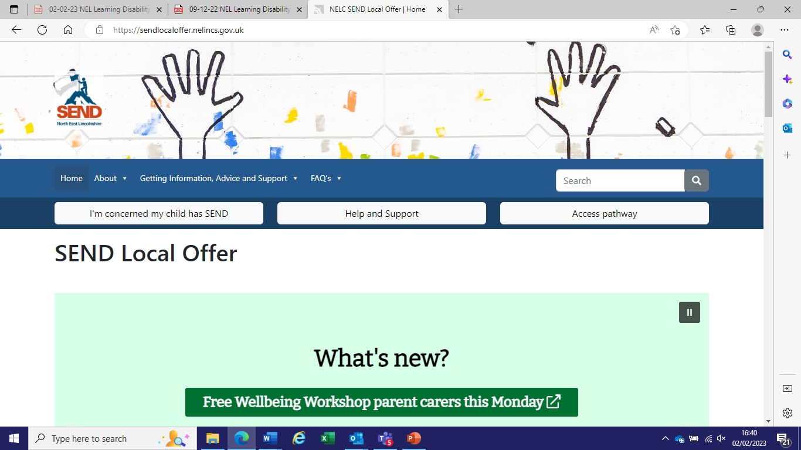
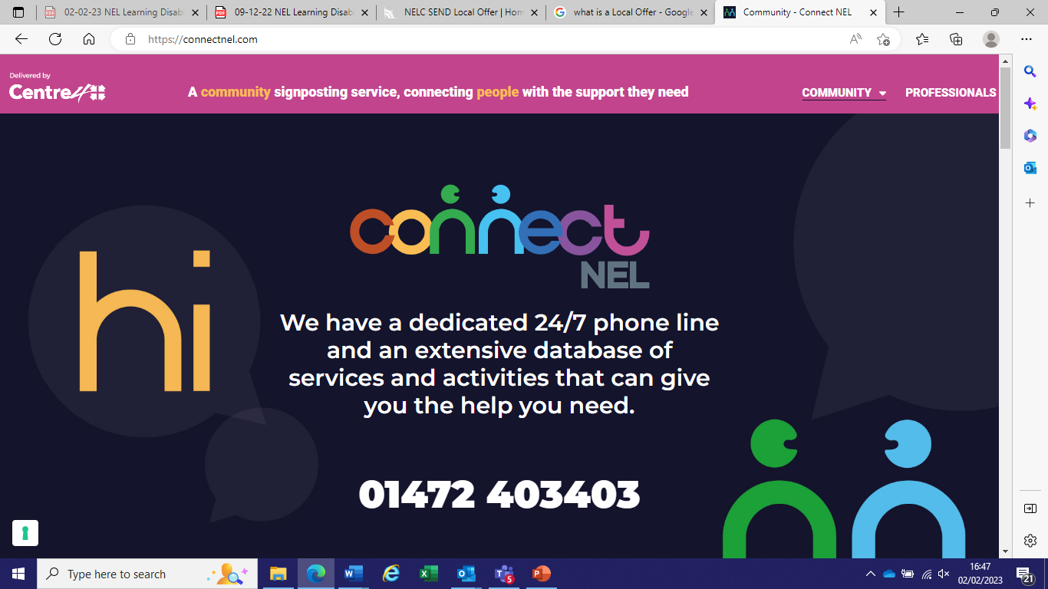
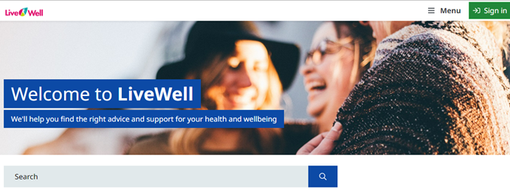
Further information, additional local services and support, whilst not exclusively for autistic people, which may be of interest can be found at Appendix 1 of this strategy.
8. The outcome of engagement with autistic adults in North East Lincolnshire.

Discussions were held with autistic residents of North East Lincolnshire regarding lived experiences of employment, engagement, health, support and well-being, access to services, and interactions with the police. Many people had not had positive experiences and spoke of a lack of understanding and empathy.

My employers were not originally helpful, but after making some adjustments to my working day, both myself and my employers were much happier”
Our transport services are very good in North East Lincolnshire and certainly help in accessing support and work

I want doctors to understand that I have autism and how this affects me
I want to feel safe

I don’t know where to go to look for help looking for work
Volunteering is a really good way to start looking for work, it helped me build my confidence

I want to work, and I want my employer to give the right support to be able to do my job
The employability team offer excellent support

Staff can continue to support autistic people year on year, and get better and better at helping us, I'm so glad I am getting this support.
I think the [Navigo} service is excellent.
The placements on my college course were really useful in helping me prepare for a job”
Sometimes I need a little help dealing with things, I find it difficult to communicate at times
I don’t know where to go to look for help looking for work
The diagnosis service is extremely important and useful
I really struggled at work and didn’t feel supported by my colleagues or my managers

The doctors speak to me, but this makes me very anxious, I’d rather they spoke to my mum

People think I’m going to be really good at Maths, or IT, there are some myths that need busting

The CPG employability team helped me write my CV

College was not a pleasant experience for some, due to attitudes from peers and staff

Services should be funded and not rely on volunteers for support, services should be funded fairly
I’d really like to build links with other social groups outside of our area
There needs to be acceptance, not just awareness

I was offered a course in maths by the Job Centre when I have an A level.

I want to join autism-friendly groups that help with education and employment

PIP is very helpful, it but the forms can be very confusing!

I want services that I speak to know how to make reasonable adjustments to include me and accept me as I am

9. Themes and priorities for North East Lincolnshire

The aim of this strategy is to ask: “how we can make North East Lincolnshire a great place for autistic people to live, and what can we do to support and help improve their outcomes?”
Our focus of this strategy is local services for local people. The themes and priorities set out in this strategy will become our workstreams. Each workstream will have an autistic person and/or a parent/carer co-leading the work, with people with lived experience and people from services shaping the action plans that will be overseen by the Adult Autism Board. Implementation will be monitored by (add when confirmed) to ensure outcomes are delivered and opportunities maximised. The themes and priorities are:

10. North East Lincolnshire’s Action Plan

In response to the priorities outlined in the government’s National Autism Strategy and its Implementation Plan 2021-22 , these have been used to inform the Action Plan below. The actions in italics are directly taken from or ‘localised’ from the Implementation Plan.
Also, we have identified the aims set out in the NHS Long Term Plan , specifically chapter 3 and the commitments relating to Mental Health, Learning Disabilities and Autism respectively.
Delivering the vision and outcomes will require all those involved to work together and where needed set up Task and Finish groups, develop timelines for the actions. The actions will be reviewed each year to reflect changes to local priorities and the available resources.
The actions highlighted in green are the priorities identified for action by autistic people in NEL.

Action 1 Diagnosis of autism

Outcomes |  | What we will do | When will we do this
 |  |  | 2023-24 | 2024-25 | 2025-26 | 2026-27 | 2027-28
I am supported by services and staff that understand my needs | 1 | Optimise the timeliness and quality of the diagnostic and post-diagnostic pathways and help to address the impact of the Covid-19 pandemic on waiting lists. | X | x | x | x | X
 | 2 | Improve the efficiency of identification for autistic people who are waiting for their autism diagnosis assessments and are at risk of crisis or being admitted to inpatient mental health settings. |  | x | x | x | X
 | 3 | Improve the quality of data on autism waiting times, and set out a plan to specifically improve the collection of data. |  | x | x | x | X
 | 4 | Continue to explore, develop, and improve to ensure that the most effective care and skilled advice is provided in an appropriate timely manner in the identification, diagnosis and assessment of need. |  |  | X | x | X
 | 5 | Consider expanding the Waiting Well Scheme (and other schemes) so we are looking after patients whilst they are on the waiting list. |  | x | x | x | X
 | 6 | Ensure parent/carers can access training at the right time, to enhance their understanding of how autism affects their family member and explore ways to improve support for them. |  | x | x | x | X

Action 2: Access to an education and awareness programme for the local workforce
Outcomes |  | What we will do | When we will do this
 |  |  | 2023-24 | 2024-25 | 2025-26 | 2026-27 | 2027-28
I feel accepted and confident within my community | 1 | Develop options and approaches for an autism education and awareness programme.  • Engage with stakeholders to identify the need for training and understand the audience size and priority groups for training.  • Co-design training with people who have lived experience  • Monitor autism training delivered to priority groups | X | x | x | x | x
 | 2 | Develop a delivery plan for the Oliver McGowan Mandatory training on learning disability and autism for all health and adult social care staff. | x | x
 | 3 | Explore use of the Capability Statement for social workers working with autistic people. | x | x | x
 | 4 | Increase public understanding and acceptance of autism, so that that autistic people feel welcome, more included in their local communities and are to live their lives to the fullest. |  | x | x | x | X
 | 5 | Roll out an education and awareness programme across a range of organisations, services and retailers. |  | x | x | x | X
 | 6 | Increase understanding and acceptance of autism enabling service and support providers to make reasonable adjustments within their provision and raising awareness of the Accessible Information Standard (AIS). |  | x | x | x | X
 | 7 | Develop North East Lincolnshire as ‘autism-friendly’. |  |  | x | x | X
 | 8 | Develop and deliver a web-based training programme to all NHS staff, providers, Council staff, and local businesses in NEL, including NLAG, Primary Care and the the Police. | x
 | 9 | Promote disability equality training package to Transport staff. |  | x

Action 3 Access to education and employment
Outcomes |  | What we will do | When we will do this
 |  |  | 2023-24 | 2024-25 | 2025-26 | 2026-27 | 2027-28
I am supported by services and staff that understand my needs | 1 | Explore developing specific provision for autistic young people with complex needs to avoid them having to go out of the area to have their needs met. |  | x | x | x | X
 | 2 | Continue to recognise the needs of autistic children and young people as part of actions we take to support children with SEND, as we move out of COVID-19 restrictions
 | 3 | Ensure considerations around autism and transitions into adulthood are included in our programme of school and college workforce training
 | 4 | Strengthen and promote pathways to employment, such as Supported Internships, Traineeships and Apprenticeships. |  | x | x | x | X
 | 5 | Ensure the NEL Wide Employability Forum and NEL Governance Panel has awareness of how to support autistic people and improve accessibility of training and employment. |  | x | x | x | X
 | 6 | Continue to work with Jobcentre Plus to ensure that centres and potential employers are welcoming and supporting to autistic people. | x | x | x | x | X
 | 7 | Raise awareness of the support autistic people can access to find and stay in work. | x | x | x | x | X
 | 8 | Ensure that autistic people’s experience of being in work has improved. |  | x | x | x
 | 9 | Ensure that through the Disability Confident Scheme, we promote the skills and abilities of autistic people, and signpost employers to resources on supporting autistic people. | x | x | x | x | X
 | 10 | Continue to promote existing programmes, including the Access to Work scheme, and Intensive Personalised Employment Support (IPES) for autistic people who are at least a year away from work. |  | x | x | x | X

Action 4 Access to support
Outcomes |  | What we will do | When we will do this
 |  |  | 2023-24 | 2024-25 | 2025-26 | 2026-27 | 2027-29
I know what help and support is available to me in my community  I am given the opportunity to access services using technology but if I can't I am supported to do this in other ways | 1 | Engage more autistic people in sport and physical activity. |  |  | x | x | X
 | 2 | Review the support and service provision to ensure the needs of autistic people across their life course. |  | x | x | x | X
 | 3 | Ensure the agreed NEL Preparing for Adulthood pathways and processes (from age 14) are embedded to support the achievement of key life outcomes and transfer to adult services, where necessary. | x | x | x | x | X
 | 4 | Support disabled people, including autistic people, to use public transport by raising awareness of people’s needs and improving signposting support services and safety measures. |  | x | x | x | X
 | 5 | Raise awareness of services to meet the differing support needs of autistic people e.g. pensions and benefits. |  | x | x | x | X
 | 6 | Ensure when autistic people are at risk of being affected by criminal activity, they gain support from services that understand their autism (e.g Police, Advocacy Services, Youth Offenders Service, Forensic Services) and reasonable adjustments are put in place. | x | x | x | x | X
 | 7 | Explore how police use out-of-court disposals (OOCDs) to support adults with vulnerabilities, including autistic adults. |  | x | x
 | 8 | Encourage more autism-friendly programmes in the cultural and heritage sectors. |  |  |  | x | X
 | 9 | Ensure housing, including supported housing, helps autisitc people to lead healthy independent lives. |  | x | x | x | x
 | 10 | Improve autistic people’s access to supported living and housing that meets their needs. | x | x | x | x | X
 | 11 | The needs of autistic people are considered in all new buildings e.g. new support based developments. | x | x | x | x | X
 | 12 | Raise awareness of the Disabled Facilities Grant (DFG) for autistic people, including exploring key issues and how best to overcome barriers with Home Improvement Agencies e.g. Foundations and key charitable organisations for autistic people. |  | x | x | x | x
 | 13 | Provide a designated keyworker for CYP with learning disabilities, autism or both who are inpatients or at risk of being admitted to hospital

Action 5 Tackling health inequalities
Outcomes |  | What we will do | When we will this
 |  |  | 2023-24 | 2024-25 | 2025-26 | 2026-27 | 2027-28
I have the same access to health and care support as everyone else | 1 | All NHS / NHS providers need to consider how they will tackle health inequalities relating to access to healthcare for people with additional needs and ethnic minority communities. | x | x | x | x | X
 | 2 | Ensure current pathways for care are fit for purpose and continually drive for improvement. | x | x | x | x | X
 | 3 | Explore opportunities to use the Community Discharge Grant to accelerate discharges. |  | x | x | x | X
I can get help urgently if I need it | 4 | Build on the current mental health / crisis, psychological and therapeutic support in NEL. |  | x | x | x | X
 | 5 | Address the obstacles autistic people encounter when attempting to access mental health / crisis, psychological and therapeutic support services. | x | x | x | x | X
 | 6 | Review current provision to verify the need to build the capacity and capability of seven-day specialist multidisciplinary and crisis services supporting autistic people and people with a learning disability. |  | x | x | x | X
 | 7 | Explore the need to develop respite and short breaks after COVID-19 with the aim of reducing admissions of autistic children and young people with and without a learning disability to tier 4 mental health settings. |  | x | x
My life expectancy is not lower than average simply because I have a mental health issue, learning disability or autism | 8 | Continue the expansion of the Stopping over medication of people with a learning disability, autism or both (STOMP) and Supporting Treatment and Appropriate Medication in Paediatrics (STAMP) programmes. | x | x | x | x | X
 | 9 | Implement the Lives and Deaths Programme (LeDeR) programme for autistic people without a learning disability. | x | x | x | x | X
 | 10 | Work in partnership with primary care to support the introduction the annual health checks for autistic people. |  | x | x | x | X
 | 11 | Work with primary care to improve recording of reasonable adjustments (RA) and the use of the ‘digital flag’ in patient records. |  | x | x | x | X
 | 12 | Ensure mainstream health services such as GPs, dentistry, optometry, audiology, chiropody, respiratory and epilepsy etc make reasonable adjustments to ensure autistic people get access to the health support they need, in line with the national NHS Long-Term Plan and NICE guidance. | x | x | x | x | X

Action 6 Engagement
Outcomes |  | What we will do | When we will do this
 |  |  | 2023-24 | 2024-25 | 2025-26 | 2026-27 | 2027-28
Services are easy for me to navigate | 1 | Continue to develop opportunities for engagement and co-production. | x | x | x | x | X
 | 2 | Maintain and build on autistic people’s and parent / carers’ involvement in the Adult Autism Board. | x | x | x | x | X
 | 3 | Embed across all aspects of commissioning services and design that enables autistic people and their parent / carers to effectively co-produce services and support with professionals. | x | x | x | x | X
 | 4 | Explore the development of a central online information point for autistic people | x | x | x | x
 | 5 | Recruit champions in autism and learning disability in the Integrated Care System (ICS). |  |  | x | x | X
 | 6 | Encourage people to become autism champions within schools, colleges,the business sector, and in community services and settings. | x | x | x | x | X
 | 7 | Work in partnership with autistic people to develop the provider market, community and voluntary sector groups. |  |  | x | X | X
 | 8 | Ensure that all services and supporters utilise person centred and family friendly principles. |  | x | x | x | X

9. Appendix 1
This list of services and support is not exhaustive and whilst not exclusively for autistic people, may be of interest. Links are provided below to make contact or view websites that have a comprehensive range of the latest information on services, support, advice and activities.
Navigo – provide a comprehensive range of mental health services, support, including employability services.
Care Plus Group - provide a diverse range of health and care and employability services.
Nurtrio - Part of the NAViGO family, Nurtrio provides a range of social care and support services.
Young Peoples’ Support Services - IAG on careers, further education, training and employment, aged 13-19 (or 25 for those with additional needs).
National Careers Service – IAG for all adults aged 19+ with weekly access to sessions in NEL, contact IAG-NEL@nelincs.gov.uk
Jobcentre Plus - provides resources to enable job-searchers to find work.
Livewell - a wide range of organisations; support groups, community groups, events, sports and activities that can help improve health and wellbeing.
Simply Connect – healthy living, social groups and activities, advice support and self - help
NEL Local Offer – information about specialist and targeted services and activities for young people with SEND
The Faraway community interest company (CIC) - autistic established, autistic led services and activities and mentoring for autistic people.
Carers Support Centre provides a range of confidential practical and emotional support and information on local support services and events.
Housing options, Supported Living and the Carers Support Service provide information on housing options and support
Foresight - daily social activities and courses for disabled adults, as well as to disabled 8- to 17-year-olds during school and college half-term holidays.
Linkage Choices a range of day, evening and weekend activities from age 16+
The Rock Foundation – a variety of practical workshops and supported work placements
Flourish - offer a variety of fun and community activities, email office@support2flourish.co.uk for further details
The National Institute for Clinical Excellence NICE provides evidence-based recommendations developed by independent committees, including professionals and lay members, and consulted on by stakeholders.

See page 6 for more information.
Please see page 4
Note that these figures only include pupils who are sole or dual main registered and therefore only count children once and are for national curriculum years N1 to 14. Also note that not all these pupils recorded with a SEN of autism will necessarily have had a formal diagnosis of autism.
Main and sole registered pupils, excluding out of county pupils, NCY N1-14
These are extrapolations of the NAS statements.
It is important to remember that applying the findings of other studies to our local population gives estimated figures, therefore these estimates should only be used as indicative because there will be inherent differences between the study population and our local population.
This is an estimate, and we expect it to be understating the real position.
As above.
Please note, data is always 1 quarter (3 months) behind, this is due to reporting and contracting arrangements. Additionally, specialist assessments take time, therefore figures assessed will not align with figures referred per quarter.

