SEND Annual
Survey Results 2022

Introduction
The SEND survey was first co-produced with parents and carers in 2019.
The questions have remained the same each year for comparison.
The survey is split into the following sections:
- Information, Advice and Support
- Education, Health and Care Plan (EHCP)
- Changes, progression and communities
- Health and Social Care
- Early Years
- We had 258 responses to this years 2022 annual SEND Survey compared to 107 last year and 26 responses in 2020 .
- Average time taken to complete survey was 5 mins.

What is working well?
- 44% of people feel their child and family get the right help and support compared with 39% last year and 34% the year before.
- 52% of people know where to go to get information about SEND compared to 39% in last year’s survey and 43% the year before.
- 40% of people find the Local Offer useful compared to 30% in last year’s survey and only 9% the year before.
- 46% of people feel that health services for their child aged under 5 works well in our local area compared to 40% last year and 38% the year before.
- 48% of people are confident that their child will be supported to live independently compared to 40% last year and only 18% the year before.
- 51% of people were confident that if their child would like to access further education when they turn 16 that they will be supported to do so compared with 43% last year and only 18% the year before.

Areas for improvement
- 28% of people feel they get the social care they need compared with 50% last year and 13% the year before.
- 38% of people understand their child's EHCP compared with 63% last year and 53% the year before.
- 37% My child's annual review process works well 57% last year and 37% the year before.
- 52% of people feel there’s good communication in their child’s school about their needs compared to 74% last year and 47% the year before.

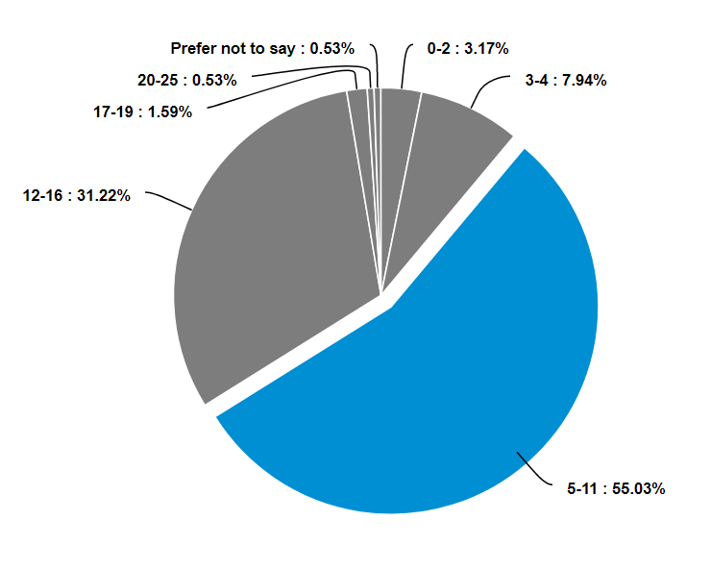
Age of child

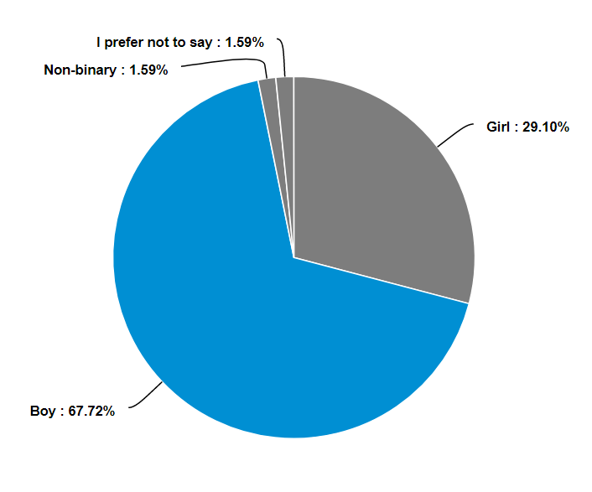

Age of child

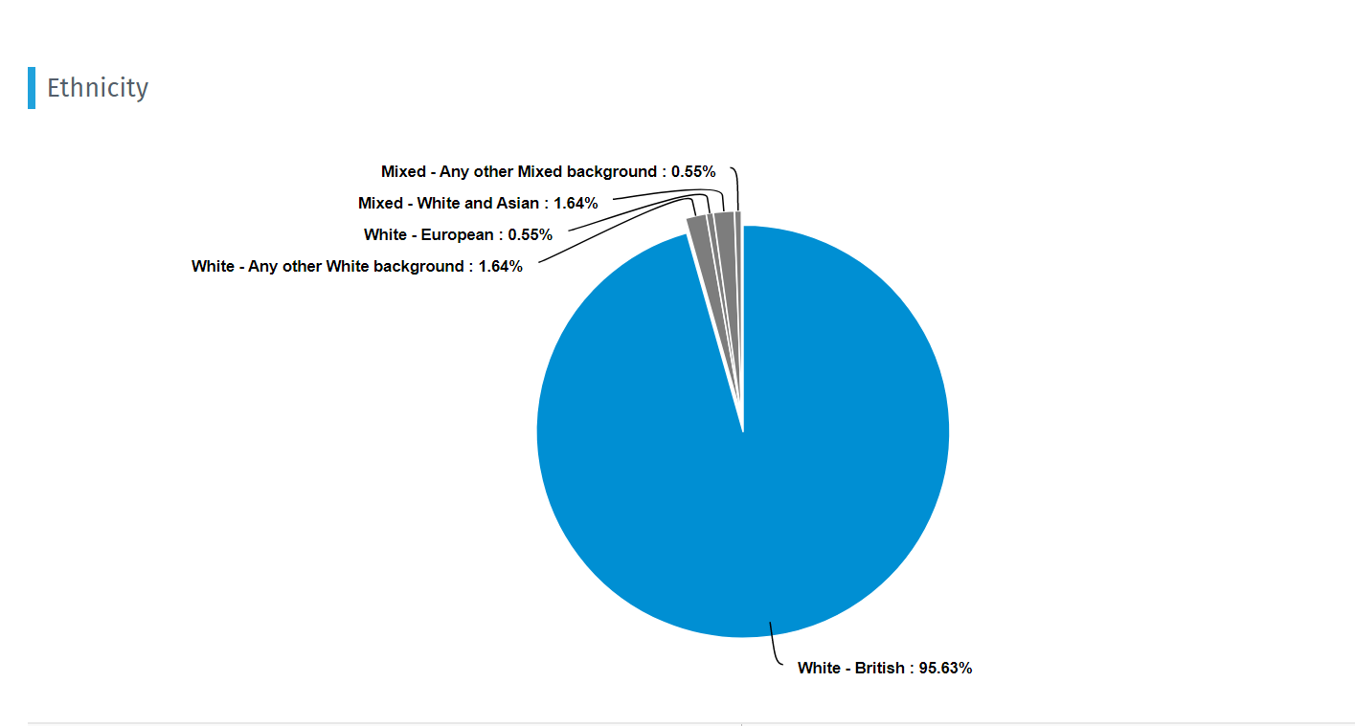

100% of the responses showed that English was the child’s first language

Information, advice and support

- I know where to go to get information about SEND
    - 2022= 52%
    - 2021= 35%
    - 2020=43%

- My child and family get the right help and support
    - 2022= 44%
    - 2021= 39%
    - 2020= 34%
- I get feedback about SEND developments in my area
    - 2022=42%
    - 2021=36%
    - 2020=13%
- I find the Local Offer useful
    - 2022=40%
    - 2021=30%
    - 2020=9%

Overall a fantastic SEND support in our experience so far. The local authority is clearly devoted to genuine coproduction with parent carers, welcoming of the knowledge and experience as resource available to them and passionate about creating change for the better

The school my child attends is fantastic
The NAS teen life course has worked well for myself and my family as it gave good support, information as well as the chance to meet other parents of children with autism. Sadly what is not working well is how the provisions listed in my child’s EHC plan are not fully in place in my child’s school.
I know my child has special classes at school but what they do for him I have no idea or if they will help in any way
I struggle to get to support groups for parents as I am working so find were very isolated as a family.
Teachers need to listen to parents as we know our child better than anyone.
Need more communication and accessibility to school SENCc
Education, Health and Care Plan (EHCP)
My child's Special Educational Needs Coordinator (SENCO) is supportive
2022= 52%
2021= 59%
2020= 40%
I understand my child's EHCP
2022= 38%
2021= 63%
2020= 53%
I agree with the outcomes of my child’s EHCP
2022= 39%
2021=63%
2020=53%
My child's annual review process works well
2022= 37%
2021= 57%
2020= 37%
`
Please only answer this question if your child is in year 9 or above: Talking about preparing for adulthood started in year 9
2022= 365
2021= 50%
2020= 38%

Things need to improve to help me as a parent they (school) only helped me few times since coming back after Xmas to school. My son refuses to get in my car most days they just don't understand what I go through as a parent

I think what is not working well is how EHCPs are being interpreted in secondary school. I feel the system could be improved through regular communication from school that relates specifically to the outcomes in the EHCP.

Need more support into where to go and process on been assessed for autism etc
You need to have more special school places and stop putting everything into normal schools
Children without banding can still have SEND needs however it is extremely difficult to get additional support without an EHCP
What works well is setting plans at home and school, getting feedback from school
Doing annual review with a person who has never met my young adult. They get reports from tutors but they need to be at the review.
It all takes too long.
Changes, progression, and community
I’m confident that if my child would like to access further education when they turn 16 that they will be supported to do so
2022= 51%
2021= 43%
2020= 18%
I am confident that my child will be supported to gain employment
2022= 45%
2021= 30%
2020= 18%
I am confident that my child will be supported to live independently
2022= 48%
2021= 41%
2020= 18%
There’s good communication in my child’s school about their needs
2022= 52%
2021= 74%
2020= 47%
I feel my child is part of their community
2022= 50%
2021= 59%
2020= 31%
My child has equal chances at school
2022= 50%
2021= 54%
2020= 40%
Please only answer this question if your child is in year 9 or above:
My child has been supported to reach their goals
2022= 46%
2021= 68%
2020= 44%

Less stigma in secondary schools about SEN support and SEN areas by other children which means educating the children and promoting awareness, inclusion and being kind. Health and social professionals could be linked up with specific local schools perhaps If not already so multidisciplinary working can work smoothly. with SEN and disabilities in school and the community.
We need more regular reports and updates and .also let the .parents know what we can do to assist even if its extra work at home
My son has autism but because it isn't seen as severe and he is extremely clever he has been left as though he is fine. His autism affects him greatly, it shouldn't matter that he is clever, he still needs extra help.
Annual reviews undertaken in primary school but none in secondary school. I'm not sure if this is even required for SEND without an EHCP anymore
My son extremely sporty but is not supported at his school. I would like him to be able to do a BTEC in sport rather than the traditional GCSE route, which secondary school insist children have to take. it would amazing if schools could think differently than the traditional exam route for some students.
Health and Social Care
Our family gets the social care/social worker support they need
2022= 28%
2021= 50%
2020= 13%
Our child gets the health care support they need
2022=52%
2021= 51%
2020= 30%
Our family gets the health care support we need
2022= 46%
2021= 48%
2020= 31%
Having a diagnosis is necessary to get the support
2022=78%
2021= 80%
2020= 85%
I know how to access therapy services for my child in my local area
2022= 37%
2021= 30%
2020= 24%
I know which social care service will be looking after my child's care needs when they turn 16
2022= 26%
2021= 25%
2020= 13%
I know which health service will be looking after my child’s health when they turn 16
2022= 28%
2021= 25%
2020= 19%

Great access to support- but wait times could be improved. Services available are approachable, friendly and supportive. I’ve been particularly impressed with the CAMHS/young minds matter support.
I am unsure as how the NHS will review my child once he is no longer at out patient at the child development centre. I would think of looking at the local offer to see what therapy services are available and how to refer or contacting my GP for support and advice.
We’ve not seen my sons consultant since before Covid began and have had one telephone appointment.
Carer support although granted hours struggle to get good quality carers for long term
We need more than 1 night respite a month were on our knees!
The formula used for working out care support is rediculous and does not reflect the care time ect required for children like our daughter.
We’ve not seen my sons consultant since before Covid began and have had one telephone appointment.
Early Years
Health services for my child works well in my local area
2022= 46%
2021= 40%
2020= 38%
Our health visitor supports us well with our needs
2022= 40%
2021= 26%
2020= 22%
My child had their needs identified early enough
2022= 40%
2021= 46%
2020= 36%
My child with SEND and our family have our views listened to and acted
2022= 41%
2021= 36%
2020= 30%
My child had their needs met
2022=40%
2021= 52%
2020= 49%
My child has been well supported to move from one room/class/setting/school to another
2022= 53%
2021= 58%
2020= 53%
School try their best to help my son, with everything they do
Having a child with additional needs is very isolating and we would benefit from having support of others in a similar situation.
Children without banding can still have SEND needs however it is extremely difficult to get additional support without an EHCP

I feel like this area could benefit from a building tailored to children with SEN or a play area that is made safe for older children to play. families
Pre school are amazing . However we have experience massive delay in our child accessing SALT , audiology etc etc which has delayed their development further and as a result I am concerned my child will not be school ready in September.
My daughters nursery have been brilliant, during summer holidays in 2021 they supported her really well moving from one class room to another without much distress for my daughter.
My son is only young so my answers may change in the future we have only had an EHCP in place for just over a year and Covid has been a right pain in getting it in place and upkeeping it. So this process is still new and confusing to us as a family

