EDUCATION, HEALTH AND caRE hUB
GUIDE 9 FOR SEncos – Decision to issue plan
APRIL 2022

Decision to Issue Plan
Once the case co-ordinator has indicated that the case is ready to progress to the decision, this change in status will be reflected in the display of the case in the My cases in progress

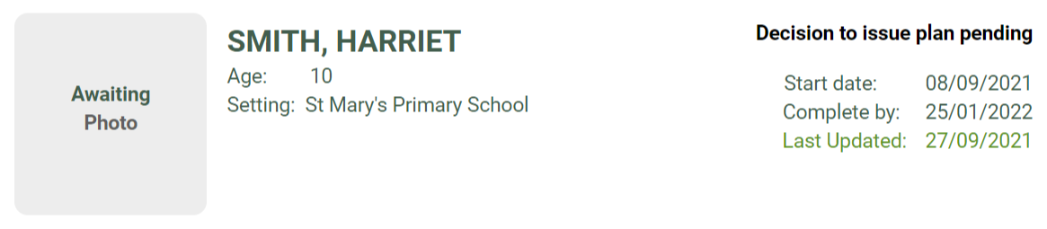

Once the decision has been published, you will get an email asking you to log in to the hub to view the decision:

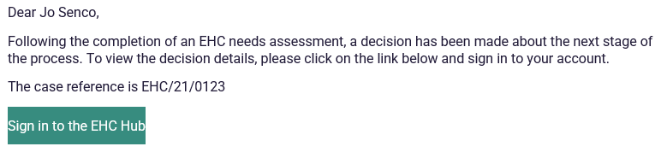

When you log into the hub, the status will be displayed. If the decision has been made to issue a care plan, the status will look like this:

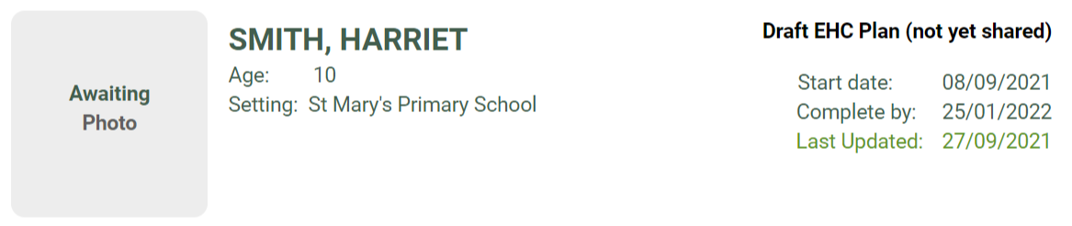

If the decision was made not to proceed to issue a plan, the case file will not be displayed in the My cases in progress tray as this case is no longer in progress. To view the information select Include closed cases tick in the filter bar on the left-hand side:
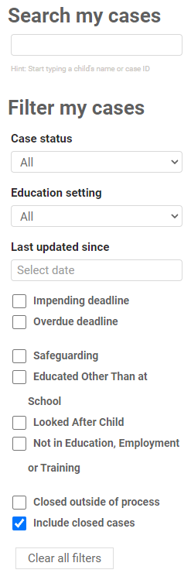

The case file will show a status of Decision made not to issue an EHC Plan:

For more information about the decision, click on the case file

The reason for the decision will be displayed, and it will be possible to view a letter with details about the decision:

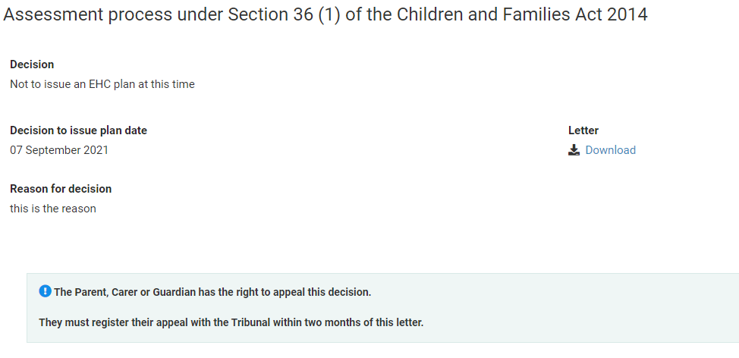

To view the letter, click the Download link and a copy can be saved to your device.
You can view the information previously entered in the needs assessment process by clicking on Assessment in the icon bar at the top:

