EDUCATION, HEALTH AND caRE hUB

GUIDE 8 FOR SEncos – How to contribute to an assessment

APRIL 2022

How to contribute to an assessment

If the decision has been taken to proceed with an EHC Needs Assessment, when you click on the case, you will be provided with information about the EHC needs assessment process.

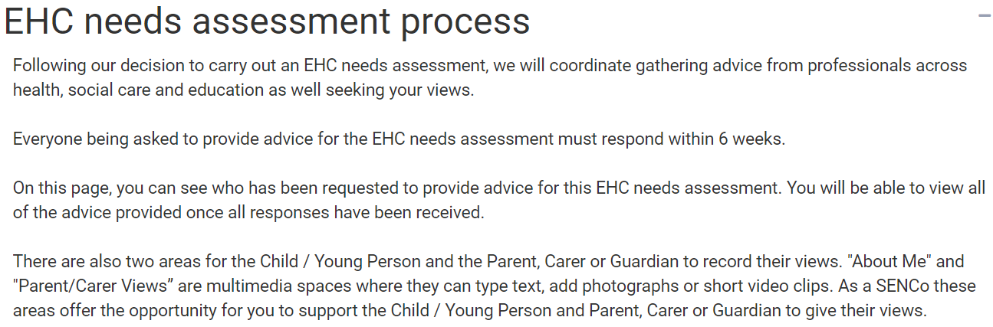

Requests for Advice

If you have been requested for advice, your name will be displayed in the list below:

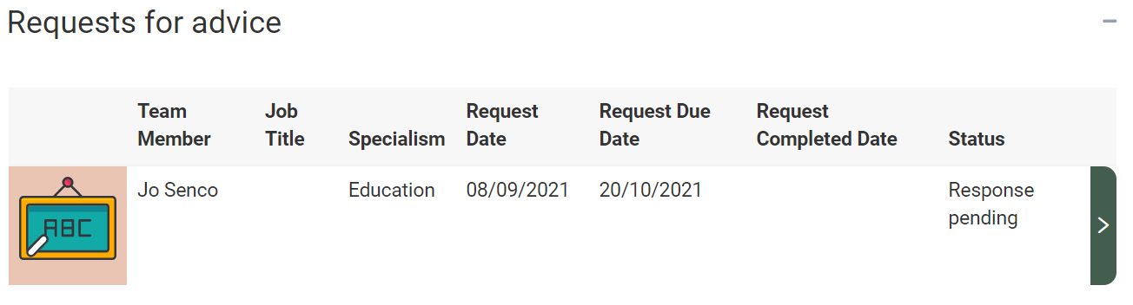

The date of the request and the date your response is due will be displayed, as well as the status of the request for advice.

To enter your advice, click on the right pointing arrow. The following page will be displayed:

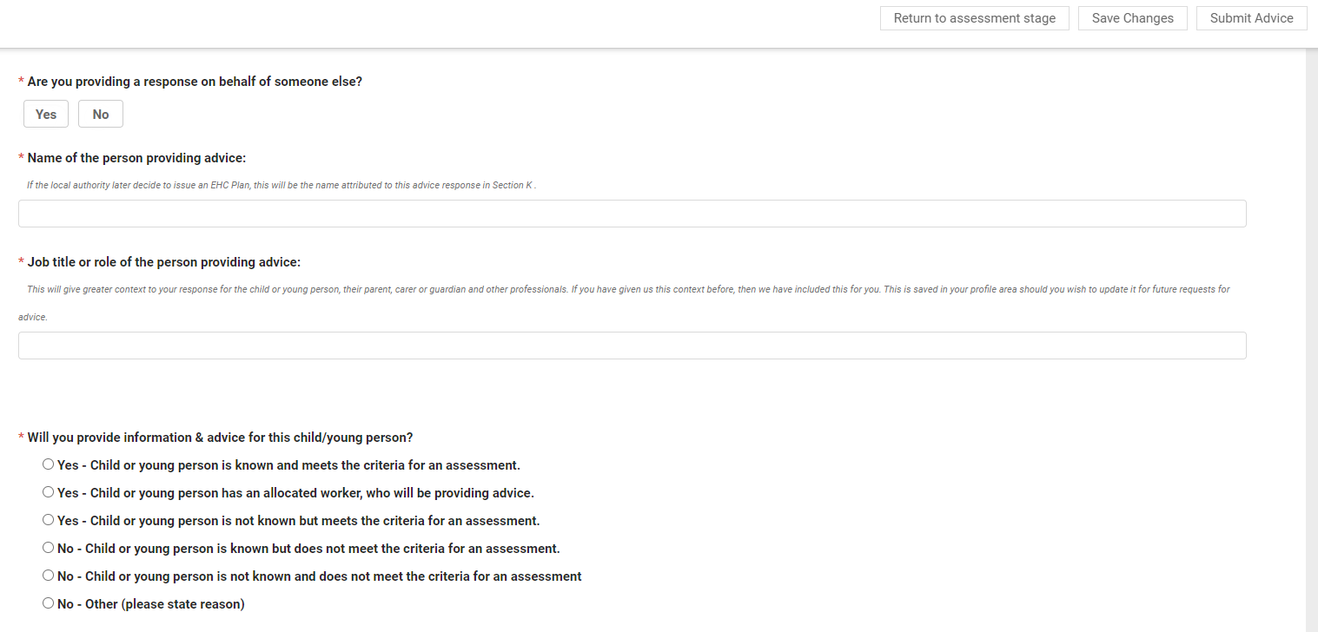

You will need to specify if you are providing information on behalf of someone else or not; “Yes” or “No.”

If you are providing advice on behalf of someone else, you will need to enter their name and job title/role. If you are not providing advice on behalf of someone else, these details will be added for you from your user profile.

Indicate if information will be being provided, and the reason for this answer. To select your answer, click on the appropriate radio button.

Below this, there are free text fields for you to provide details.

The first section has six fields to be completed:

* Details
* When did the child or young person first come into contact with your organisation? (This field is mandatory and must be completed before the advice can be submitted)
* Details of any discussion held between the child or young person and your organisation (if relevant)
* Details of any discussion held between the parent(s) or carer(s) and your organisation (if relevant)
* What has your organisation put in place already to support the child or young person’s needs? (This field is mandatory and must be completed before the advice can be submitted)
* What has been the effect of any support or strategies already put in place by your organisation?

Below that, there are six more sections:

* SEN - Communication and Interaction
* SEN - Cognition and Learning
* SEN - Sensory and/or Physical needs
* SEN - Social, Emotional and Mental Health
* Health
* Social Care

Each section has a text field that can be completed.

It also has a section for recording the long-term outcomes to be achieved:

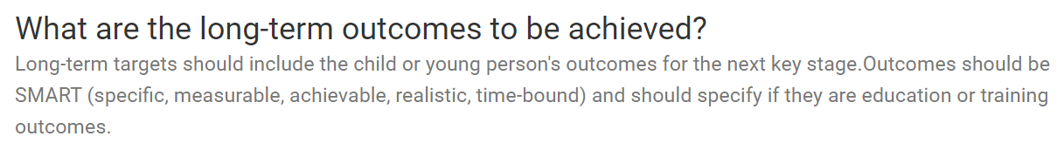

**Steps an****d Provisions**:

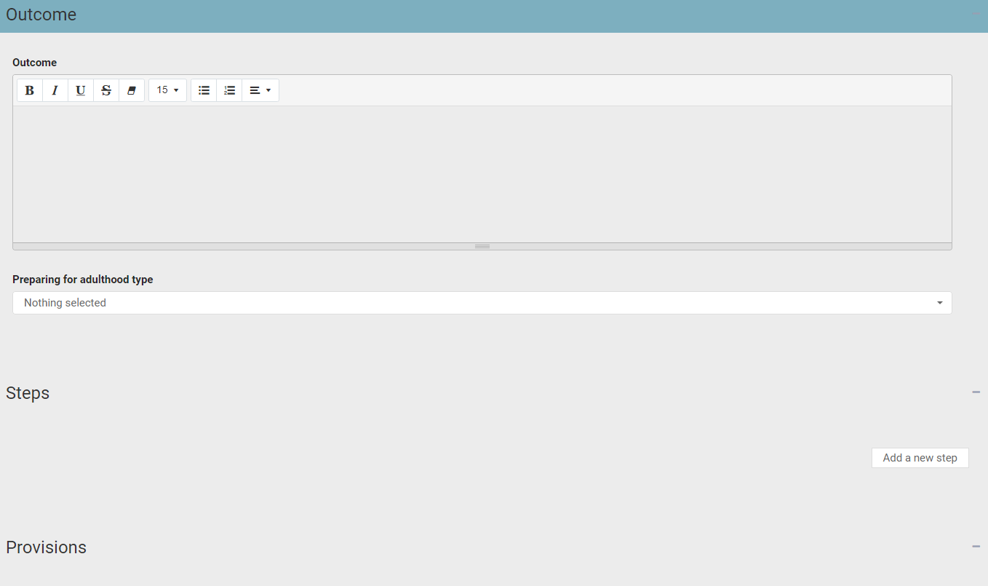

**Outcome** - Enter the details of the outcome in the text field.

**Preparing for adulthood type** – Select the correct type from the pick list.

**Steps** – to add a step, click on the Add a new step button. The display will change:

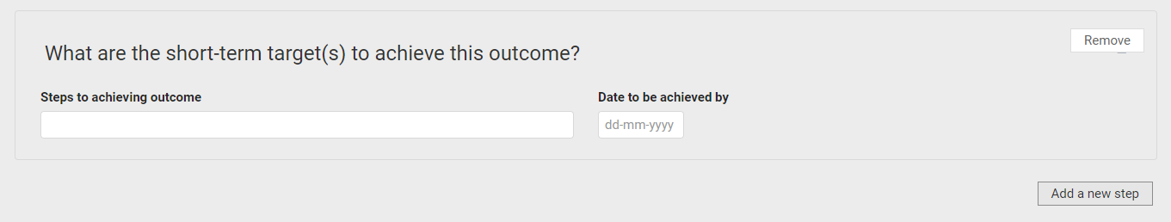

Enter the step to achieving outcome and the date to be achieved by:

**Provision** – Click on the Add a new provision button. The display will change:

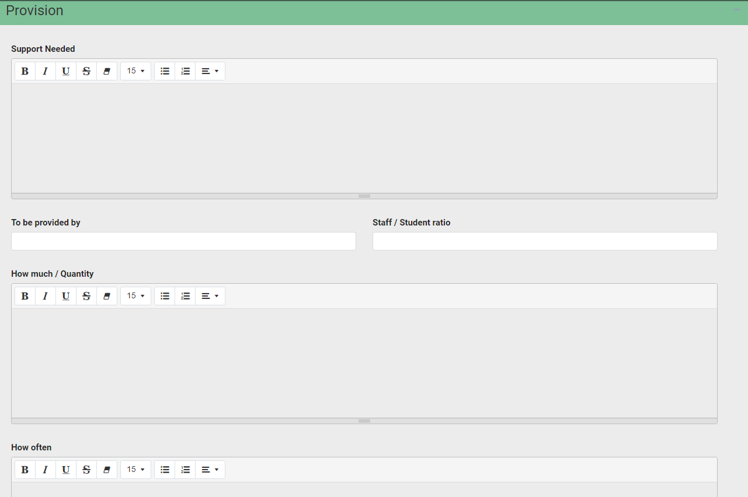

Enter the details of the support provision then click on Add a new provision.

When all of the information in the section has been completed, click on Save Section:



There are certain fields that are mandatory. These fields will be indicated with a red asterix. You will not be able to submit your advice unless these fields have been completed.

Documents

Any addition information to support the advice can be uploaded here:

If you want to add any documents, click on the Add Files button:

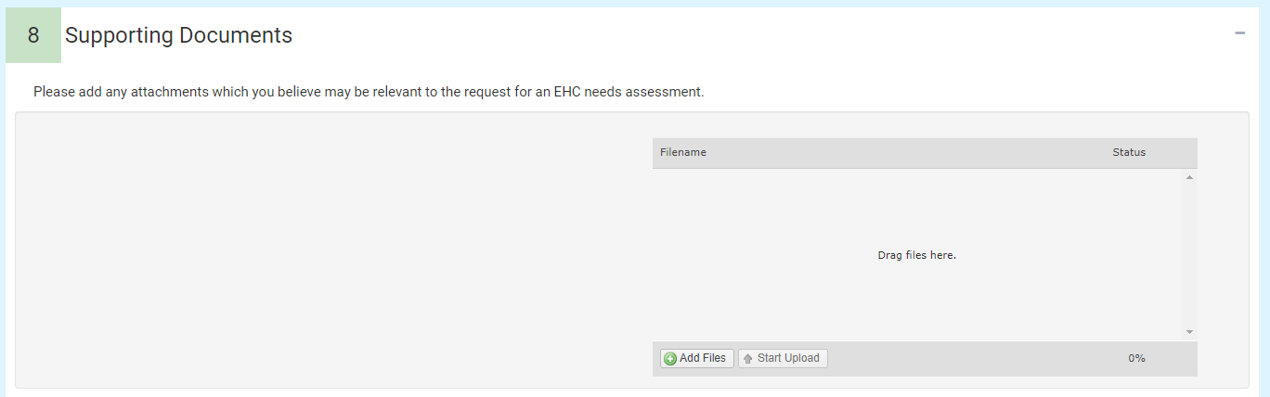

You will then need to navigate to the file wherever it is saved on your PC:

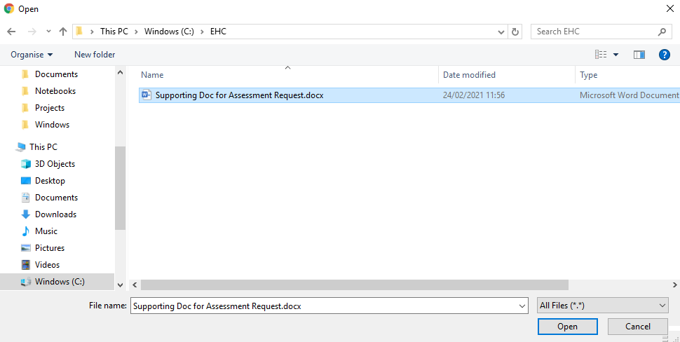

Click on Open and the file will be uploaded. The uploaded file will be displayed:

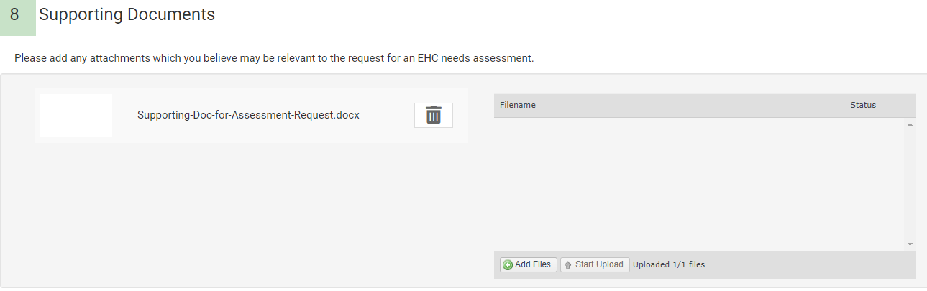

At the top of the screen, there are four options:

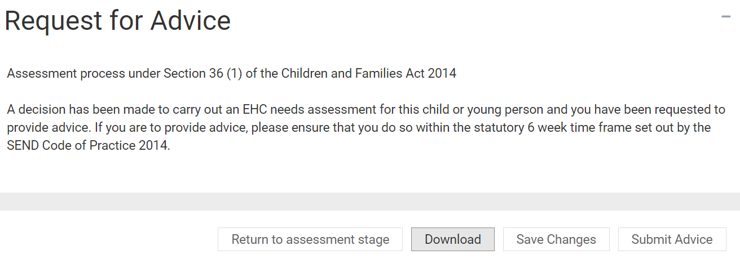

**Return to assessment stage** - This will return you to the assessment page (please make sure changes are saved before returning to the assessment page – a warning message will be displayed if there are unsaved changes):

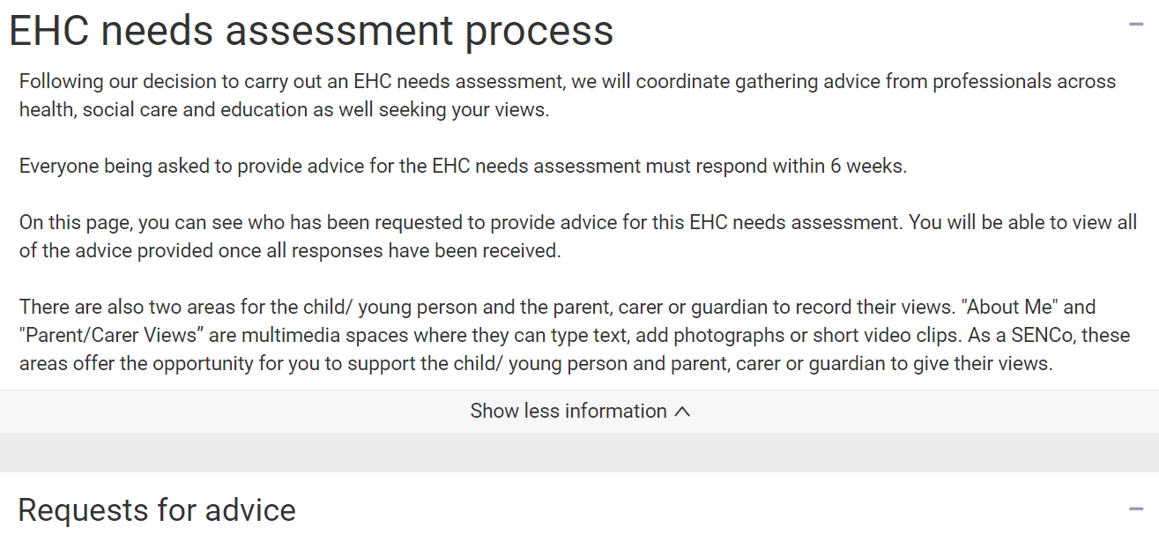

**Download** – it is possible to download a copy of the completed advice request as a PDF document. When you click on download, the file can be saved to your device:

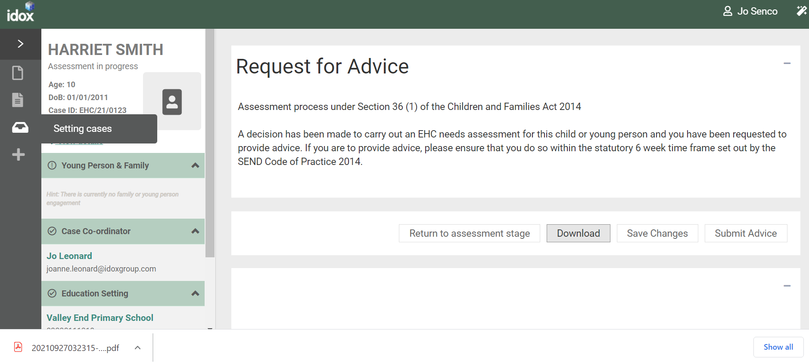

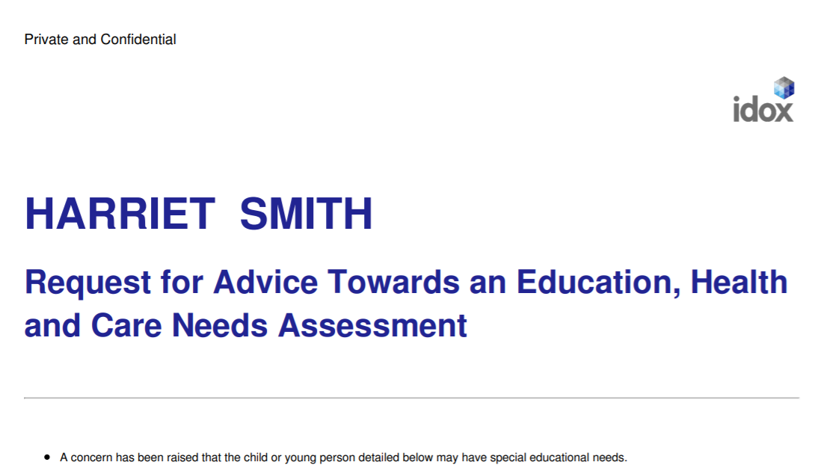

**Save Changes** – when you have completed your advice information, click on Save Changes.

Submit Advice

When you are ready to submit your advice, click on Submit Advice.

You will be asked to confirm you wish to submit the advice:

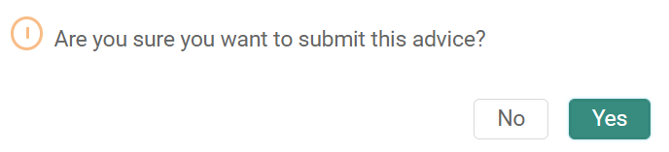

When you click on yes, you will be taken to the Assessment page and the display of the Requests for advice will be updated:

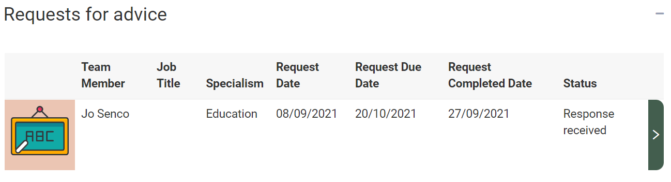

Having submitted advice towards the assessment, it will now be possible to read all other professional advice that has been submitted.