EDUCATION, HEALTH AND caRE hUB

GUIDE 7 FOR SEncos – decision

APRIL 2022

Decision

Once the decision has been made, you will receive an email indicating this:

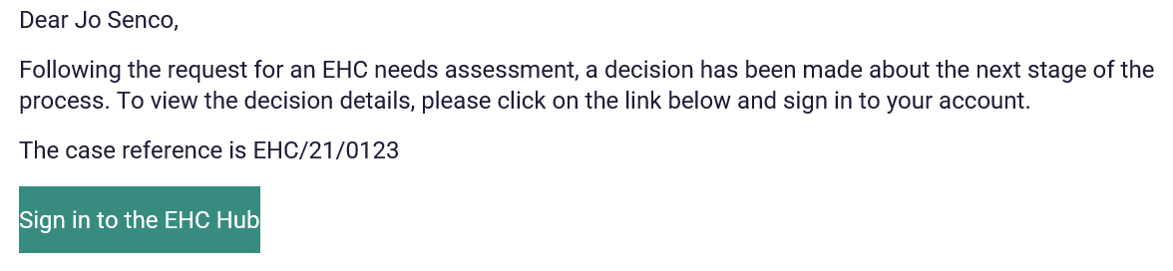

When you log into the Hub, the status of the case file will have changed to reflect this:

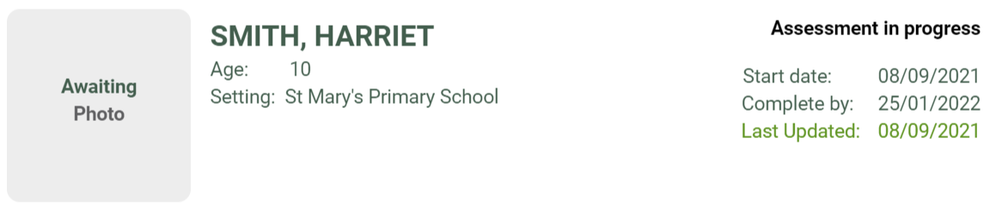

If the decision was made not to proceed to an assessment, the case file will not be displayed in the My cases in progress tray as this case is no longer in progress.

To view the information select Include closed cases tick in the filter bar on the left-hand side:

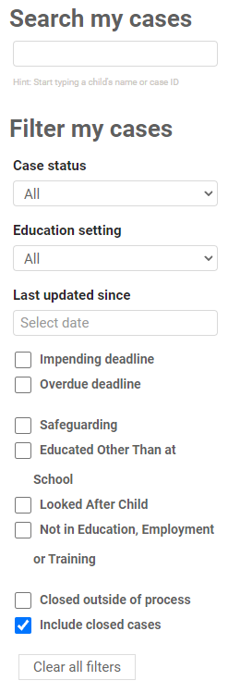

The case file will show a status of decision made not to assess:

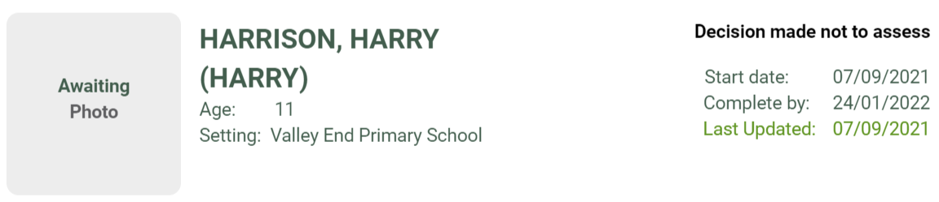

For more information about the decision, click on the case file.

The reason for the decision will be displayed, and it will be possible to view a letter with details about the decision:

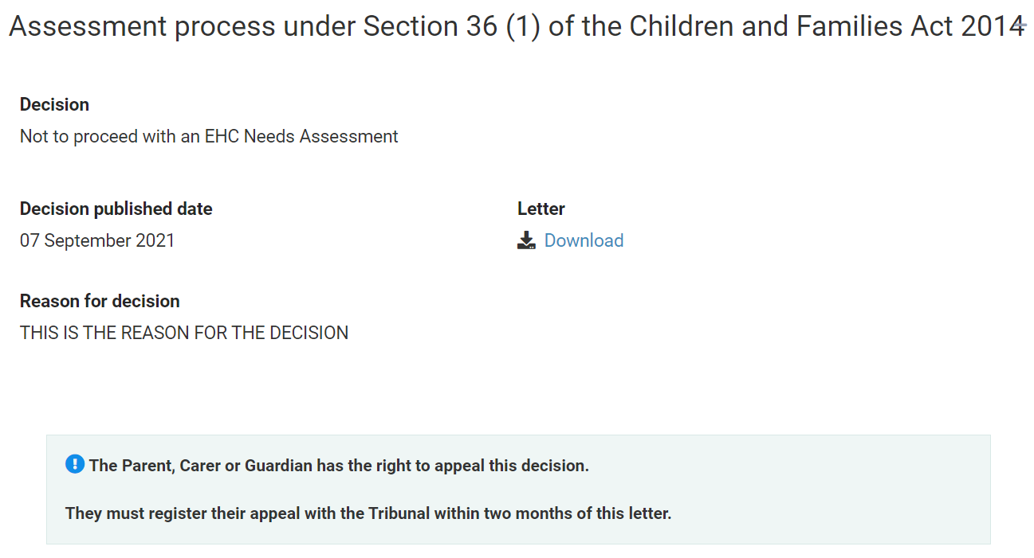

To view the letter, click the Download link and a copy can be saved to your device.