EDUCATION, HEALTH AND caRE hUB
GUIDE 6 FOR SEncos – Progress to decision
APRIL 2022

Progress to Decision
When the case co-ordinator has indicated that the request is ready to be progressed to a decision, the status will change to reflect this:

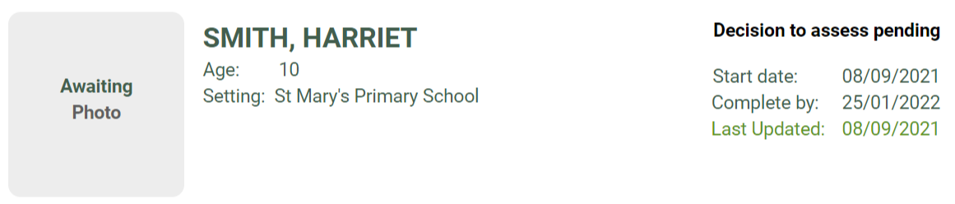

When this case field is viewed, it will look like this:

