EDUCATION, HEALTH AND caRE hUB

GUIDE 5 FOR SEncos – How to contribute to a request

APRIL 2022

How to contribute to a request

Once the case co-ordinator has assigned the case, you will get an email to say that you have been added to an active EHC Case:

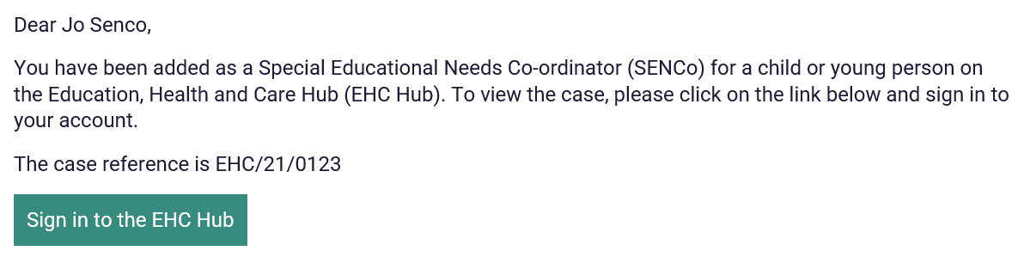

When you sign into the EHC Hub, the request will appear in your cases in progress list with a status of Request for assessment (information gathering):

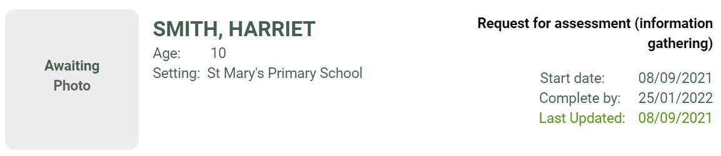

Some of the information can be amended or added to here by you, but some information can only be amended by the case co-ordinator. This will be indicated with this message:

screenshot of case co ordinator message

If you want to change information in an area that can only be amended by the case co-ordinator, you should email the case co-ordinator with the request.

The details of the case co-ordinator, including their email address are displayed on the left-hand side of the screen:

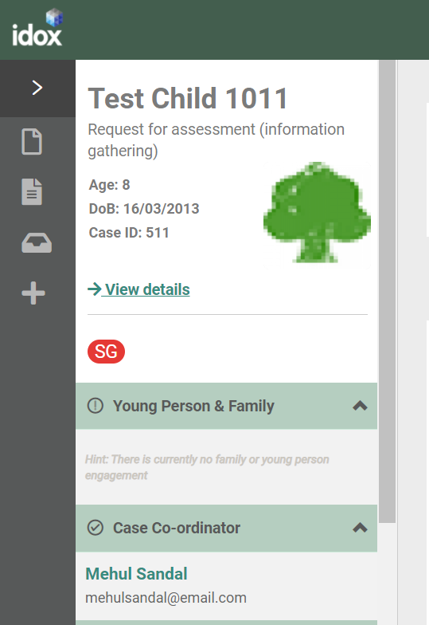

If you do make any changes to those sections that can be amended, you will need to click on Save changes to save those changes.

Enter the correct information and click on save changes at the top of the screen:



When you click on save, the information will update and the following message will appear:



Once all of the information for the decision on the assessment has been gathered, the case co-ordinator will progress the case to the next stage and a message will appear to say that the decision is pending:

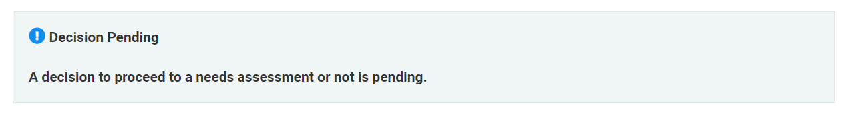

Once this message appears, it will not be possible to amend the request.