EDUCATION, HEALTH AND caRE hUB
GUIDE 4 FOR SEncos – Completing a needs assessment request
APRIL 2022

Completing a Needs Assessment Request
The following sections contain details on how to complete the different sections of the needs assessment request if you are the SENCo making the request.

To make a new request, click on the Plus on the left hand of the screen:

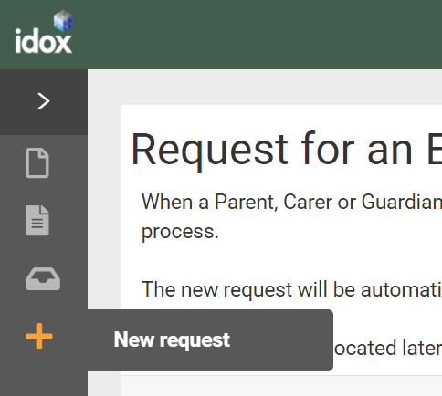

Consent

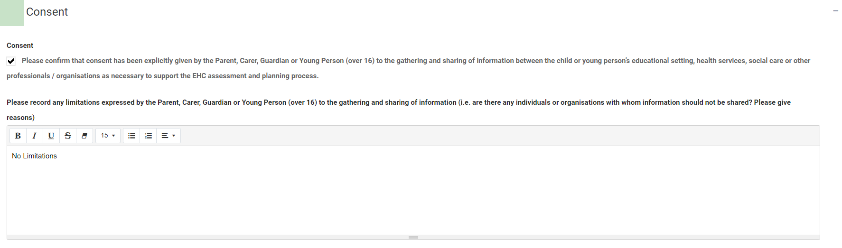

Click in the tick box to confirm that the Parent, Carer, Guardian, or Young Person (over 16) has given consent to the gathering and sharing of information.

Click in the text box to record any limitations expressed by the Parent, Carer, Guardian, or Young Person (over 16).

Details of person requesting a EHCP Assessment

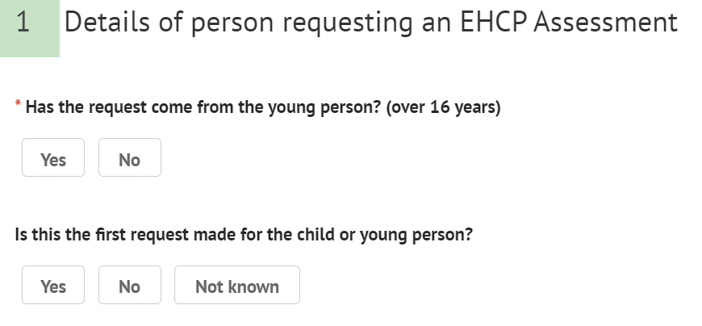

A SENCo completing the request should click “No.” The following extra fields will be displayed for the requester’s details:

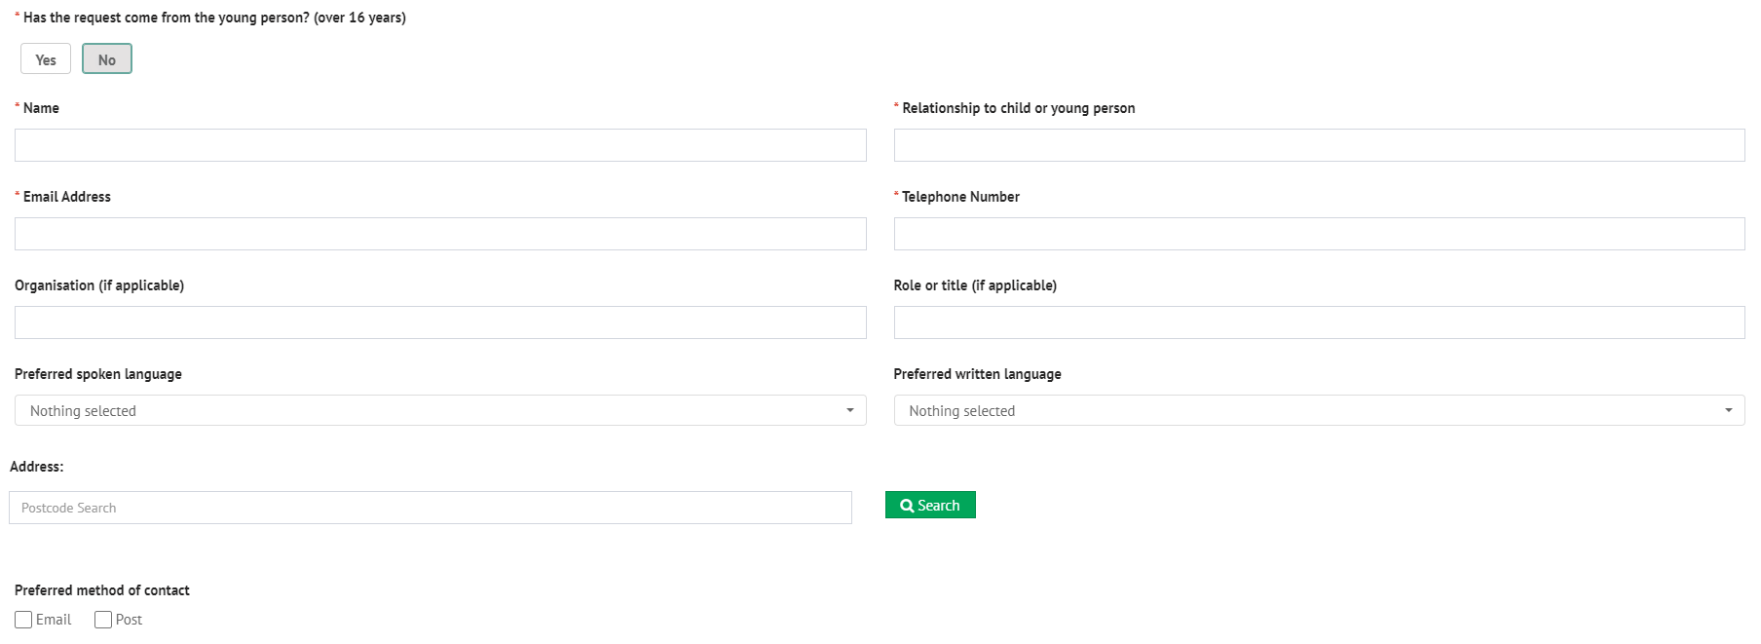

Name – Enter your name.

Relationship to child or young person – Enter the nature of the relationship between yourself and the young person.

Email Address – Enter your contact email address if you are the person making the request. When the request has been completed and sent, a confirmation email will be sent to this email address to show that an assessment request has been sent.

Telephone Number – Enter your contact telephone number if you are the person making the request for the assessment.

Organisation – If you are making the request for this young person on behalf of an organisation, enter the organisation name here.

Role or Title – Enter your job role or title in the organisation.

Preferred spoken language:

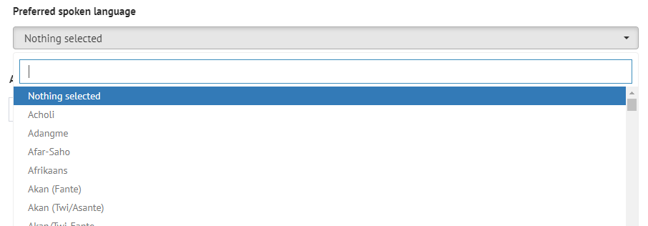

Preferred written language

Address

Preferred method of contact – select if you would prefer to be contacted by email or post.

Is the first request made for the child or young person – select Yes, No or Not known as applicable. If No is selected, enter the date a previous request was made, if known.

Child or young person’s details.

First name – enter the first name of the child or young person the request for an assessment is for.

Last name – enter the last name of the child or young person the request for an assessment is for.

Middle name(s) – enter the middle name(s) of the child or young person the request for an assessment is for.

Preferred name – enter the preferred name of the child or young person the request for an assessment is for.

UPN – enter the UPN if known. Otherwise, leave blank.

Internal system reference – local authority office use only. This should be left blank.

Date of Birth – Type in the date of birth, with a dash between the day, month and year.

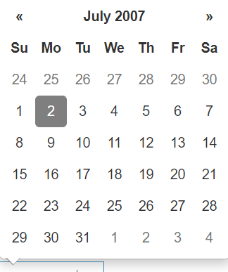

Once the date has been selected, the age will be calculated and displayed automatically:
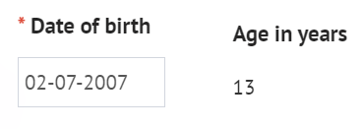

Year Group Offset – if the child or young person is not in their age expected year group, use this field to apply a correction, e.g., a child or young person in the year group below their age expectation would require an offset of “-1”.

Click on the up or down arrow to change the year group offset.

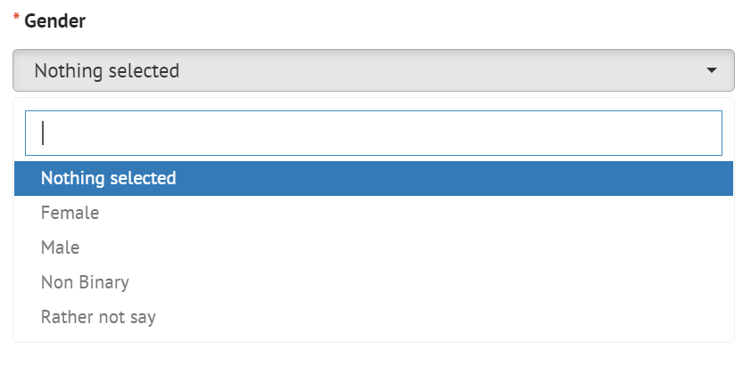

NHS Number – Enter the NHS Number of the child or young person, if known.

Legal Status:
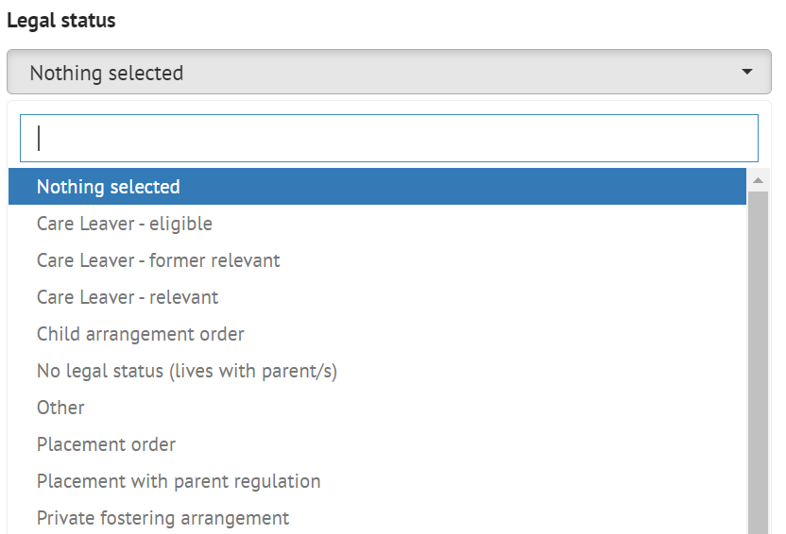

Ethnicity

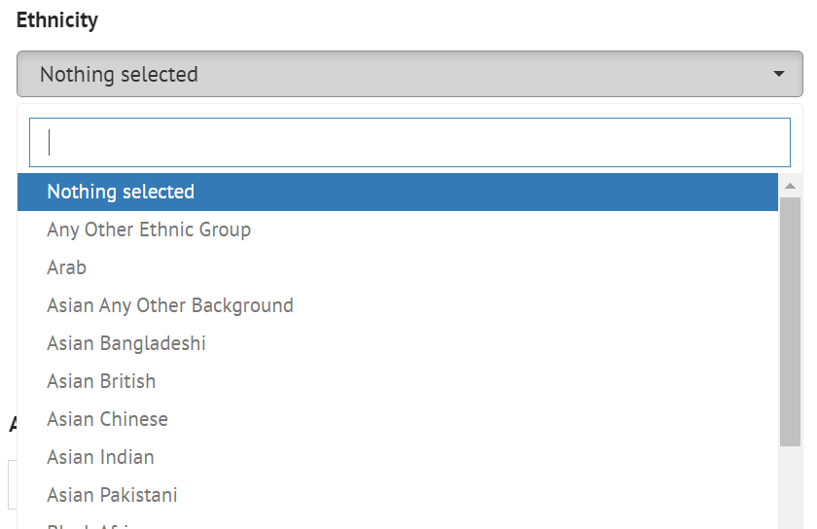

Preferred spoken language:

Preferred written language – This will automatically default to the preferred spoken language but can be amended if not correct.

Main telephone – Enter the main telephone number for this child or young person.

Email address – Enter the email address of the child or young person. This is NOT the email address any confirmation emails or requests for registration will be sent to and is just for information.

Address

Preferred method of contact – select if the young person would prefer to be contacted by email or post, if appropriate.

Child or young person’s main contacts (family and involved professionals)

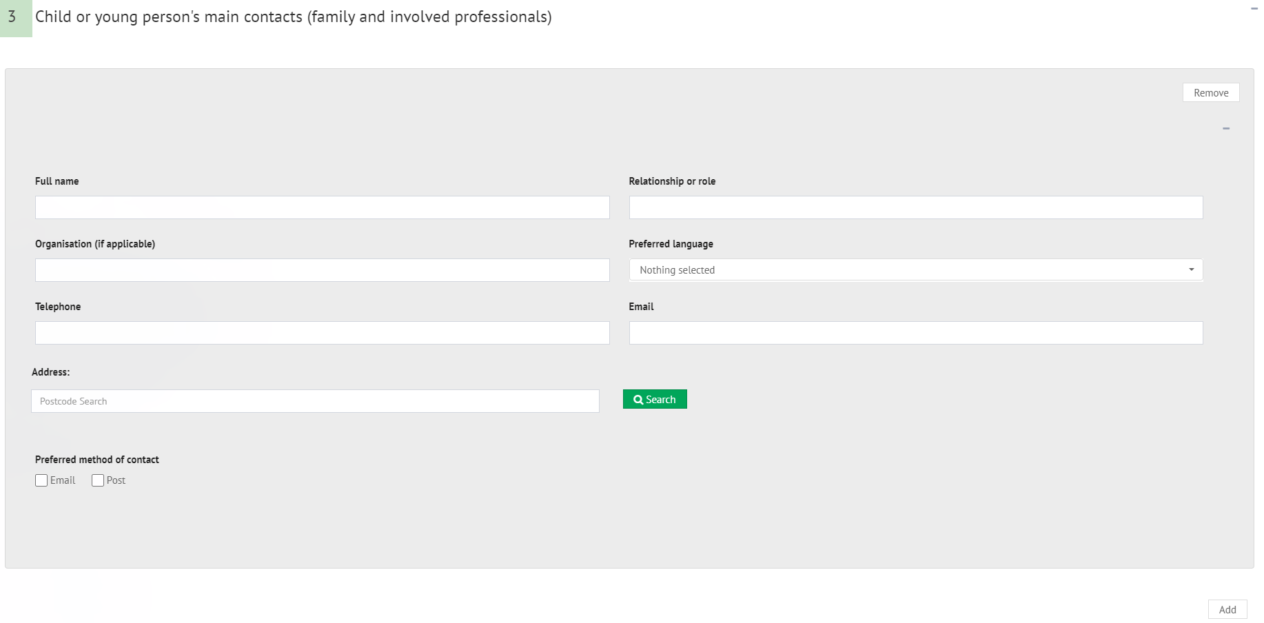

This section is for details of any contacts for the child or young person the request for an assessment is being made for. All family and involved professionals relevant to the request should be included.

Full name – Enter the name of the Full Name of the contact e.g., John Smith.

Relationship or role – enter the relationship between or the role of the contact to the child or young person the request for an assessment is being made for. E.g., Father

Organisation (if applicable) – if this contact is part of an organisation (as opposed to a family member), enter the name of the organisation here

Preferred Language

Address – Enter the details of the contact for the child or young person.

Preferred method of contact – Select the preferred method of contact for the child or young person’s contact.

It is possible to add more than one contact to the assessment. To add further contacts to the request, click on the Add button in the bottom right-hand corner and complete the fields as above. This can be done as many times as required.

To remove a contact, click on Remove in the top right-hand corner of the section:

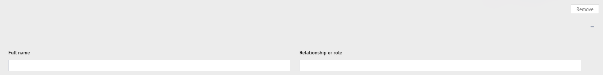

Details of the child or young person’s current education setting(s)

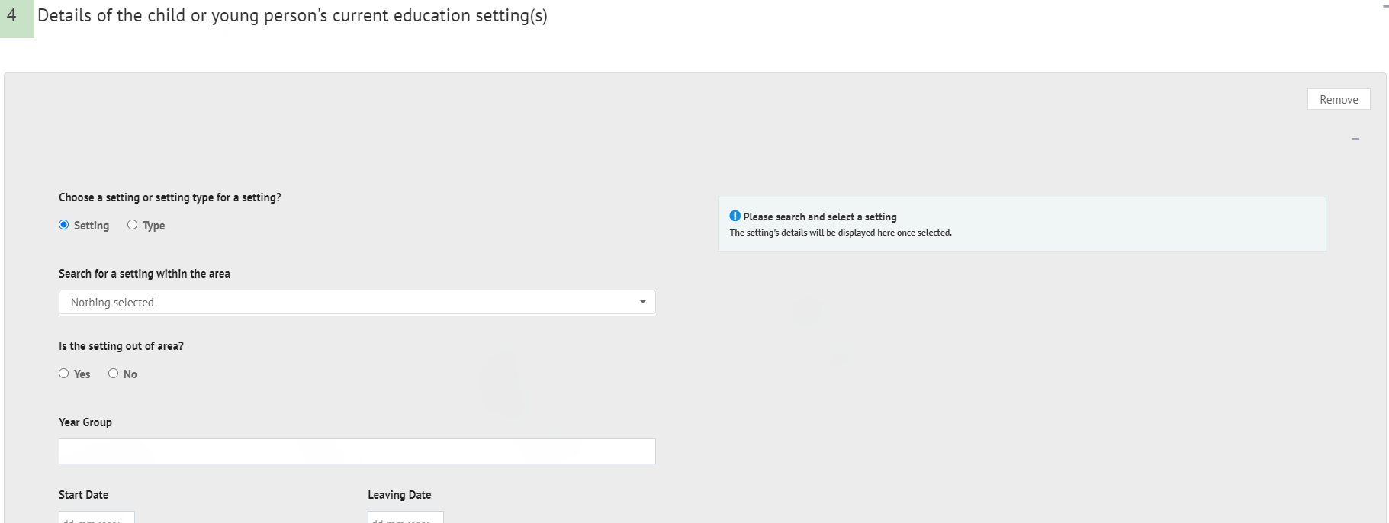

It is possible to add an educational setting either based on the setting itself (e.g., the actual name of the education setting) or based on the type of setting (e.g., Mainstream school, Special school: Non-maintained etc). The details available to be completed will be based on if Setting or Type is selected.

Setting
If Setting is selected, the screen will look like this:
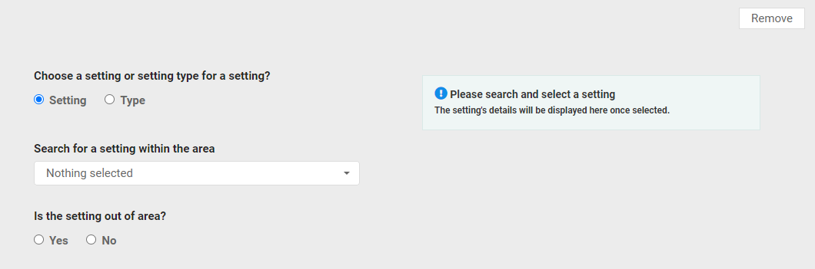

Search for a setting within the area:

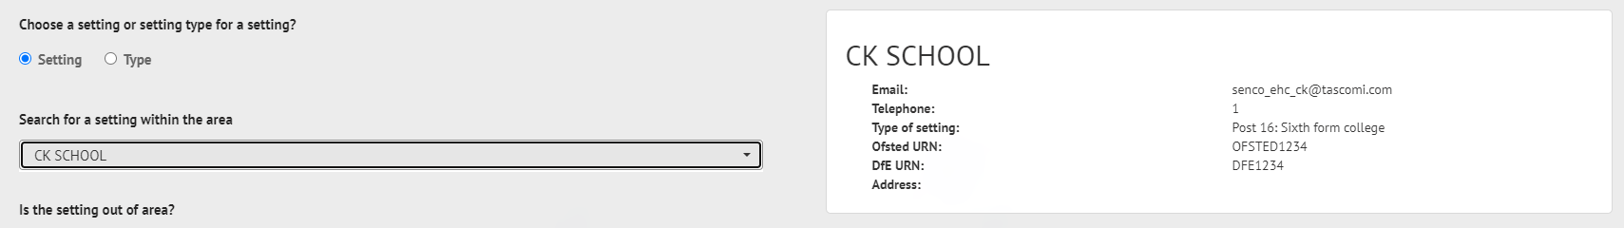

If the setting is not on the list, click on Nothing selected and click on Yes to the next question, Is the setting out of area. The setting can then be added manually in the fields on the right:

Start Date – Type in the date the child or young person started at the educational setting.

Leaving Date – if known, enter the date the child or young person left or will leave the education setting.

Reason for leaving – Enter a reason for leaving.

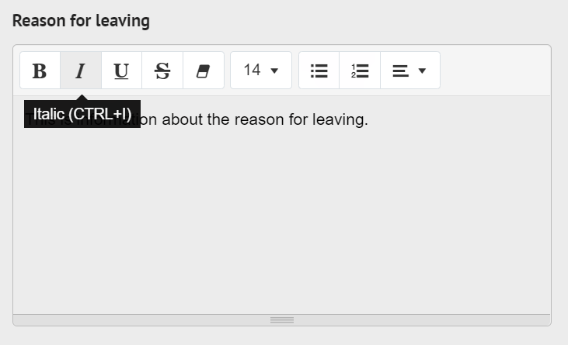

Percentage attendance of child or young person in the last year and any comments on this

Additional Details

Type - If type is selected, the screen will look like this:

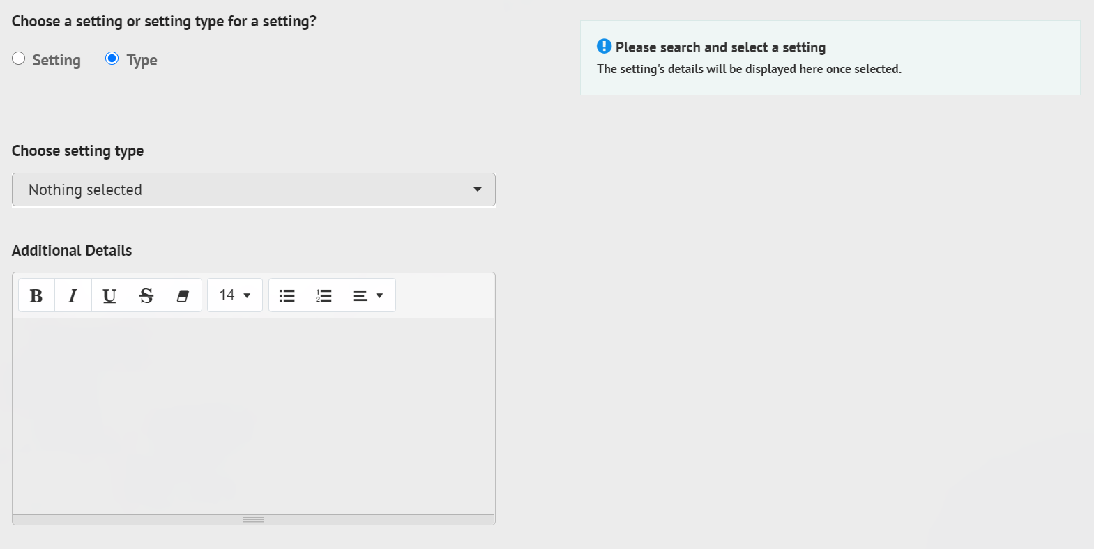

Choosing setting type:

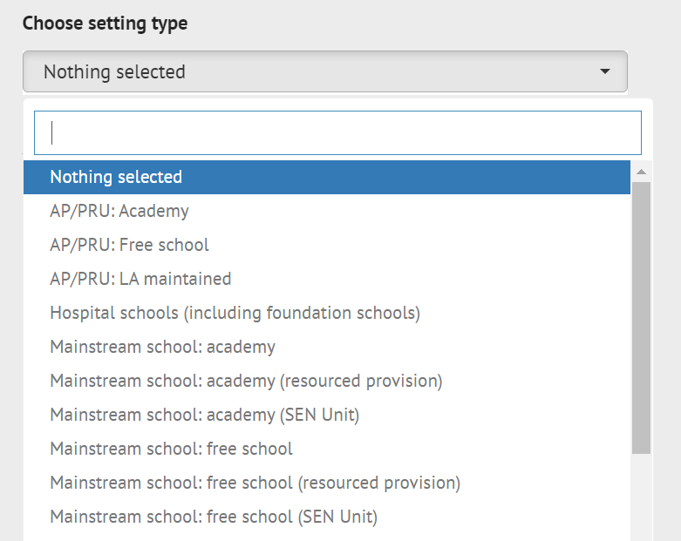

Left click on the required option to select it.

Additional details – click into the field to enter information.

Multiple education settings can be added. To add further education settings to the request, click on the Add button in the bottom right-hand corner and complete the fields as above. This can be done as many times as required.

To remove an education setting, click on Remove in the top right-hand corner of the section.

Details of previous setting(s)
If the child or young person has attended any other education settings in the last five years, click on Yes and enter the details as described above.

Important information about the child or young person

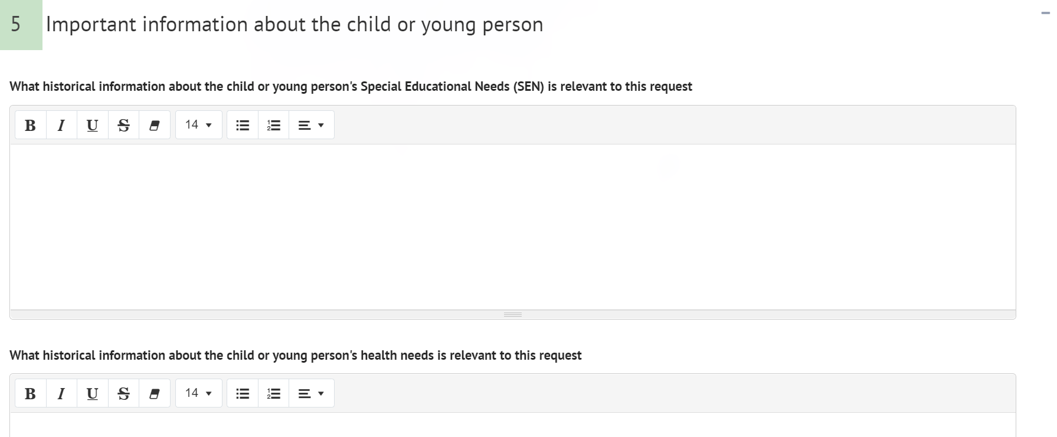

The section is used to enter historical information relevant to the request.

What information about the child or young person's Special Educational Needs (SEN) is relevant?

What information about the child or young person's health needs is relevant?

What information about the child or young person's social care needs is relevant?

Was the child or young person involved in the discussion that led to this request – click on Yes or No.

If Yes is selected, the following fields will be displayed, A Views and opinions of the child or young person:
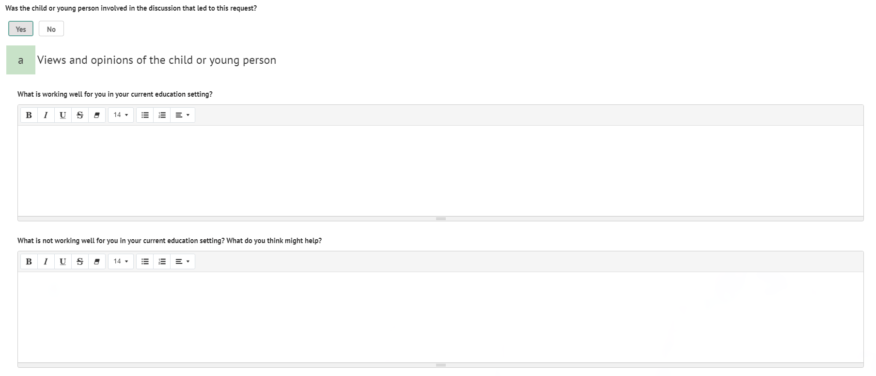

What is working well for you in your current education setting?

What is not working well for you in your current education setting? What do you think might help?

If No is selected, the following field will be displayed:

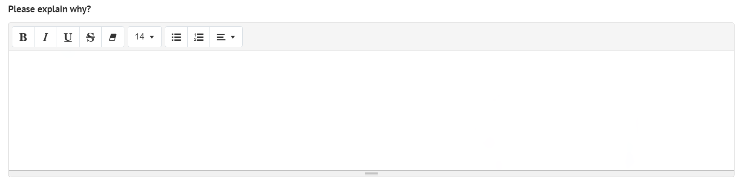

Please explain why

Has the parent(s) or carer(s) been involved in the discussions that led to this request – left click on Yes or No.

If Yes is selected, the following fields will be displayed, b Views and opinions of the parent(s) or carer(s):
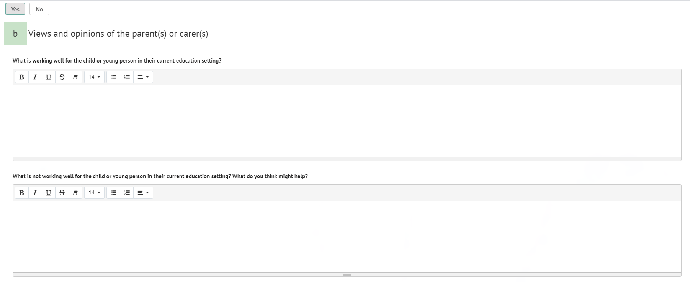

What is working well for the child or young person in their current education setting?

What is not working well for the child or young person in their current education setting? What do you think might help?

If No is selected, the following field will be displayed:

Please explain why

Identified special education needs (SEN)
There are four sections to this
- Communication and interaction
- Cognition and learning
- Social, emotional and mental health
- Sensory and/or physical needs
Click on Yes or no as applicable. If Yes is selected, more free text fields will be displayed to be completed with the appropriate information.

Supporting Documents
Any addition information to support the request can be uploaded here. Examples of supporting documents are listed on the page:

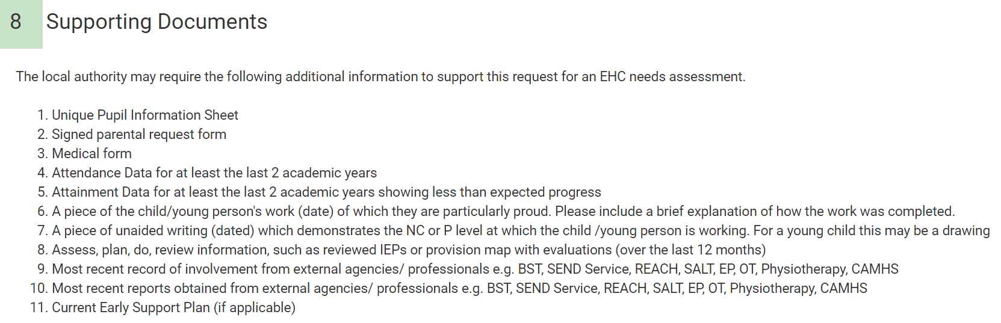

If you want to add any relevant supporting documents, click on the Add Files button:

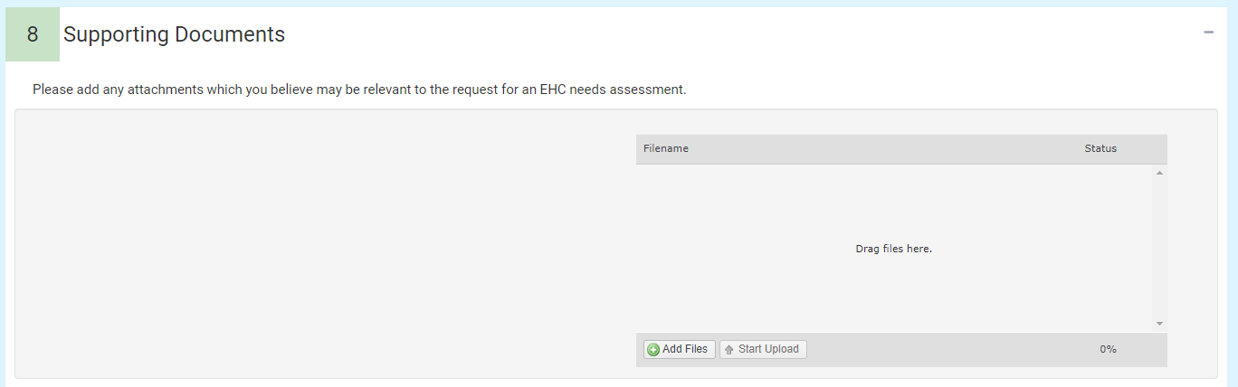

You will then need to navigate to the file wherever it is saved on your PC:

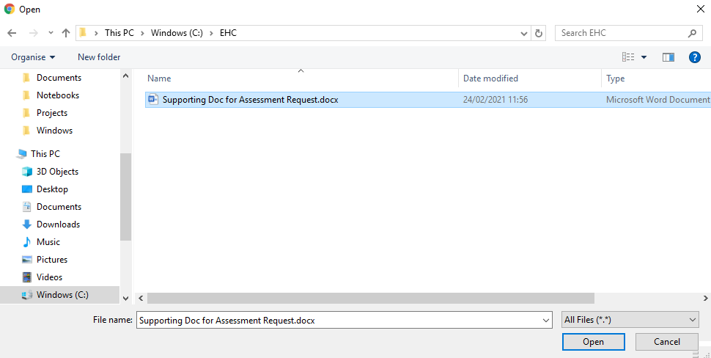

Click on Open and the file will be uploaded. The uploaded file will be displayed:

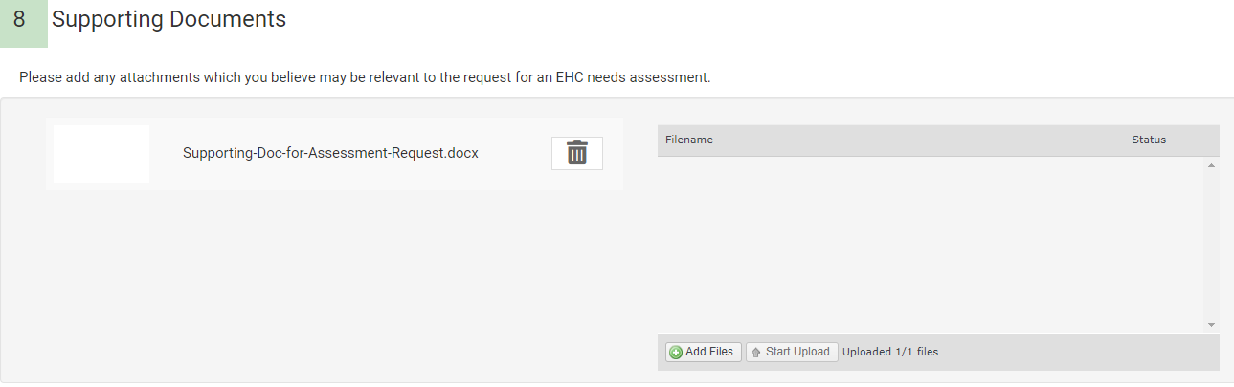

The request can be saved at any time by clicking on the Save Draft button at the top of the screen. These options will remain available as you scroll down the sections of the request.

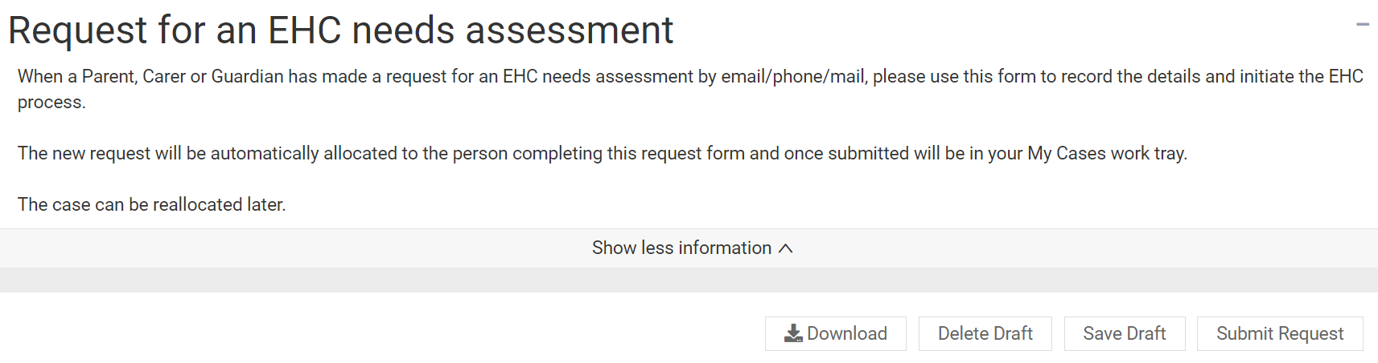

The information entered into the request can be downloaded as a PDF at any time. Click on Download to download the file. The file will appear in the bottom left-hand corner of the screen. Double click to open the downloaded file. The PDF will look like this:

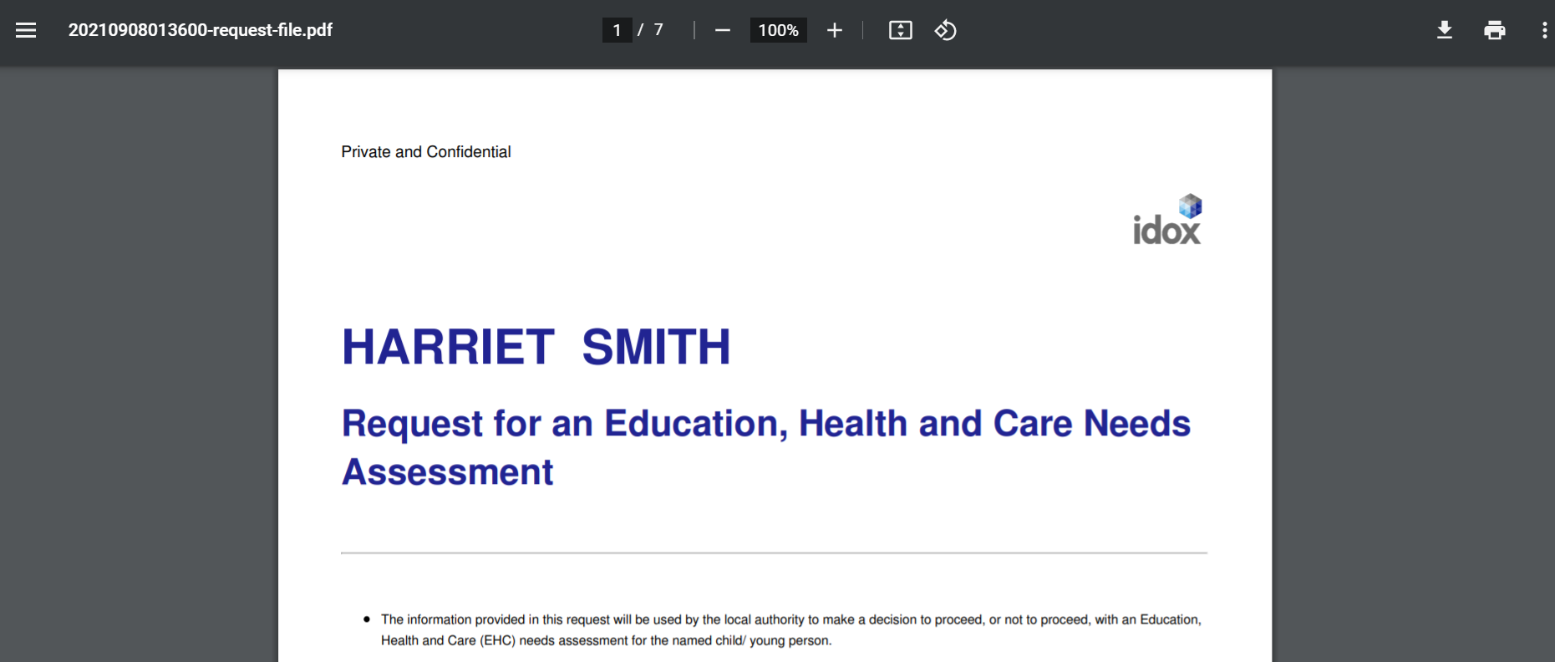

Deleting the request
To delete the draft request, click on Delete Draft

Submitting the request
When the request information has been completed, it can be submitted. To submit a request, click on Submit Request. You will be asked to confirm that you want to submit the request:

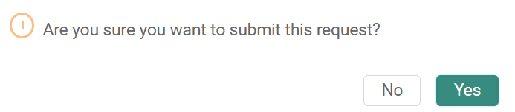

Click on Yes.

There are certain fields that are required and that must be completed in order for the request to be sent. These are indicated with a red asterisk:

If information has not be entered into a required field, when the Submit Request button is clicked on, the section header containing the required information will turn red and the field to be completed will be shown with a message saying “This field is required.”
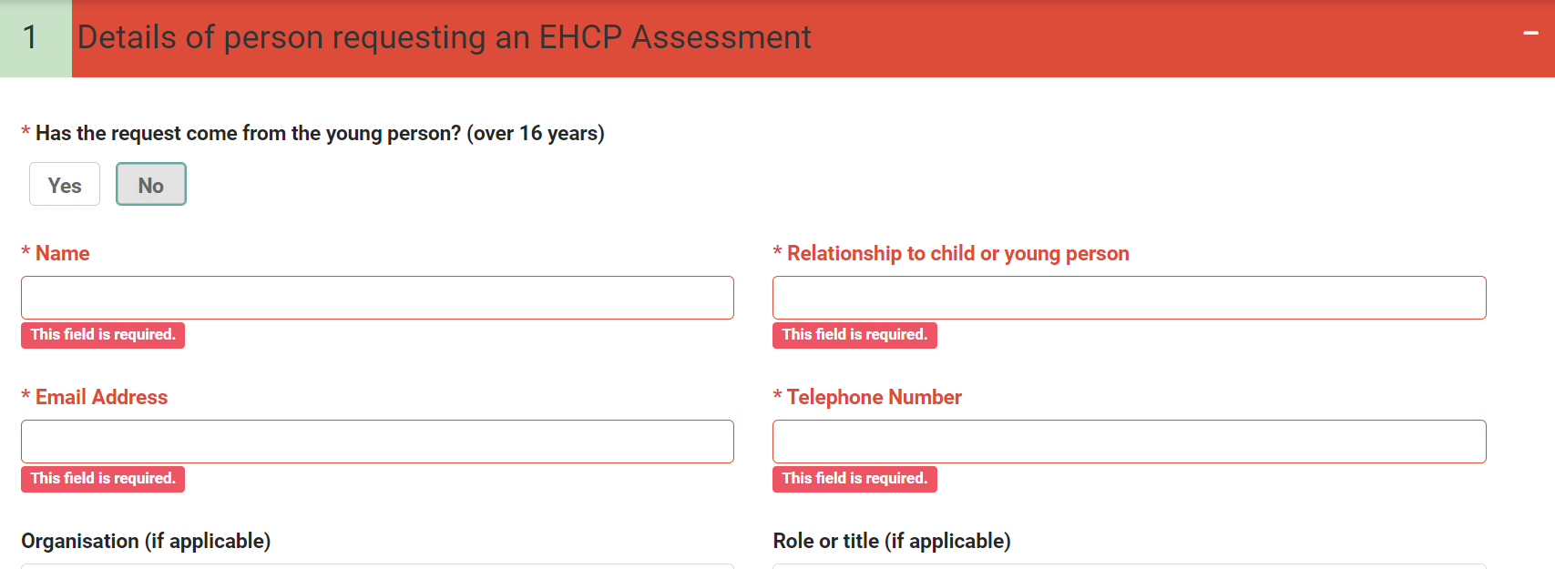

If any mandatory fields have not been completed, these will be highlighted with a red box.

Complete the fields and then click on Submit Request. When the request has been submitted correctly, a message will appear to confirm this.

Once the request has been submitted, it will be sent to the case co-ordinator.

NB it will not appear in your cases until you have been allocated as SENCo by the case co-ordinator.

