EDUCATION, HEALTH AND caRE hUB
GUIDE 3 FOR SEncos – VIEWING A CASE FILE
APRIL 2022

Viewing a Case File
To view a case, click anywhere on the details for the case. The following page will appear:

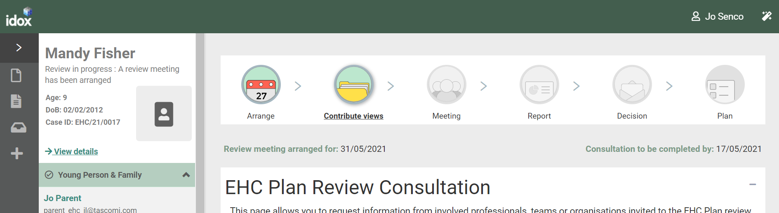

Status of the Process
The top of the screen will show what stage of the process the EHC plan is currently at.

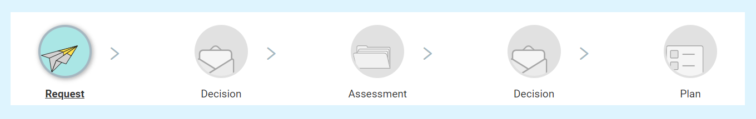

Underneath this, key details relevant to the stage of the process will be displayed. For example, if the process is at the Consultation stage, the review meeting date and the date the consultation is to be completed by will be displayed:

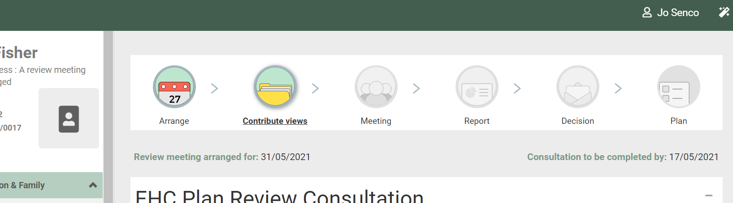

Details of the Case
The left-hand side of the screen can be used to access different parts of the case record.

The top section shows the name, current status of the process, age, DoB and Case ID as well as a photo if uploaded by a parent/carer/guardian or the case co-ordinator:

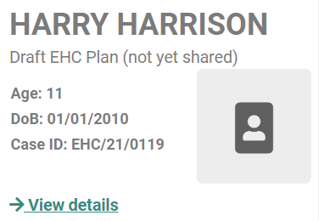

Click on the View details option to view:
- Child or young person’s details
- Child or young person’s main contacts (family and involved professionals)
- Current Education Setting
- Previous Education Setting

Below this there are sections for Young Person and Family, Case Co-ordinator, Education Setting, Notes & Timeline and Key Dates.

You can expand each section to view information on it by clicking on the green header of the section or on the arrow at the end of each section header:

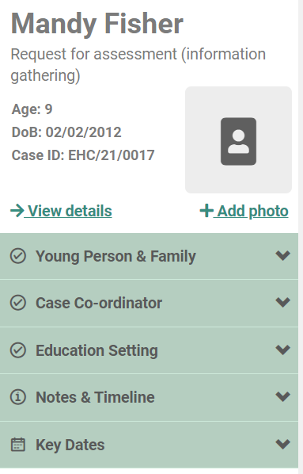

When you click on the header or the arrow, the display will change like this. Note the direction of the arrow has changed from down to up:

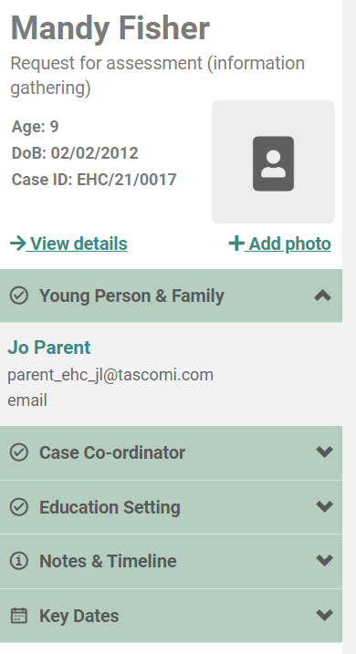

Young Person and Family – This will show the details of any parent, carer, guardian, the young person or advocate who has access to the case.

Case co-ordinator – This will show the case co-ordinator responsible for overseeing the process.
Education Setting – This will show the details of the education setting which has access to the case. This can also show a named SENCo within the setting.

Notes and Timeline – This page will display all activity on the case in date order, with the most recent at the top. Click on View details to see this information:

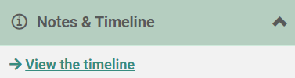

Key Dates – this will display the key dates in the process, based on the statutory date requirements. For example, it could show the start date of the case, when the decision to assess needs to be made and when the case needs to be completed:

