EDUCATION, HEALTH AND caRE hUB
GUIDE 2 FOR SEncos – VIEWING THE MY CASES WORK TRAY
APRIL 2022

Viewing the My Cases work tray
When you log into the EHC Hub, you will see a list of any cases currently assigned to you that are in progress:

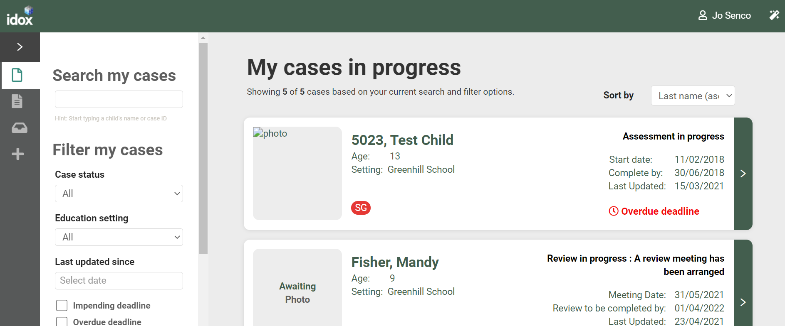

To view a case, click anywhere on the details for the case. The case file will be displayed:

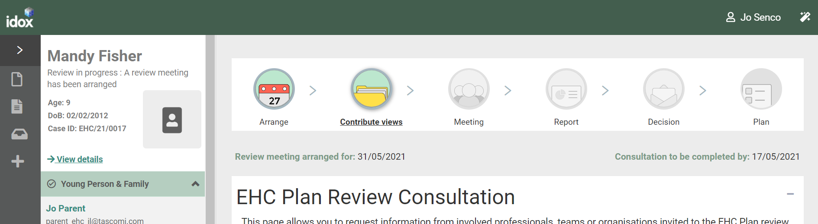

Searching for a Case
By default, all cases in progress assigned to a SENCo will be displayed. The toolbar on the left-hand side of the screen can be used to filter the display of the cases or find a specific case:
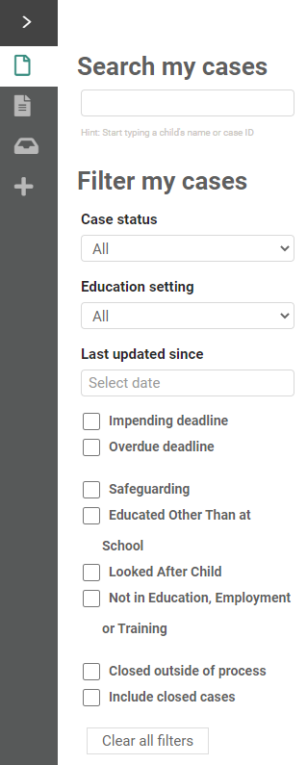

There are three ways cases can be displayed:

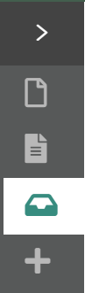

My cases in progress – This will display all cases currently in either the assessment or review pathway where you are the named SENCo

My live cases – This will display all cases that have a plan and are waiting for the next review where you are the named SENCo

Setting cases – This will display all the cases that the setting(s) you are linked to has access to.

Click on each icon to view the list of cases in each category.

When viewing these lists, multiple filtering options can be used. These options will vary depending on which list of cases is being viewed (My cases in progress, My live cases or Setting cases).

Search my cases – start typing the name or the case ID into this field and the system will filter the list to display cases that match this criteria. For example, if you start typing “ha” in here, any case name that contain ha will be displayed.

Filter my cases – the display can be filtered by Case Status, Education setting and Last updated since.
Case Status – click on All in the Case status field and a box will be displayed showing all the statuses currently in use:

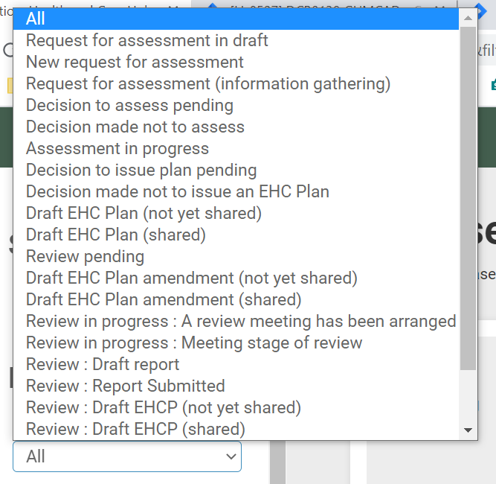

Click to select the required status

Education Setting – Click on All in the Education setting field to view the available education settings:

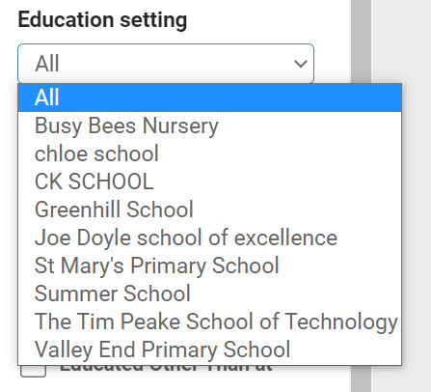

Click to select the required education setting

Last updated since – Type in the date required with a dash between the day, month and year. Alternatively, left click on the field and select the date from the calendar:
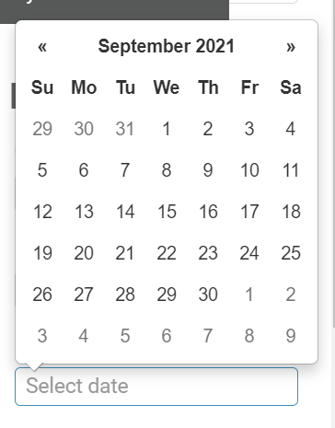

Navigate around the calendar using the arrows in the top right and left corners until the correct date is available. Left click on the date to select it.

There are also eight checkboxes:
- Impending Deadline
- Overdue Deadline
- Safeguarding
- Educated Other Than at School
- Looked After Child
- Not in Education, Employment or Training
- Closed outside of Process
- Include closed cases

To clear any filters, click on the Clear all filters button at the bottom of the list of filters.

