EDUCATION, HEALTH AND caRE hUB
GUIDE 19 FOR SEncos – decision
APRIL 2022

Decision
The status of the case will be shown as Review: Report Submitted:

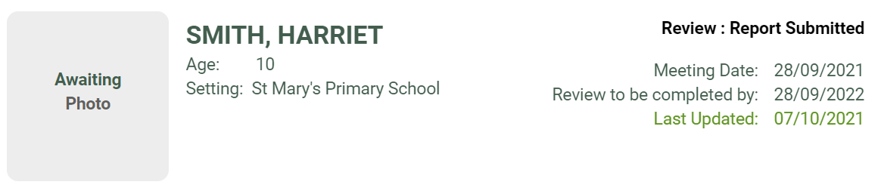

The pathway status displayed will change:

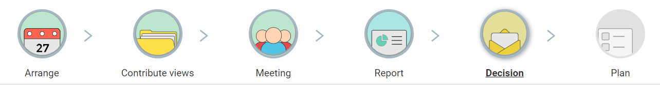

A message will be displayed that the decision about the current EHC plan is being considered.

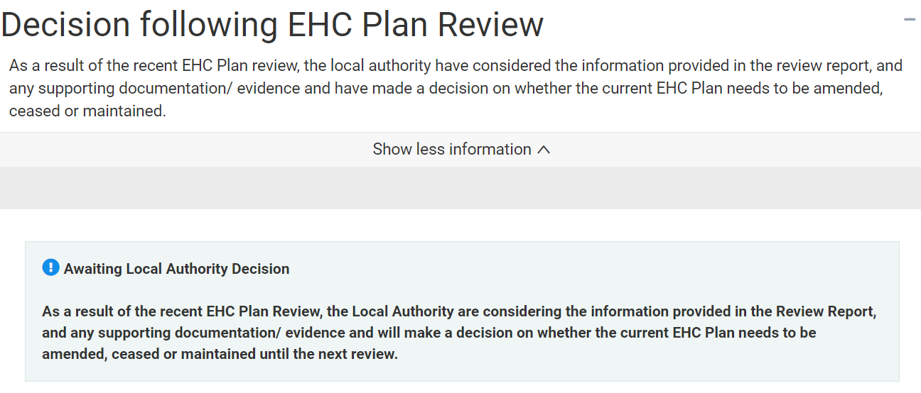

When the decision has been made by the local authority, this will be updated by the Case Co-ordinator and published. An email will be sent to you informing you of this:

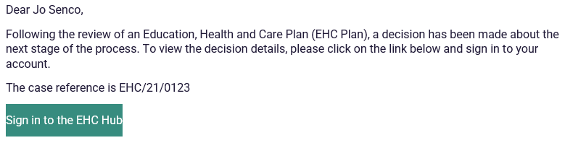

When you log in and look at the case, you will be able to see information about the decision on the EHC Case Summary Page:

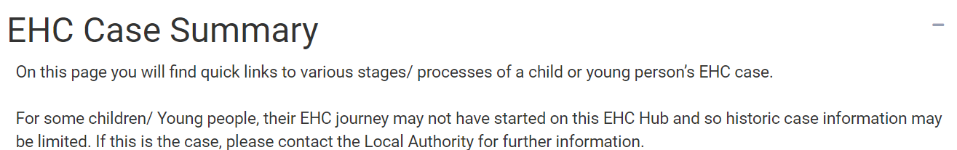

The results of the review process will be one of three options
- Keep the current EHC Plan as it is
- Amend the EHC Plan
- Cease to maintain the EHC Plan

Keep the current EHC Plan as it is
If the decision has been taken to keep the current EHC Plan as it is, scroll down the screen to the completed review section and the outcome will be displayed as Keep the current EHC plan as it is.

Amend the EHC Plan
If the decision has been taken to amend the EHC plan, when you click on the case file, the Plan page on the pathway will display the following screen:

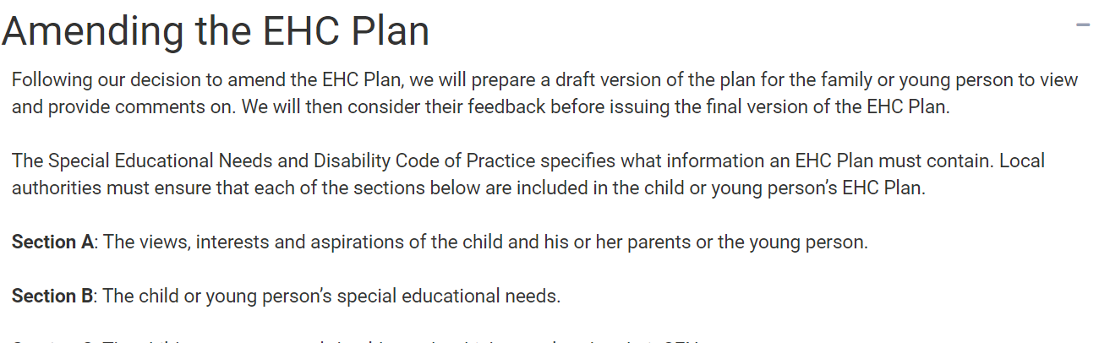

At the bottom of the screen, it will display a message to say the revised plan is being drafted:

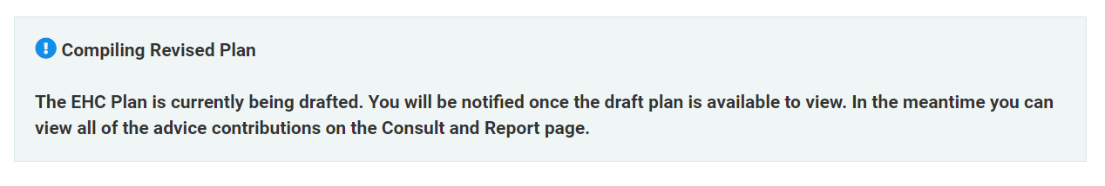

When the draft plan has been revised, it will be shared by the case co-ordinator and you will get an email informing you of this. When you log into the hub, you will be able to see the draft revised version:

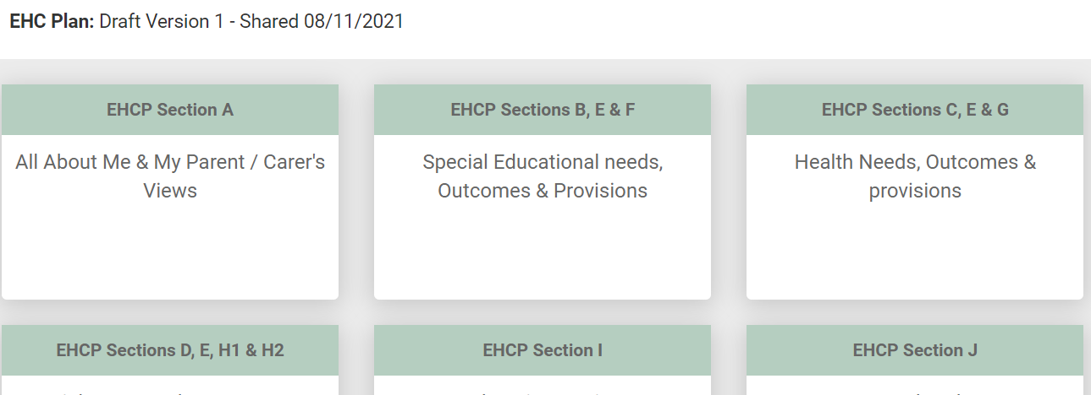

When the plan has been finalised and shared, you will get an email informing you of this and when you log into the hub, the case summary page will be displayed.

Cease to maintain the EHC Plan
If the decision has been taken to cease to maintain the EHC plan, scroll down the screen to the completed review section and the outcome will be displayed as Cease to maintain the EHC plan.

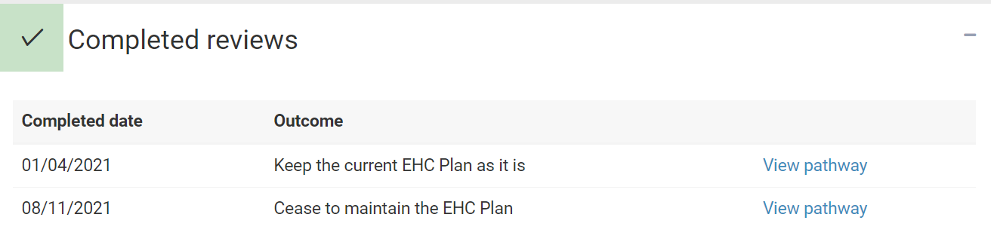

To view more information about this decision, click on view pathway, and go to the Decision icon on the pathway.
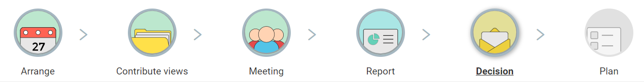

This will display information about the decision.

The case summary page
There are five possible sections of the case summary page:
- Education, Health & Care Plan – the current EHC Plan
- Review (not yet started or in progress)
- Completed Reviews
- Amendments to the EHC Plan outside of review
- EHC Assessment and Planning Pathway

Which of these sections is visible on the screen will depend on the history of activity on the EHC Hub.

Education, Health & Care Plan
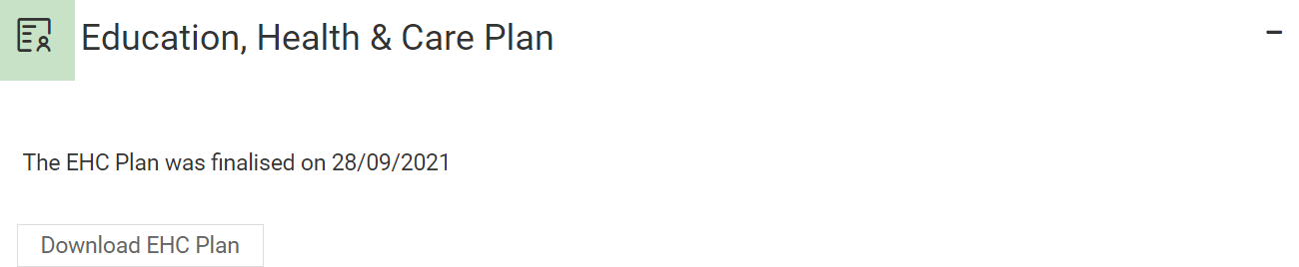

This will show the date the EHC plan was finalised. To download the plan, click on Download EHC Plan.

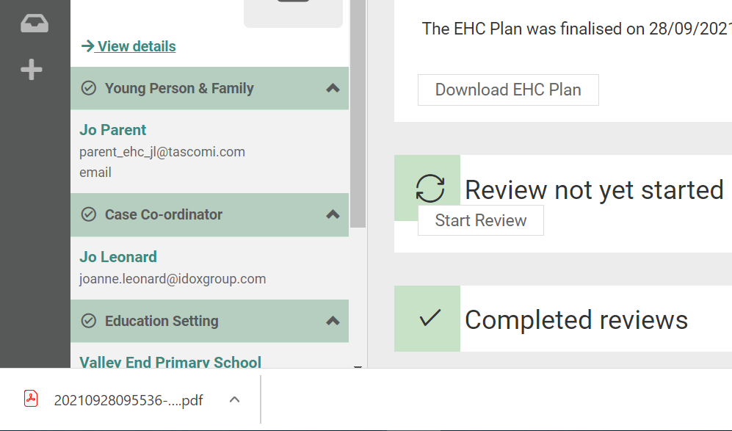

The above screenshot shows how a downloaded file is accessed when using Google Chrome. Other web browsers may appear differently.

Review not yet started
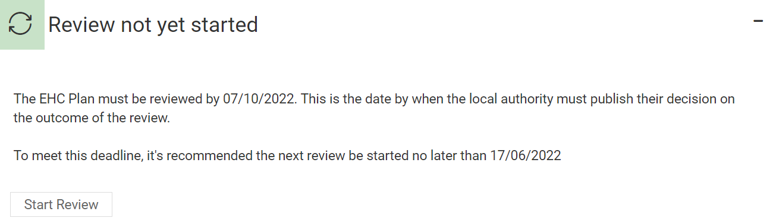

This will display the date by when the next review process must have been completed by and a recommended date by when to have started the review to be able to meet that deadline.

To start the next review, click on Start Review. When you click on this, the Arrange pathway for the next review will be displayed.

Completed Reviews
This will display the outcome of any completed reviews:

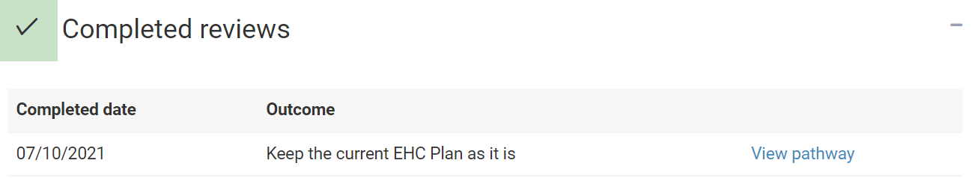

The outcome of the review will be displayed in the Outcome column.

To view the pathway for the completed review, click on View pathway. The review pathway screen will be displayed:

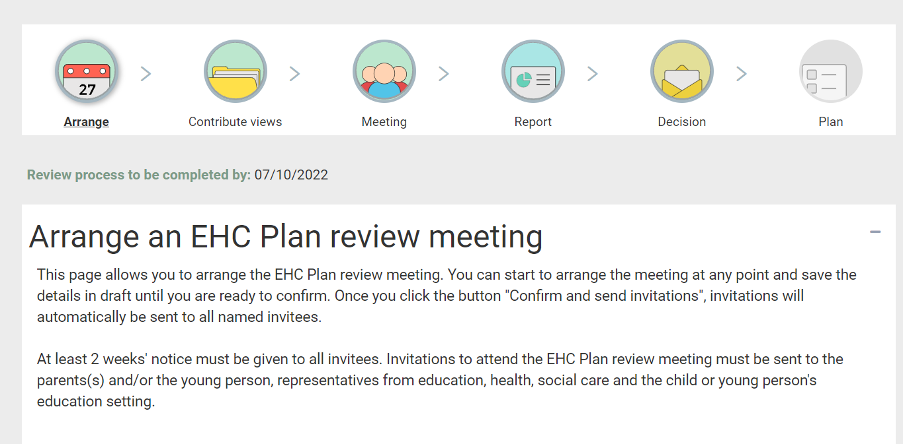

Click on the appropriate icon on the pathway to view the contents.

EHC Assessment and Planning pathway
This information will not be available for EHC Plans that have been imported. This is because their assessment and planning process will have been completed outside of the EHC Hub.

This will show the date the EHC Assessment and planning pathway was completed.

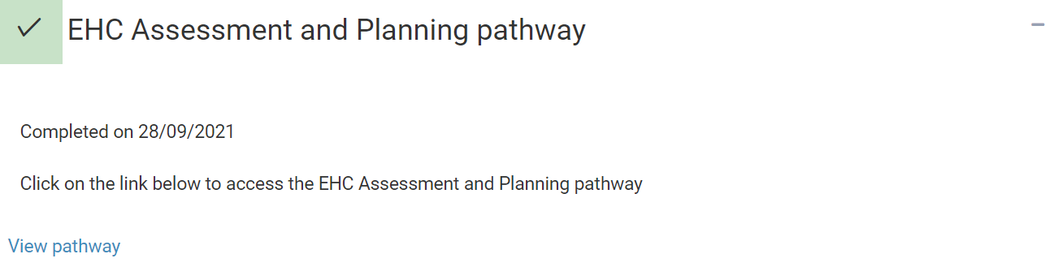

To view the pathway, click on View pathway. The EHC needs assessment pathway will be displayed:

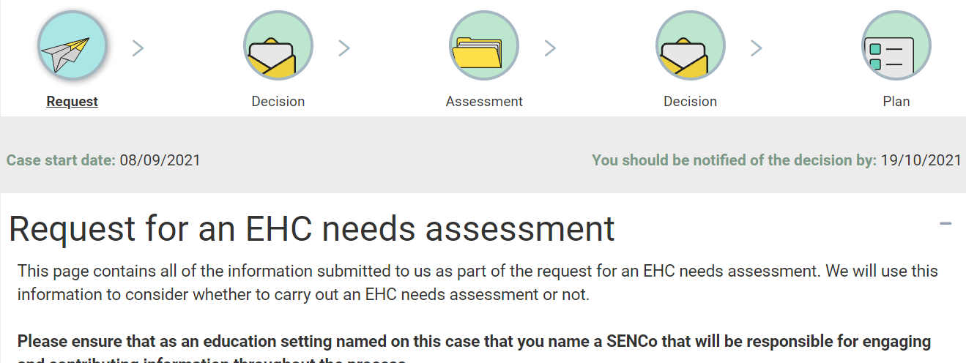

Click on the appropriate icon to view the information.

