EDUCATION, HEALTH AND caRE hUB

GUIDE 18 FOR SEncos – Progress to draft report

APRIL 2022

Progress to Draft Report

When the Progress to report button is clicked, the status of the case will change:

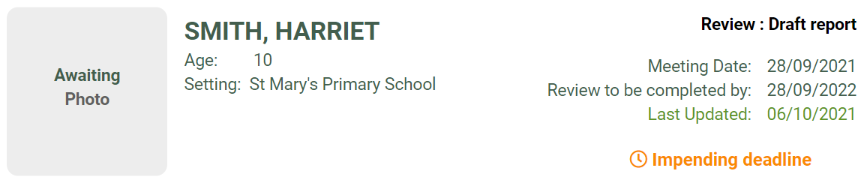

The pathway status will change to show this:

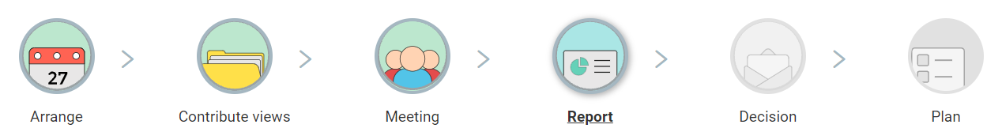

The EHC Plan Review Report page will be displayed:

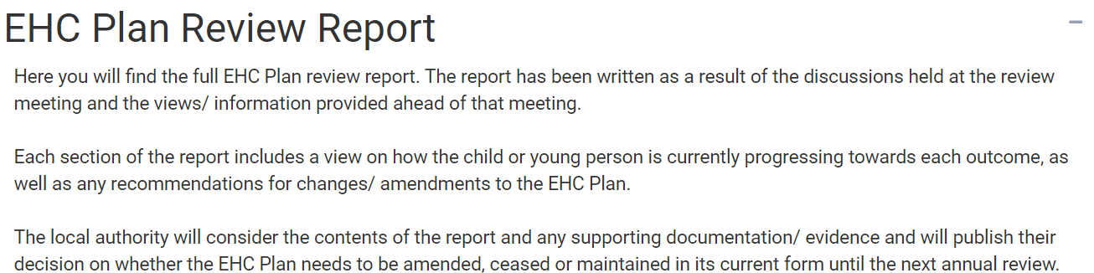

Draft Report Areas

The report areas will be displayed below. They are:

* Details for the child or young person’s current education setting
* The child or young person’s views
* The parent(s) or carer(s) views
* SEN – Communication and Interaction
* SEN – Cognition and Learning
* SEN – Sensory and/or physical health
* SEN – Social, Emotional and Mental Health
* Health
* Social Care
* Transition and preparing for further education and adulthood
* Transport assistance
* The child or young person’s personal budget
* Summary of EHC Plan annual review recommendations

**Details of the child or young person’s current educational setting**

Click on the green right pointing arrow to complete this information:

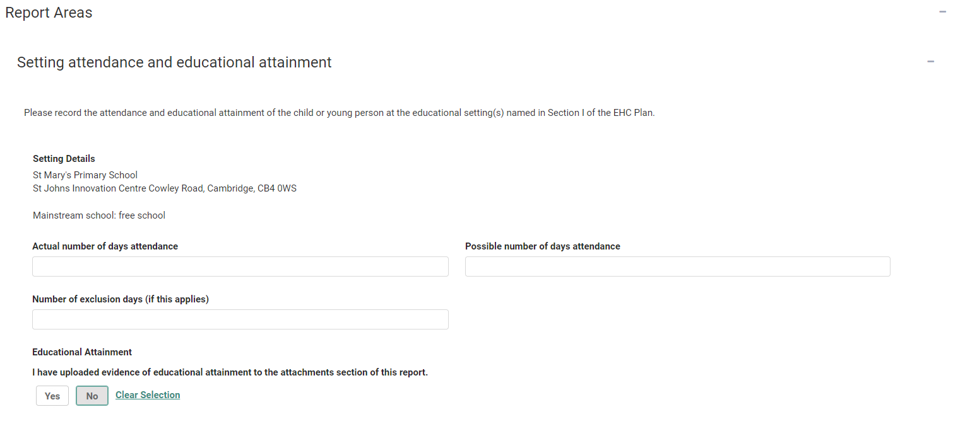

The details of the Setting will be populated from that entered in Section I of the EHC Plan.

**Actual number of days attendance** – enter the actual number of days the child or young person attended at the education setting.

**Possible number of days attendance** – enter the possible number of days the child or young person could have attended the education setting.

**Number of exclusion days (if this applies)** – if the child or young person was excluded from school at any time, enter the number of exclusion days.

**I have uploaded evidence of educational attainment to the attachments section of this report** – click on Yes or No as applicable.

Supporting Documents - Any addition information can be uploaded here:

If you want to add any documents, click on the Add Files button:

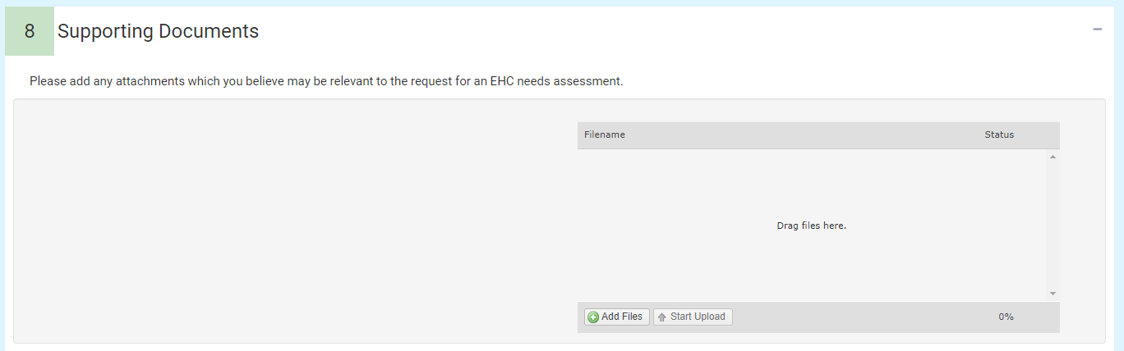

You will then need to navigate to the file wherever it is saved on your PC:

Click on Open and the file will be uploaded. The uploaded file will be displayed.

Each section contains a green arrow to the right of the screen. If there is information in that section, it will be displayed with a green tick. If any area has no outcomes in it, it will display 0 outcomes.

Click on this to review the information within that section.

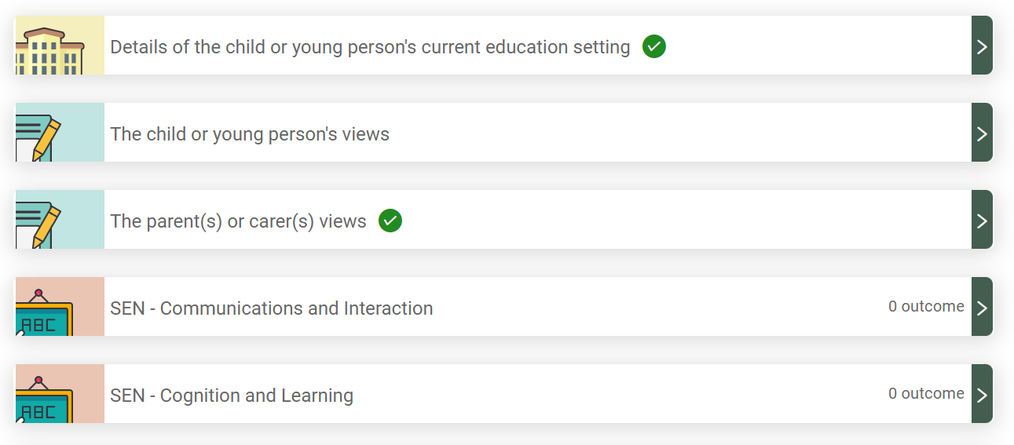

To add information to one of the report areas, click on the green pointing arrow to the right of that section:

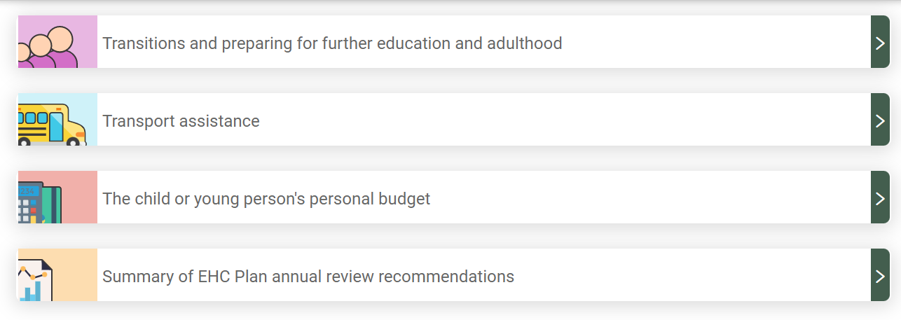

The section will be displayed to be completed:

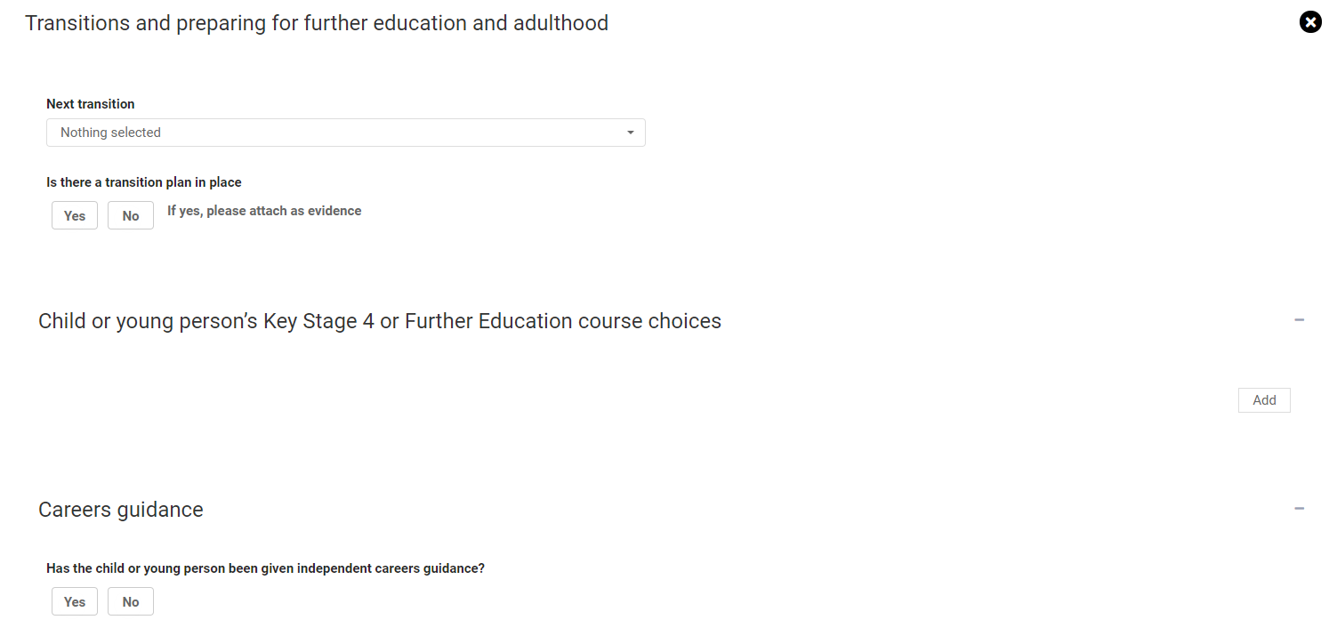

Summary of EHC Plan annual review recommendations

At the bottom of the sections there is Summary of EHC Plan annual review recommendations:

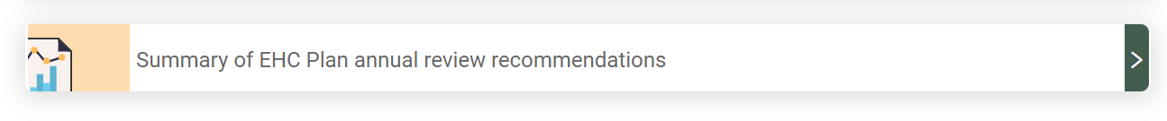

Click on the green arrow on the right to access this section:

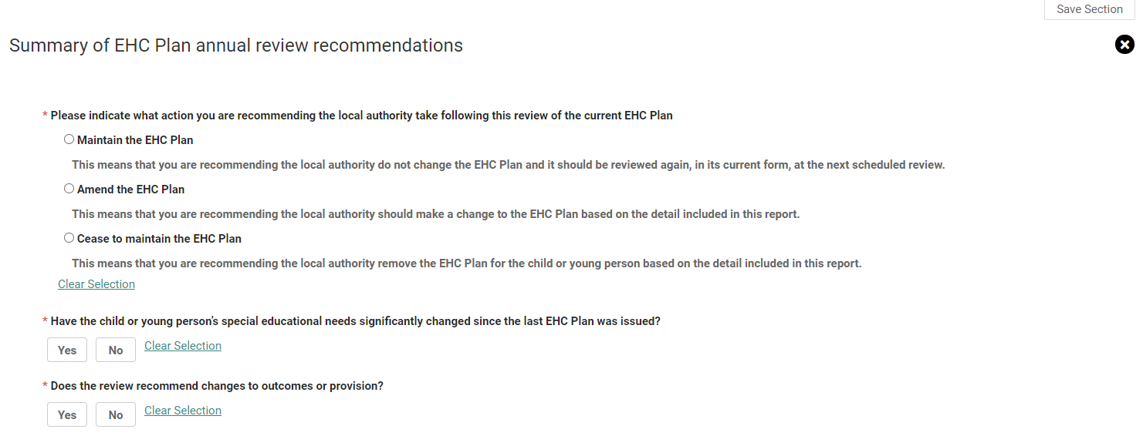

You will need to indicate what action you are recommending the local authority take following this review. You can either recommend

* Maintain the EHC Plan
* Amend the EHC Plan
* Cease to Maintain the EHC Plan

Click on the radio button to the left of the action you wish to recommend.

Underneath this there are additional questions to be completed.

Has the child or young person’s special education needs significantly changed since the last EHC Plan was issued – Click on Yes or No.

Does the review recommend changes to outcomes or provisions – click on Yes or No.

Does the current education setting remain appropriate to meet the needs of the child or young person? – Click on Yes or No.

Please provide your summary of the review and recommendations – this is a free text field.

Agreed Actions

This is a space to add any actions that were discussed and agreed during the review meeting that are to be completed.

To add an action, click on the Add action link:

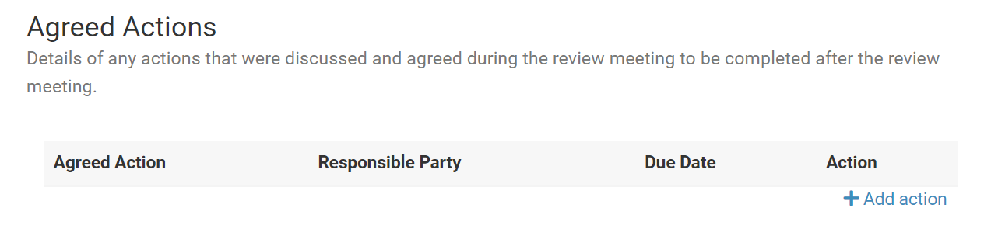

The Agreed Actions window will be displayed:

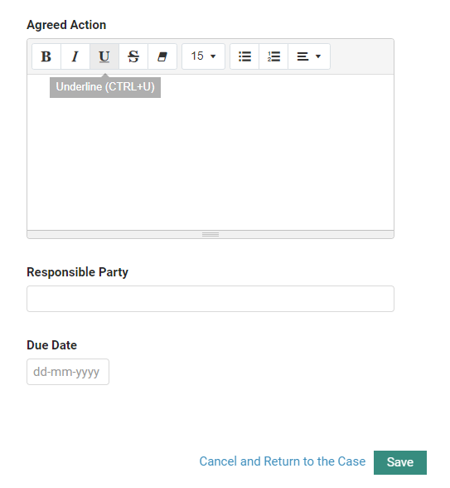

**Agreed action** – enter details about the agreed action.

**Responsible Party** – enter the responsible party for this action.

**Due Date** – enter the date this action is due by.

Click on Save.

The agreed action will then be displayed:

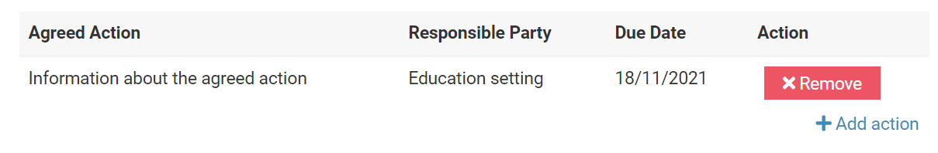

To add a further action, click on Add Action.

To remove an action, click on Remove.

Supporting Document

Any addition information to support the advice can be uploaded here:

If you want to add any documents, click on the Add Files button:



You will then need to navigate to the file wherever it is saved on your PC:

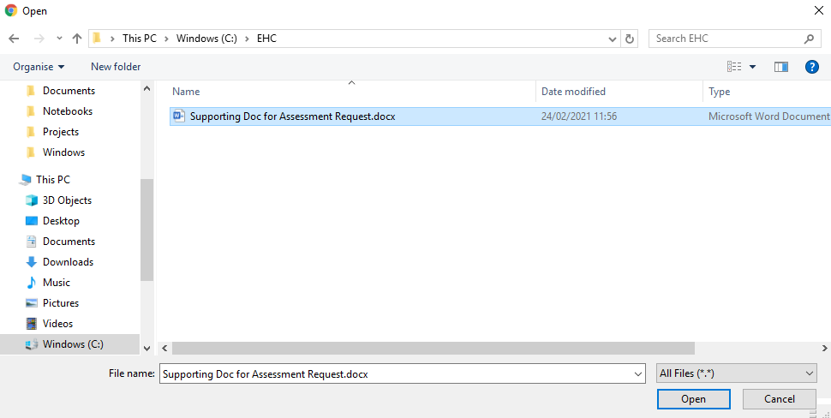

Click on Open and the file will be uploaded. The uploaded file will be displayed:

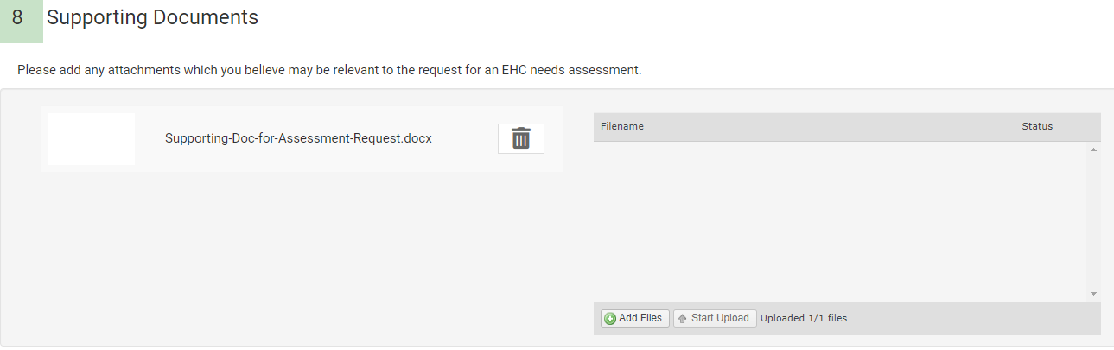

When the information has been reviewed and is complete, click on Submit Report:

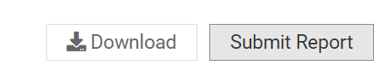

You will be asked to confirm you wish to submit the report. Click on Yes.

**Downloading the Report**

The report can be downloaded both before and after submission.

To download the report before submission, click on the Download button:



The file will be displayed in the bottom left-hand corner of the screen.

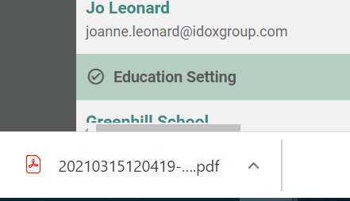

Click on the file to open it and view the report.

To download the report after submission, click on the download button at the top of the screen:

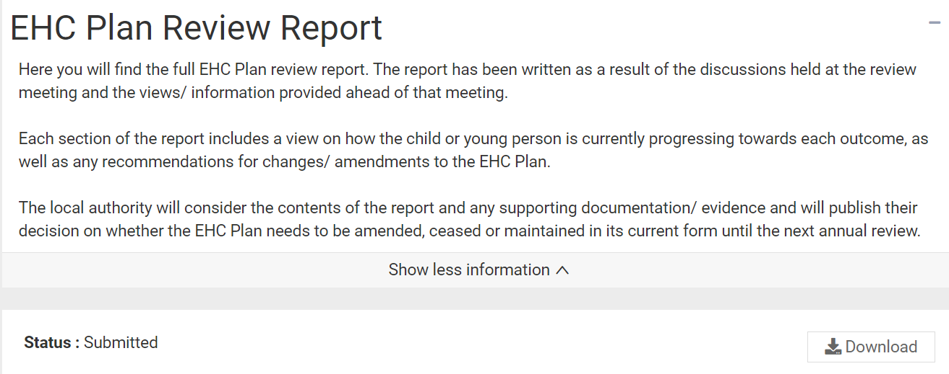

As before, the file will be displayed in the bottom left-hand corner of the screen.



Click on the file to open it and view the report.

**Reopening the Review Report**

If you identify an error in the review report after it has been submitted, please contact the case co-ordinator and they will be able to reopen the review report for you. This is possible until the local authority publishes their review decision.