EDUCATION, HEALTH AND caRE hUB
GUIDE 17 FOR SEncos – EHC Plan review meeting
APRIL 2022

EHC Plan Review Meeting
When the meeting has taken place, the details of the discussions held at the meeting and any recommendations made will need to be entered on the hub.

The status of the case will change to reflect this:

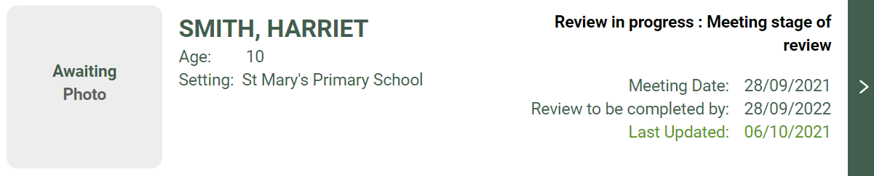

When you click on this, the pathway status will be displayed like this:

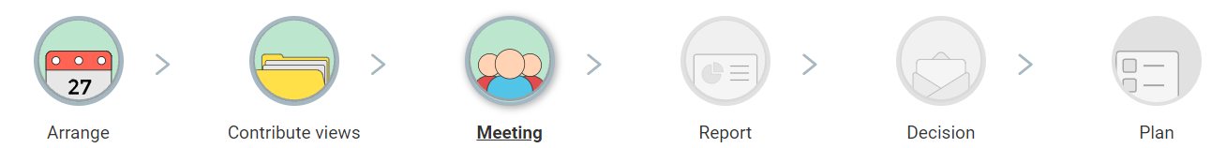

This has 5 sections:

EHC Plan Review Meeting Details
This will show the date, start time and end time and location of the meeting. Enter any changes to this information if required. The meeting details can be changed until the review report is submitted to allow for an administration error to be corrected.

Record of people who were invited and attended
This will show who was invited and if they attended. To confirm if they attended, click on the tick box in the Attended meeting column for each person:

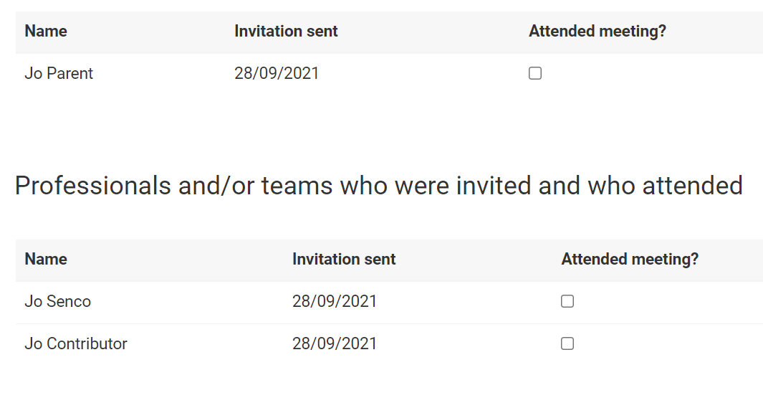

Other Attendees
This will show a list of people who were not originally invited to attend ahead of the meeting but were in attendance.

To add another attendee, click on Add:

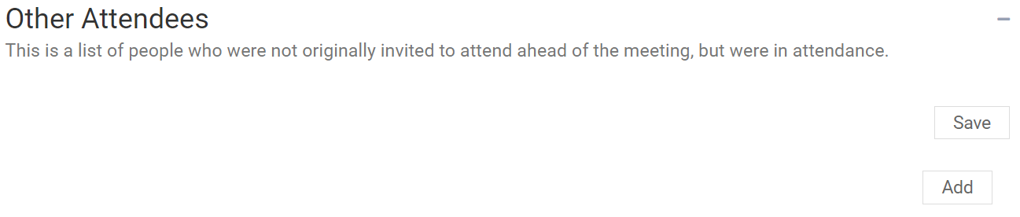

The following will appear:

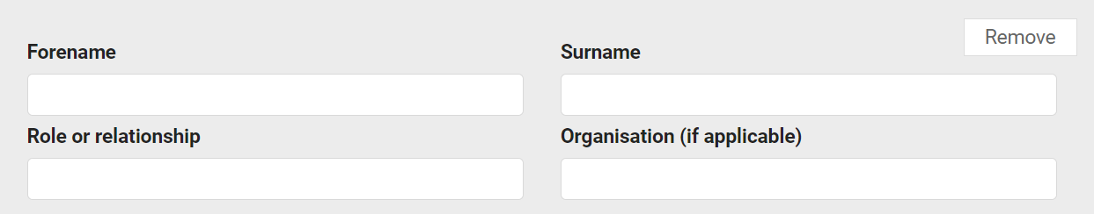

Enter the information and click on Save.

Additional Meeting Information
This will show any specific information about the meeting, like if apologies had been received or new information was brought to the meeting. The additional information can be entered in the free text field.

Click on Save.

(The details of the actual plan review discussion will be shown in the review report in the next section).

Meeting Documents
Any supporting documents from the EHC review meeting can be attached here. If you want to add any documents, click on the Add Files button:

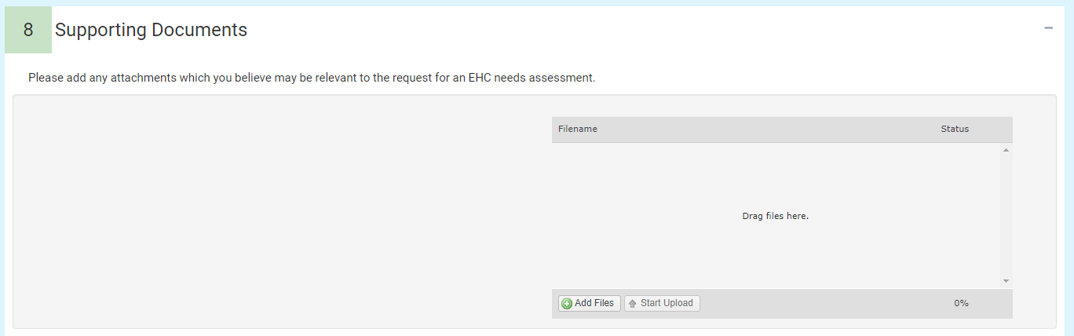

You will then need to navigate to the file wherever it is saved on your PC:

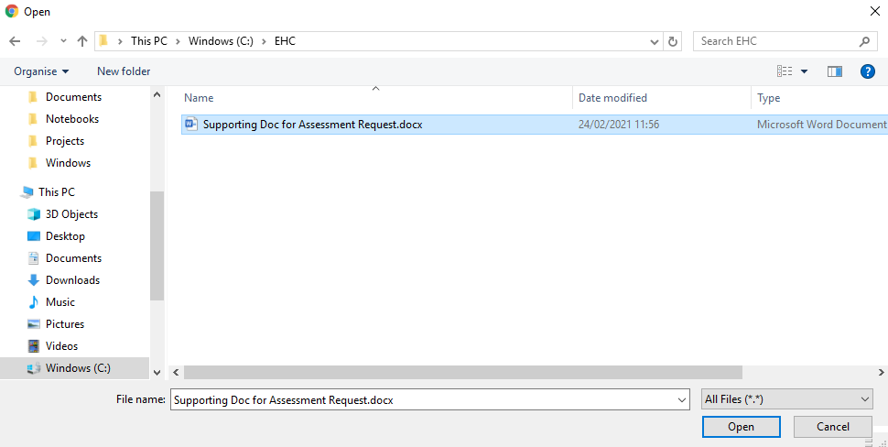

Click on Open and the file will be uploaded. The uploaded file will be displayed
When all of the meeting details have been reviewed and entered, click on Save meeting details.

When you are ready, click on Progress to report:

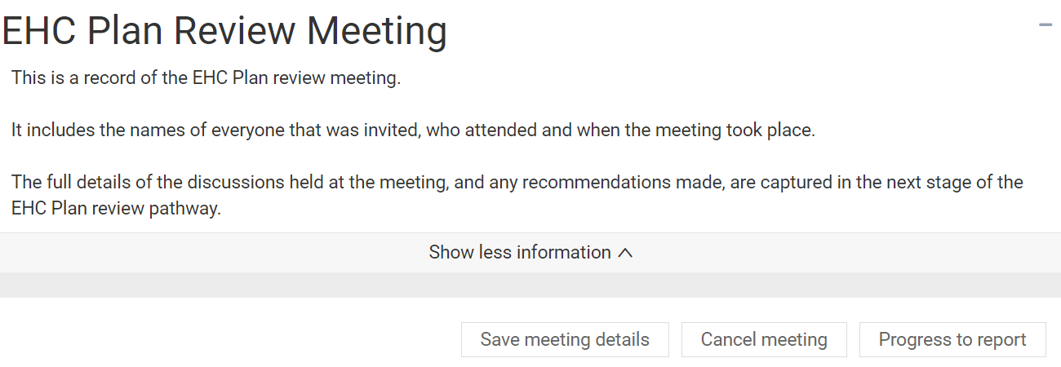

Re-opening the Contribute Views stage
If you wish to re-open the Contribute Views stage of the review, click on the Cancel meeting button. You will be asked to confirm you wish to cancel the meeting. Click on Yes.

If you cancel the meeting the status of the case will return to the Contribute views stage of the pathway:
