EDUCATION, HEALTH AND caRE hUB
GUIDE 16 FOR SEncos – Progress to meeting
APRIL 2022

Progress to Meeting
Once all the requests for information have been responded to, the Progress to meeting button will become available. This will not be available until all requests for advice have either been responded to or closed. To close a request, click on Close Request. The status will change to show that the request was closed:

To progress to the meeting stage of review, click on Progress to meeting:

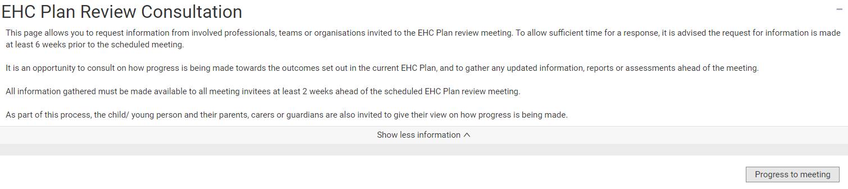

You will be asked to confirm this:

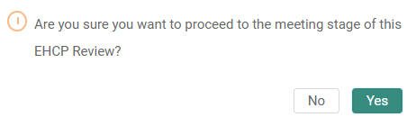

Click on Yes.

