EDUCATION, HEALTH AND caRE hUB
GUIDE 15 FOR SEncos – arranging the ehc plan review meeting
APRIL 2022

Arranging the EHC Plan Review Meeting
The top of the screen will display information about arranging the EHC Plan review meeting:

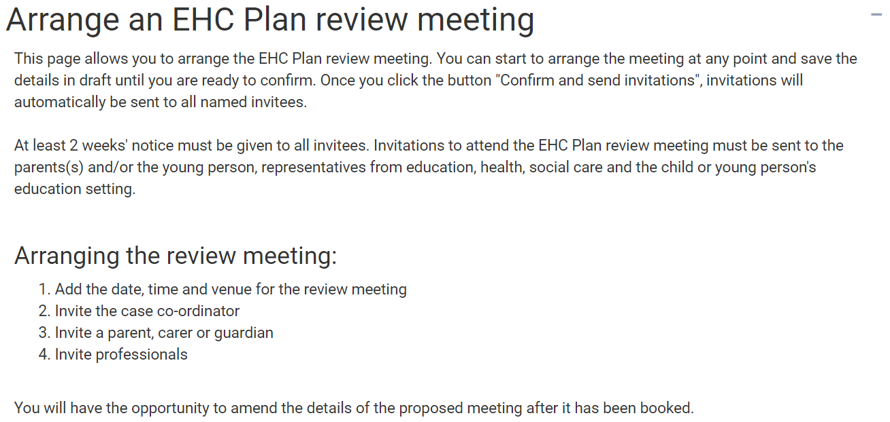

There are four sections
- EHC Plan Review Meeting Details
- People invited to attend the EHC Plan Review meeting
- Professionals and/or teams invited to attend
- Case Co-Ordinator(s) and/or Local Authority representative(s) invited to attend

NB – you can save the meeting details as draft at any time, and then Confirm and send invitations when all information has been completed

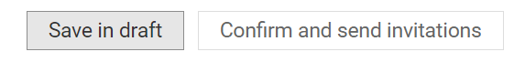

EHC Plan Review Meeting Details

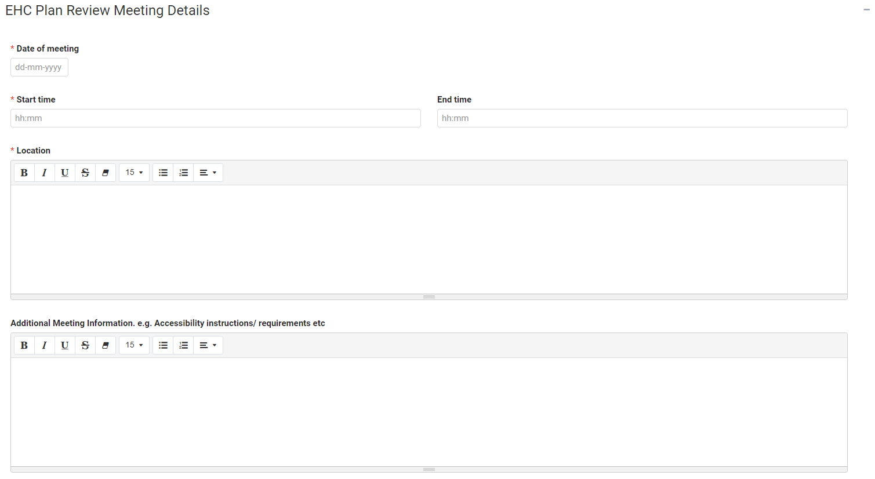

Date of meeting - Enter the date of meeting.

Start time and End time – either enter the start time and end time for the meeting or left click on the field and select the required time from the list.

Location – enter the details of the location of the meeting.

Additional Meeting Information – enter any addition information like accessibility instructions etc.

People invited to attend the EHC Plan Review meeting
A parent, carer, guardian, the young person or advocate already linked to the case will be automatically included in this section.

To invite a parent, carer or guardian to the meeting, click on Add Parent, Carer or Guardian:

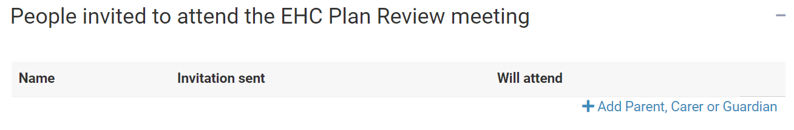

The following page will appear:

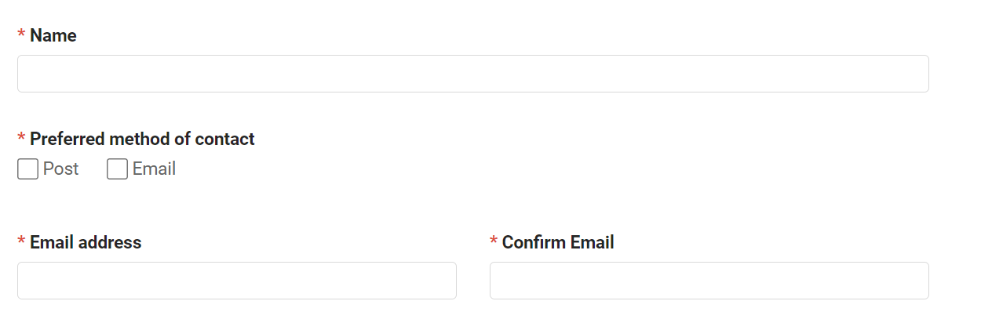

Name – Enter the name of the Parent, Carer or Guardian.

Preferred method of contact – select Post or Email.

Email address – enter the email address for the Parent, Carer or Guardian.

Confirm Email – Confirm the email address for the Parent, Carer or Guardian.

When you click on create, you will be asked to confirm that you want to invite the person to access the case:

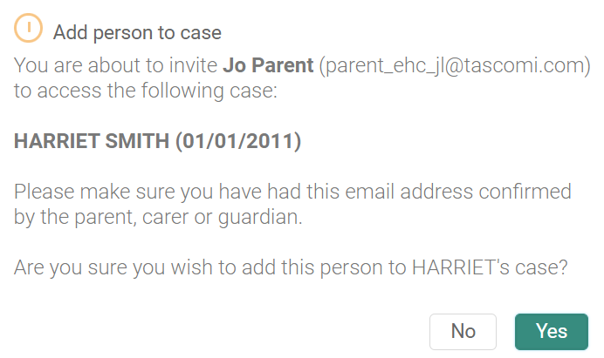

The information will then be displayed:

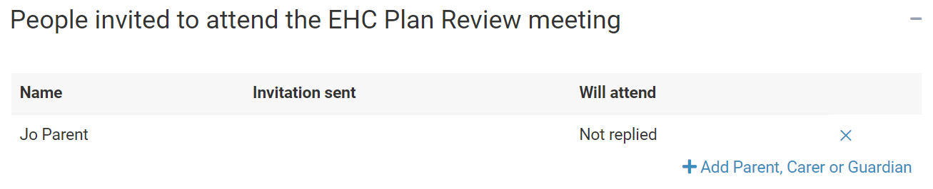

To add further parent, carers or guardians, click on Add again and repeat the process.

The parent, carer or guardian will receive an email asking them to view the case.

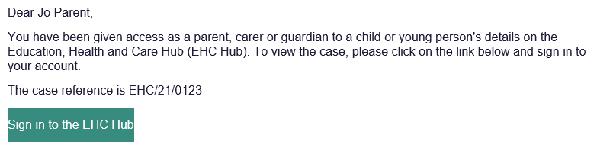

Professionals and/or teams invited to attend
A SENCo already linked to the case will be automatically included in this section.
To invite a professional and/or team, click on Add Professional:

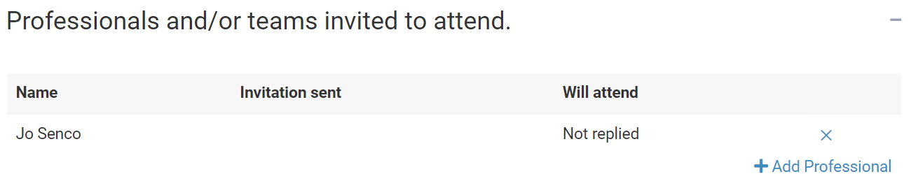

The following screen will be displayed:

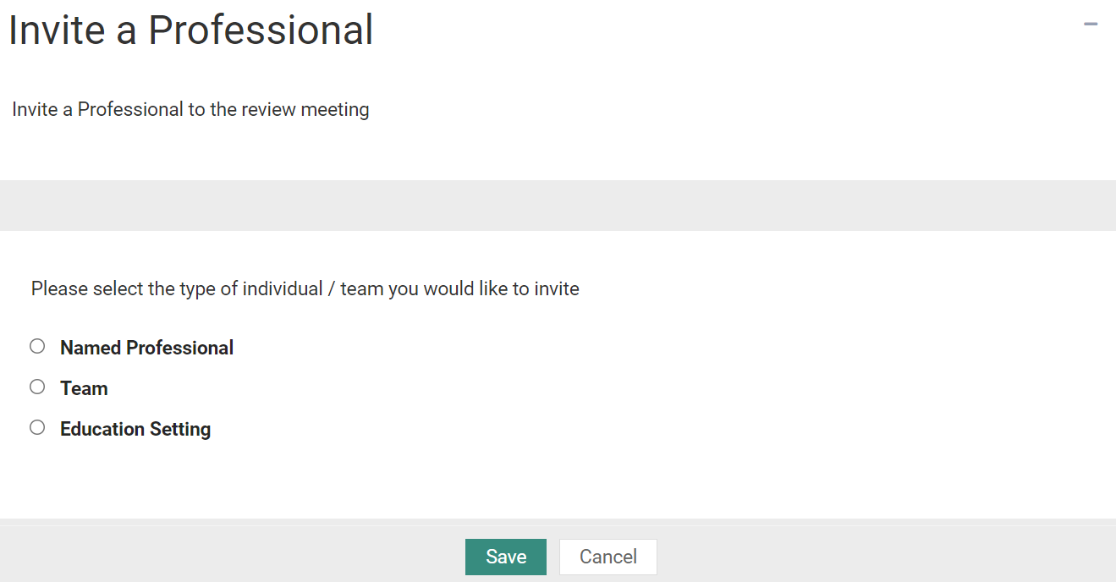

Click to select the type of individual/team you would like to invite.

Named Professional
If you click on Named Professional, left click on Nothing selected and select the required Named Professional from the picklist.

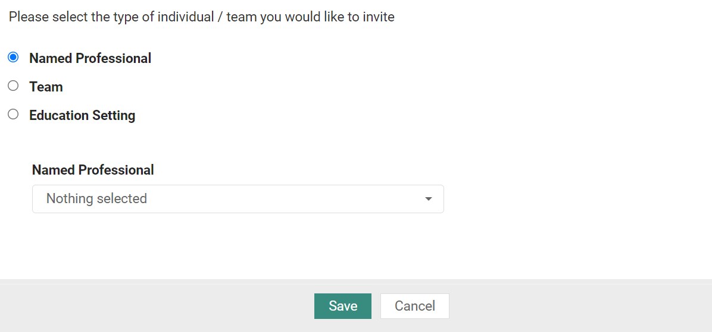

Click on Save.

Team
If you click on Team, left click on Nothing selected and select the require team from the picklist. Click here for more information on using pick list fields:

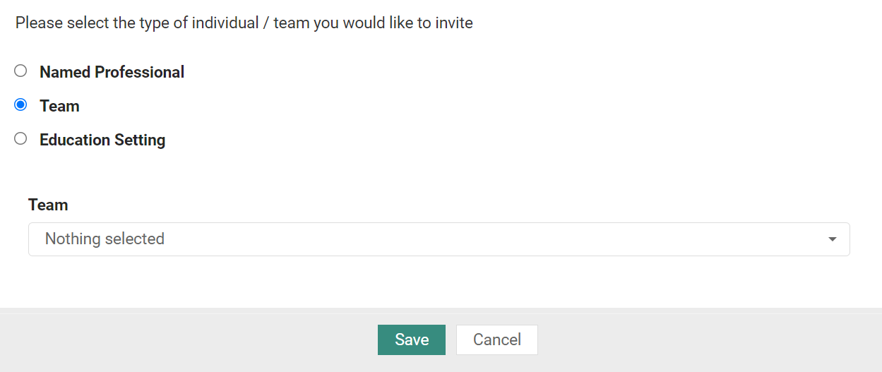

Click on Save.

Education Setting
If you click on Education Setting, left click on Nothing selected and select the require SENCo from the picklist. Click here for more information on using pick list fields:

Only SENCos that are linked to the case will be available to add to the review meeting invitations. If the intended SENCo that you wish to add is not available to select, you will need to contact the case co-ordinator and request they be added to the case.
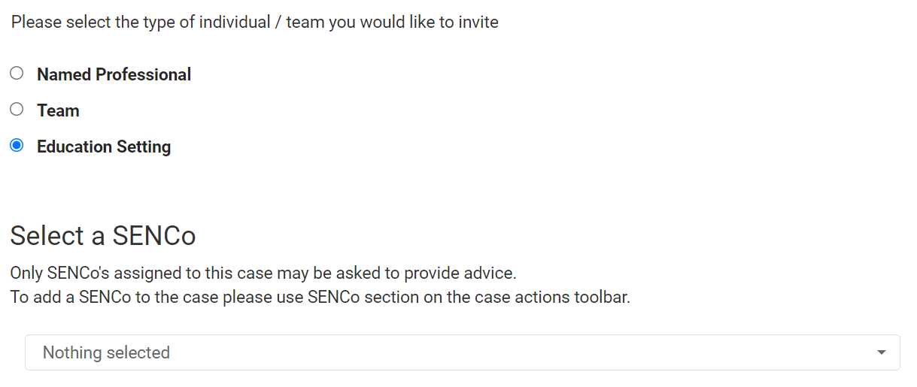

Click on Save.

Any professionals and or teams invited to attend will then be displayed:

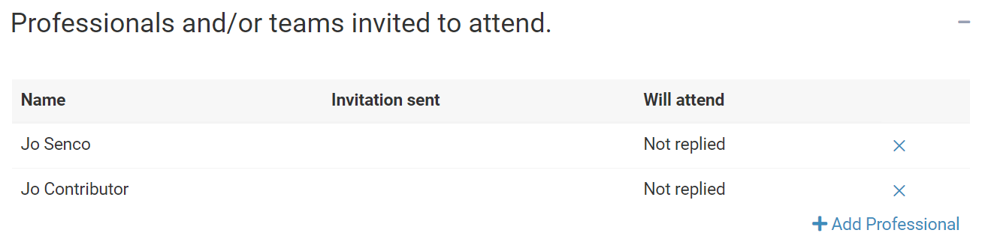

Case Co-ordinator(s) and/or Local Authority representative(s) invited to attend
The Case Co-ordinator assigned to this case will be automatically included in this section.

To invite additional Case Co-ordinator(s) and/or Local Authority representative(s), click on Add Co-ordinator:

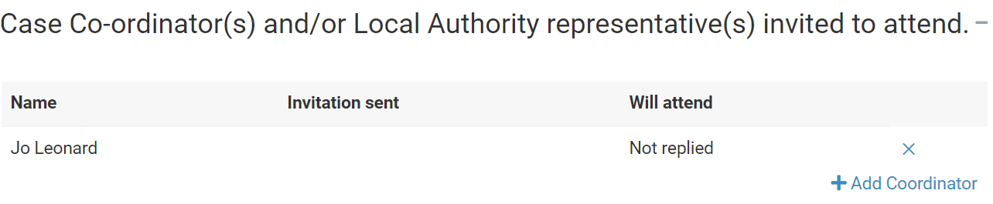

The following page will be displayed:
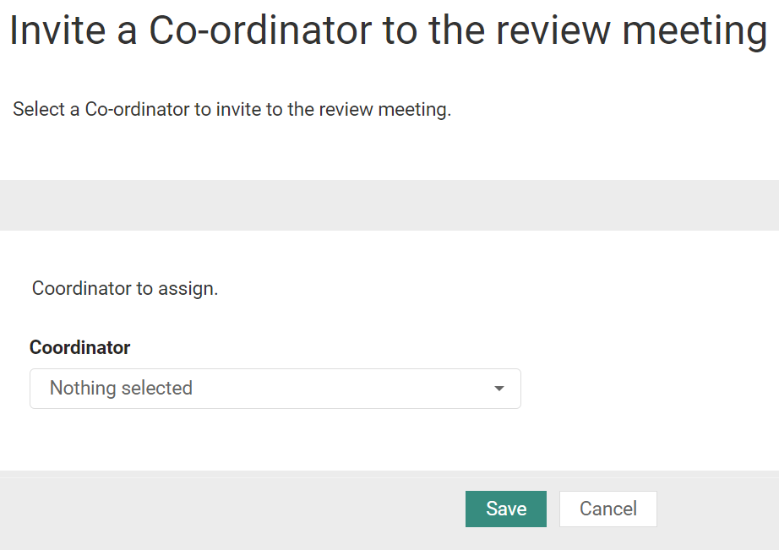

Left click on Nothing selected and select the required co-ordinator from the list.

Click on Save.

The case co-ordinators invited to attend will be displayed:

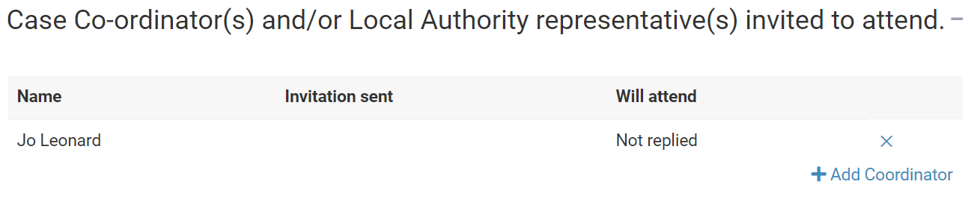

Confirm and send invitations
Once all the information has been completed, click on Confirm and send invitations:

You will be asked to confirm this meeting and send invitations:

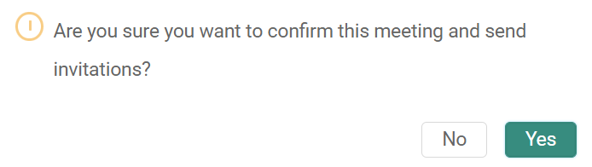

Click on Yes.

All the attendees invited to the meeting will receive an email like this:

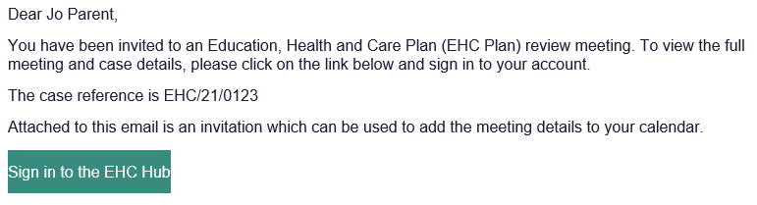

They will log into the hub to indicate if they will be attending the meeting.

Viewing who has confirmed attendance for the meeting
A list of all the people who have confirmed they will be attending the meeting will be displayed:

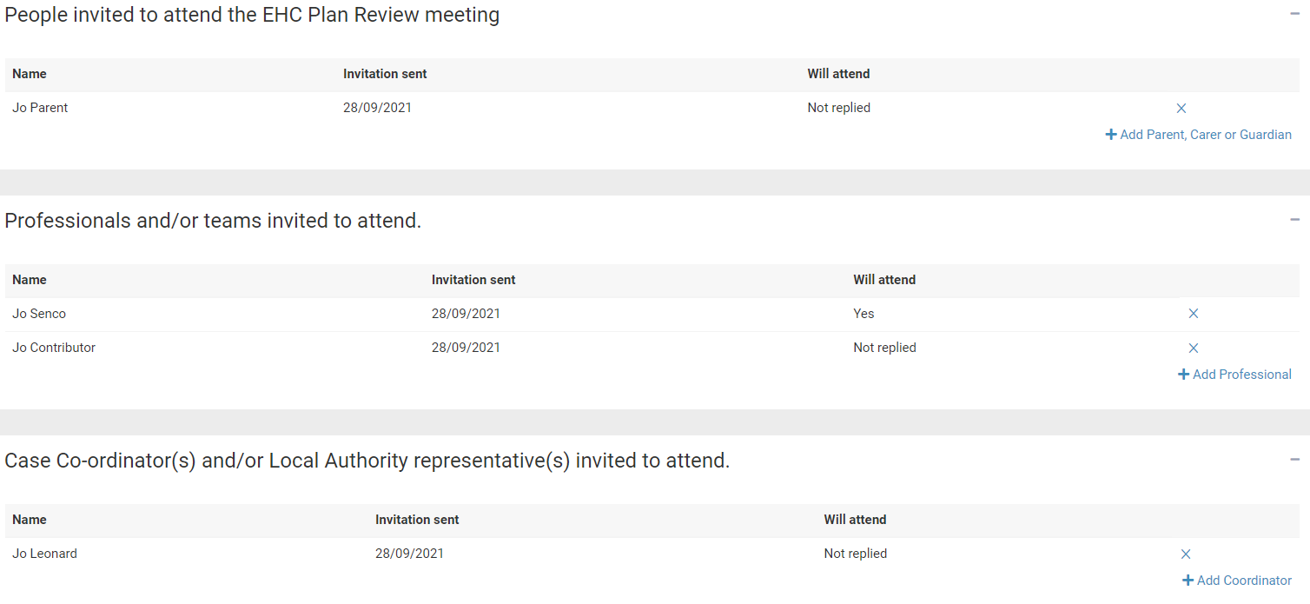

EHC Plan Review Consultation

Confirming Attendance for the meeting

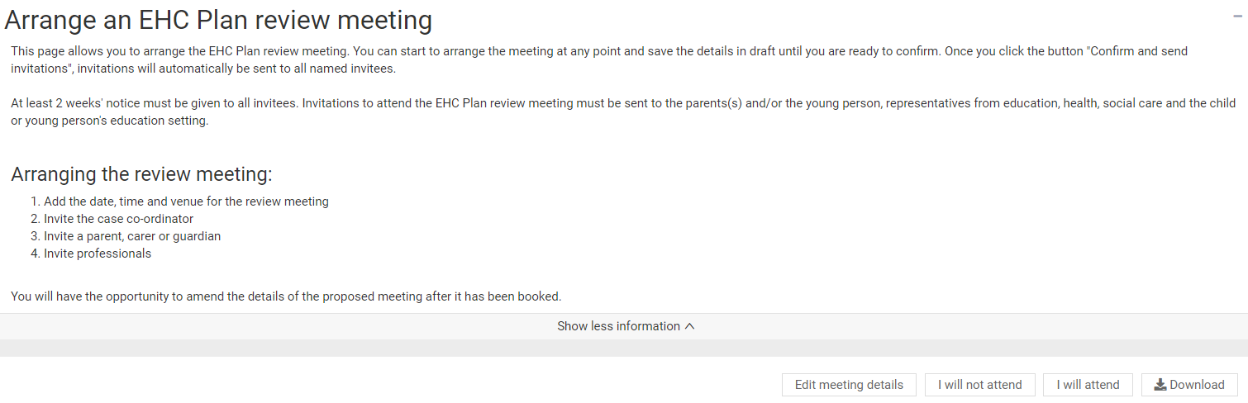

At the top of the screen, there will be two buttons:

Click on the button to indicate if you will or will not attend the meeting.

Sending Requests for Information
Once the invitations have been sent, information can be requested from involved professionals, teams or organisations that have been invited to the meeting:

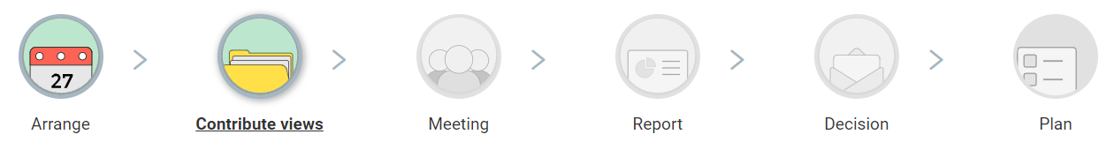

To send a request for information, click on Request information.

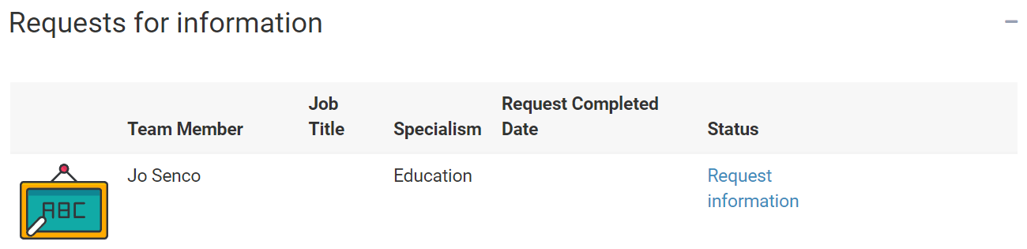

The person the information was requested from will receive an email like this:
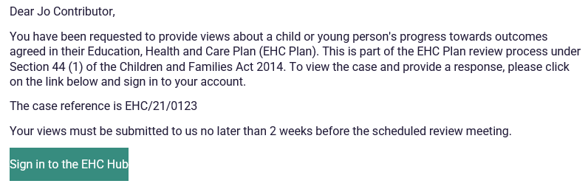

And the status of the request will be updated to show the response is Pending.

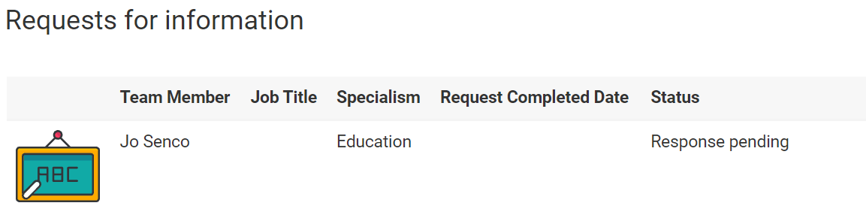

To request information from additional professionals not listed on this stage, return to the “Arrange” stage and add the person or team to the list of attendees. That person or team will then be available to request information from at the “Contribute Views” stage.

Once the request has been responded to, the status will be updating to show that a response has been received and the date it was completed:

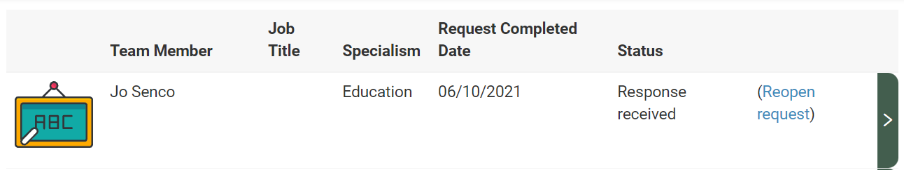

To view the response, click on the green arrow to the right of the request. A response can be viewed unless your own information has not yet been submitted.

Responding to a request for information
To respond to a request for information, click on the Green Arrow to the right of the request:
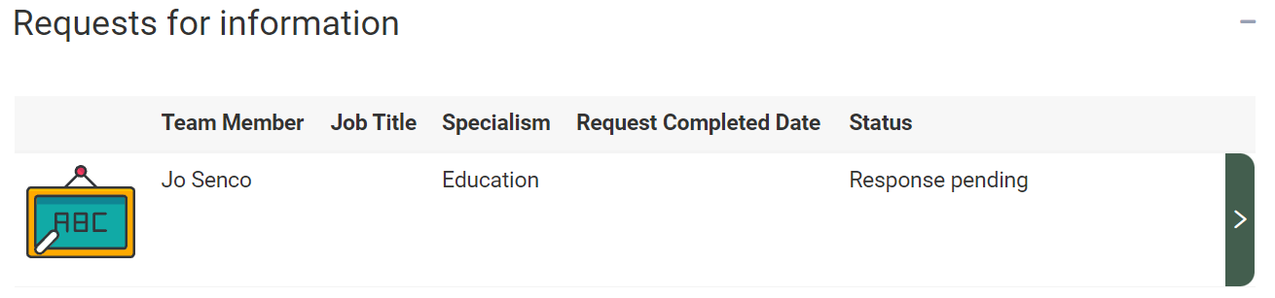

The request for information page will be displayed:

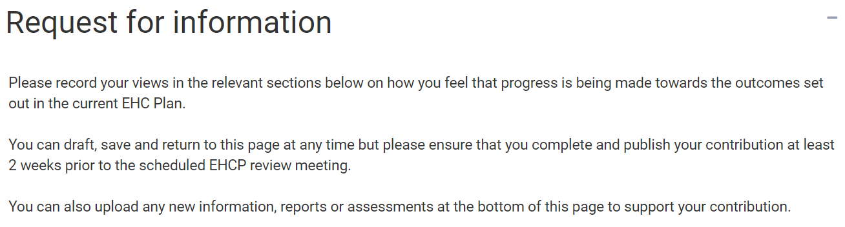

At the top of the screen, you will need to complete information about the response.

Are you providing a response on behalf of someone else – click on the Yes or No button as appropriate.

Name of the person providing the advice – enter the name of the person providing the advice. If the local authority later decides to issue an EHC plan, this will be the name attributed to this advice response in Section K.

Job title or role of the person providing advice – enter the job title of role of the person providing advice.

Will you provide information and advice for this child/young person – click Yes or No. If you answer No to this question, it is mandatory that you enter details as to why you are not willing.

Below that, there are six more sections:
- SEN - Communication and Interaction
- SEN - Cognition and Learning
- SEN - Sensory and/or Physical needs
- SEN - Social, Emotional and Mental Health
- Health
- Social Care
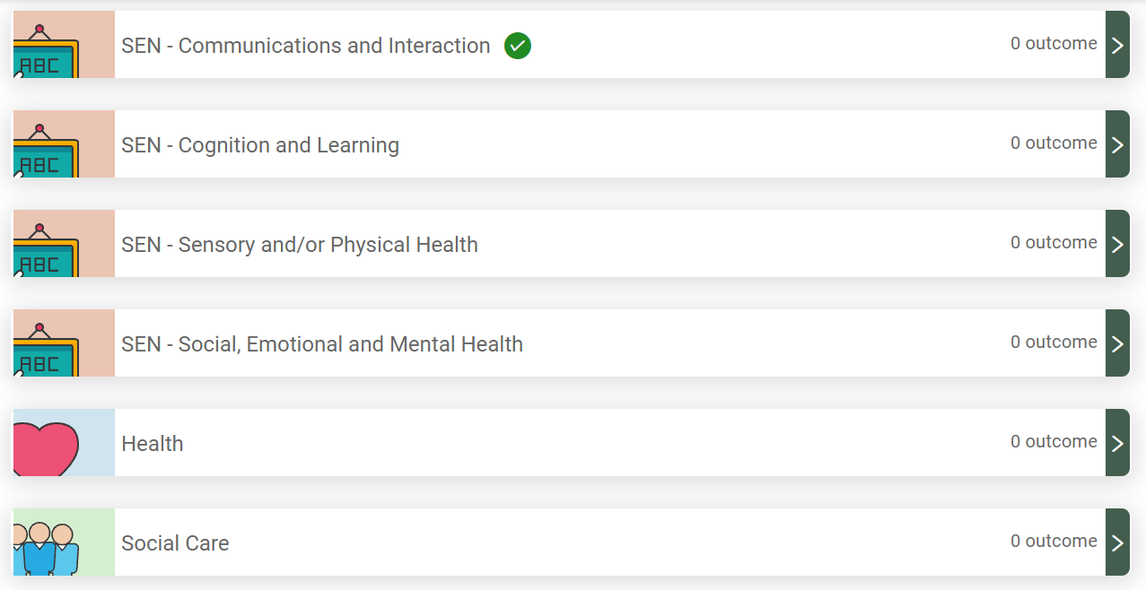

If a section has outcomes specified in the current EHC Plan, it will have a green tick next to it and show how many outcomes there are.

To review the information in each section, click on the green arrow on the right. The information previously entered as part of the plan will be displayed.

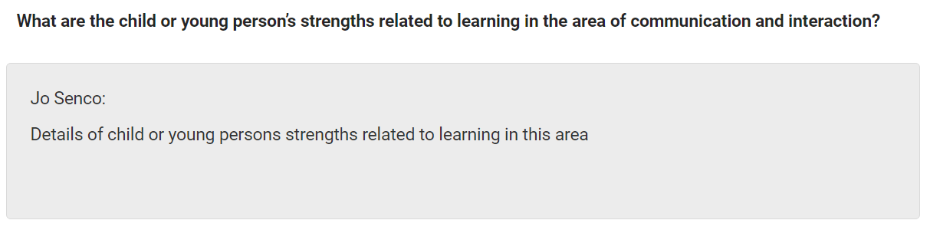

There are various sections that can be commented on:

Is there any change:

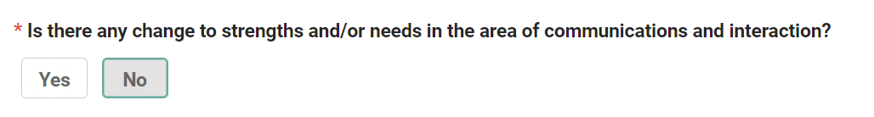

If you click on Yes, a free text field will appear for you to enter details of the change:

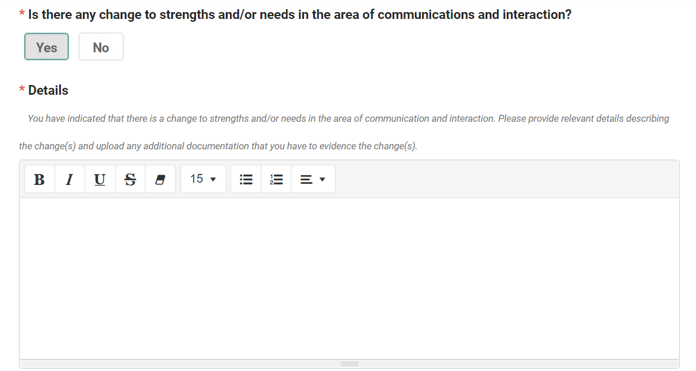

Outcome(s) and Provisions Comments - You can comment on Current Progress towards this outcome. To do this, click on the down pointing arrow at the end of the field:

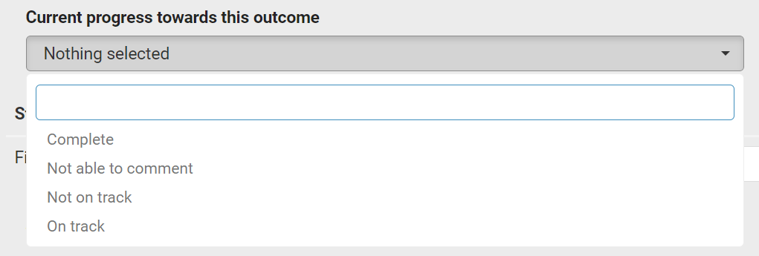

Steps to achieving this outcome:

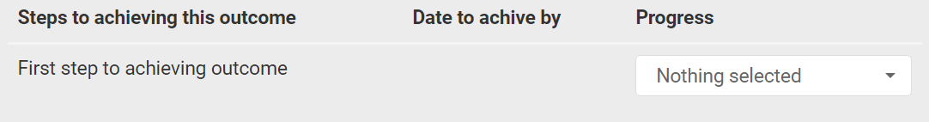

What has been working well: This is a free text field.
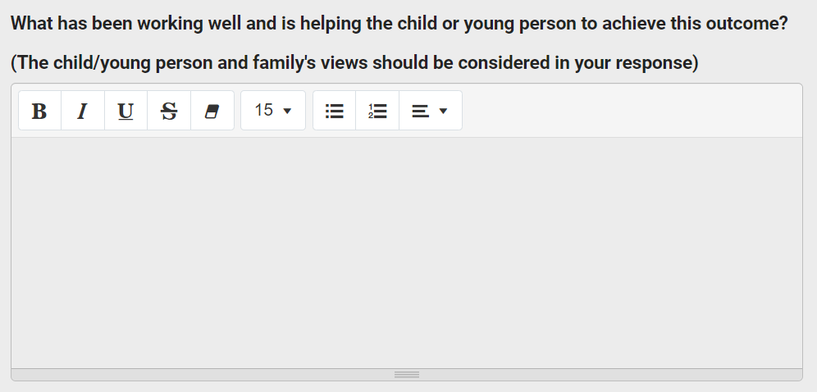

Are there any changes needed to this outcome – Click Yes or No. If you select Yes, a free text field will be displayed to enter information about this.

Are there additional short-term targets –Click Yes or No. If you select Yes, click on Add a new step to enter information about the new step.

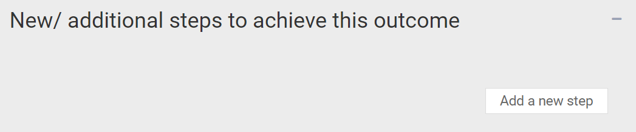

Are there any changes needed to the SEN provision to support the child or young person to meet this outcome – click Yes or No. If you select Yes, click on add a new provision to enter information about the new provision or recommended changes to existing provision.

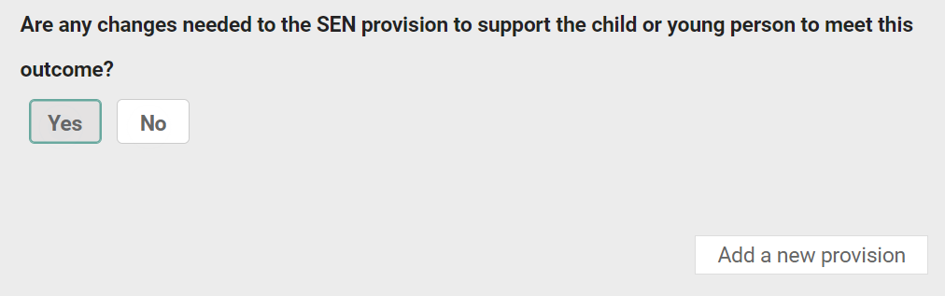

Once you have entered the relevant information, click on the Save Section button at the top of the section:
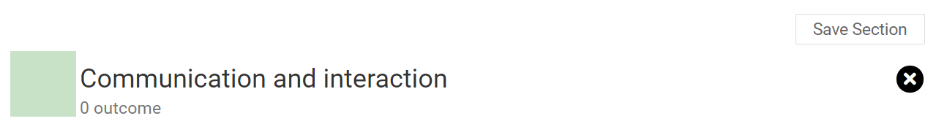

Documents
Any addition information to support the advice can be uploaded here:
If you want to add any documents, click on the Add Files button:

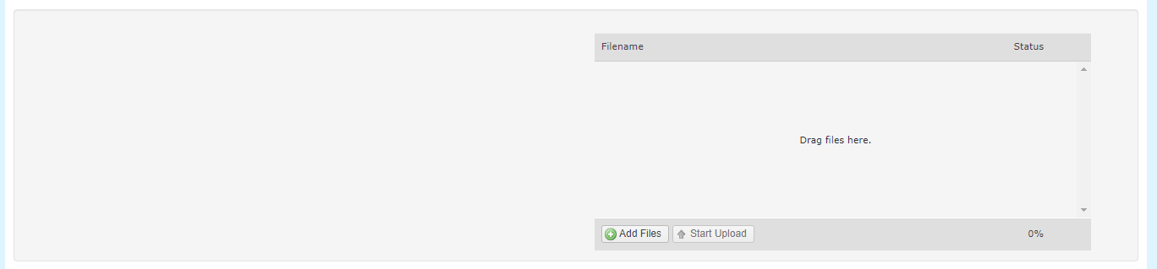

You will then need to navigate to the file wherever it is saved on your PC:

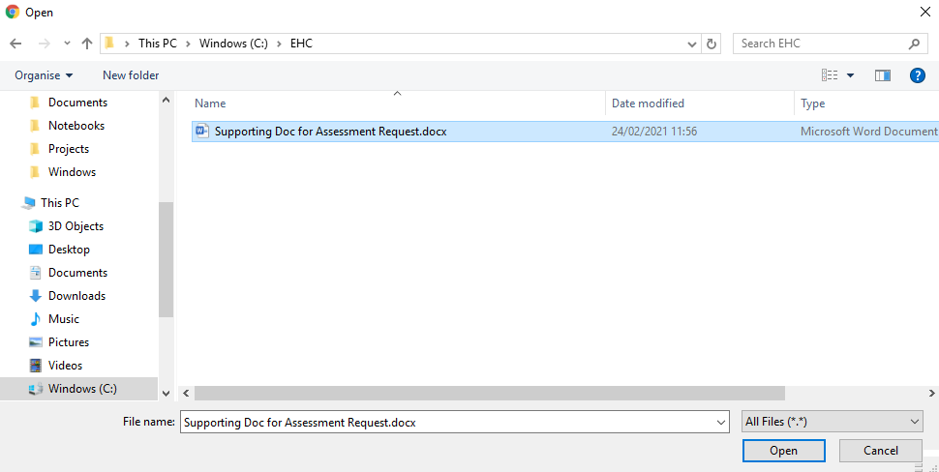

Click on Open and the file will be uploaded. The uploaded file will be displayed. Once you have completed the information for all the relevant sections, click on Submit information at the top of the screen:

The Childs or Young Persons Views
This section can be completed by the young person or supported by a SENCo, parent/carer or case coordinator.

Any information previously entered during the assessment, or previous review leading to an amended EHC Plan, can be viewed:

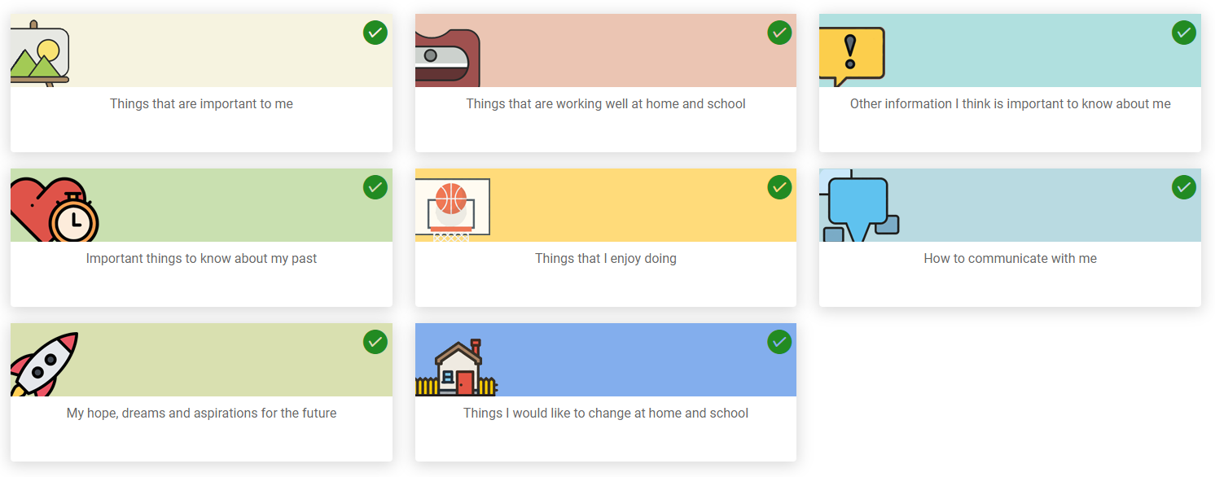

A green tick in the top right-hand corner of the section means information has previously been entered this section. To view that information, click on the tile and it will be displayed:

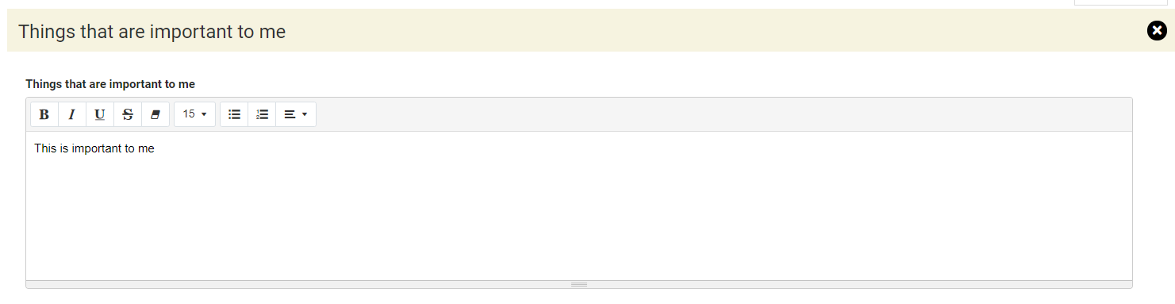

The Parent or Carer’s Views
This section can be completed by the young person or supported by a SENCo, parent/carer or case coordinator.

Any information previously entered during the assessment, or previous review leading to an amended EHC Plan, can be viewed:
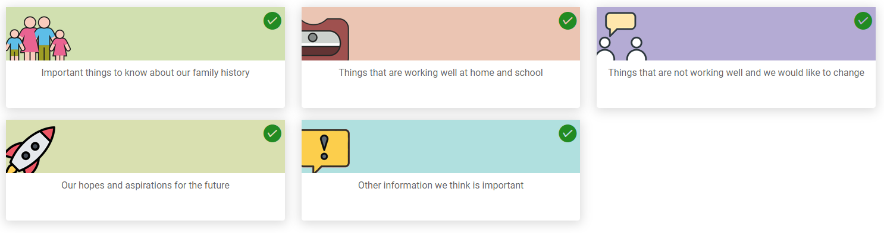

A green tick in the top right-hand corner of the section means information has been added or changed as part of this review. To view that information, click on the tile and it will be displayed:

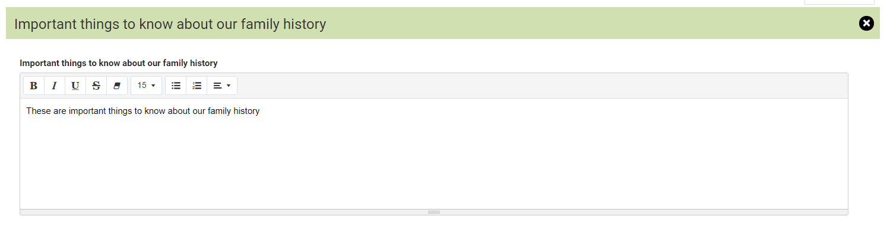

Reopen a Request that has been submitted
It is possible to reopen a request that has been submitted whilst the current state is Contribute views. This means changes can be made to the response and it be submitted again.

To reopen a request, click on Reopen request.

You will be asked to confirm you want to reopen the advice request. Click on Yes. The status of the request will then be displayed as Response Pending.

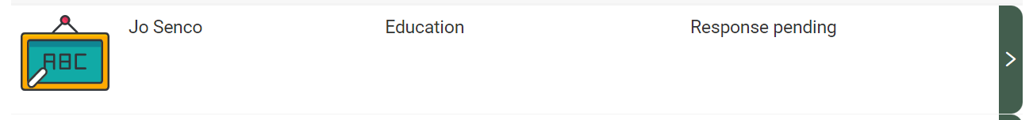

If the re-opened request for information is your own response, then click on the green pointing arrow to amend the details entered previously. When the changes have been made, click on Submit Information:

The status will then be updated to say Response received:

