EDUCATION, HEALTH AND caRE hUB
GUIDE 14 FOR SEncos – EHC Plan review
APRIL 2022

EHC Plan Review
Once a plan has been finalised, it must be reviewed annually. Information about the review date will be displayed when you log into the Hub and view the case.

To start the review process, click on Start Review in the Review not yet started section of the EHC Summary page:

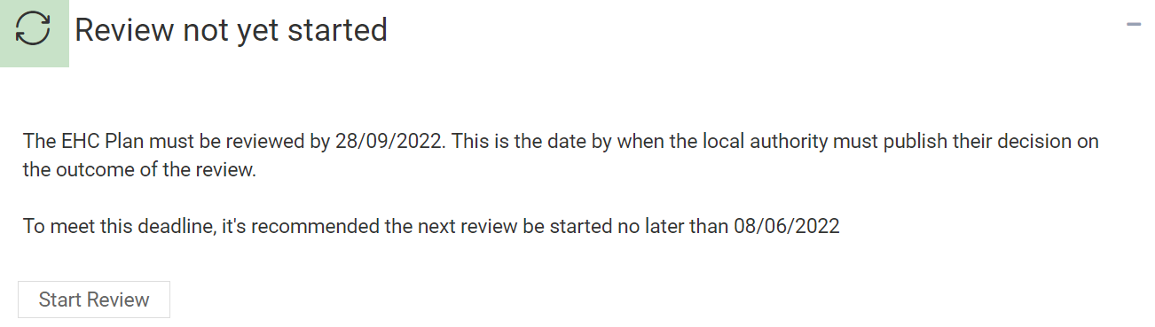

You will be asked to confirm that you want to start a review:

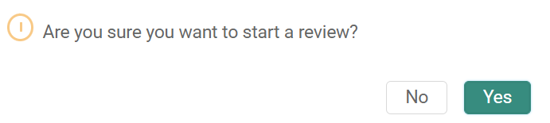

The pathway for the review meeting will then be displayed at the top of the screen:

