EDUCATION, HEALTH AND caRE hUB
GUIDE 13 FOR SEncos – finalised and issued ehcp
APRIL 2022

Finalised and Issued EHCP
Once the case co-ordinator has finalised the EHCP, it will be issued. An email will be sent to inform you of this:

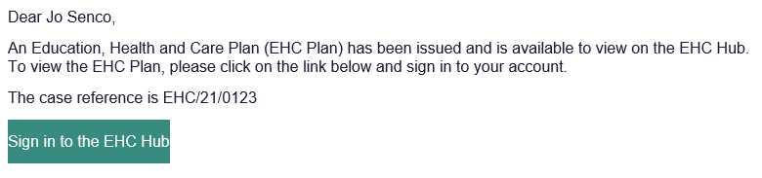

When you log into the hub, the case file will no longer be displayed in the My cases in progress tray, as the plan has been issued. The case will now be displayed in the My live cases tray.

The status of the file will show as Review pending, as that is the next stage the process that the hub will manage:

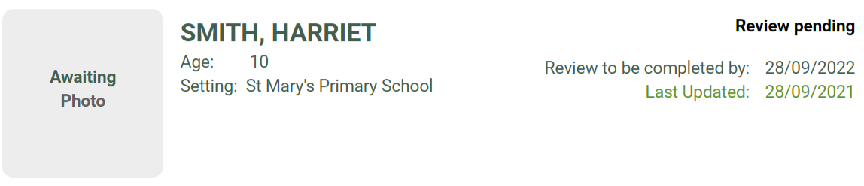

When you click on the file, the EHC Case Summary will be displayed. This has three sections:
- Education, Health and Care Plan
- Review not yet started
- EHC Assessment and Planning Pathway

Education, Health and Care Plan
This section will allow you to Download the EHC Plan:

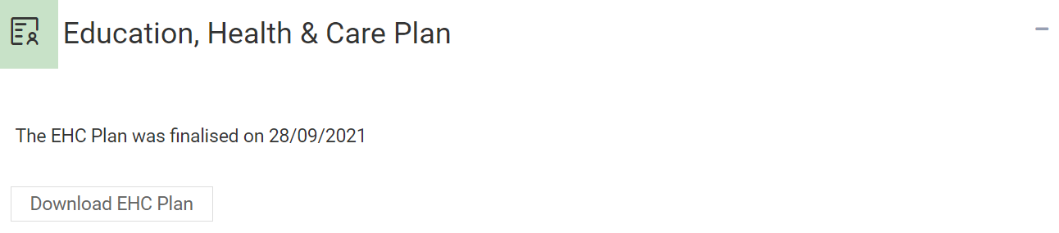

The downloaded plan will then be available to save to your device.
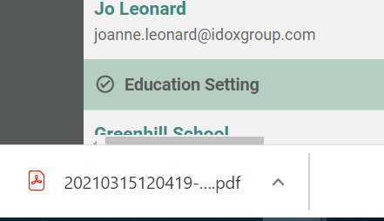

The above screenshot shows how a downloaded file is accessed when using Google Chrome. Other web browsers may appear differently.

Review not yet started
This will display the date by when the review process must have been completed by and a recommended date by when to have started the review to be able to meet that deadline.

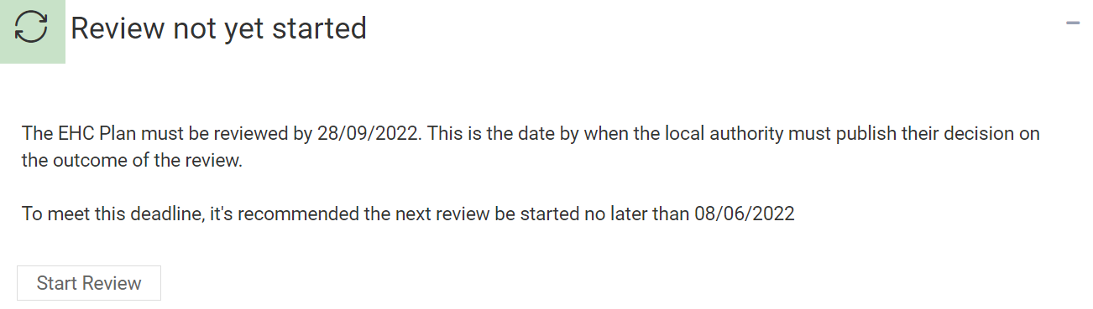

Click here for more information about starting the Review process.

EHC Assessment and Planning pathway
This will display the date the assessment and planning pathway was completed, and has a link to enable you to view the pathway:

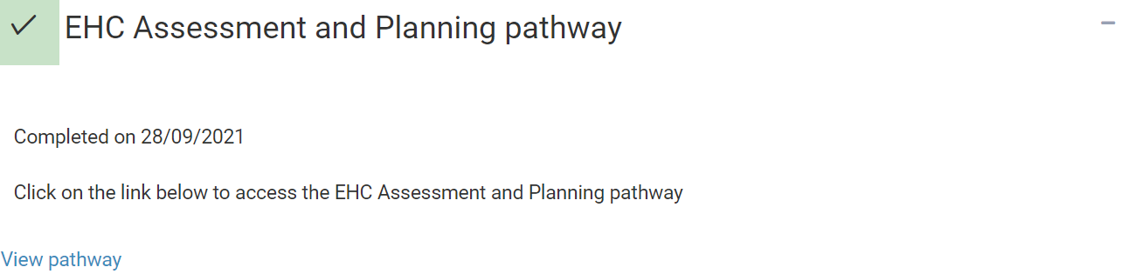

This information will not be available for EHC Plans that have been imported. This is because their assessment and planning process will have been completed outside of the EHC Hub.

