EDUCATION, HEALTH AND caRE hUB
GUIDE 12 FOR SEncos – Consultation for education settings
APRIL 2022

Consultation for Education Settings
When the draft plan is shared by the case co-ordinator, they will enter information for the education setting(s) that should be consulted on the draft plan.

Under the educational settings, it will show all educational settings that have been consulted and the status of that consultation.

If your education setting had been consulted for advice, the education setting will receive an email indicating this. The email will look something like this:

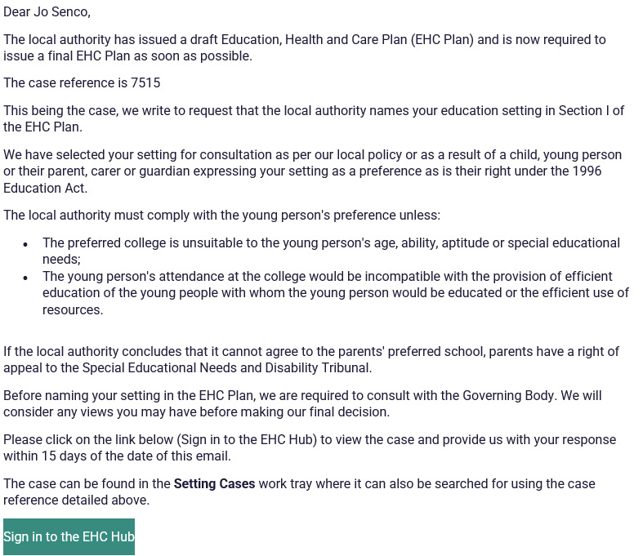

To view the case, log into the EHC hub and click on Setting cases:

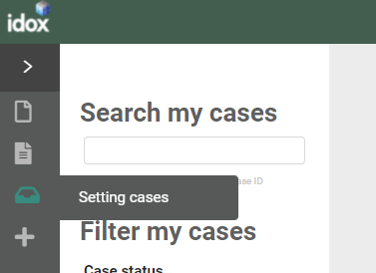

You can either enter the case ID which can be found on the email or use the tick box filter for Open Education Setting Consultation:
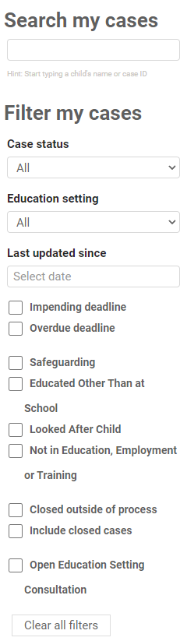

Click on the child or young person’s case and the Education, Health and Care Plan will be displayed:

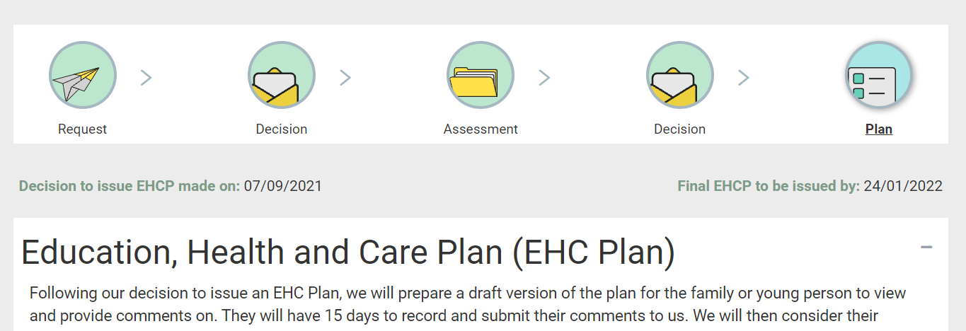

Please note that if you are not the named SENCo for this case, you will only have access to the file to complete the consultation. Once the consultation response has been submitted, access to the case is removed.

Scroll to the bottom of the screen to view the Consultation Request:
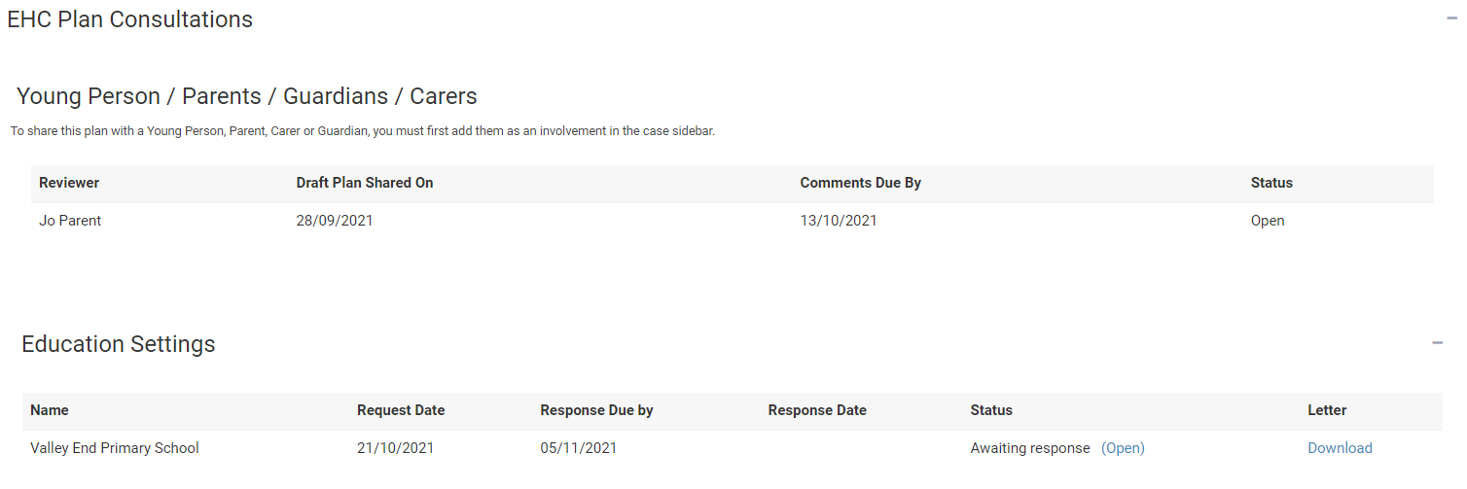

To view the letter the educational setting was sent as part of the consultation, click on Download in the letter column and you will be able to save this to your device.

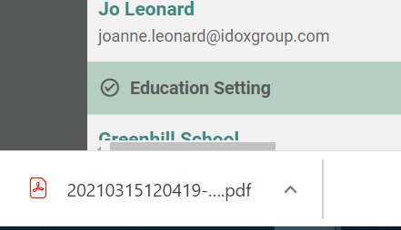

The above screenshot shows how a downloaded file is accessed when using Google Chrome. Other web browsers may appear differently.
Click on Open:

The Education Setting Consultation page will be displayed:
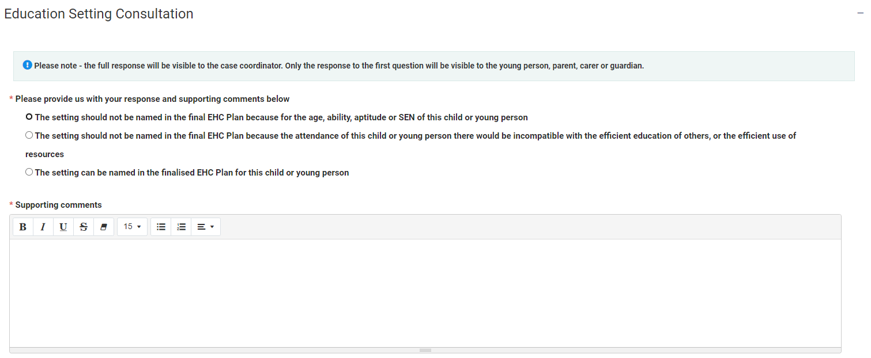

There are two sections to this, the response and the supporting comments.

Response
To provide your response, click on the appropriate radio button.

The options are:
- This setting should not be named in the final EHC Plan because of age, ability, aptitude or SEN of this child or young person
- This setting should not be named in the final EHC plan because the attendance of this child or young person there would be incompatible with the efficient education of others, or the efficient use of resources
- The setting can name in the finalised EHC Plan for this child or young person

Please note that only the above response will be visible to the young person, parent, carer or guardian, they will not be able to see the supporting comments. The supporting comments will only be visible to the case co-coordinator

Supporting Comments
This is a mandatory field and must be completed. It is a free text field.

Documents (Case Co-ordinator)
Any documents that were added by the case co-ordinator will be displayed here. Click on the document to download it:
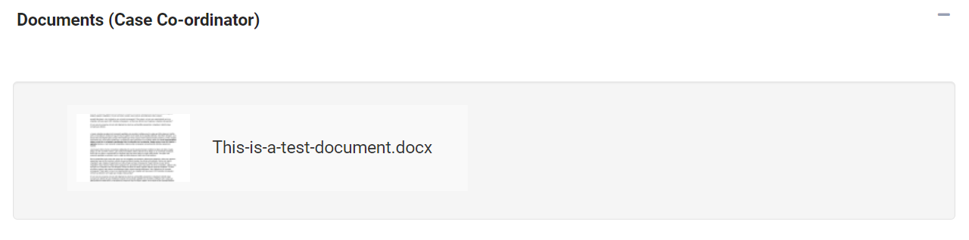

Documents (Education Setting)
If you want to add any relevant supporting documents, click on the Add Files button:

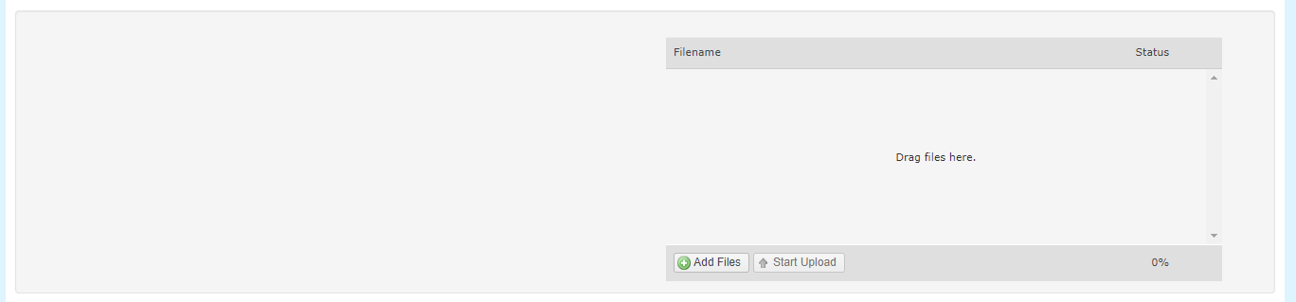

You will then need to navigate to the file wherever it is saved on your PC:

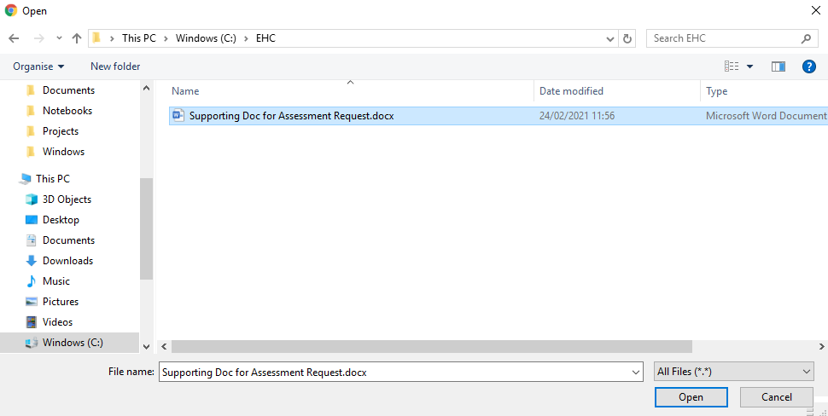

Click on Open and the file will be uploaded. The uploaded file will be displayed:

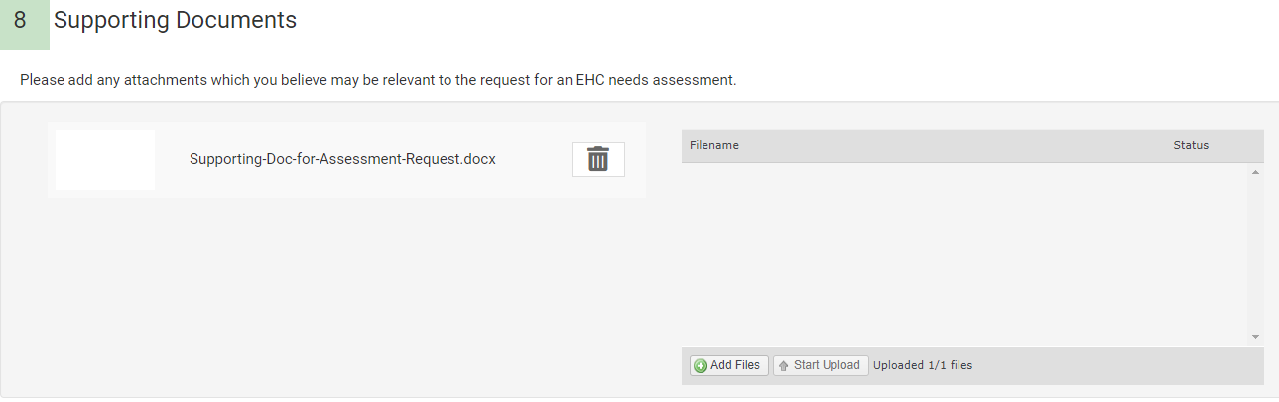

When the response has been completed, click on the Save button:

It is possible to view the case file prior to completing the response to the consultation. To view the pathway click on Close in the consultation to return to the main EHC Plan page:

Click on the icons on the pathway to view the previous information:

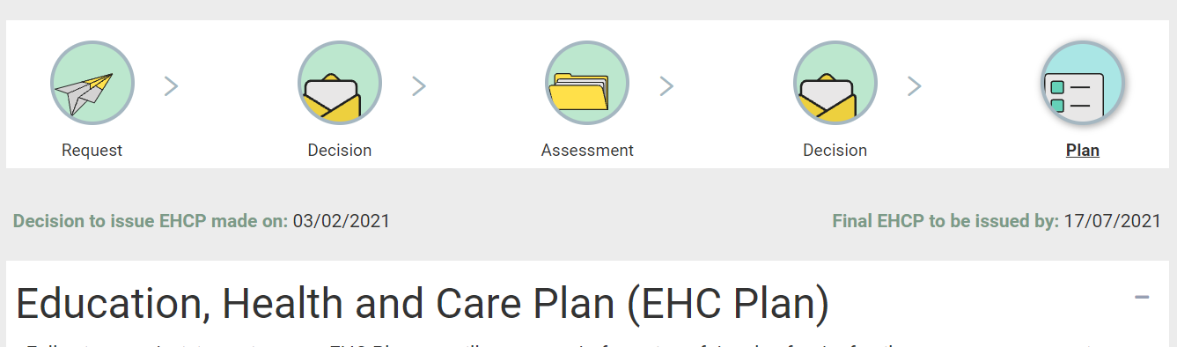

Once you have completed the consultation information, click on save. The information entered can be saved at any point, providing mandatory fields have been completed.
Once all the information entered has been completed and is ready to be submitted, click on Submit:

The status of the response will be updated to show the response date and that it is complete:

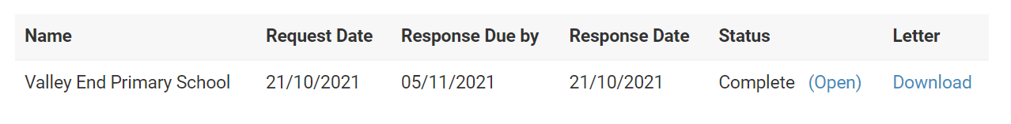

Please note that if you are not the named the SENCo assigned to the case, you will not be able to access the case once you have submitted your consultation and navigated away from the case.

