EDUCATION, HEALTH AND caRE hUB
GUIDE 11 FOR SEncos – EHC Plan consultationS
APRIL 2022

EHC Plan Consultations

Parents/Guardians/Carers
At the bottom of the plan, there will be list of the Parent/Guardians/Carers or young people that have been consulted about this draft plan:

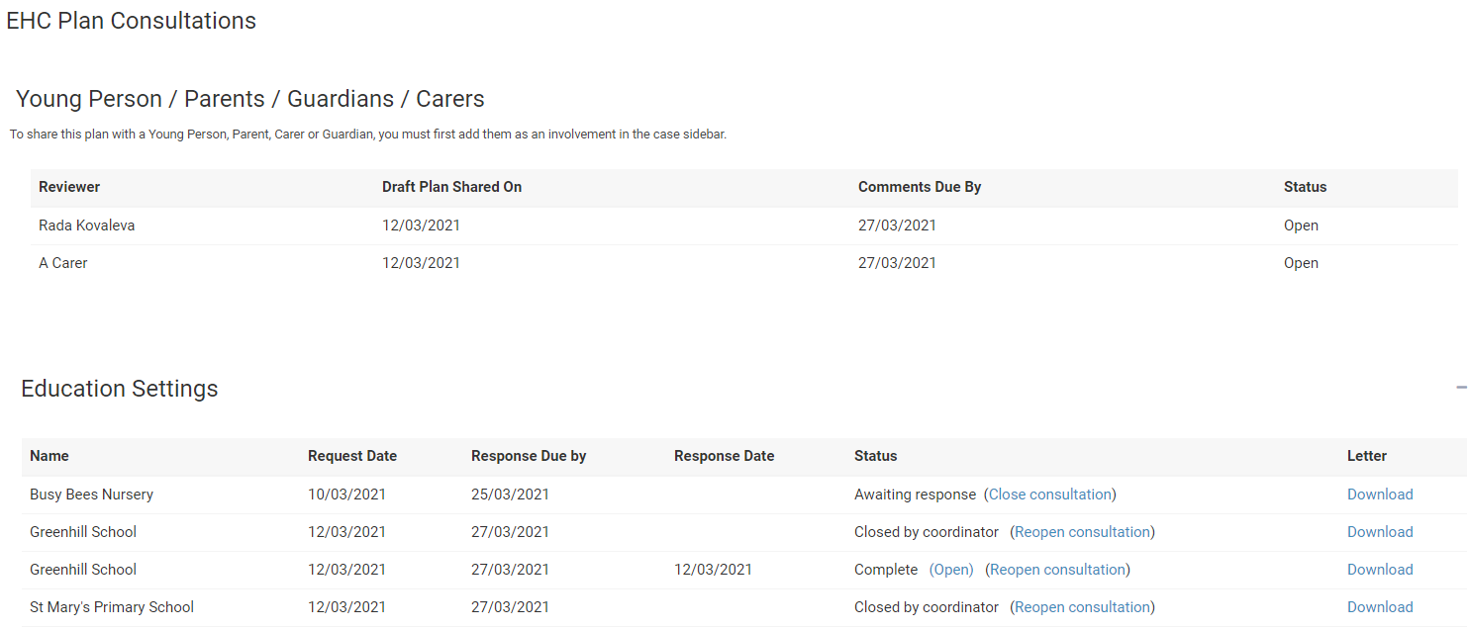

It will list all Parent/Guardians/Carers or young people who have been asked to review the plan, when the draft plan was shared with them and when they need to comment by. It will also have the status of the comments process. If this says Open, then that person is still in the process of adding comments.

Once the comments have been entered, the status will change to show completed:

