EDUCATION, HEALTH AND caRE hUB
GUIDE 10 FOR SEncos – viewing the draft plan
APRIL 2022

Viewing the Draft Plan
When the draft plan is being created, before it has been shared, the case file will look like this:

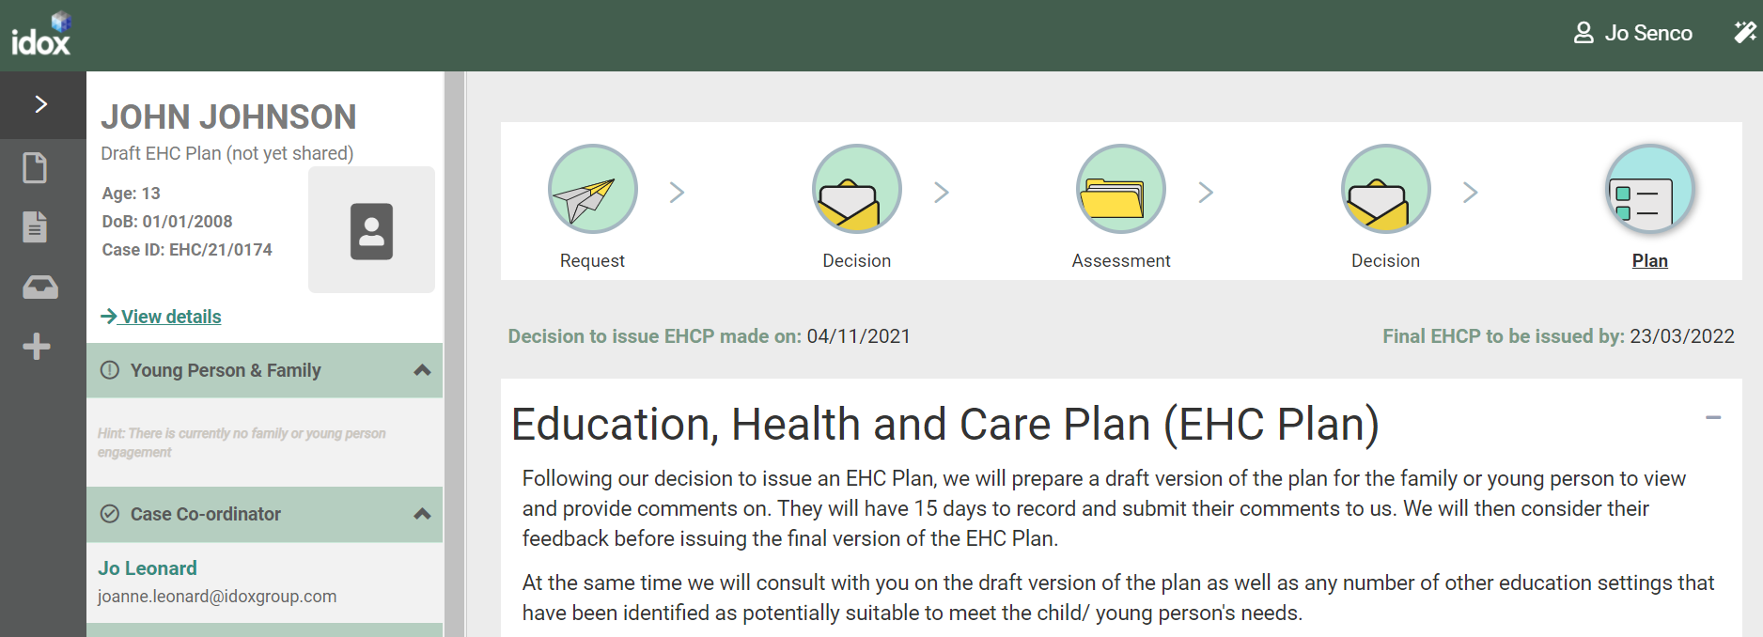

Once the draft plan has been created, it will be published and shared by the case co-ordinator and you will receive an email to this effect:

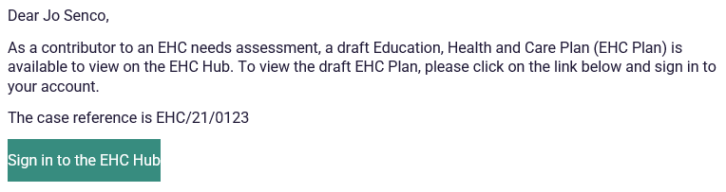

The status of the case file will change to reflect this.

If the draft plan is ready to be viewed, the screen underneath the information section will look like this, showing when the Draft was shared:

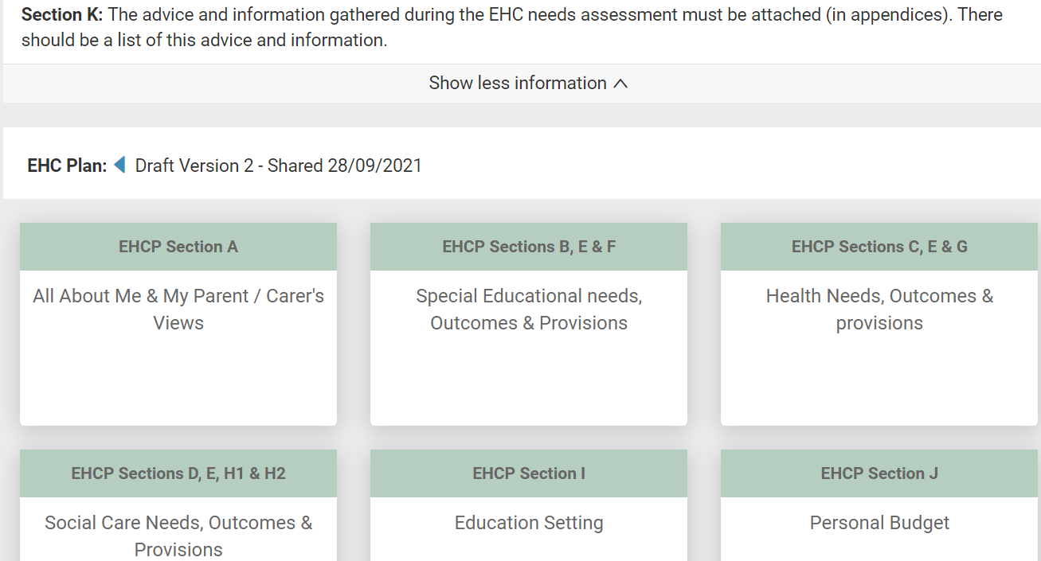

Each of the sections make up part of the Plan. To view more information on each section, left click on that section.

Each section may have multiple parts to it.

When you click on a EHCP section, the different parts of that section will be displayed with a brown heading:

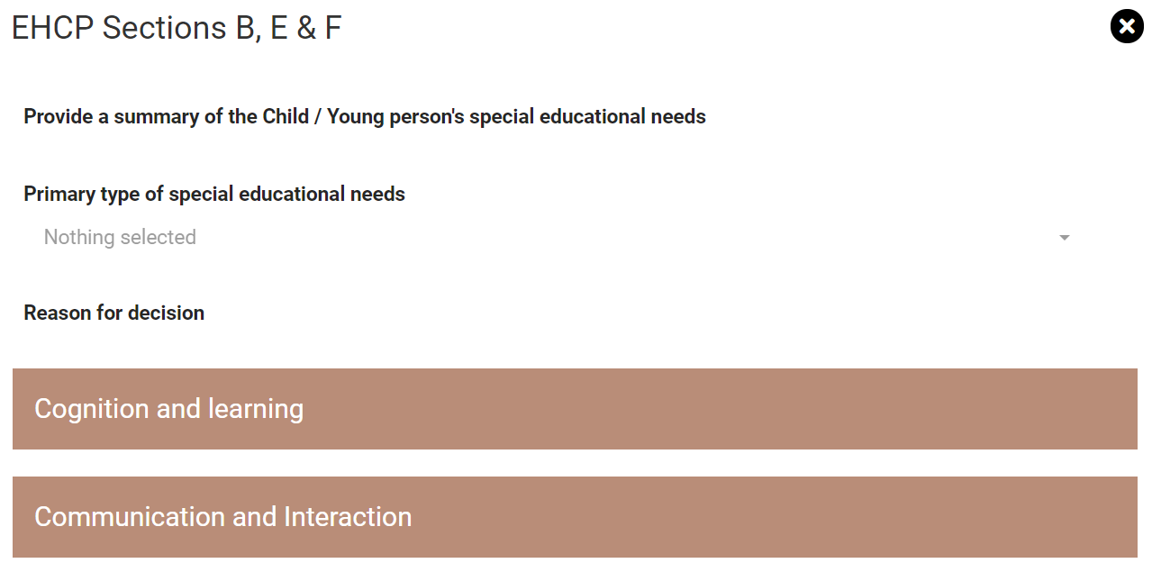

Left click on each of the part headings to view any information that has been entered:

If a section is not applicable (for example, the child or young person does not have extra Health Needs) it will look like the above.

It is important to scroll up and down the screen to make sure you can see all the information that has been added to the plan. Left click on the scroll bar on the right-hand side of the screen to move up and down on the screen.

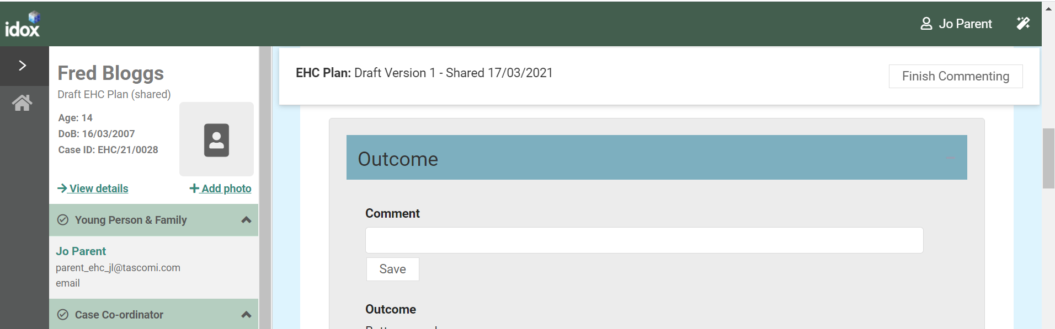

Click on the X to return to the main screen:

EHCP Section A – Left click on this to display the previous information entered by the Parent/Carer and /or young person during the contribution to the assessment stage.

This has three parts:
- About
- Parent/Carer’s Views
- Local authority background information

EHCP Sections B, E and F – Left click on this to display information about Special Educational needs, Outcomes and Provisions.

EHCP Sections C, E and G – Left click on this to display information about Health Needs, Outcomes and Provisions which relate to the special educational needs of the child or young person.

EHCP Sections D, E, H1 and H2 – Left click on this to display information about Social Care Needs, Outcomes and Provisions which relate to the special educational needs of the child or young person.

EHCP Section I – Left click on this to display information about the Education Setting. This information is not populated at this draft plan stage. The settings will be recorded in the Final EHC Plan.

EHCP Section J – Left click on this to display any information about the personal budget. This has two parts:
- Personal Budget
- Annual Cost of Support

EHCP Information and Advice – Left click on this to display any information and advice provided by professionals during the assessment process
This has 2 parts
- Monitoring and review
- Progress towards outcomes specified in this plan will be monitored by

It also has a section on Advice Contributions. To view any advice contributions that have been made, click on view:

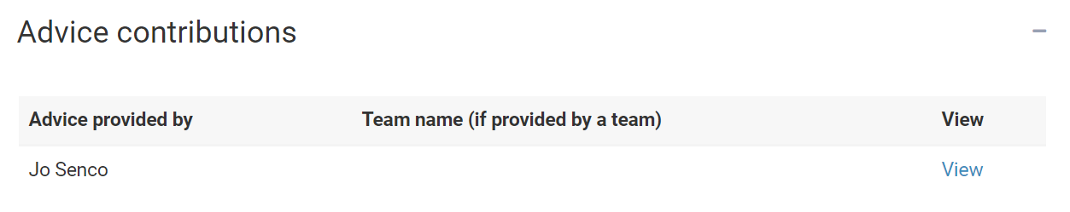

You will then be able to view the information.

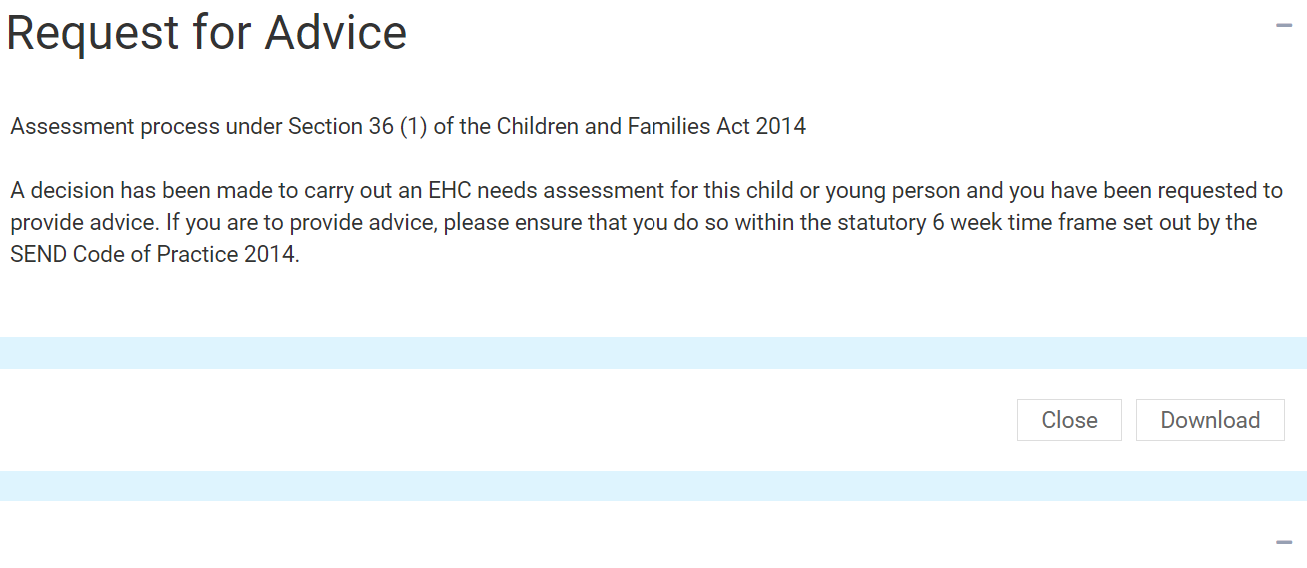

Left click on Plan at the top of the screen to return to the draft plan:
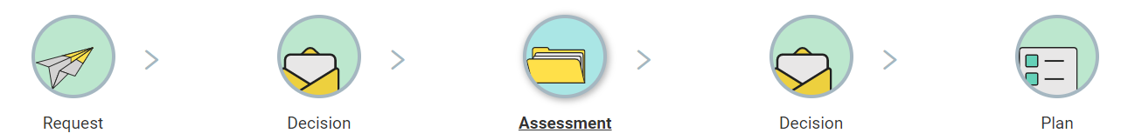

Downloading a Draft Plan
If you wish to download the draft plan as a PDF file. Click on Download Draft Plan and you will be able to save this to your device:

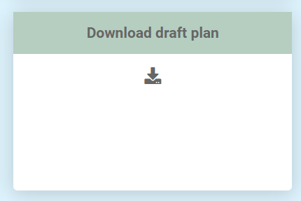
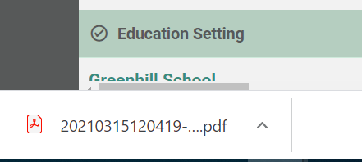

The above screenshot shows how a downloaded file is accessed when using Google Chrome. Other web browsers may appear differently.

