EDUCATION, HEALTH AND caRE hUB
GUIDE 1 FOR SEncos – HOW TO REGISTER FOR AN ACCOUNT
APRIL 2022

How to Register for an Account
An account on the EHC Hub will be created for you by the local authority and they will contact you by email to register this account. In order to access the Hub, you will need a username and password. There is also a second level of security (known as two factor authentication) which will involve the entering of a six-digit code provided to you either by an authentication app or a text message. The username will be your email address.

You will receive an email:

The email will look like this:

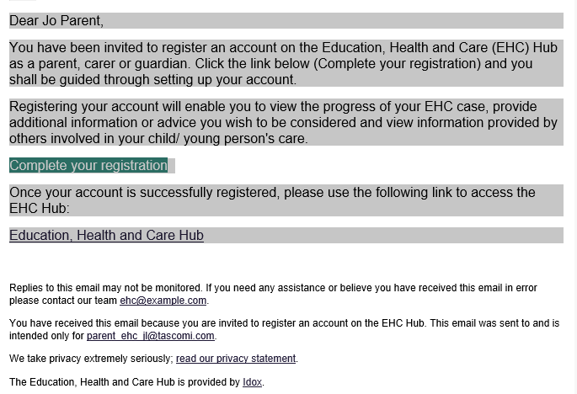

Click on the Complete your registration link in the email. The following page will appear:
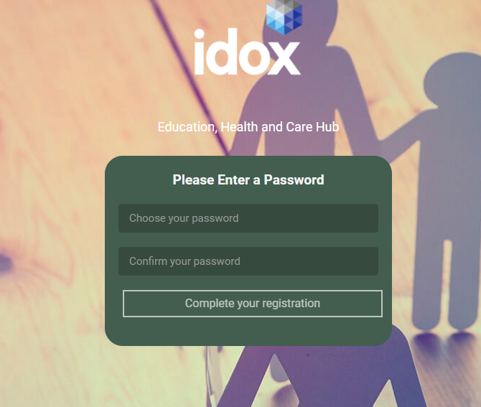

Enter a password for your EHC Hub account in the Choose your password field. This must be at least 6 characters long. Enter the password again in the Confirm your password field. If the two passwords don’t match, you will get a warning message prompting you to type it again. You won’t be able to complete your registration unless the two passwords match:

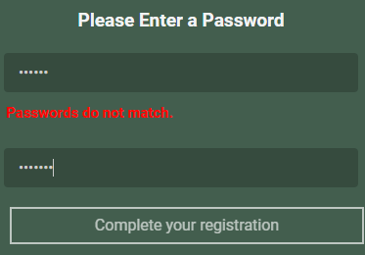

Click on Complete your registration.

If there is a problem with your account, this message will appear in the top right-hand corner of the screen:

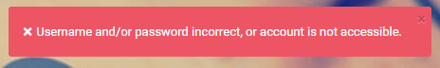

In this case, check you are entering the correct username (your email address) and password (just created). If problems persist, please contact your local authority. Contact details are included at the bottom of EHC Hub notification emails.

Once your username and password have been entered correctly, the following page will be displayed:

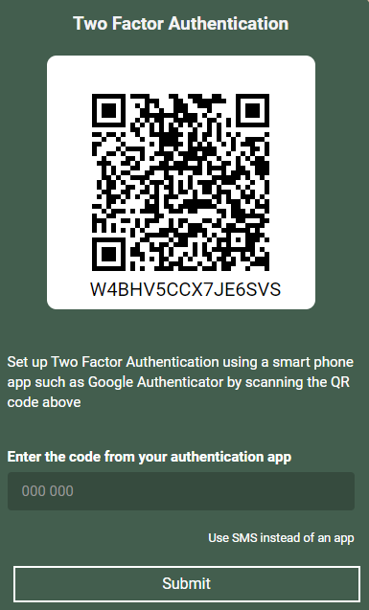

This is a second level of security to make sure only you can access the request details on the EHC Hub. This can be done with an authentication app on your smart phone, or using SMS text messages, whichever you prefer.
If you select an authentication app, this app will provide you with a 6-digit code to be entered. If you select Use SMS instead of an app, the 6-digit code will be sent to your mobile via a text message, and this can be entered on screen.

App Authentication
If you already have Google Authentication or an equivalent app on your phone, turn on the camera on your phone and use it to scan the QR code on the screen. You will automatically be directed to your authentication app and it will provide you with a six-digit code.
Enter this code into the field and click on Submit. A welcome page will then be displayed.

SMS Authentication
If you would prefer to use SMS instead of an authentication app, click on Use SMS instead of an app:

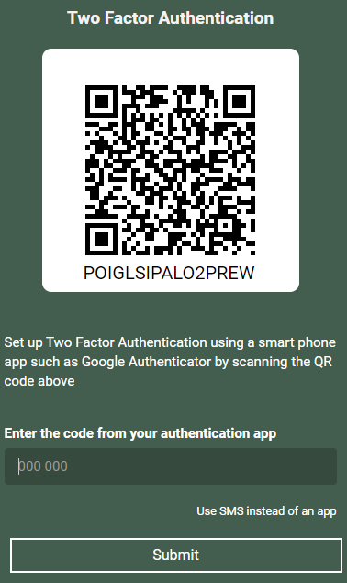

The following page will appear:

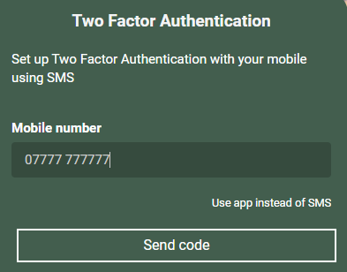

Enter the mobile number the text message with the code should be sent to and click on Send code.

A field will then be displayed for you to enter the code sent to your mobile as text message:

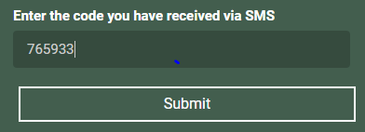

Enter the code and click on Submit. The My cases in progress page will be displayed.

You have now successfully logged into the EHC Hub.

