EDUCATION, HEALTH AND caRE hUB
GUide 9 for parents – help using forms
APRIL 2022

Help Using Forms

Pick List Fields
Click on the down pointing arrow at the end of the field to view the available options for selection. There is a scroll bar on the right to allow you to scroll down to view more options in the list. Scroll down until you can see the option you require and then left click to select it. Alternatively, if you know the option you require, you can begin to type it in the field and the list will show options that match what you type:
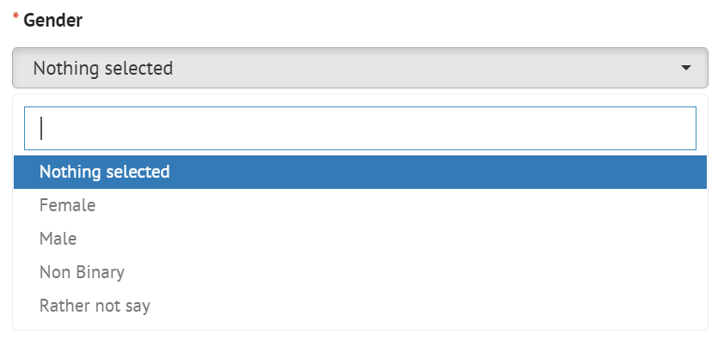

Text Formatting
Left click anywhere in the box and start typing any information you want to enter here. If required, there are various formatting options for that can be accessed by clicking on the buttons at the top of the field. To see what each button does, hover over the button with the mouse pointer and a tool tip will be displayed to show what that button does

Entering an Address
Enter the postcode of your address in the postcode search field and click on Search:
Another field will be displayed:
Click on the down pointing arrow to view with all addresses that match that postcode:
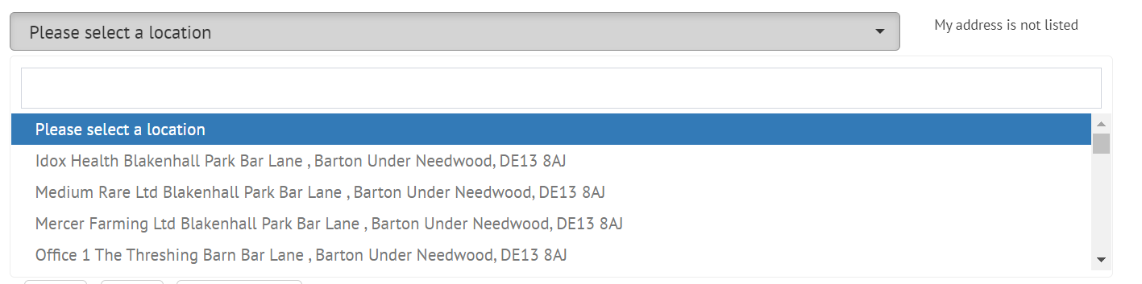
Left click on the correct address to select it. The address will then be displayed on screen:
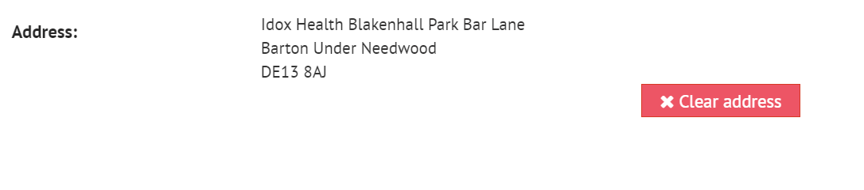
If the address is incorrect or needs to be removed, click on Clear address and a new location will be available to be selected.
If the correct address is not available to be selected from the list, click on the My address is not listed option, and the fields will be made available to be completed manually:
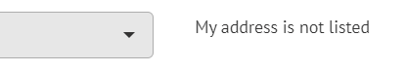

Date Fields
Type in the date required with a dash between the day, month and year. Alternatively, left click on the field and select the date from the calendar. Navigate around the calendar using the arrows in the top right and left corners until the correct date is available. Left click on the date to select it

