EDUCATION, HEALTH AND caRE hUB
Guide 8 for Parents – EHC Plan Meeting & Meeting Report
APRIL 2022

EHC Plan Review Meeting
When the review meeting has been arranged, you will receive an email with the details of the date, time and venue for the meeting:
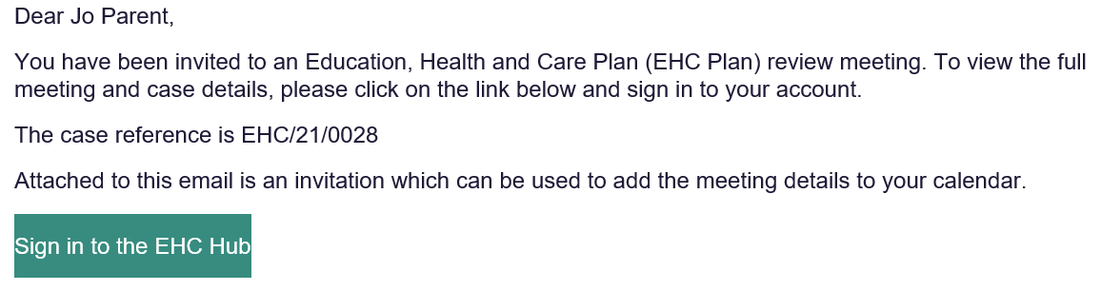
When you have your email, and sign into the HUB, the main screen will look like this:
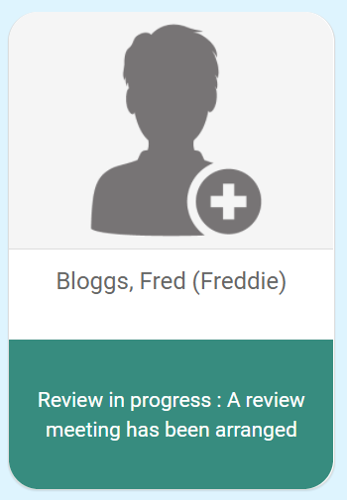
When you click on this, to view the details of the meeting, click on View the case summary on the left-hand side:
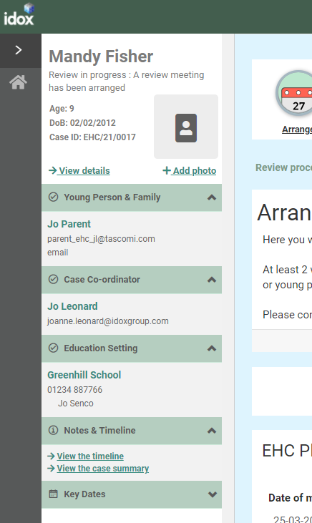
In the Review in progress section, click on Open review at the current stage.

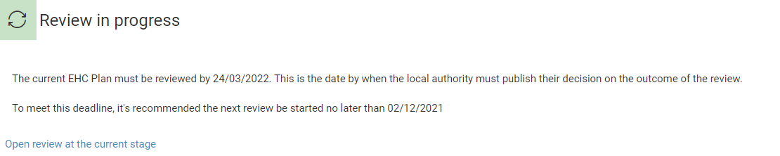

Details of the meeting will be displayed:
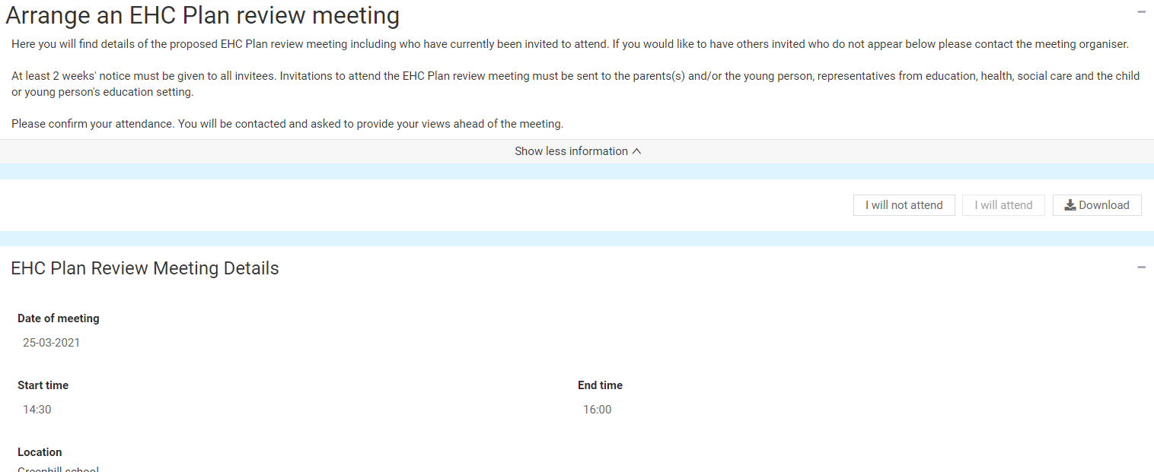
EHC Plan Review Meeting Details
This will show the date, time and location of the meeting:
People Invited to the Meeting
This will show all the people who have been invited to the meeting and if they have confirmed if they will attend or not:
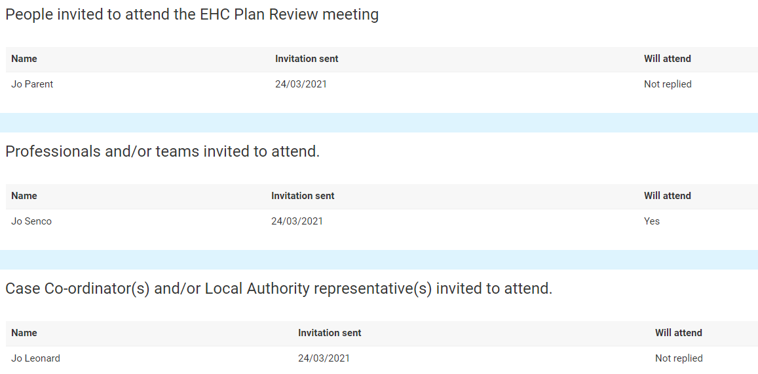
You will need to confirm if you will or will not be attending the meeting. To do this, click on view the Case Summary on the left-hand menu bar:

At the top of the screen, there will be two buttons:
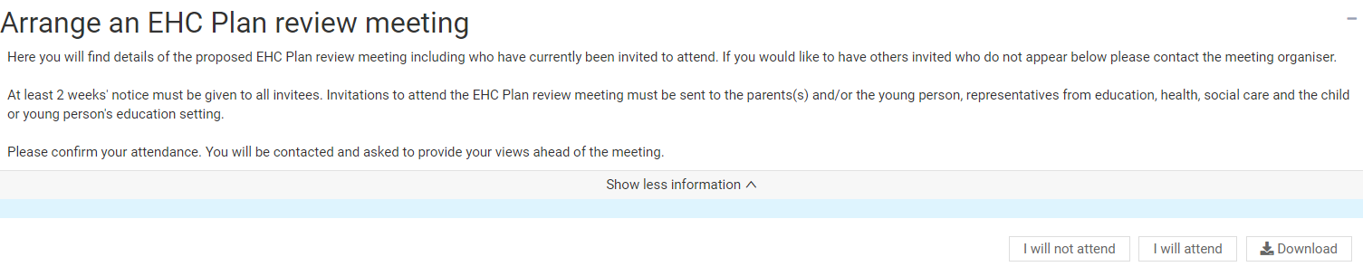
Click on the button to indicate if you will or will not attend the meeting.

Views on the Plans Progress and Outcomes
As part of the review, there will be a consultation as to if it is felt that progress is being made towards the outcomes set out in the Plan. Both you and the child or young person can put your views on this.

The Childs or Young Persons Views
The first section will be the views of the child or young person:
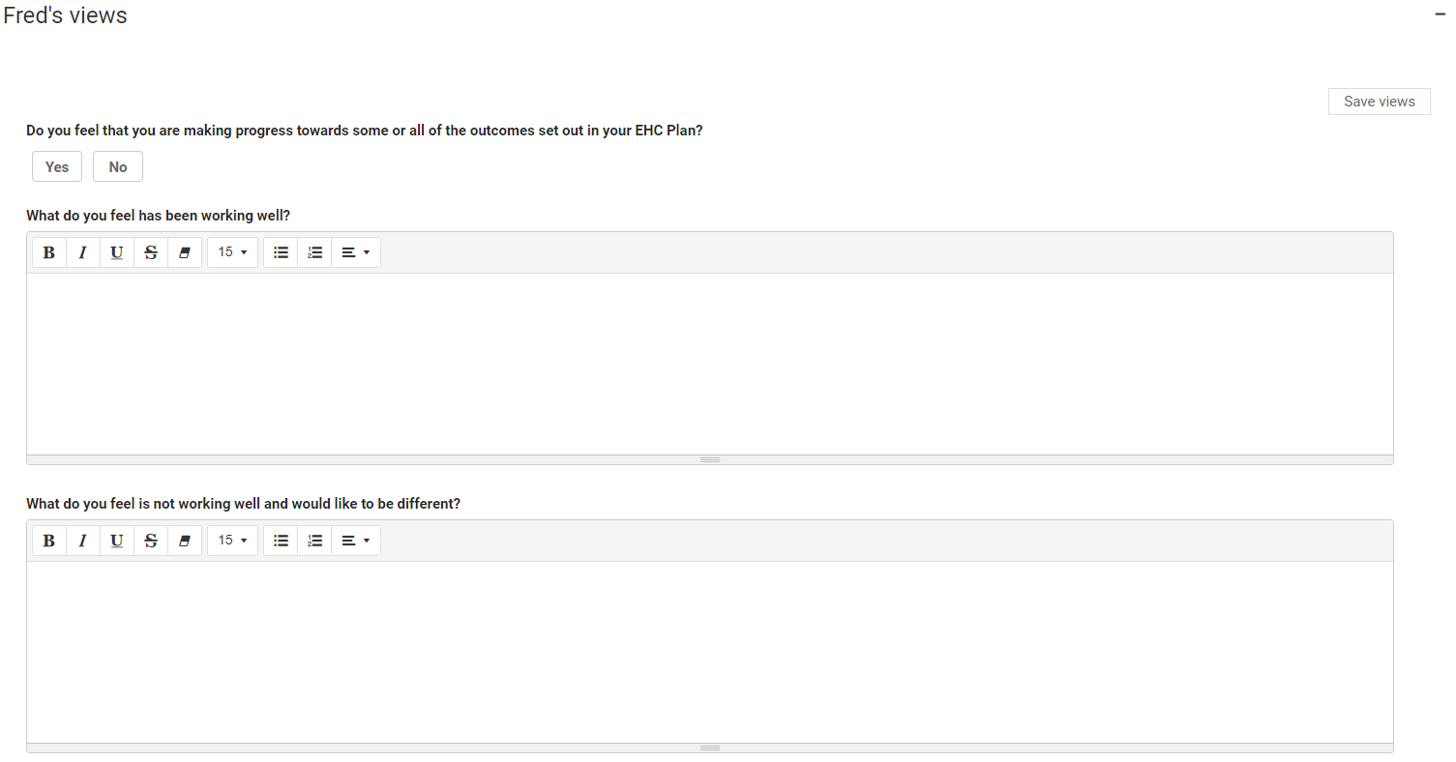
Click on the Yes or No button to indicate if you feel that progress is being made towards the outcomes in the EHC Plan.
To enter more information about what is and isn’t working well, left click anywhere in the boxes.
When you have entered your views, click on Save Views.
Any information previous entered during the assessment process can be viewed below this:
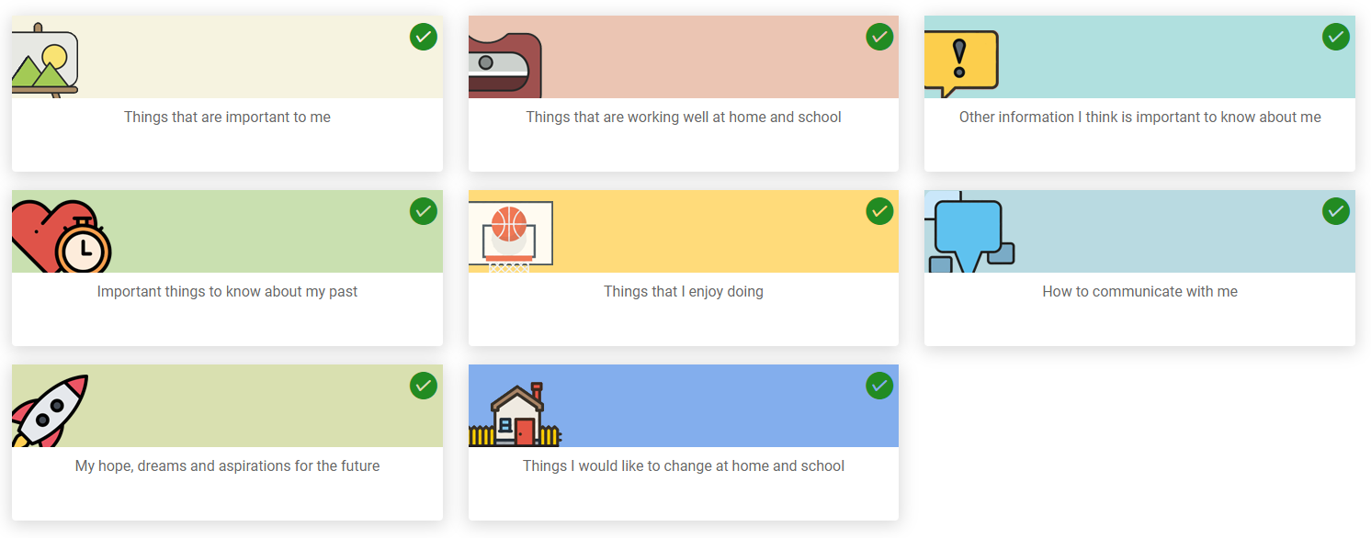
A green tick in the top right-hand corner of the section means information has previously been entered this section. To view that information, click on the tile and it will be displayed:
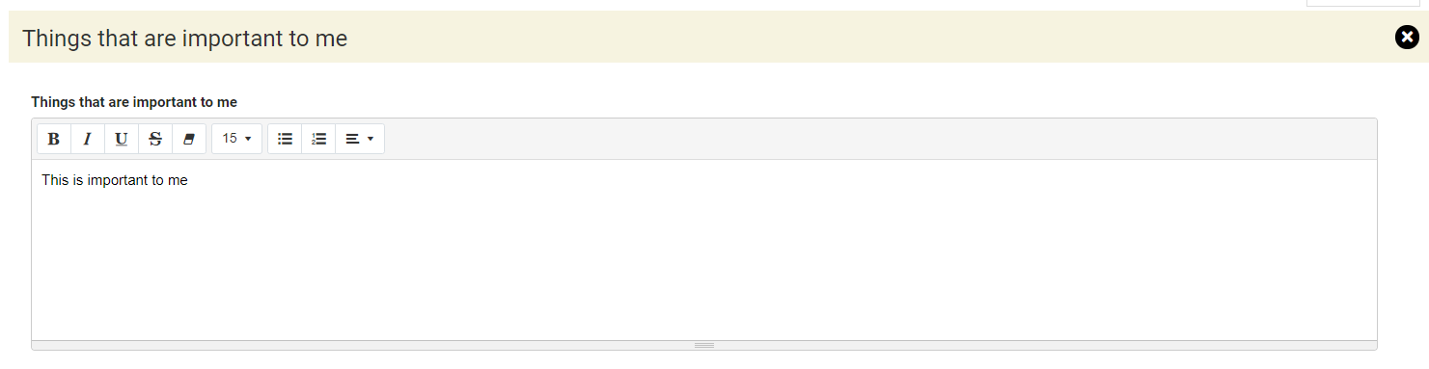

The Parent or Carer’s Views
The second section is for the Parent/Carer’s views:
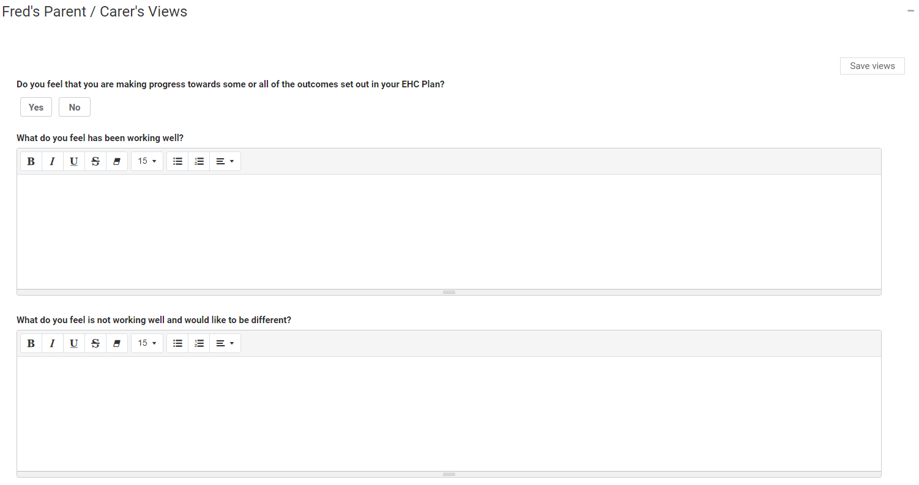
Click on the Yes or No button to indicate if you feel that progress is being made towards the outcomes in the EHC Plan.
To enter more information about what is and isn’t working well, left click anywhere in the boxes and start typing any information you want to enter here.
When you have entered your views, click on Save Views.

Any information previous entered during the assessment process can be viewed below this:
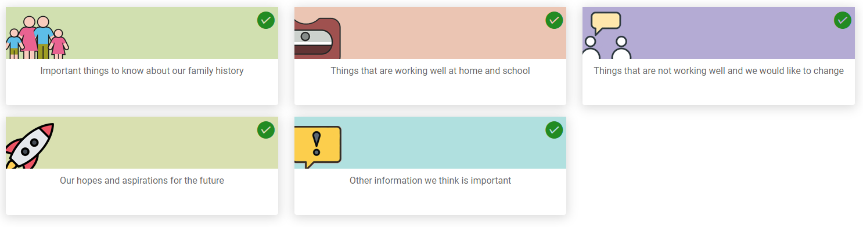
A green tick in the top right-hand corner of the section means information has previously been entered this section. To view that information, click on the tile and it will be displayed:
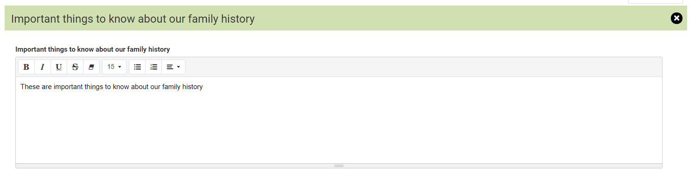

Requests for Information
At the bottom of the page, there is a section showing who else has been asked to provide their views on the progress towards outcomes of the EHC Care Plan:
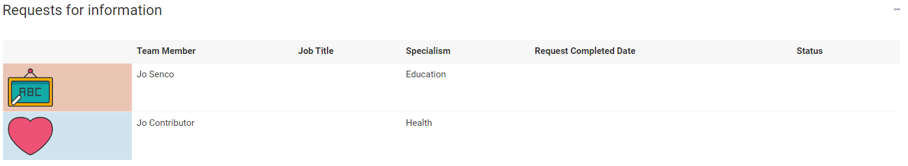
Once the response to the request for information has been received, the status will change to show this:
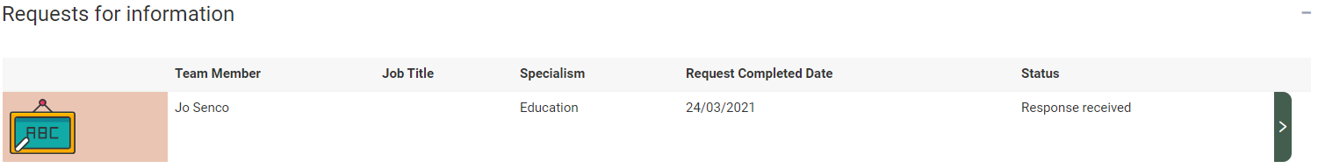
To view the response, click on the Green right pointing arrow and the Request for information screen will be displayed, with the information entered by the person it was requested from.
Where an advice area has been commented on, they will be displayed with a green tick and a green arrow on the right:
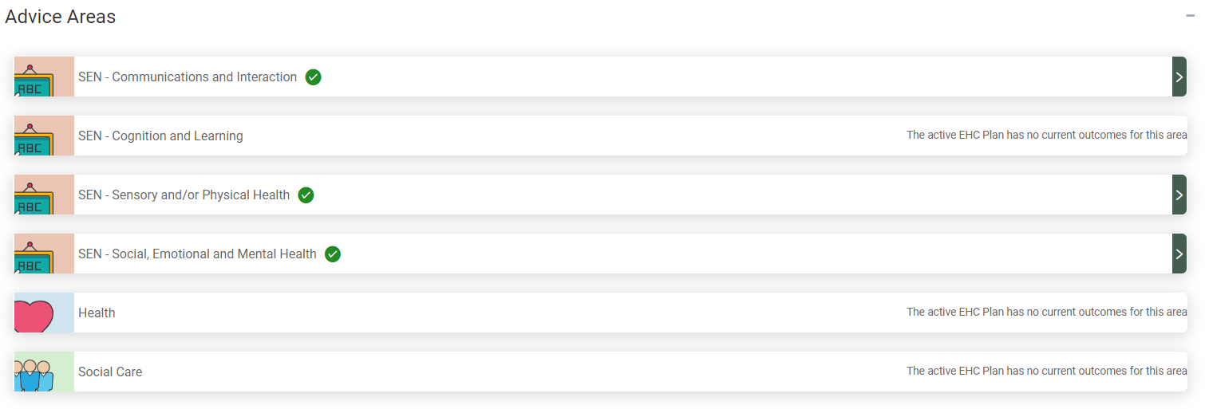
Click on the green arrow and scroll down to view the information entered. Comments will have been made as to if any changes are needed to the outcome or any additional short-term targets needed, as well any changed needed to the Special educational needs provision:
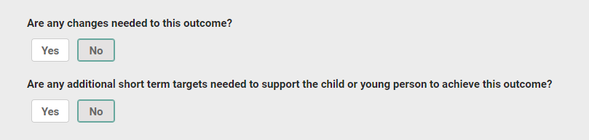
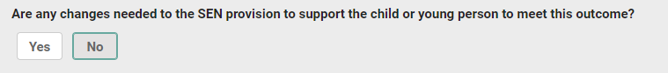
Click on the X to close the section and view another section:
. There is also a section displaying any documents that have been uploaded:
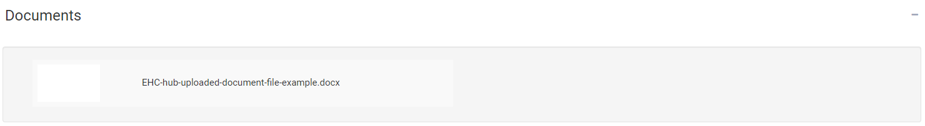
To view these documents, click on the white square and the document will show as a download in the bottom left-hand corner of the screen:
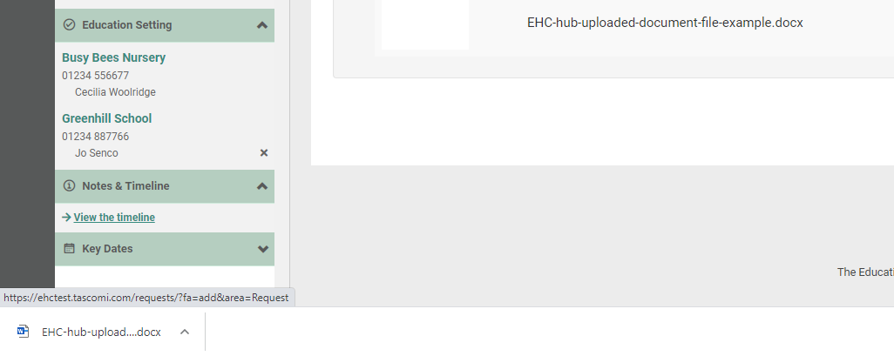
Left click on this to open it and view the information.

Confirming Attendance for the meeting
You will need to confirm if you will or will not be attending the meeting. To do this, click on view the Case Summary on the left-hand menu bar:

At the top of the screen, there will be two buttons:
Click on the button to indicate if you will or will not attend the meeting.
As previously discussed, details of the meeting will be displayed below this
EHC Plan Review Meeting Details
This will show the date, time and location of the meeting:
People Invited to the Meeting
This will show all the people who have been invited to the meeting and if they have confirmed if they will attend or not:

EHC Plan Review Meeting
When the meeting has taken place, a record will be created of who was invited, who attendance and when the meeting took place. The details of the discussions held at the meeting and any recommendations made will be displayed in the next section, the Report on the review.
When the meeting record has been created, when you log into the Hub, the status will look like this:
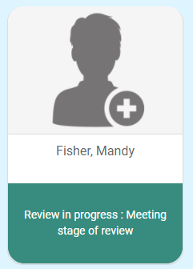
When you click on this, the status will be displayed like this:
This has 5 sections

EHC Plan Review Meeting Details
This will show the date, start time and end time and Location of the meeting.

Record of people who were invited and attended
This will show who was invited and if they attended.

Other Attendees
This will show a list of people who were not originally invited to attend ahead of the meeting, but were in attendance

Additional Meeting Information
This will show any specific information about the meeting, like if apologies had been received or new information was brought to the meeting.
The details of the actual plan review discussion will be shown in the review report in the next section.

Meeting Documents
Any supporting documents from the EHC review meeting will be attached here and can be viewed.

EHC Plan Review Meeting: Draft Report
When the report on the plan review meeting is being compiled, when you log into the Hub it will look like this:
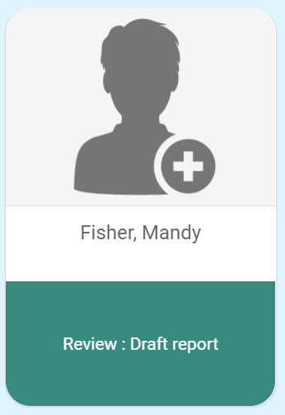
When you view the case, a message will be displayed to say that it is being drafted:
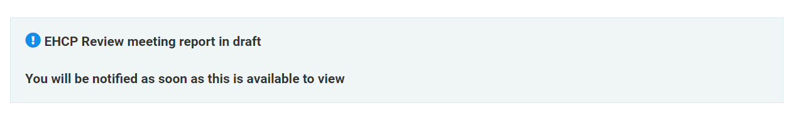
When the report is complete, it will be submitted to the local authority to consider the information provided and decide on whether the current EHC Plan needs to be amended, ceased or maintained.
If you log into the hub, during this time, the status will look like this:
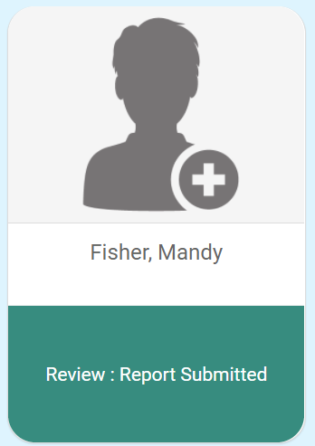
When you view the case, there will be a message to say this:
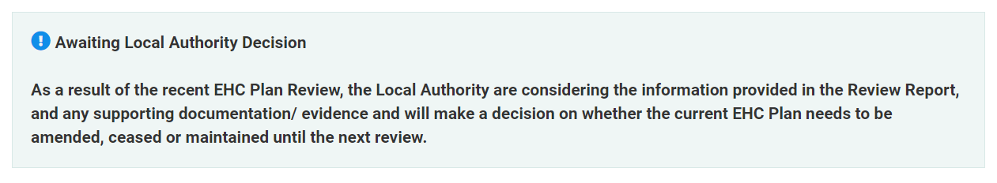
When the decision has been made about the next stage of the process, you will receive an email telling you the decision has been made and asking you to sign into the hub. This should be within four weeks of the meeting taking place:
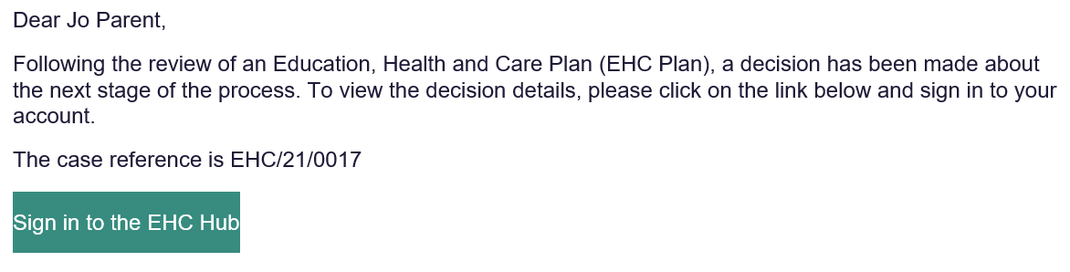

EHC Plan Review Meeting Report
When you log into the hub and click on the case file, the EHC Case Summary Page will be displayed. The contents of the page displayed will vary dependent on the outcome of the review.

Viewing the EHC Plan Review Meeting Report
Under the Completed reviews section, click on view pathway:
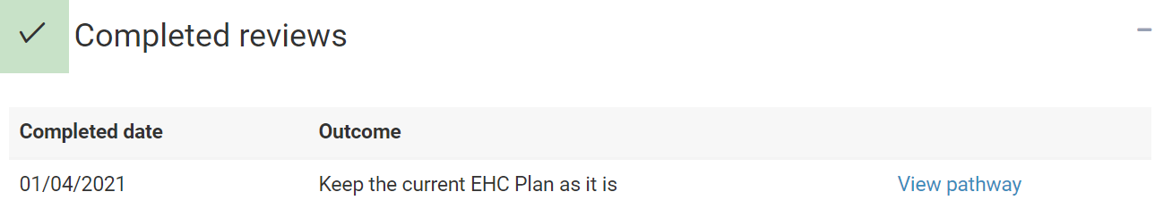
To view the Report, click on Report at the top of the screen:
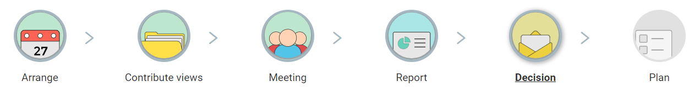

The following screen will appear:
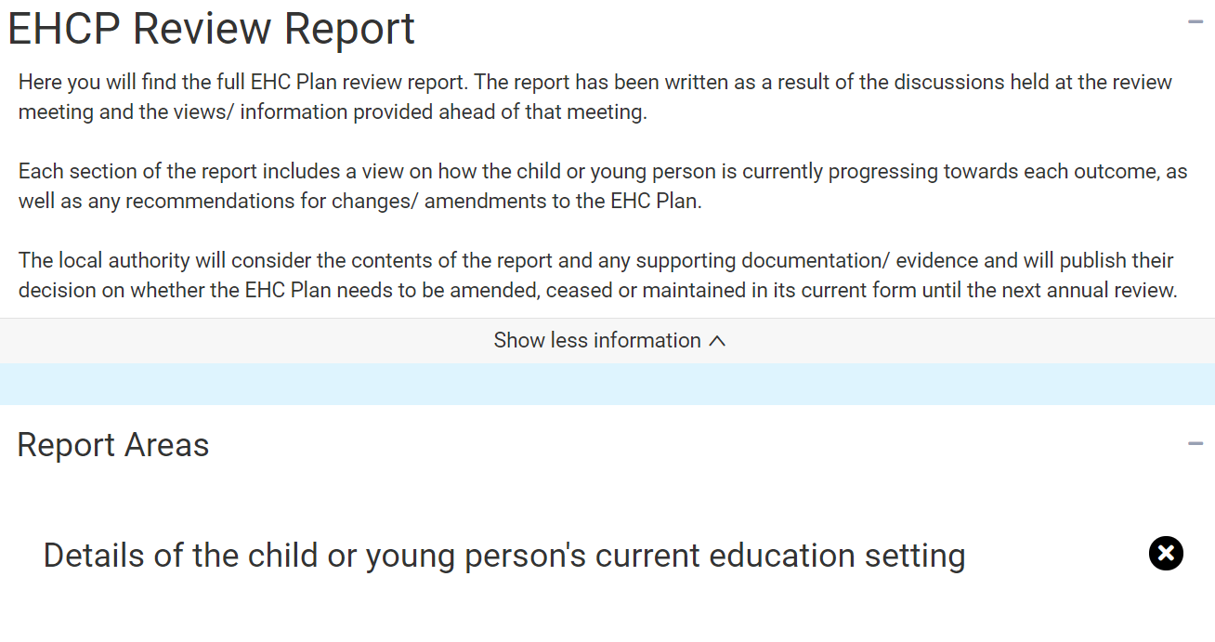
At the top of the screen will be information about the report.
Below that are listed the Report Areas:
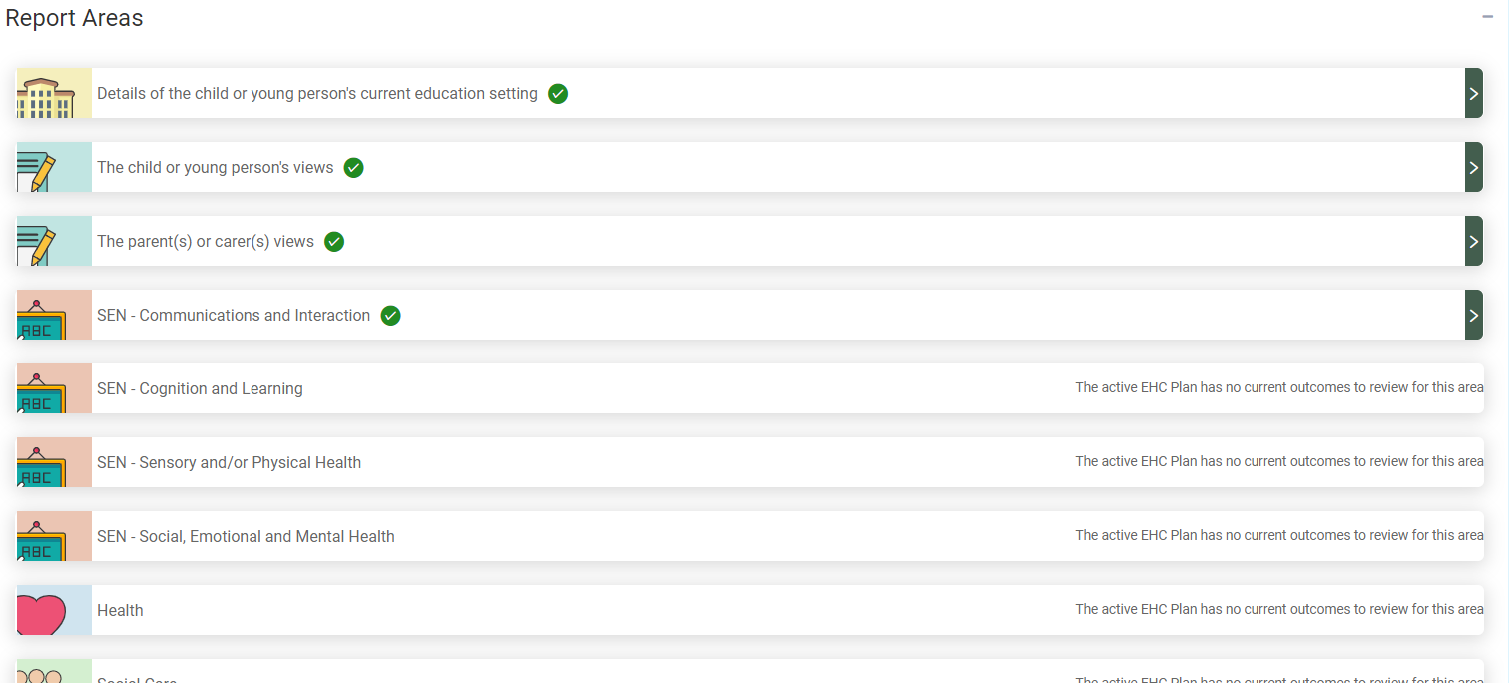

To view the details of that area, click on the Green arrow on the right. The section will then be shown in more detail:
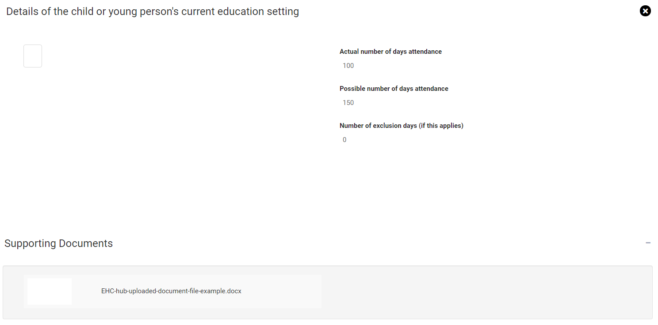
Click on the X to close that section and view another section.

Outcome of a Review
Once the review has taken place, there are three potential outcomes.
- The local authority decides to make no changes to the plan and must be reviewed again within 12 months.
- The local authority decides to amend the plan based on recommendations in the review.
- The local authority decides to cease to maintain the plan. The plan will be removed based on recommendations in the review. If the plan is ceased to be maintained, you will still be able to access all of the historical information on the EHC Hub.

