EDUCATION, HEALTH AND caRE hUB
Guide 7 for parents – EHC Plan REview
APRIL 2022

EHC Plan Review
Once a plan has been finalised, it must be reviewed annually. Information about the review date will be displayed when you log into the Hub and view the case.
You will receive an email with the details of the review meeting when it has been arranged. This is usually done by the SENCo within the education setting.
In the meantime, when you log in, the case status will be displayed like this:
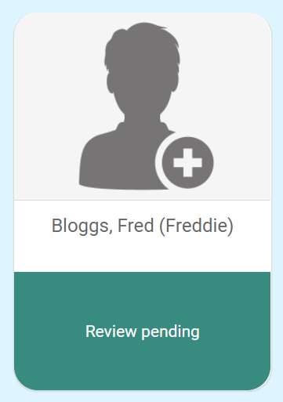
When you click on this, you will be taken to the EHC Case Summary page:

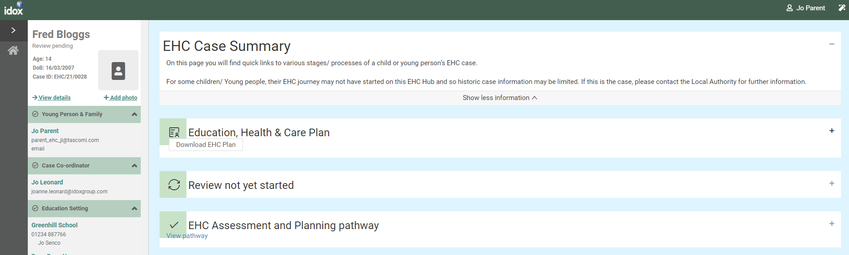

EHC Case Summary Page
This includes sections of information for the history of activity on the EHC Hub.
Education, Health and Care Plan
Click on the Plus to open this section:
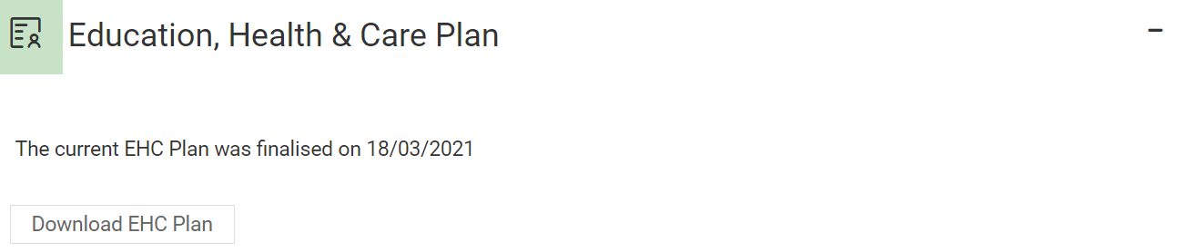
This will display when the current plan was finalised. You can also download a copy of the plan if required by clicking on the Download EHC Plan button. The download will appear in the bottom left-hand corner of the screen:
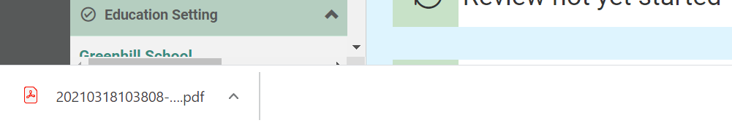
Review not yet started
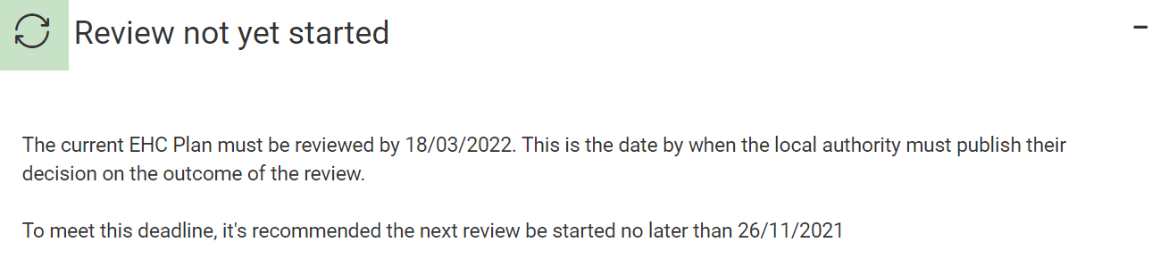
This will tell you when the plan is due to be reviewed.
EHC Assessment and Planning Pathway
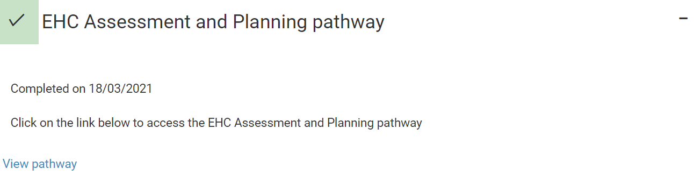
This will tell when the assessment and planning pathway was completed. To view the pathway, click on View Pathway.
This will take you to the pathway page where you can view the information entered previously on the pathway to the Plan:
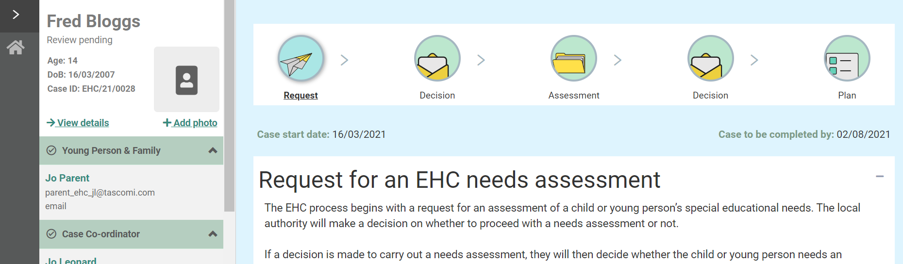
Click on any of the status buttons at the top of the screen to view the information.

