EDUCATION, HEALTH AND caRE hUB
Guide 6 for parents – how to comment on a draft plan
APRIL 2022

How to Comment on a Draft Plan
When the draft plan is ready, it will be shared. When it has been shared, you will get an email to say that it is available to view:
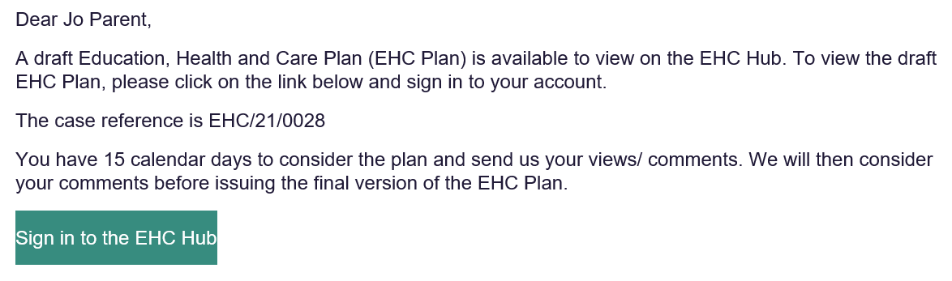
The draft plan will show the advice that has been submitted by any of the professionals who were asked for advice as well as the planned outcomes and provisions.
If the draft plan is ready to be viewed, the screen underneath the information section will look like this, showing when the Draft was shared:
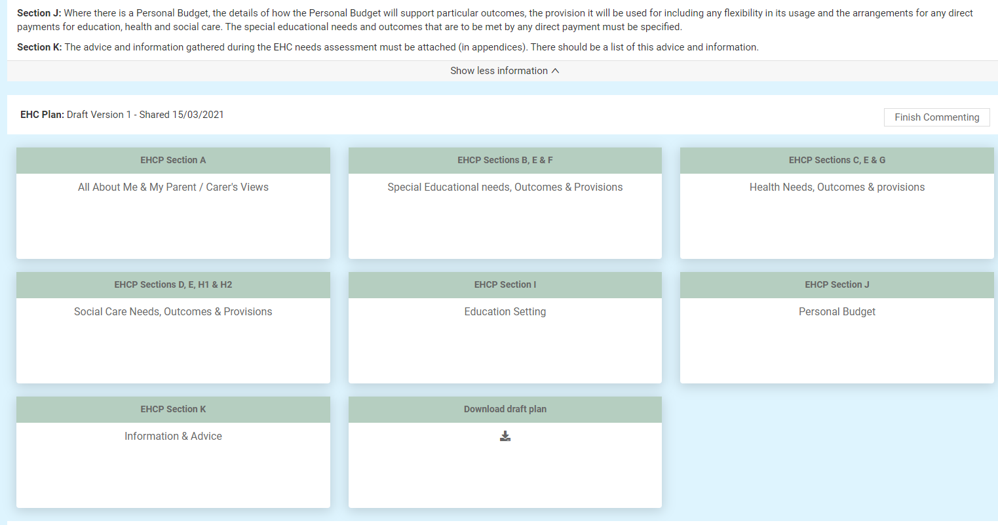
Each of the sections make up part of the Plan. To view more information on each section, left click on that section.
You will be able to comment on the whole section, any parts of the section and any outcomes or provisions in that section.
Each section may have multiple parts to it.
When you click on a EHCP section, the different parts of that section will be displayed with a brown heading:
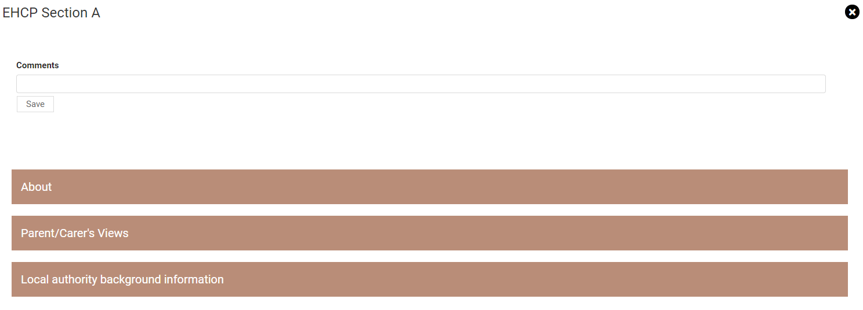
Left click on each of the part headings to view any information that has been entered
If a section is not applicable (for example, the child or young person does not have extra Health Needs) it will look like this:
(It is still possible to add a comment to this section if required.)
It is important to scroll up and down the screen to make sure you can see all the information that has been added to the plan. Left click on the scroll bar on the right-hand side of the screen to move up and down on the screen.
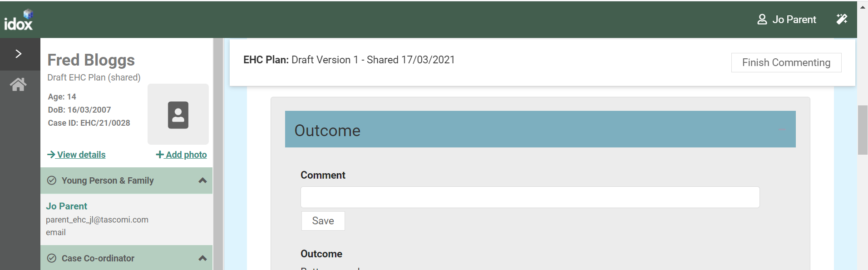
Click on the X to return to the main screen:

Adding a comment to a Section
To add a comment to section, left click on that section
Each section will have a comments box for you to enter your comments on the information in the plan:
When you have entered your comment, click on Save to save the comment. This will be a draft and no one will see them until you click on Finish Commenting to submit your comments.

Adding a comment to an Outcome or Provision in a Section
Scroll to that part of the section. To enter a comment on the outcomes and provisions of any part of the plan, that section will display a comment field for you to complete:
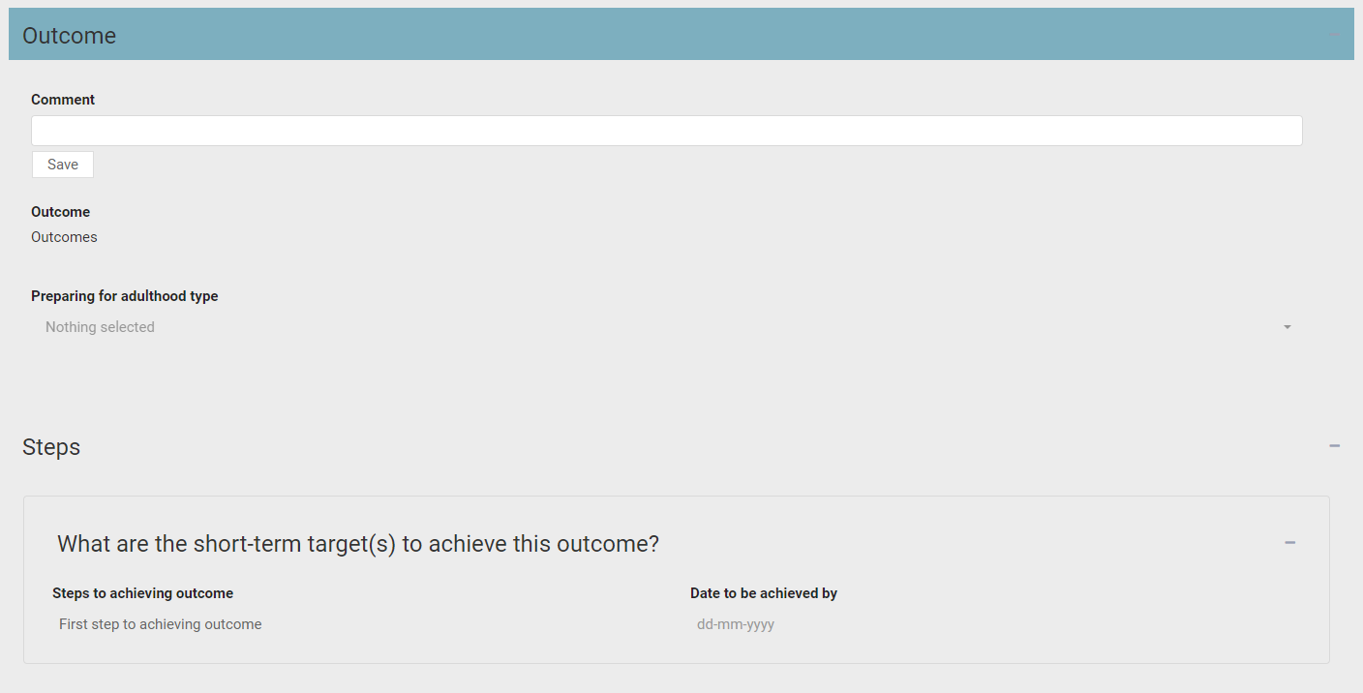
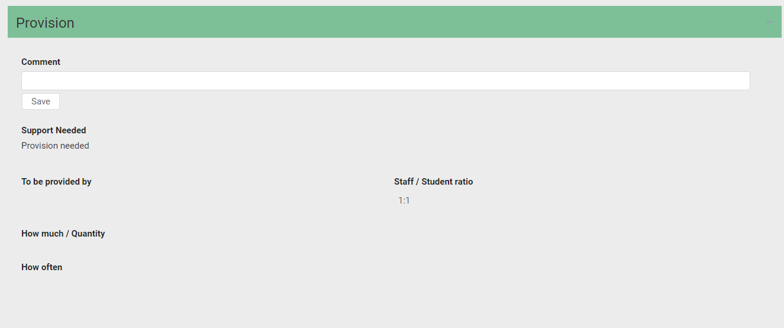
You can type as much information as required in this field. It will all be included, even if it can’t be viewed in this field in one go. When you have entered the comment, click on Save to save your comment.
Then click on the X to return to the main screen.

EHCP Section A – Left click on this to display the previous information entered by the Parent/Carer and /or young person during the contribution to the assessment stage.
This has three parts:

About

Parent/Carer’s Views

Local authority background information
EHCP Sections B, E and F – Left click on this to display information about Special Educational needs, Outcomes and Provisions.
This has four parts:

Cognition and Learning

Communication and Interaction

Social, Emotional and Mental Health

Sensory and/or Physical needs
You can enter comments here about the planned outcome and the planned provision.
EHCP Sections C, E and G – Left click on this to display information about Health Needs, Outcomes and Provisions which relate to the special educational needs of the child or young person.
You can enter comments here about the planned outcome and the planned provision.
EHCP Sections D,E,H1 and H2 – Left click on this to display information about Social Care Needs, Outcomes and Provisions which relate to the special educational needs of the child or young person.
You can enter comments here about the planned outcome and planned provision.
EHCP Section I – Left click on this to display information about the Education Setting. This information is not populated at this draft plan stage. The settings will be recorded in the Final EHC Plan. You can enter information in the comment box as part of the consultation to name your preferred education setting.
EHCP Section J – Left click on this to display any information about the personal budget. This has two parts:

Personal Budget

Annual Cost of Support
Contact the case co-ordinator if you would like to discuss personal budgets or are not sure whether this applies.
EHCP Information and Advice – Left click on this to display any information and advice provided by professionals during the assessment process.
This has 2 parts

Monitoring and review

Progress towards outcomes specified in this plan will be monitored by
It also has a section on Advice Contributions. To view any advice contributions that have been made, click on view:
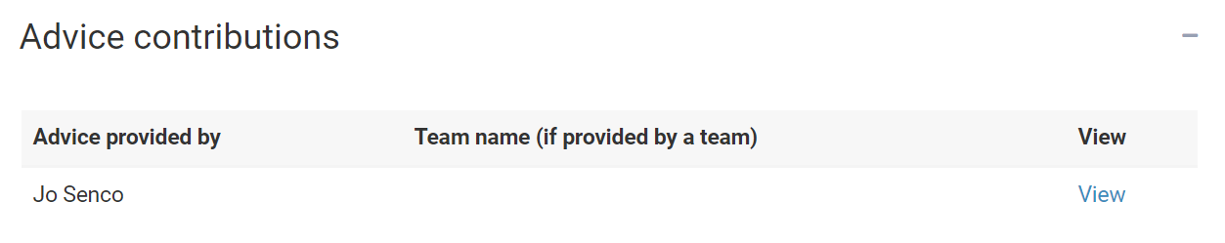
You will then be able to view the information. When you have finished looking at this information, click on close:
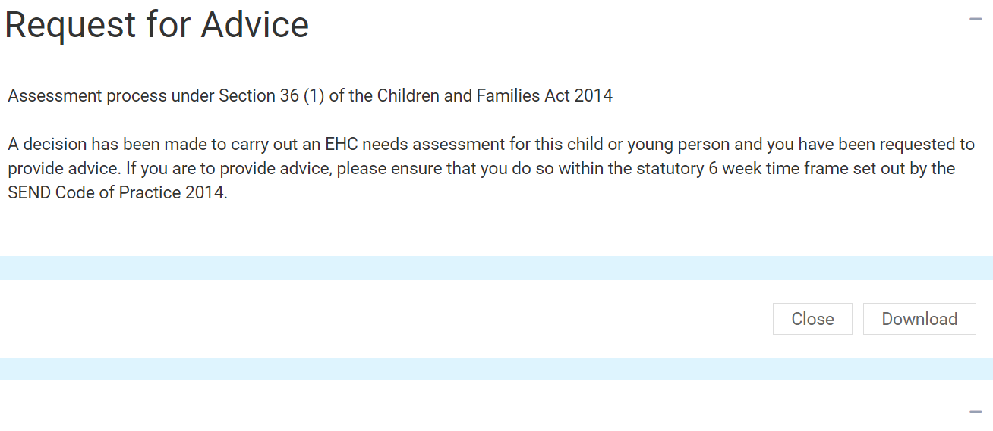
Left click on Plan at the top of the screen to return to the draft plan:
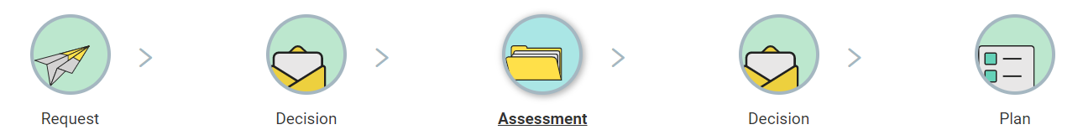

How to finish commenting on a draft plan
When you have added all of your comments and you are ready to submit them, click on Finish Commenting:
Any comments you add will not be visible to other people until you click on Finish Commenting. At that point they will be added to the plan and other people with access to the case will be able to read them. Even if you have no comments, this will tell the Case Coordinator that you have finished looking at the document and have no comment to make.

Downloading a Draft Plan
If you wish to download the draft plan as a PDF file. Click on Download Draft Plan:
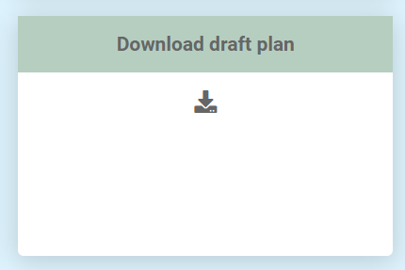
The downloaded plan will then show in the bottom left-hand corner of the screen:
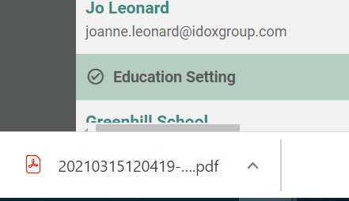
Left click on this to view the contents of the PDF file. This can be saved to your own device, if required.

EHC Plan Consultations
At the bottom of the plan, there will be list of the Parent/Guardians/Carers or young people that have been consulted about this draft plan, as well as Education Settings consultations:
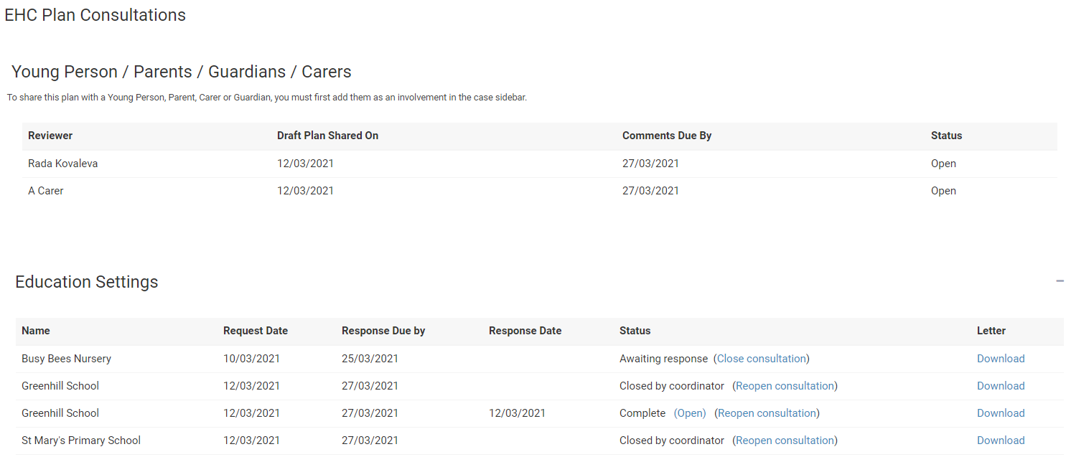
It will list all Parent/Guardians/Carers or young people who have been asked to review the plan, when the draft plan was shared with them and when they need to comment by. It will also have the status of the comments process. If this says Open, then that person is still in the process of adding comments. Once you have click on Finish Commenting the status will change to show Completed:
Under the educational settings, it will show all educational settings that have been consulted and the status of that consultation. To view the letter the educational setting was sent as part of the consultation, click on Download in the letter column:

The downloaded letter will then show in the bottom left-hand corner of the screen:
Left click on this to view the contents of the PDF file. This can be saved to your own device, if required.

As a final piece of advice, parents have previously asked when there is a new plan and the first draft is then issued, how can they see the amendments. With the formatting on the Hub, it is possible to use strike through/bold to highlight changes. Also, it is possible to click on the arrow toggle to see the original draft and all the comments, as the history still stays on the Hub. In addition, some parents may wish to print out the different draft versions, so that they can compare them side by side, in order to see the changes

