EDUCATION, HEALTH AND caRE hUB
Guide 5 for parents – how to contribute to an assessment
APRIL 2022

How to contribute to an assessment
When the decision has been made as to if an EHC needs assessment for a child or young person will be carried out, you will receive an email telling you this and asking you to access the hub to view the details. The email will look something like this:
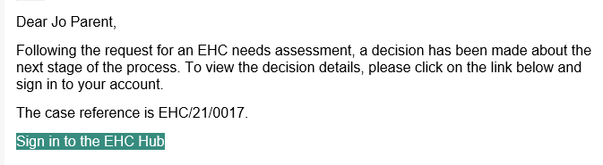
When you sign into the Hub, the welcome screen will look like this, with the status of the case shown below:
Or
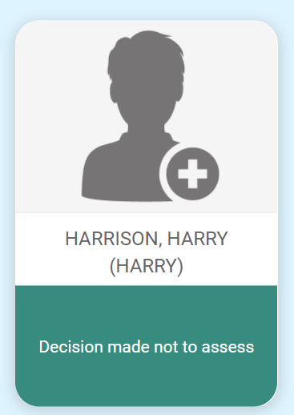
If the decision has been taken not to proceed with an EHC Needs Assessment, the reason for the decision will be displayed, and it will be possible to view a letter with details about the decision:
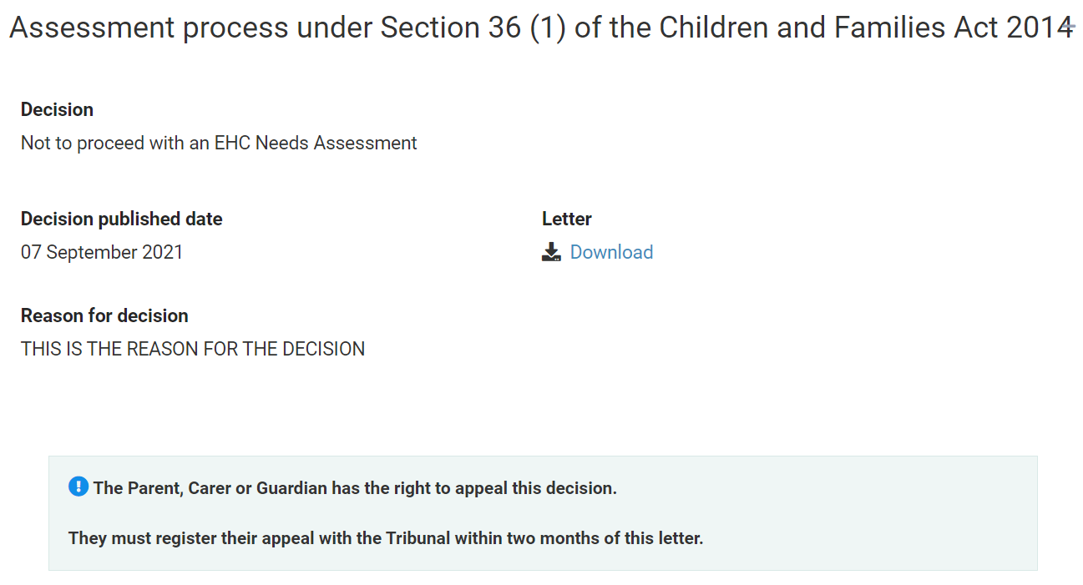
To view the letter, click on Download and click on the file in the bottom left hand corner of the screen
If the decision has been taken to proceed with an EHC needs assessment, when you click on the Assessment, you will be provided with information about the EHC needs assessment process, including a link to a website that will provide more information about the different sections of the Plan:
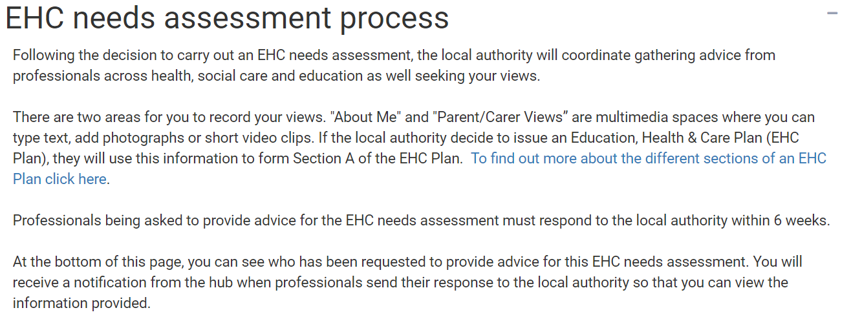
There are two sections for you to contribute to the EHC needs assessment. These are About and Parent Carer views.

About
The section is all about what is important to the child or young person. If it is possible, the information should be completed by the child or young person the assessment is for. If this child cannot complete it independently, and it is being filled in by someone else, it is important that this indicated in each section. If the local authority decide to issue a EHC Plan after the assessment is complete, content from these sections will be included.
There are 8 sections to be completed. Left click on each section to enter information:
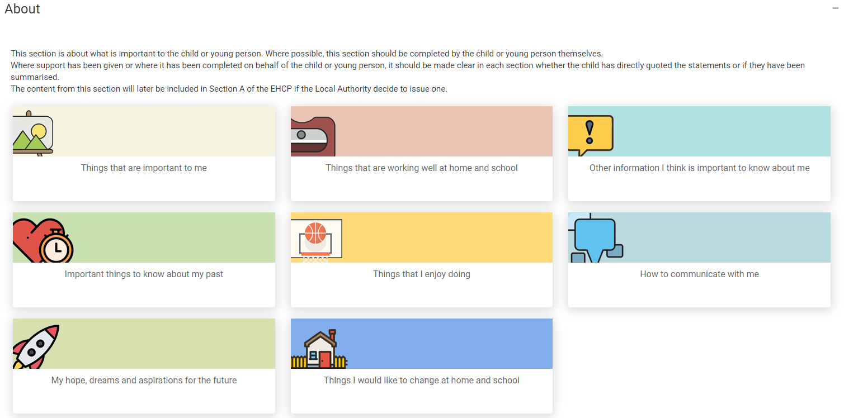
When you click on one of the options, a page will be displayed allowing information to be typed in:
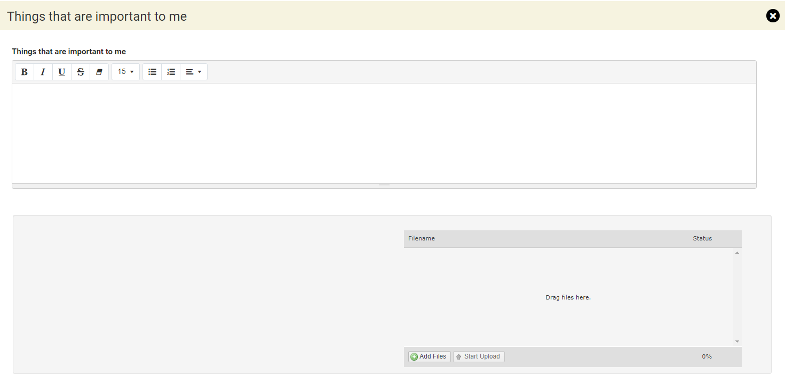
Underneath, there is also a section to add files if you wish. These could be files like documents, photos or short video clips. Click on the Add Files button and navigate to the file wherever you have it saved on your device:
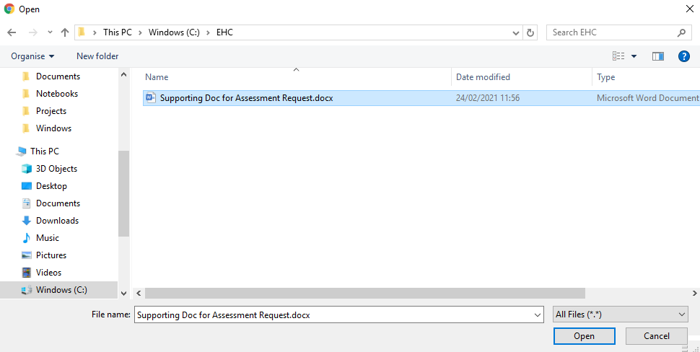
Click on Open and the file will be uploaded. The uploaded file will be displayed:
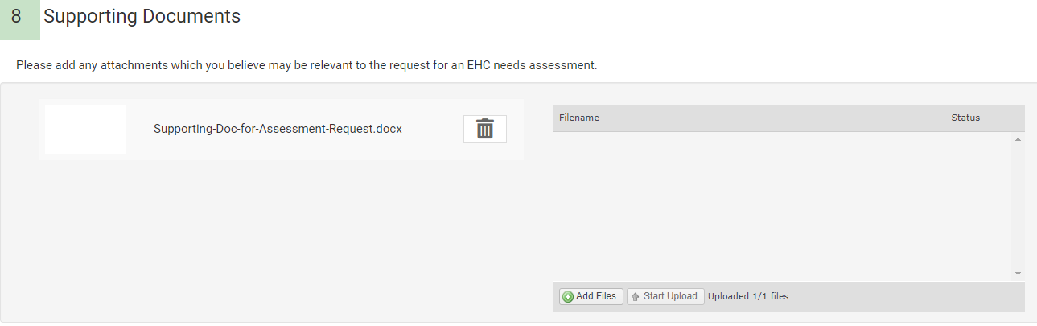
When you have completed the information, you need to save it before moving on to the next section. Click on Save Section to save the information:
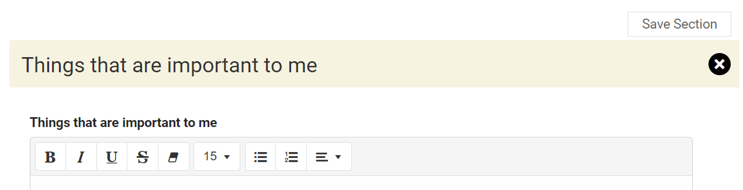
Once you have completed the information and saved it, you can access the next section. At the bottom of the section being completed, below the upload file area, there will be an arrow to the next section to be completed:
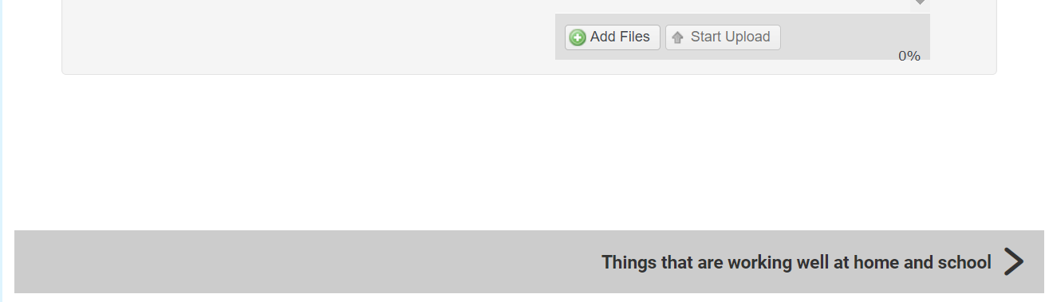
This will change depending on where you are in the record:
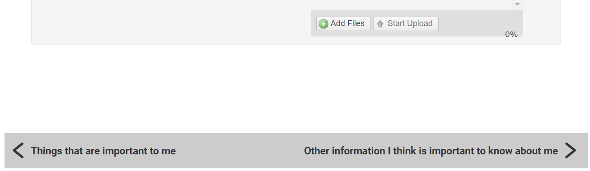
Alternatively, you can click on X and you will be taken back to the main page to choose which section you want to complete next:
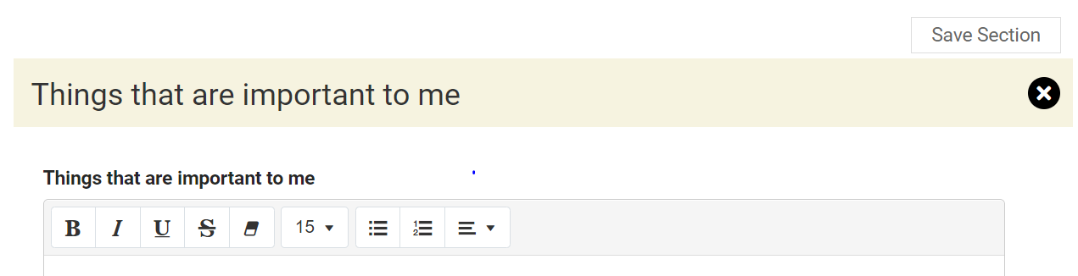
The sections to be completed are:

Things that are important to me

Things that are working well at home and school

Other information I think is important to know about me

Important things to know about my past

Things that I enjoy doing

How to communicate with me

My hopes, dreams and aspirations for the future

Things I would like to change at home and school

Parent Carer’s Views
This section is for the Parent or Carer of the child or young person to give their views:
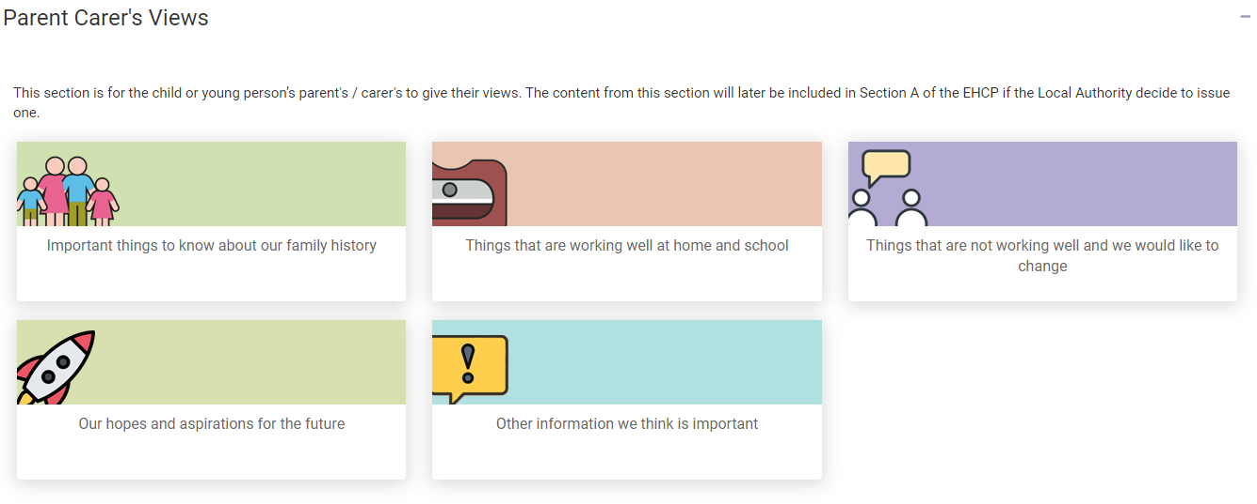
There are 5 sections to be completed.
When you click on one of the options, a page will be displayed allowing information to be typed in:
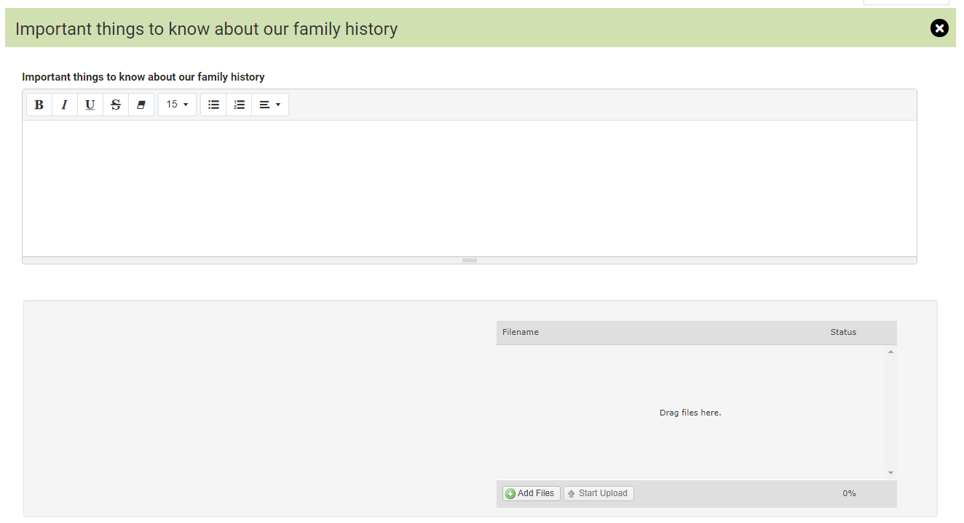
Underneath, there is also a section add files if you wish. These could be files like documents, photos or short video clips. Click on the Add Files button:
You will then need to navigate to the file wherever you have it saved on your Device:
Click on Open and the file will be uploaded. The uploaded file will be displayed:
When you have completed the information, you need to save it before moving on to the next section. Click on Save Section to save the information:
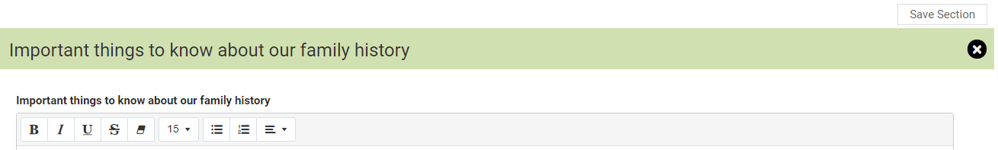
Once you have completed the information and saved it, you can access the next section. At the bottom of the section being completed, below the upload file area, there will be an arrow to the next section to be completed:
This will change depending on where you are in the record:
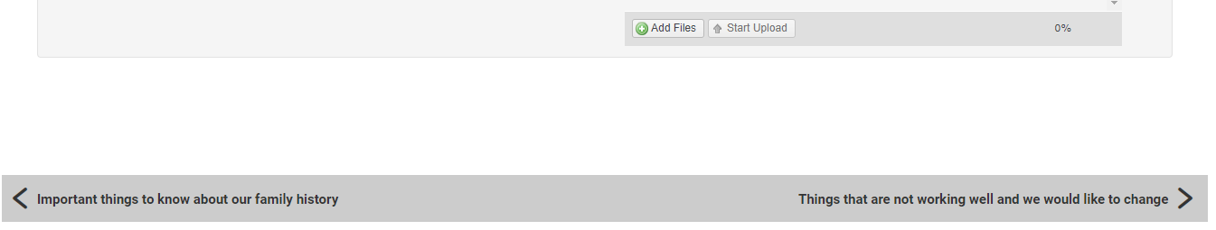
Alternatively, you can click on X and you will be taken back to the main page to choose which section you want to complete next:
The sections to be completed are:

Important things to know about our family history

Things that are working well at home and school

Things that are not working well and we would like to change

Our hopes and aspirations for the future

Other information we think is important
These are the two areas where you can contribute to the assessment.

Requests for advice
There is also a section showing who else has been asked to provide information for the assessment. When the professionals send their response to the local authority, you will get a notification email from the hub so that you can view the information provided:
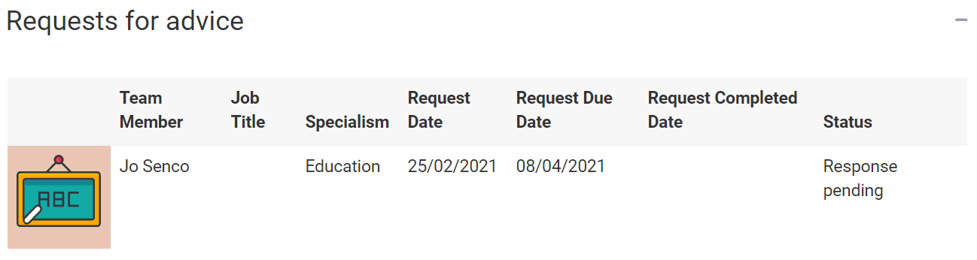
There are a number of people that might be asked to contribute to the assessment. These include:

Education professionals for education advice

Health Care professionals for medical advice

Education psychologists for psychological advice

Social Care advice

Any other person the local authority thinks is appropriate.
It is also possible for you to ask the case co-ordinator to request advice from a particular person if the local authority hasn’t done so already. A parent, carer, guardian or young person can ask the local authority to request advice from anyone working in education, health or social care as long as it is reasonable to do so. The case co-ordinator’s contact details are shown in the case sidebar.
Once the response to the request for advice has been received, the status will change to show this:
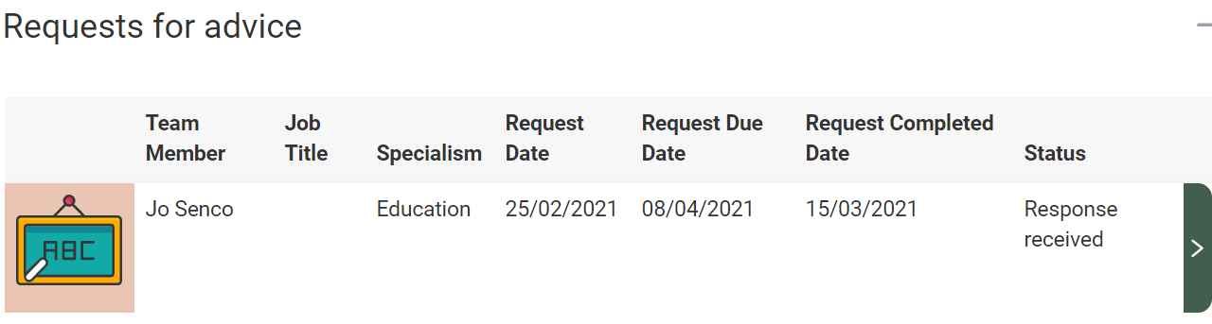
To view the response, click on the Green right pointing arrow and the Request for advice screen will be displayed, with the information entered by the person who the advice was requested from.
You can scroll up and down the screen to view the information entered, using the scroll bar on the right:
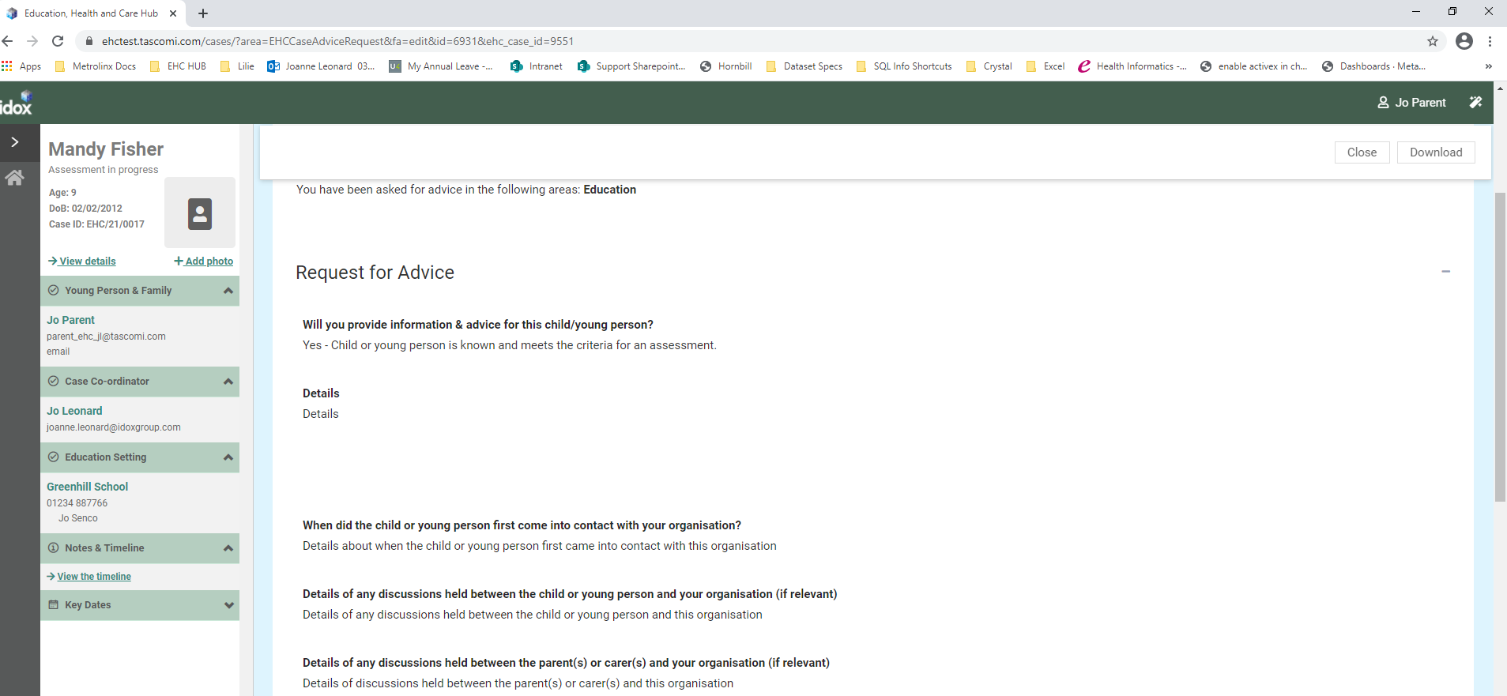
If further sections have been completed, they will be displayed with a green tick and a green arrow on the right:
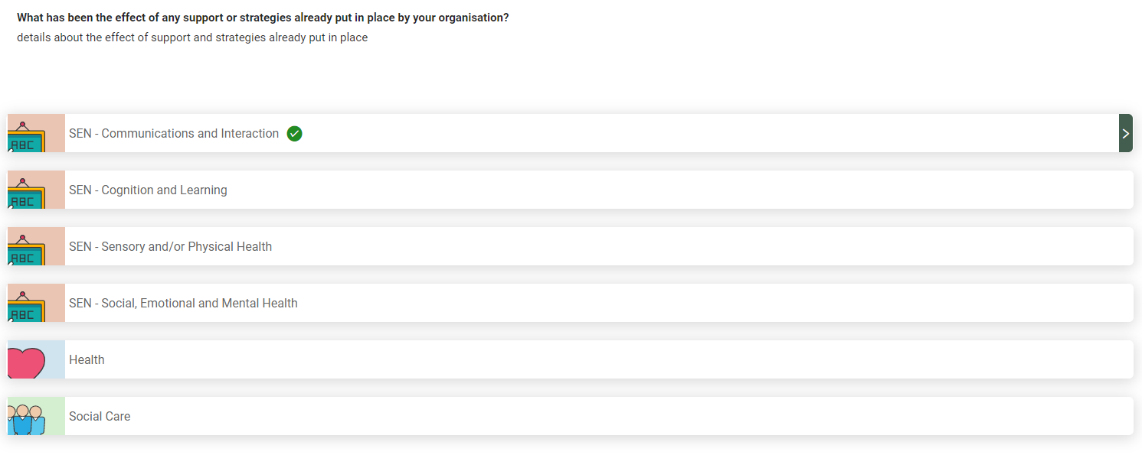
Click on the green arrow to view the information entered:
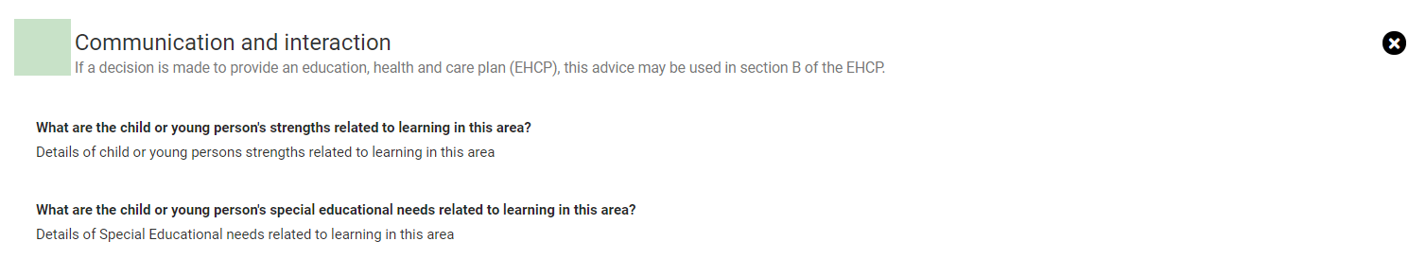
Click on the X to close the section and view another section. There is also a section displaying any documents that have been uploaded:
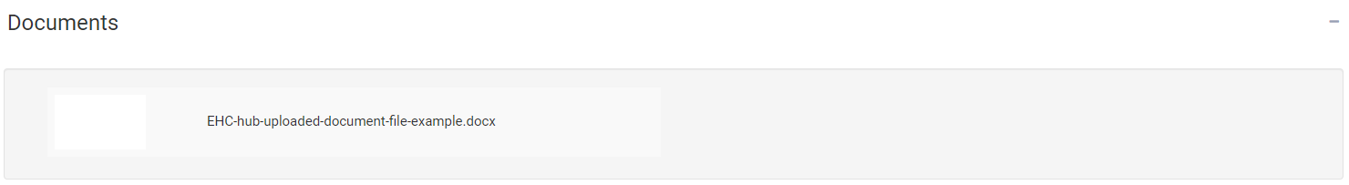
To view these documents, click on the white square and the document will show as a download in the bottom left-hand corner of the screen (the actual location of the downloaded document will be dependent on the web browser that you are using):
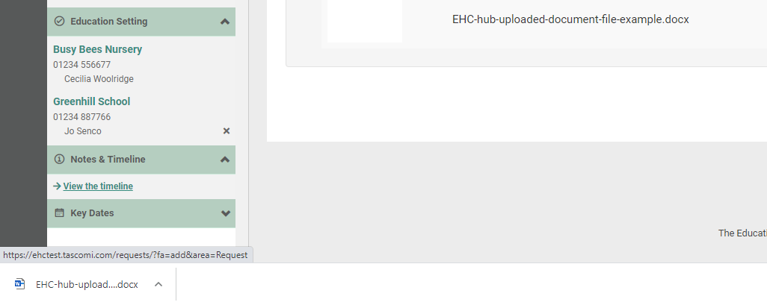
Left click on this to open it and view the information.
Once all of the information has been gathered together, the assessment can take place and the decision made about if an EHC Plan will be issued. A decision to issue a plan must be made within 16 weeks of the case start date. To view important dates, click on Key Dates at the bottom of the menu bar on the left:
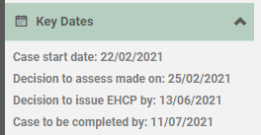
The case start date is the date the request for an EHC needs assessment was made. The dates will show when something happened or when it is due to happen.
When the decision has been made to issue a plan or not, you will receive an email telling you that there is new information on the Hub for you to view. The email will look something like this:
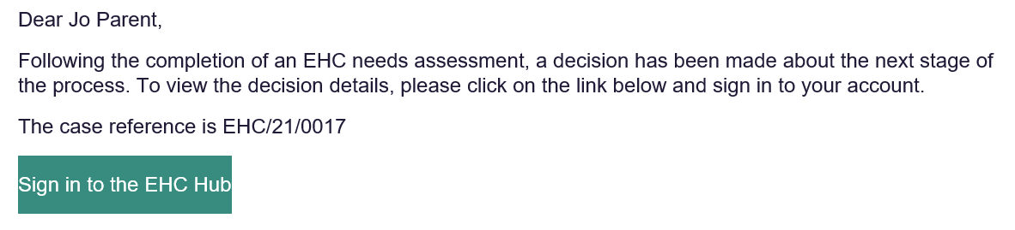
You will need to sign into the Hub to view the result of the decision.
If a decision has been made to issue an EHC Plan, a draft plan will be published as soon as possible. You will be asked to comment on this draft plan within 15 calendar days and when these comments have been submitted, the draft plan can be updated before a final plan is made.
When you log in to the Hub, the status will show like this:
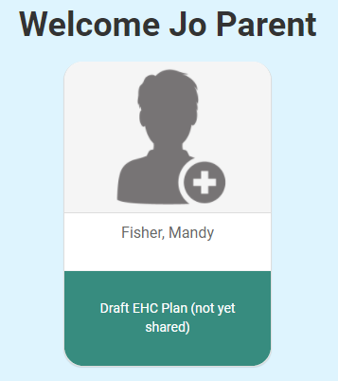
Or
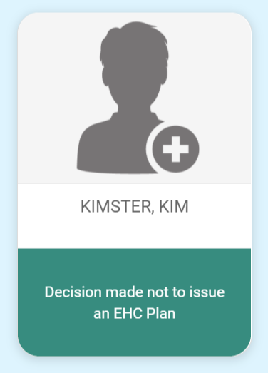
If the decision has been made to not issue an EHC Plan, the following information will be displayed:
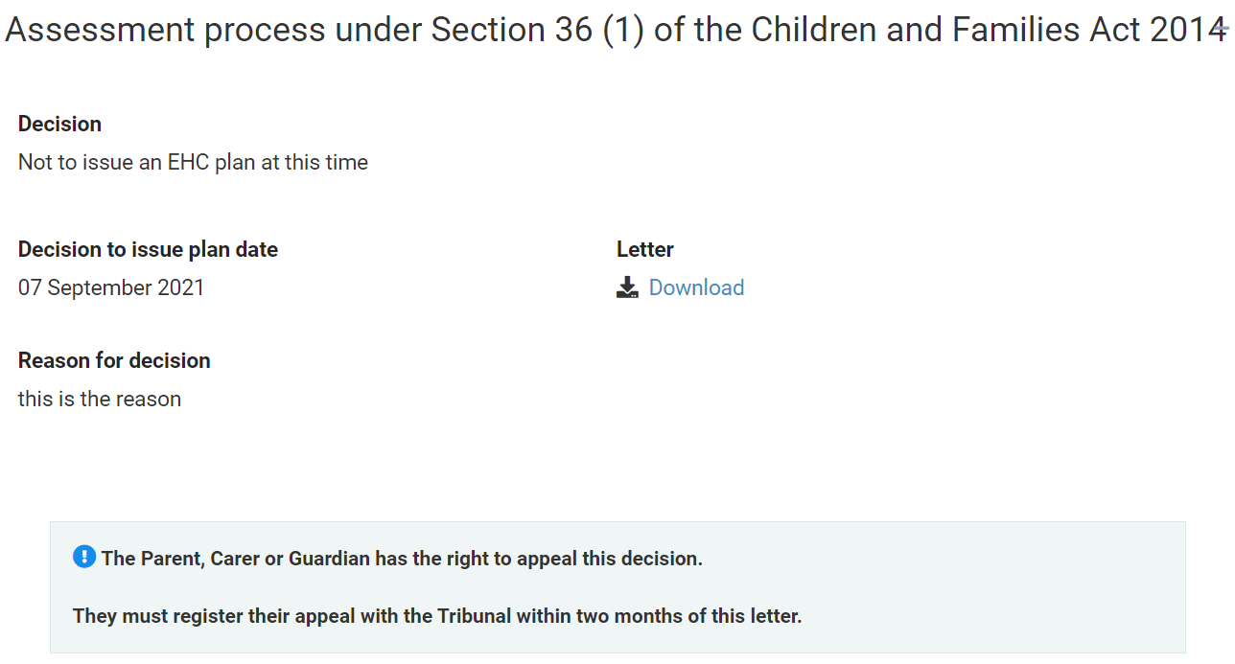
This will include the reason for the decision and a letter that can be downloaded with more information about the decision.
To view this letter, click on Download.
If the decision has been made to issue a plan, the status will show that a decision has been made to proceed to a plan:
To view details and download the letter about the decision, click on Decision:
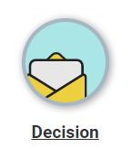
The information below will be displayed:
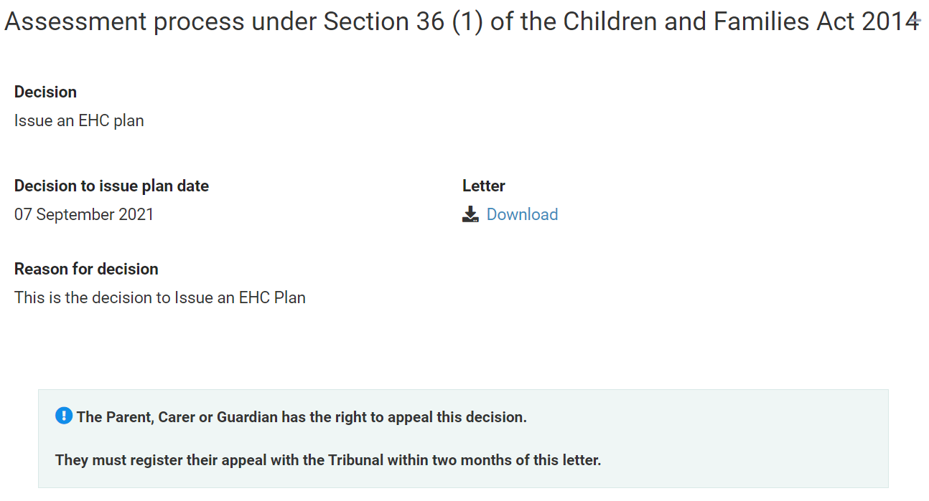
For more information about the decision, click on Download to download the letter.
Click on Plan. The main screen will show some information about the next part of the process:
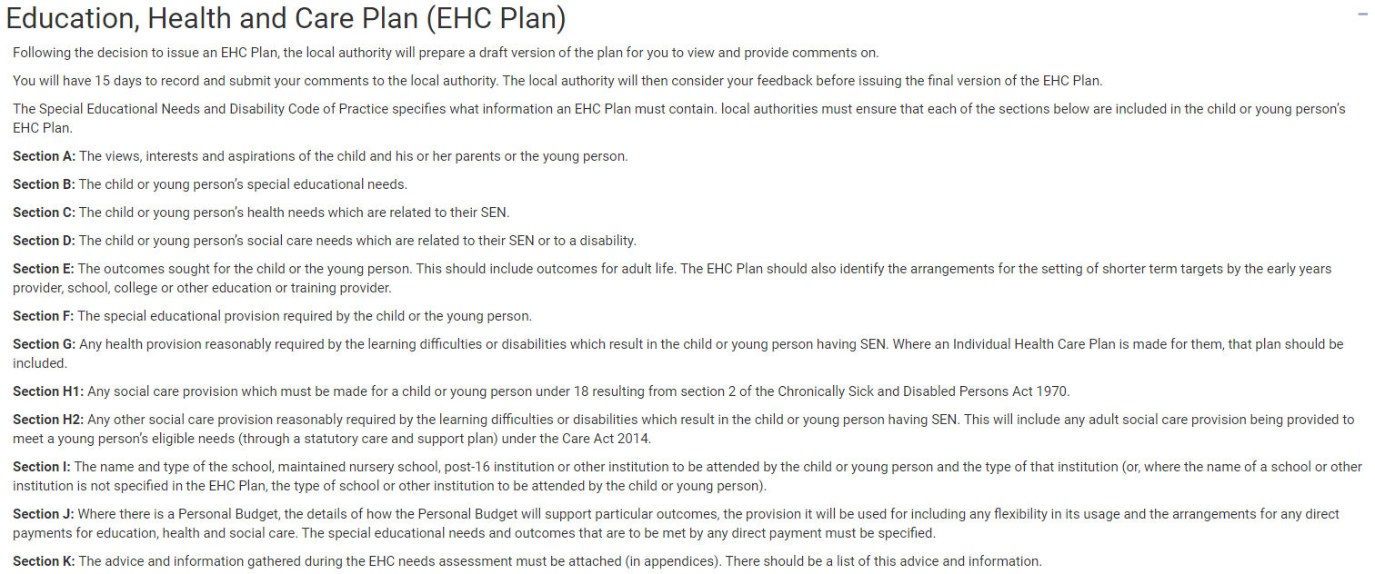
This details what information the plan must contain.
Underneath, it will show if the plan has been drafted yet. If it is still being drafted, this will be displayed:
If you haven’t already read the advice contributions that might go into the plan, click on Assessment at the top of the screen to view the Assessment page:
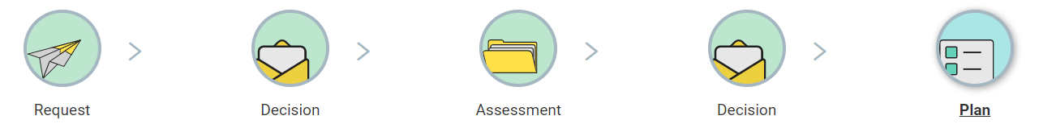
At the bottom of this screen there is the Requests for Advice section:
