EDUCATION, HEALTH AND caRE hUB
Guide 4 for Parents – How to contribute to a rEquest
APRIL 2022

How to contribute to a request
Once the request has been made, there are various things that you can do to contribute to the request. Some of the information can be amended or added to here by you, but some information can only be amended by the case co-ordinator. The details of what you can change and what the case co-ordinator can change can be found below. If you want to change information in an area that can only be amended by the case co-ordinator, you should email the case co-ordinator with the request.
The details of the case co-ordinator, including their email address are displayed on the left-hand side of the screen:
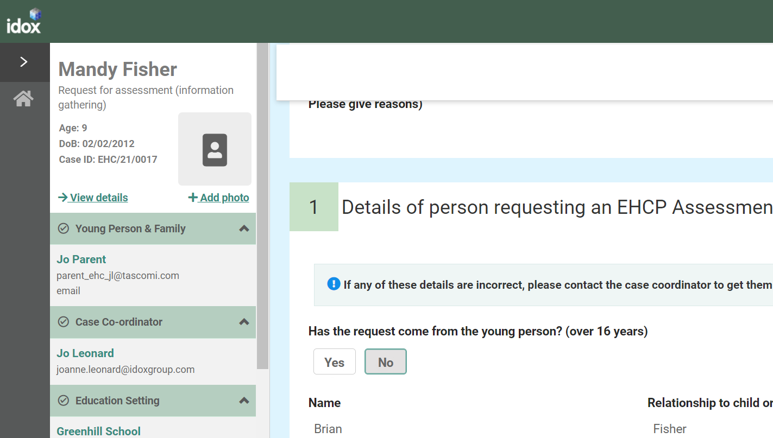
If you do make any changes to those sections that can be amended, you will need to click on Save changes to save those changes.
Enter the correct information and click on save changes at the top of the screen:
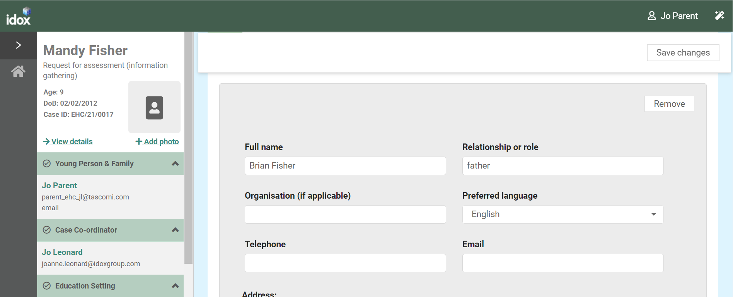
When you click on save, the information will update and the following message will appear:
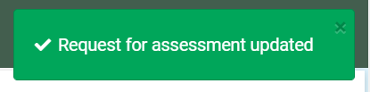
Once all of the information for the decision on the assessment has been gathered, a message will appear to say that the decision is pending:
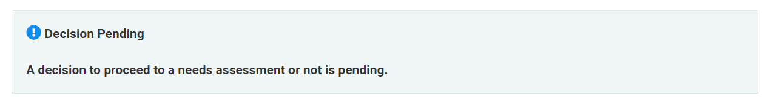
Once this message appears, it will not be possible to amend the request.

Sections of the Request
Consent - If you created the original request, you will have consented to the gathering and sharing of information, as well as indicating any limitations on this. If you wish to change your consent in any way, you will need to contact the case co-ordinator. If the request was created by someone else, they should have already sought your consent and indicated that in this space.
Details of person requesting an EHCP Assessment - If any of these details are incorrect, you will need to contact the case co-ordinator to get them updated.
Child or young person’s details - If any of these details are incorrect, you will need to contact the case co-ordinator to get them updated.
Child or young person’s main contacts - These details can be amended and further contacts can be added. To add a further contact, click on Add. Complete the details as required and click on Save Changes.
Details of the child or young person’s current education settings(s) - If any of these details are incorrect, you will need to contact the case co-ordinator to get them updated.
Details of Previous Settings - If the child or young person has attended a previous educational setting within the last 5 years, information can be added here. To add another education setting, click on Yes and the fields will appear allowing you to enter the details of the education setting.
Important information about the child or young person - Any information entered when the original request for assessment was made will be displayed here but can be amended or added to here.
Identified Special Educational Needs (SEN) - This section will be completed by the School and the Special Educational Needs Co-ordinator.
Supporting Documents -If you want to add any relevant supporting documents, click on the Add Files button:
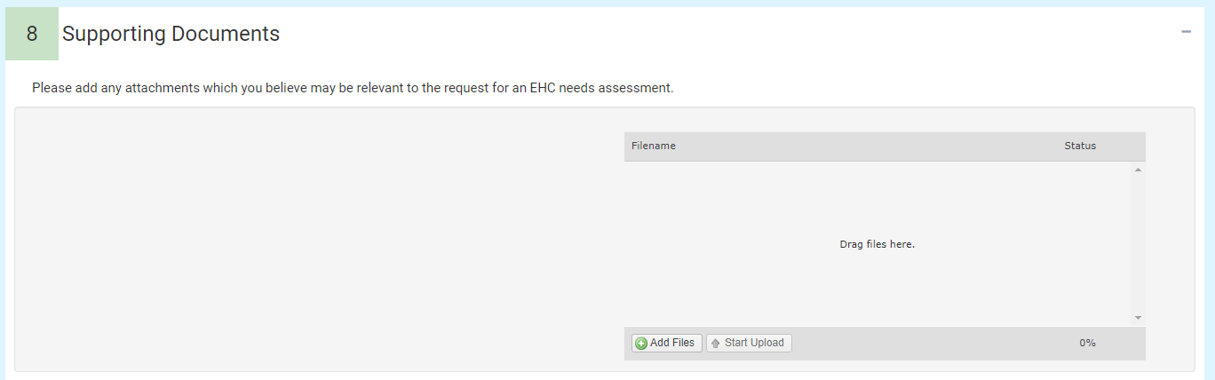
You will then need to navigate to the file wherever you have it saved on your PC:
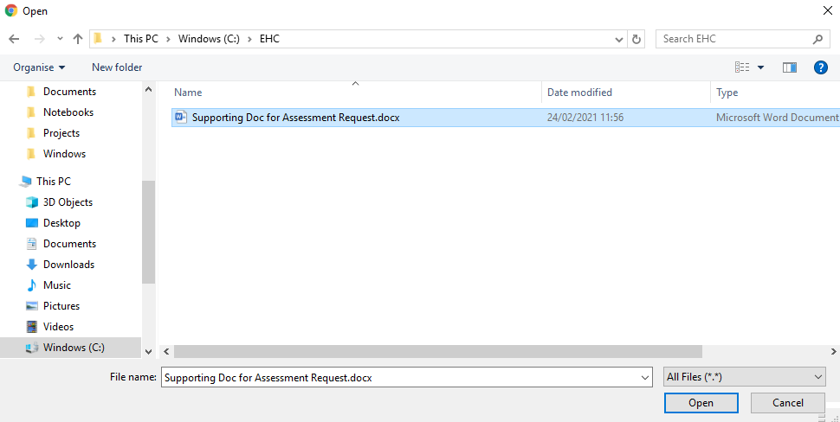
Click on Open and the file will be uploaded. The uploaded file will be displayed:
