EDUCATION, HEALTH AND caRE hUB
Guide 3 for Parents – viewing the request for assessment
APRIL 2022

Viewing the Request for Assessment
When you log into the EHC Hub, you will see the icon for the case for the child or young person:
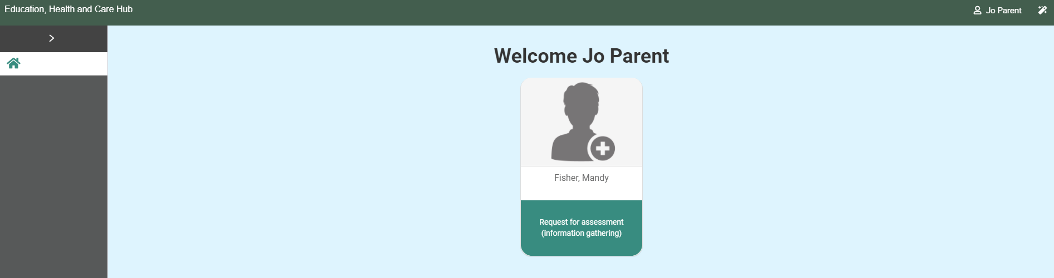
Left click anywhere on this icon to open and display the information in it. The following page will appear:
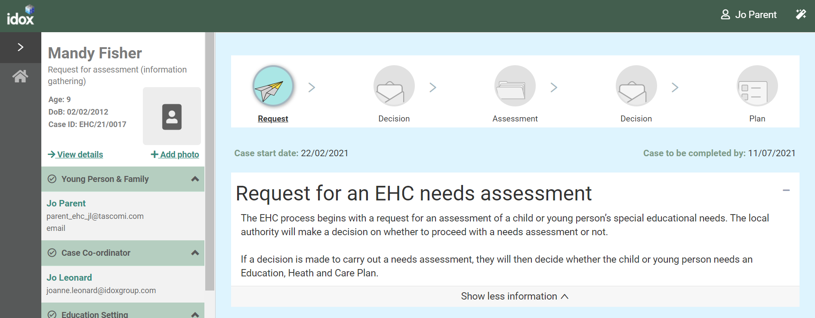

Status of the Process
The top of the screen will show what stage of the process the EHC plan is currently at.
Request – this means a request for a EHC needs assessment has been made and information is being gathered to decide if a needs assessment should take place:
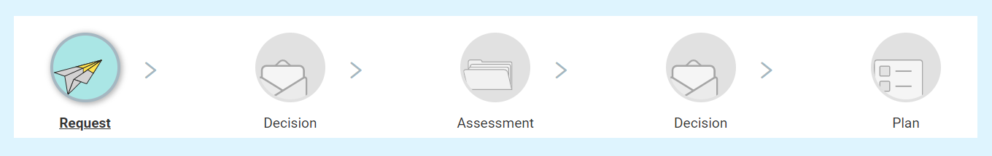

Details of the Case
The left-hand side of the screen can be used to access different parts of the case record.
These different sections are Young Person and Family, Case Co-ordinator, Education Setting, Notes & Timeline and Key Dates.
You can expand each section to view information on it by clicking on the green header of the section or on the arrow at the end of each section header:
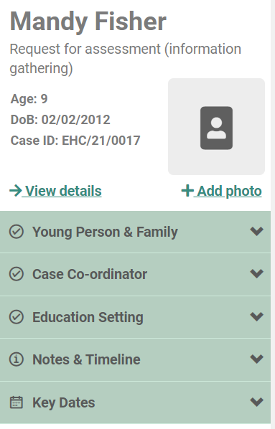
When you click on the header or the arrow, the display will change like this. Note the direction of the arrow has changed from down to up:
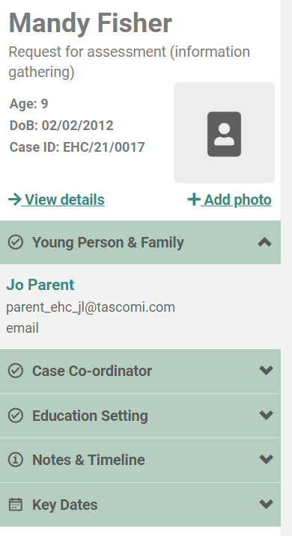
Young Person and Family – This will show the details of the person who made the request
Case co-ordinator – This will show the case co-ordinator responsible for overseeing the process
Education Setting – This will show the details of the current education setting of the child or young person
Notes and Timeline – This page will display all activity on the case in date order, with the most recent at the top. Click on View details to see this information:
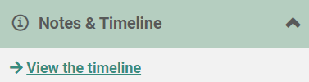
Key Dates – this will display the key dates in the process, based on the statutory date requirements. For example, it could show the start date of the case, when the decision to assess needs to be made and when the case needs to be completed:
