EDUCATION, HEALTH AND caRE hUB
GUIDE 1 FOR pARENTS – Needs assessment process
APRIL 2022

The Needs Assessment Request Process
The process to request a needs assessment is as follows:

The parent/carer/guardian or Young Person over 16 completes the request details and clicks on Send Request.

The request is processed by the local authority.

The local authority will grant access and send login details to the email provided as part of the request.

The parent/carer/guardian or Young Person over 16 will then register and log in to amend the details and upload any documents if required.
Because an account is not required to request a needs assessment, it is not possible to save a request part way through the process and then come back to it later. It is also not possible to upload documents during this part of the request process. Once the request has been sent to the local authority, and the parent/carer/guardian or Young Person over 16 has registered, you will be able to access the request to amend it and upload any documents if you wish to.
You will be directed to the EHC Hub Needs Assessment Request from the local authority website. The following page will appear:
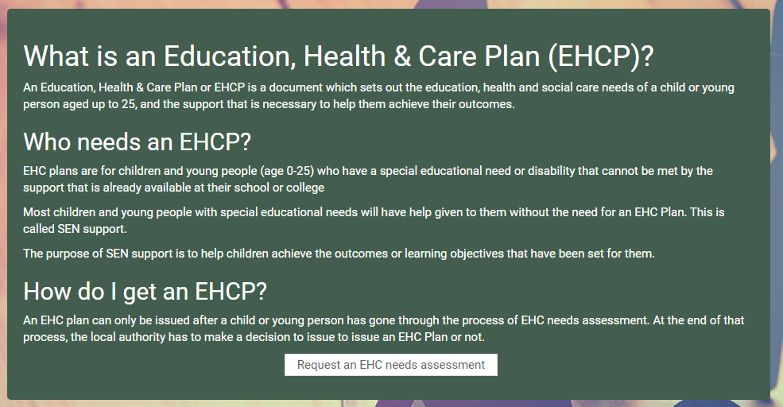
This page provides information about what an Education, Health and Care Plan is, who needs one and how to get one. Read the information and click on the Request an EHC Needs Assessment button at the bottom of the page and the following page will appear:
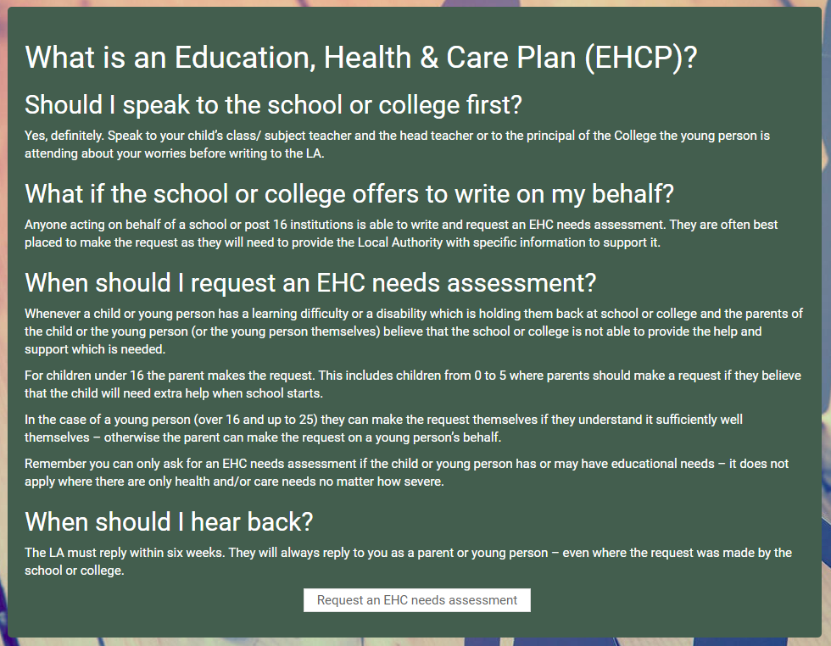
This will provide more information on the Education, Health and Care Plan. Read the information and click on Request an EHC Needs Assessment to begin the process of requesting an assessment.
This will open the request form ready for completion. As mentioned previously, because an account is not required to request a needs assessment, it is not possible to save a request part way through the process and come back to it later. It is also not possible to upload documents during this part of the request process. Once the request has been sent to the local authority, and the parent/carer/guardian or Younger Person over 16 registered, you will be able to log into the EHC Hub and access the request to amend it and upload any documents you wish.
The following page will appear:
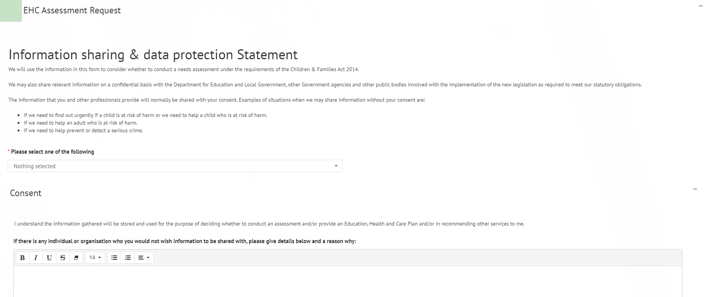
After the Information sharing and data protection Statement and the Consent section, there are five sections to be completed. These are:

1. Details of person requesting an EHCP Assessment

2. Child or young person’s details

3. Child or young person’s main contacts (family and involved professionals)

4. Details of the child or young person’s current education setting(s)

5. Important information about the child or young person
When all the required information has been entered, you will need to click on Send Request at the bottom of the form:
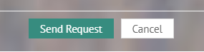
There are certain fields that are required and that must be completed in order for the request to be sent. These are indicated with a red asterisk:
If information has not be entered into a required field, when the Send Request button is clicked on, the section header containing the required information will turn red and the field to be completed will be shown with a message saying “this field is required”
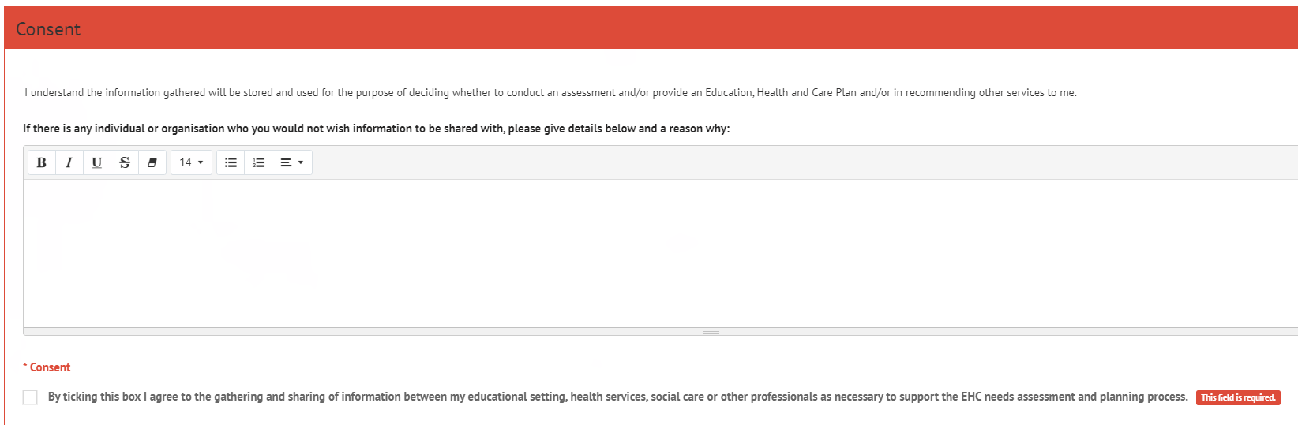
Once all the information is entered correctly, click on Send Request. The following message will be displayed:
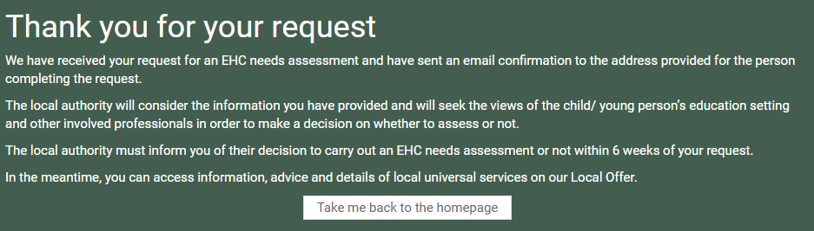
Provided you have entered your email address in Section 1 of the request (Details of person requesting an EHCP Assessment), then you will be sent an email to confirm that your request has been submitted.

Completing a Needs Assessment Request
The following sections contain details on how to complete the different sections of the needs assessment request, if you are the person making the request. If the request has come from the School, this information may have already been completed.

Information sharing and data protection statement
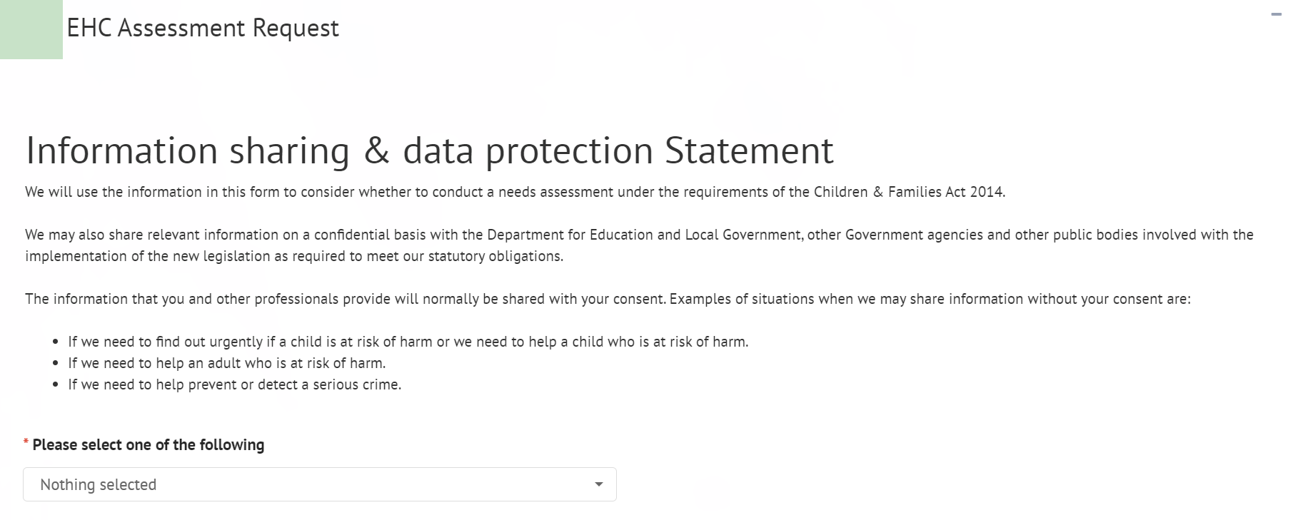
Read the information and click on the down pointing arrow at the end of the Nothing Selected field to view the options available for selection. Left click on the correct description.
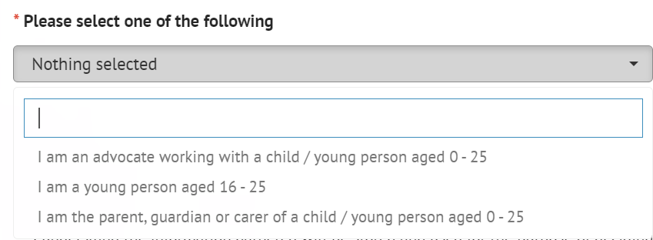
Your chosen option will be displayed in the field:
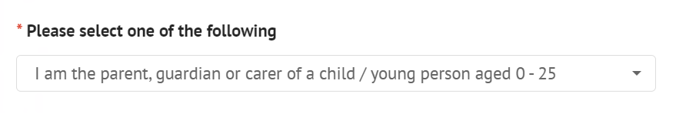

Consent
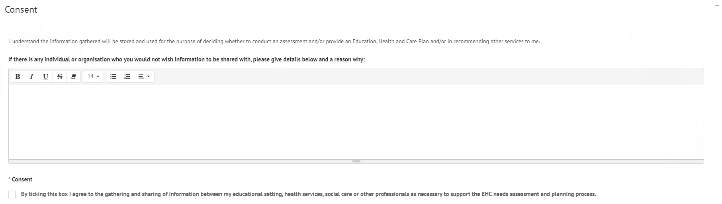
When giving consent, if there are any individuals or organisations that you do not wish information concerning the assessment to be shared with, details as to who and why can be entered here.
Consent - Left click on the tick box to give consent. You will be unable to send the request for an assessment unless consent is given.

Details of person requesting a EHCP Assessment
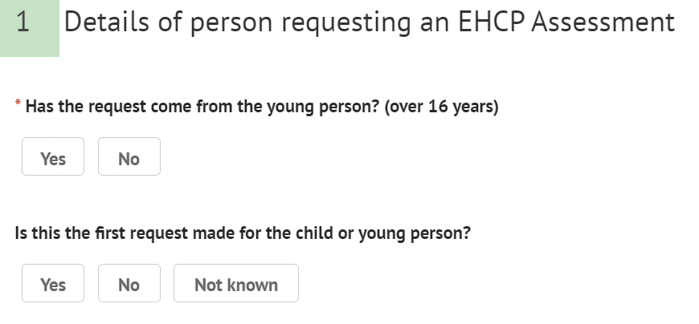
If you are completing this request on behalf of yourself and you are over 16, click on Yes.
If you are completing the on behalf of a someone else, click on No. The following extra fields will be displayed for the details of the person making the request to be entered:
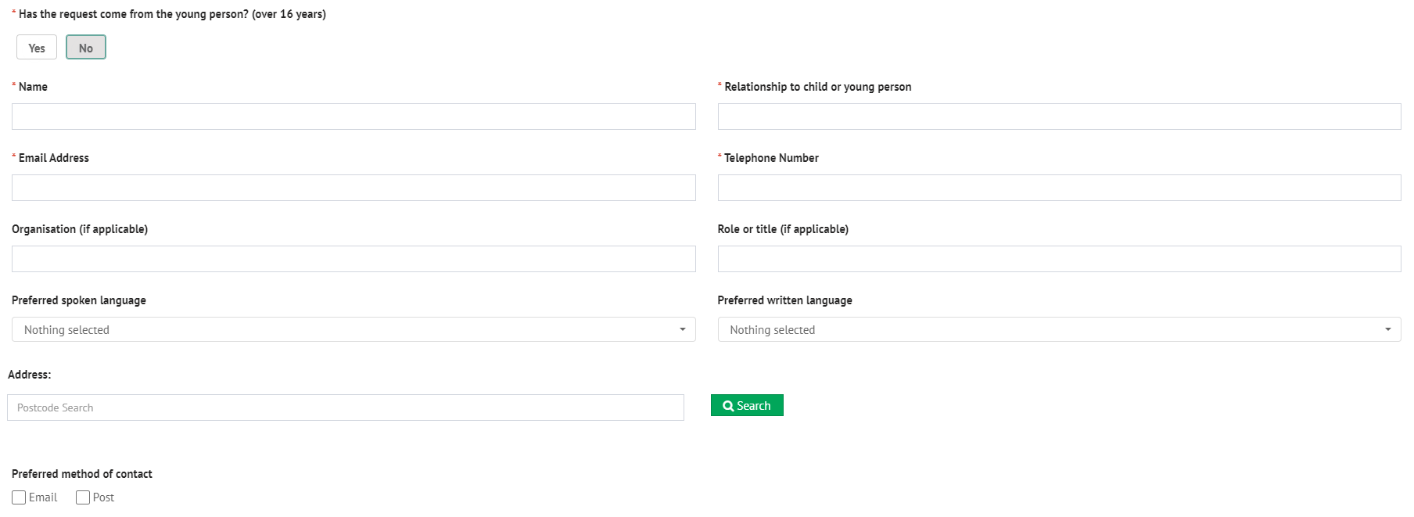
Name – Enter your name.
Relationship to child or young person – Enter the nature of the relationship between yourself and the young person e.g., Father.
Email Address – Enter your contact email address if you are the person making the request. When the request has been completed and sent, a confirmation email will be sent to this email address to show that an assessment request has been sent.
Telephone Number – Enter your contact telephone number if you are the person making the request for the assessment.
Organisation – If you are making the request for this young person on behalf of an organisation, enter the organisation name here.
Role or Title – Enter your job role or title in the organisation if applicable.
Preferred spoken language
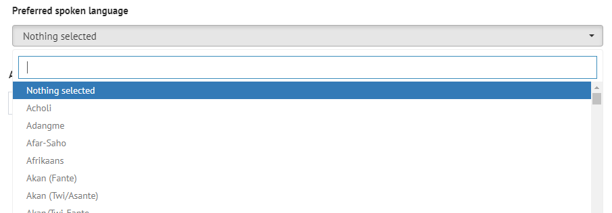
Preferred written language
Address
Preferred method of contact – select if you would prefer to be contacted by email or post
Is the first request made for the child or young person – select Yes, No or Not known as applicable. If No is selected, enter the date a previous request was made, if known.

Child or young person’s details
First name – enter the first name of the child or young person the request for an assessment is for.
Last name – enter the last name of the child or young person the request for an assessment is for.
Middle name(s) – enter the middle name(s) of the child or young person the request for an assessment is for.
Preferred name – enter the preferred name of the child or young person the request for an assessment is for.
UPN – local authority office use only. This should be left blank.
Internal system reference – local authority office use only. This should be left blank.
Date of Birth – Type in the date of birth, with a dash between the day, month and year.
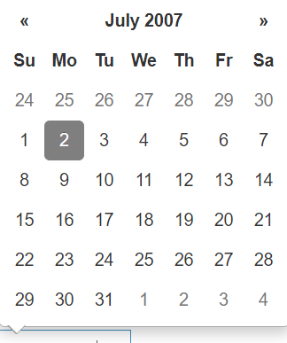
Once the date has been selected, the age will be calculated and displayed automatically:
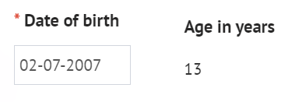
Gender
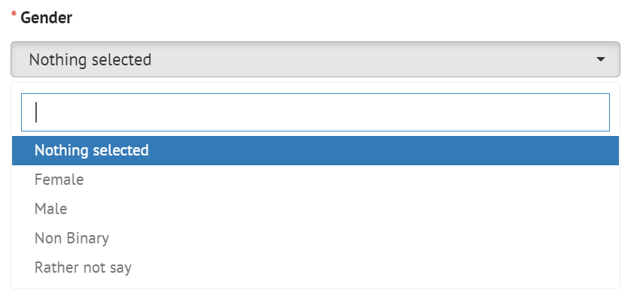
NHS Number – Enter the NHS Number of the child or young person
Legal Status
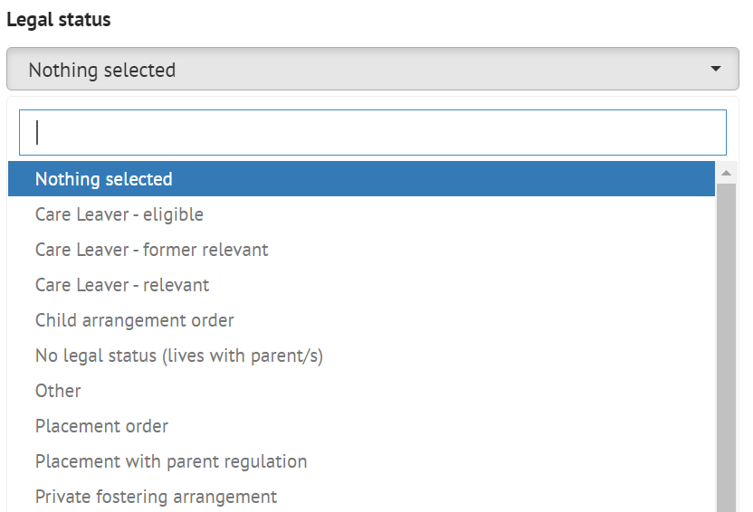
Ethnicity
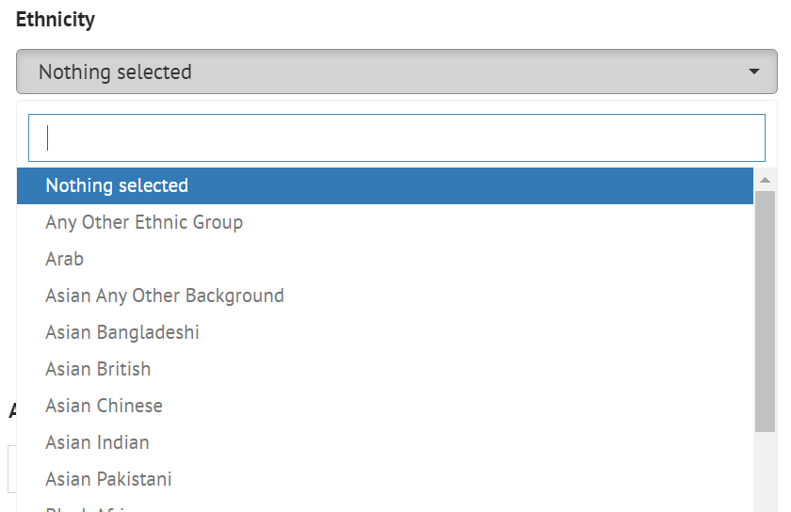
Preferred spoken language
Preferred written language – This will automatically default to the preferred spoken language but can be amended if not correct.
Main telephone – enter the main telephone number for this child or young person.
Email address – enter the email address of the child or young person. This is NOT the email address any confirmation emails or requests for registration will be sent to and is just for information.
Address
Preferred method of contact – select if the young person would prefer to be contacted by email or post, if appropriate.

Child or young person’s main contacts (family and involved professionals)
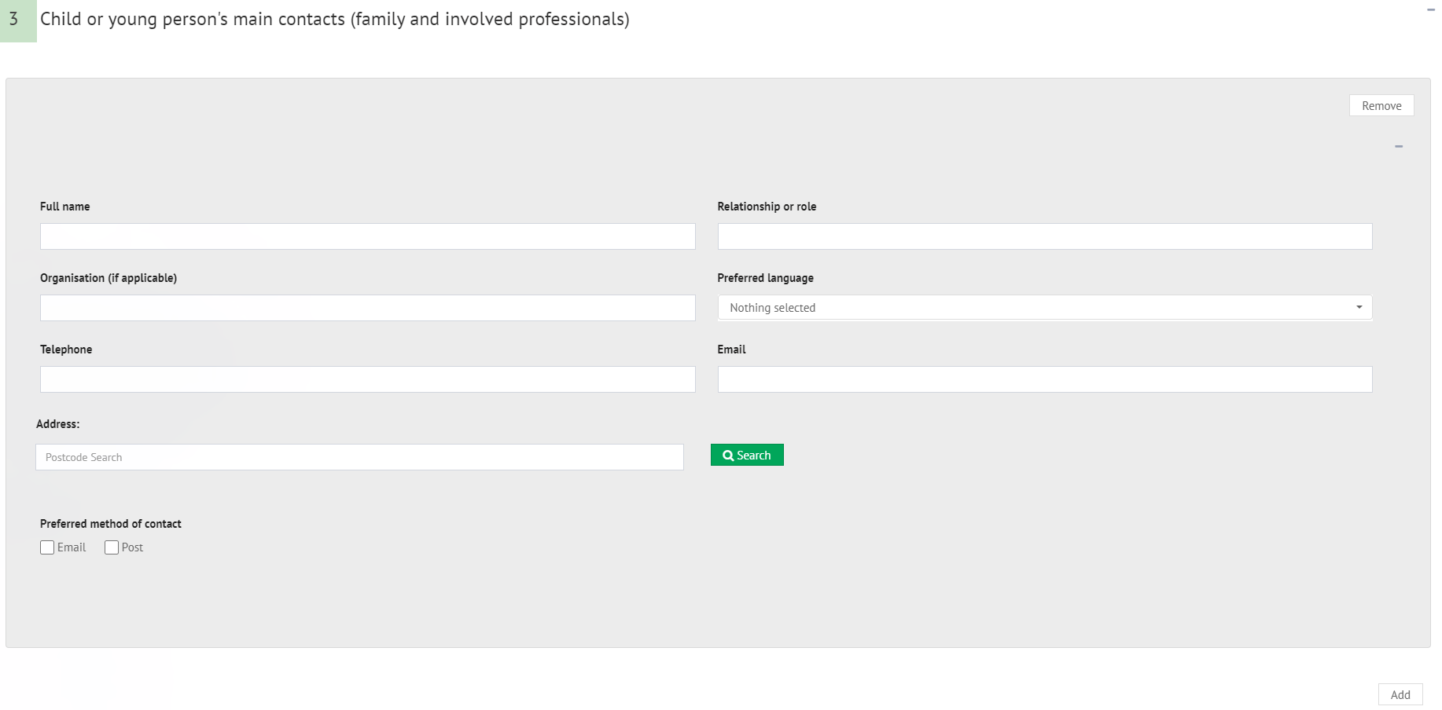
This section is for details of any contacts for the child or young person the request for an assessment is being made for.
Full name – enter the name of the Full Name of the contact e.g., John Smith
Relationship or role – enter the relationship between or the role of the contact to the child or young person the request for an assessment is being made for. E.g., Father
Organisation (if applicable) – if this contact is part of an organisation (as opposed to a family member), enter the name of the organisation here
Preferred Language
Address – Enter the details of the contact for the child or young person.
Preferred method of contact – select the preferred method of contact for the child or young person’s contact.
It is possible to add more than one contact to the assessment. To add further contacts to the request, click on the Add button in the bottom right-hand corner and complete the fields as above. This can be done as many times as required.
To remove a contact, click on Remove in the top right-hand corner of the section:
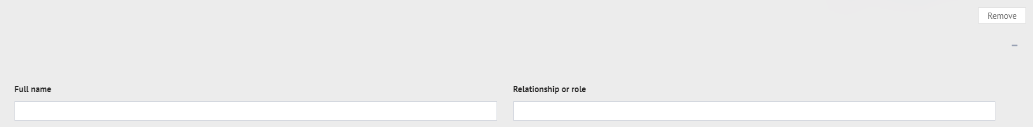

Details of the child or young person’s current education setting(s)
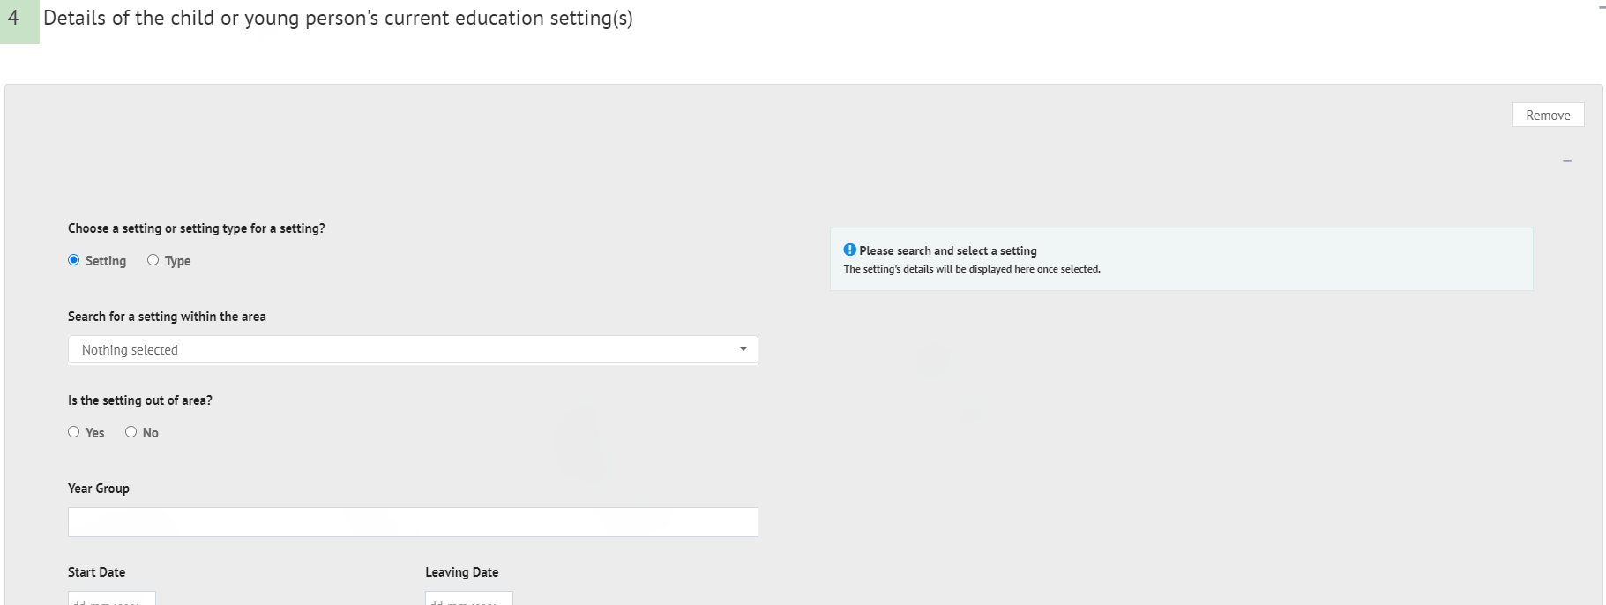
It is possible to add an educational setting either based on the setting itself (e.g., the actual name of the education setting) or based on the type of setting (e.g., Mainstream school, Special school: Non-maintained etc). The details available to be completed will be based on if Setting or Type is selected.
Setting
If Setting is selected, the screen will look like this:
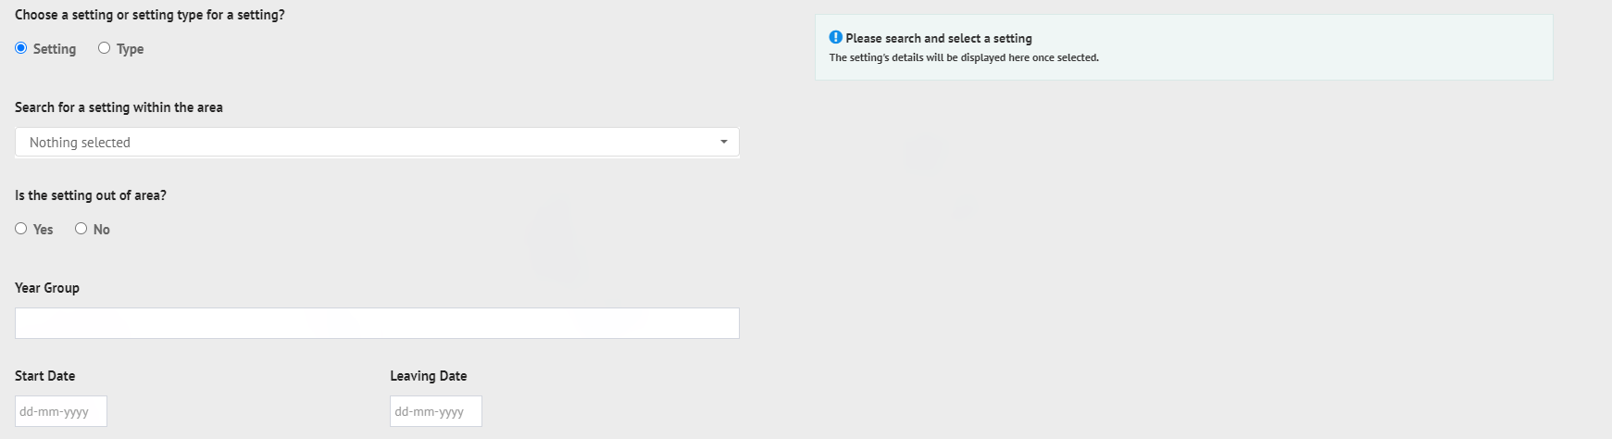
Search for a setting within the area
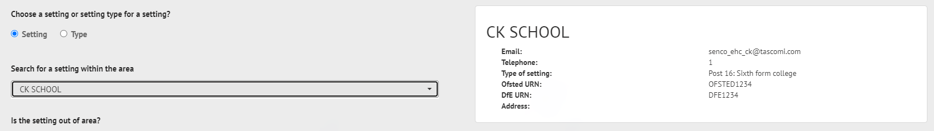
If the setting is not on the list, click on Nothing selected and click on Yes to the next question, Is the setting out of area. The setting can then be added manually in the fields on the right:
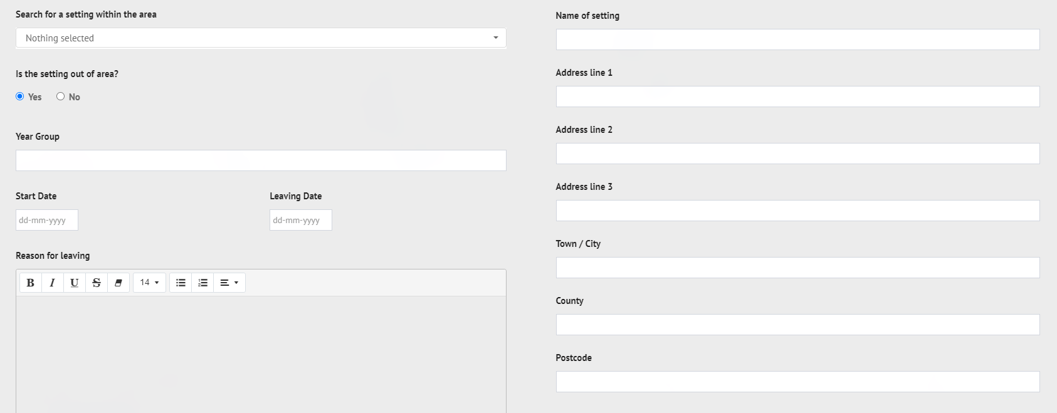
Year Group – enter the school year group of the child or young person.
Start Date – Type in the date the child or young person started at the educational setting.
Leaving Date – if known, enter the date the child or young person left or will leave the education setting.
Reason for leaving – Enter a reason for leaving.
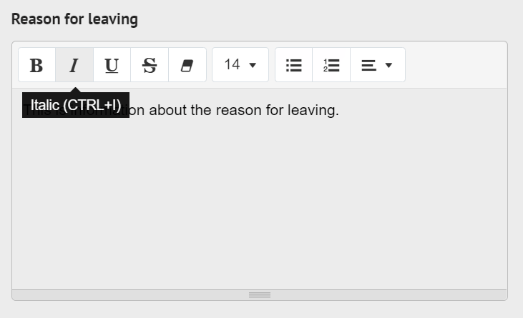
Percentage attendance of child or young person in the last year and any comments on this.
Additional Details.
Type
If type is selected, the screen will look like this:
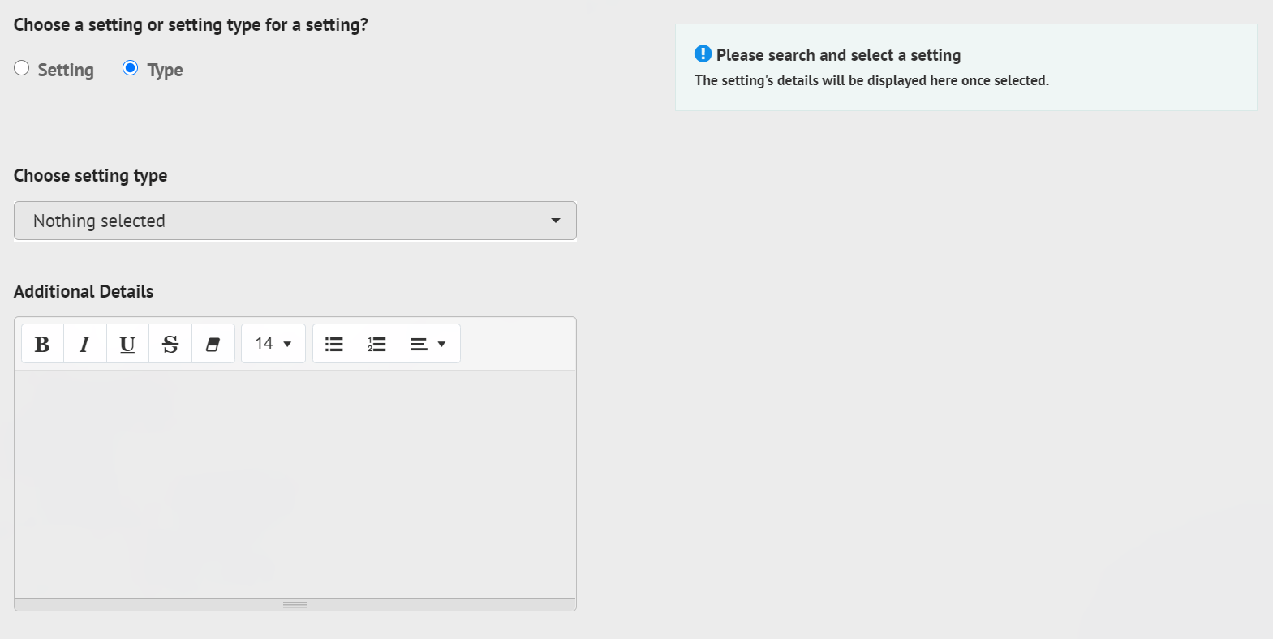
Choosing setting type.
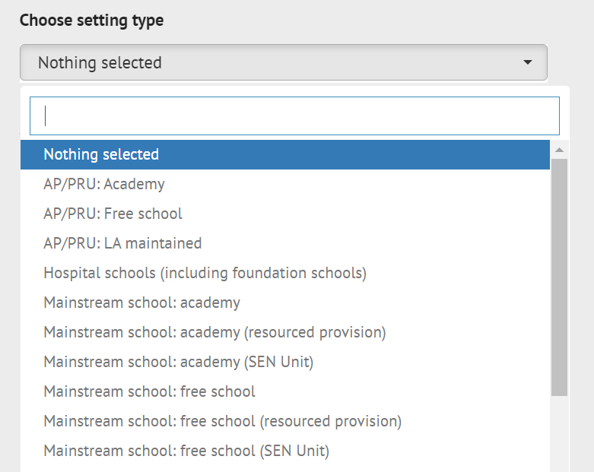
Left click on the required option to select it.
Additional details – click into the field to enter information.
Multiple education settings can be added. To add further education settings to the request, click on the Add button in the bottom right-hand corner and complete the fields as above. This can be done as many times as required.
To remove an education setting, click on Remove in the top right-hand corner of the section.

Important information about the child or young person
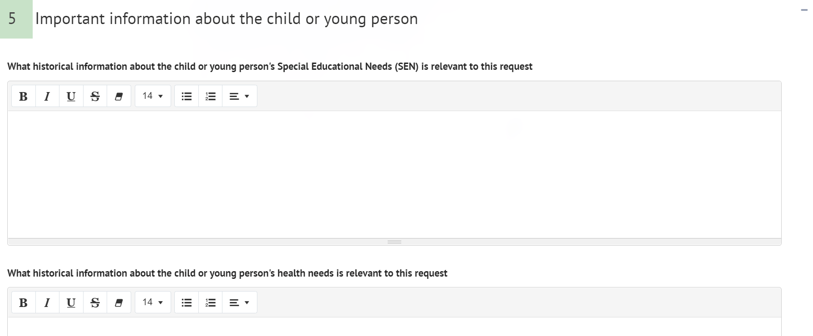
The section is used to enter historical information relevant to the request.
What historical information about the child or young person’s Special Educational Needs (SEN) is relevant to this request.
What historical information about the child or young person’s health needs is relevant to this request.
What historical information about the child or young person’s social care needs is relevant to this request.
Was the child or young person involved in the discussion that led to this request – click on Yes or No
If Yes is selected, the following fields will be displayed, A Views and opinions of the child or young person:
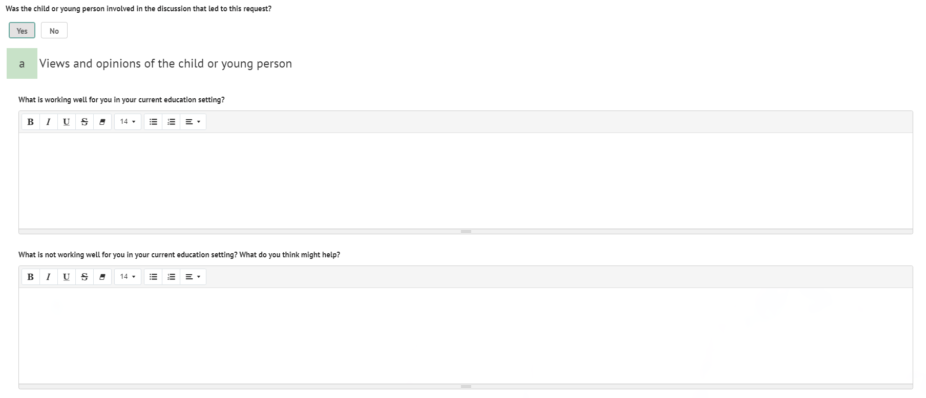
What is working well for you in your current education setting?
What is not working well for you in your current education setting? What do you think might help.
If No is selected, the following field will be displayed:
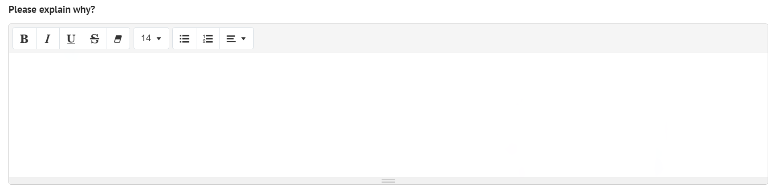
Please explain why.
Has the parent(s) or carer(s) been involved in the discussions that led to this request – left click on Yes or No.
If Yes is selected, the following fields will be displayed, b Views and opinions of the parent(s) or carer(s):
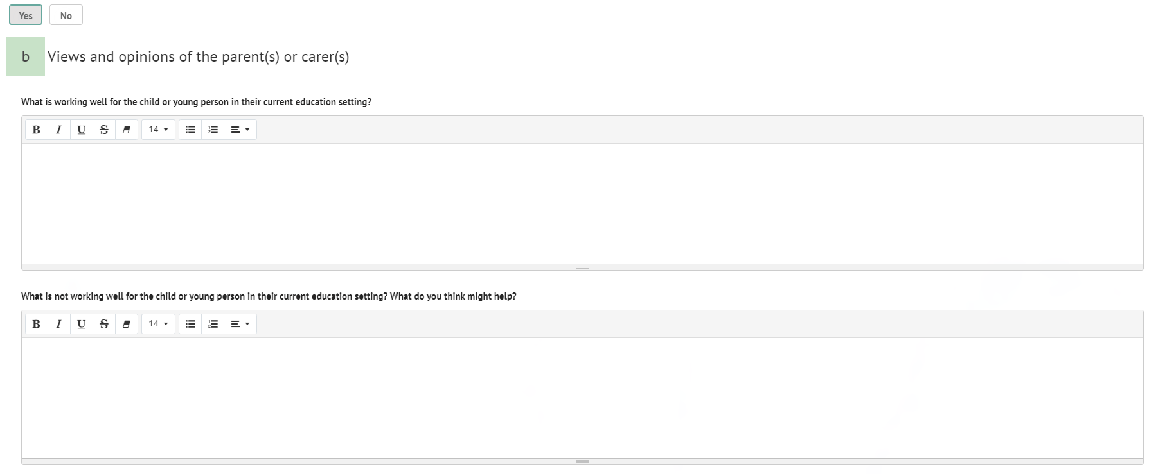
What is working well for the child or young person in their current education setting?
What is not working well for the child or young person in their current education setting? What do you think might help?
If No is selected, the following field will be displayed:

