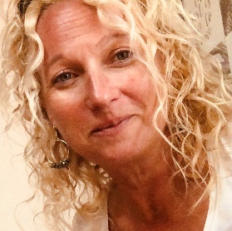
Hi my name is Clare and my job is to make a new service that helps parents of children with Special Educational Needs get the information and support they need.

The name of this service is the Special Educational Needs Independent Advice and Support Service. This is a very long name, so we call it SENDIASS. Can you guess why?
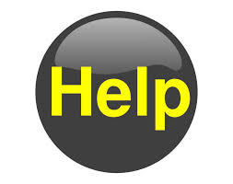
I would really like your help to create a logo for this service.

A logo is a picture or drawing that is used by a person, group, or company to mark who they are.
A company or group can use a 'logo' on the things that they make, or on the things they sell and in adverts.
When a person sees the logo picture, that person knows that the thing they see the logo on came from that company.

Most logos are very simple drawings with only a small number of colours.

Logos are not used only by companies. Many schools have logos. Some cities have logos. Clubs can have logos. Even people can have their own logos if they want. The heraldic badge is probably the oldest form of logo in the world.

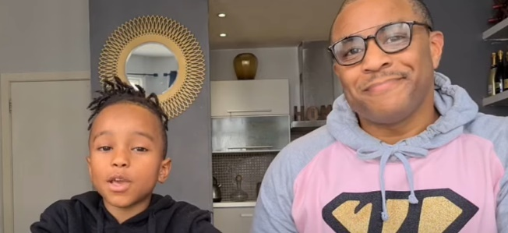
Watch this and Julian and Malachi will tell you all about Logos. https://www.youtube.com/watch?v=u76UYT9s8PI
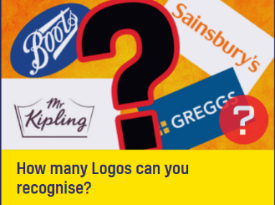
Here is a link to a Logo quiz game. https://www.beano.com/categories/logo-quizzes
How many logos do you recognise?

So do you think you can help? Can you design a logo for North East Lincolnshire (or NE Lincs) SENDIASS.

I can’t wait to see your ideas! Please email them to lauren.thompson@nelincs.gov.uk

When we have chosen the winning design, we will invite the creator and your headteacher to visit the design and print hub in the Council Offices in Grimsby to see the logo being made into a digital version ready to use on all our letters, emails and social media.
Thank you so much for helping. Clare 😊
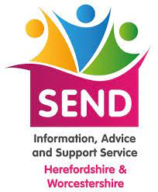
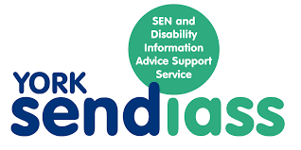
Here are some examples

