North East Lincolnshire Local Area

Easy Read

Written Statement of Action

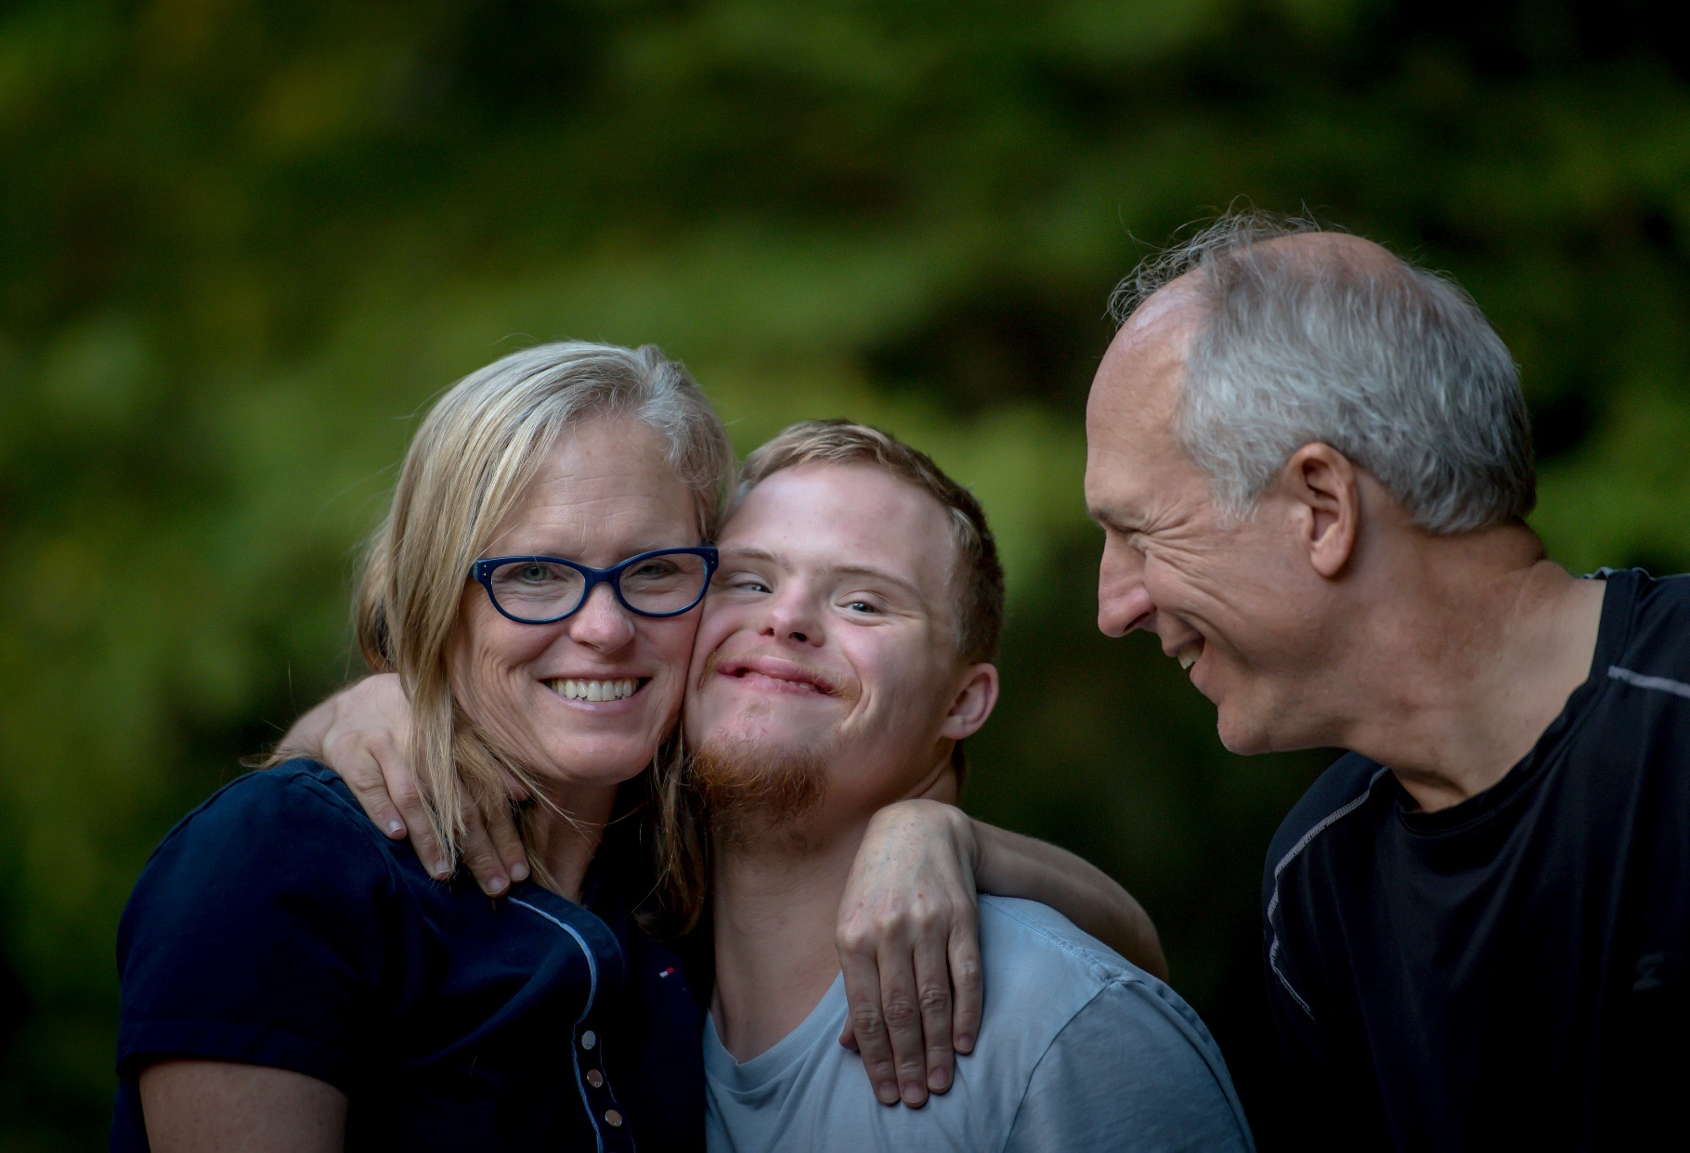

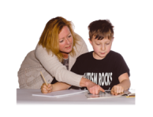
Introduction
Some children need extra support, at nursery, school and college or have health and care support needs, this is sometime called Special Educational Needs and Disabilities or SEND.
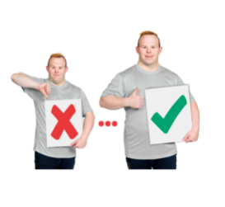
North East Lincolnshire Council and the NHS in North East Lincolnshire are responsible for providing this extra support. In July 2018 the Inspectors from Ofsted and the Care Quality Commission visited North East Lincolnshire and said that SEND services were not good enough and must be improved.

Senior staff in the Council and NHS fully accepts the report and have agreed to work hard to make services better for children and families in North East Lincolnshire.

The inspectors had 3 areas of concern:
1. Local leaders do not have a good understanding of the needs of those with SEND.
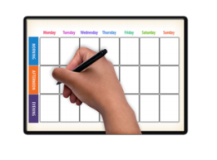
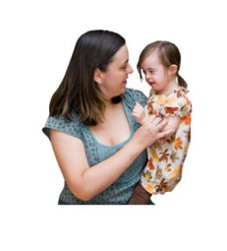
2. The process of knowing when someone needs help, deciding what help they need and delivering the support for children and young people doesn’t work well.
3. Children, young people and their families are not involved enough in designing and shaping services.
Professionals, parents, and carers have put in place a plan to make things better.
This plan was agreed by the inspectors. The plan is called a Written Statement of Action. It focuses on the three areas we need to get better at.
Here are the things we are going to do to improve in each of the three areas.

1. To make sure local leaders have a good understanding of the needs of those with SEND we will:
- Find out through assessments how many children and young people aged 0-25 in North East Lincolnshire have special educational needs and/or disabilities.
- Find out what these needs are and find out what they need to help them.
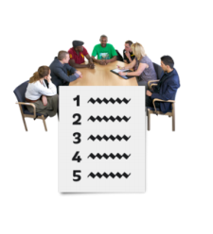
- Make sure SEND is discussed often and on the agendas of the most important boards.

2. To make sure we get better at knowing when someone needs help, deciding what help they need and delivering the support for children and young people we will:

- Improve services for very young children under 5 including how the healthy child programme for 0–5-year-olds is delivered.
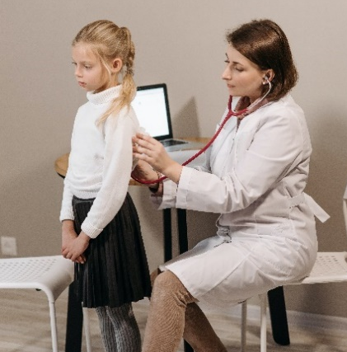
- Make sure GPs and other health professionals can share information about children and young people’s additional needs.
- Help schools and settings to support children and young people with SEND when they move classes, schools or into adult education, work and training.
- Make the quality of education, health and care plans (EHCPs) better.
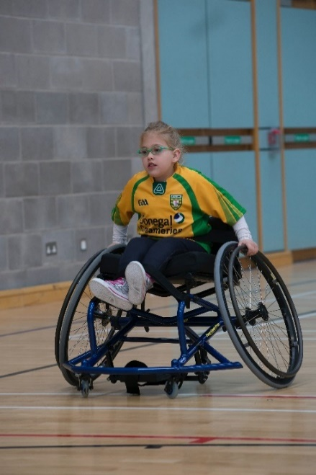
- Improve therapy and equipment services for children and young people with SEND.
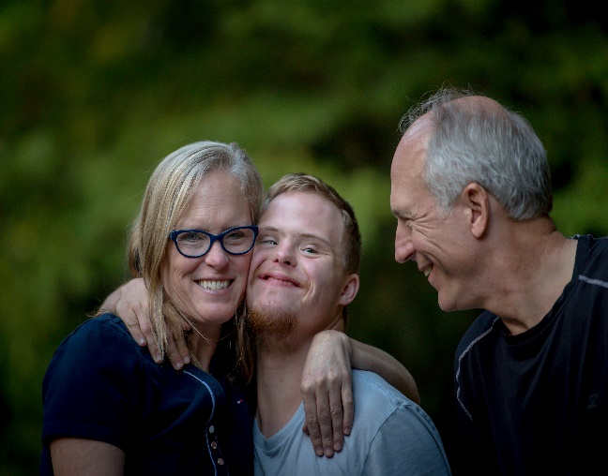
- Have an Access Pathway that helps families to get the support they need for their children with communication and interaction difficulties.
- Have a full time Designated Clinical Officer.
- Have a special nurse just for children and young people who are looked after.

3. To make sure children, young people and their families are involved in designing and shaping services we will:

- Learn how to co-produce new ideas and make sure we involve everyone right from the start.
- Make sure children and young people and their families have opportunities to have their voices heard.
- Create support opportunities for the siblings of children and young people with SEND.
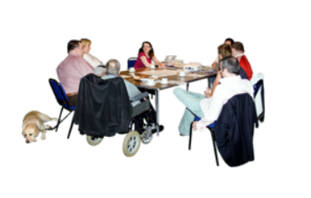
- Make sure parents/carers are on the executive boards where big decisions are made.
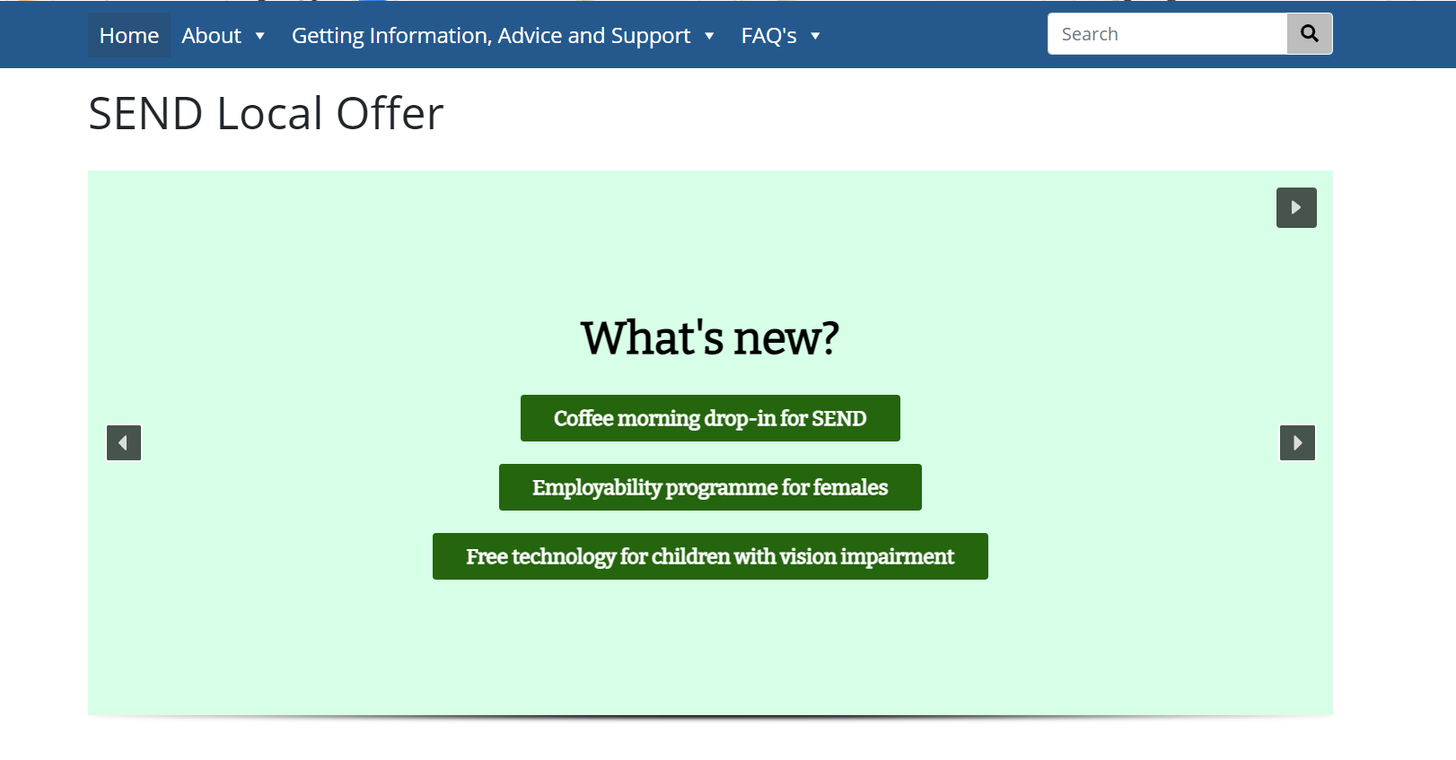
- Have a good SEND Local Offer that everyone knows about and can use.
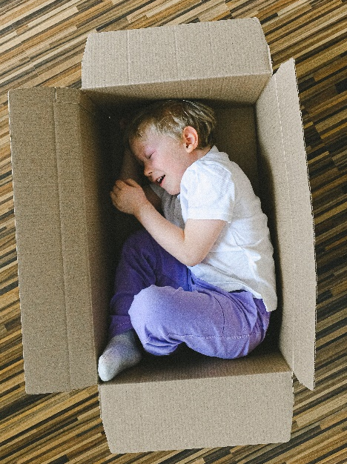
- Have a good short breaks offer so families get the right support they need.

Who to contact for help and advice on SEND
North East Lincolnshire Local Offer has Information and advice for people under 25 years old who have special educational needs and disabilities.
https://sendlocaloffer.nelincs.gov.uk/
North East Lincolnshire Special Educational Needs Information, Advice and Support Service (SENDIASS).
This is a free service that can help you if you are under 25 years old and have special educational needs and disabilities, or if you are a parent or carer.
https://barnardossendiass.org.uk/north-east-lincolnshire-sendiass/
01472 355365

