North East Lincolnshire – Education, Health and Care Hub
User Guide for Health Professionals
The Children and Families Act (2014) places a duty on health commissioning bodies and health professionals to cooperate with the local authority when undertaking needs assessments for children and young people with Special Educational Needs and Disabilities. Under this duty you may be asked to contribute to an assessment and/or review of a child or young person’s needs.

North East Lincolnshire has launched a new electronic EHC hub. Existing EHC plans will be gradually transferred to this system with the aim to be fully electronic by September 2021. Please be aware however that parents/carers are still able to make requests in an alternative format if they choose therefore you may still receive some requests via the paper/email process and must respond to these within the same statutory timescales.

This guidance aims to support health professionals with using the hub and responding to requests for advice.

If you have any queries regarding the EHC process or using the hub please contact :
Sarah Harding – Designated Clinical Officer – designatedclinicalofficer@nelincs.gov.uk

The Designated Clinical Officer is the health link professional for any queries relating to Special Educational Needs and Disabilities and the Education, Health and Care process.

Or the SEN Service : SEN@nelincs.gov.uk

To navigate to the section you require, hover mouse over contents heading and press Ctrl+click
Contents

Access 3
Registering on the hub 3
Access Permissions 3
Resetting Password 3
Information in Other Languages 3
LOGGING IN TO THE HUB 4
4
NAVIGATING THE HUB 5
Accessing case information 5
Allocating a case 6
PROVIDING ADVICE ON THE HUB 10
Uploading files to the hub 14
Saving and submitting your advice 14
CONTRIBUTING TO ANNUAL REVIEWS 15
Invitation to an Annual Review 15
16
18
18
Accepting/Declining a meeting invitation 18
TIPS FOR ADVICE WRITERS 19
Describing needs 19
Writing outcomes 20
Identifying provision 21
RESOURCES 23

Access

To access the hub, please visit https://ehchub.nelincs.gov.uk/

If you do not have login details for the hub contact: designatedclinicalofficer@nelincs.gov.uk

Registering on the hub

The following short video shows you how to register on the hub:

https://openobjects.vids.io/videos/a09dddb71f19e2c728/ehc-hub-account-registration

Access Permissions

The hub allows different access levels therefore you will be given the level of access required for your role. You will only have access to the areas of the Hub that are appropriate for you. Please only use your own log-in and password and do not share these with anyone else.

Resetting Password

In order to reset your password, there is a link at the bottom of the log-in screen. The password reset instructions will be sent to your registered e-mail address.

Information in Other Languages

The information on the Hub will be in English, but Google Translate could be used, as long as the content is in plain English. The Hub can also integrate with web accessibilities, such as Browsealoud.

LOGGING IN TO THE HUB

This is the login screen:
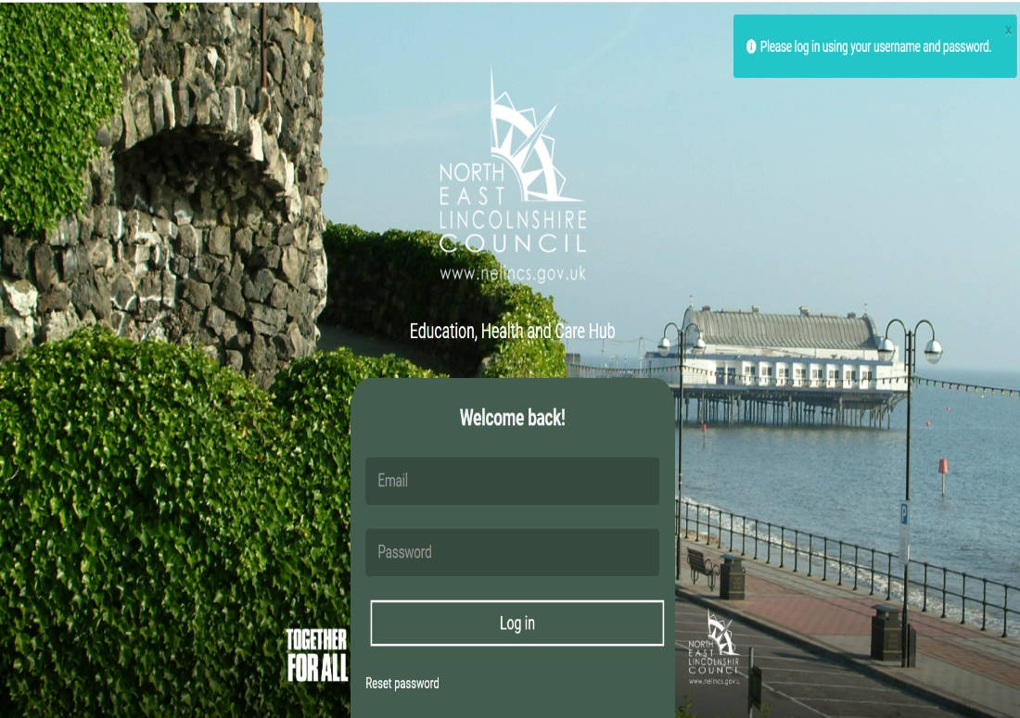

Enter your email and password and click ‘log in’

Enter your log in details here

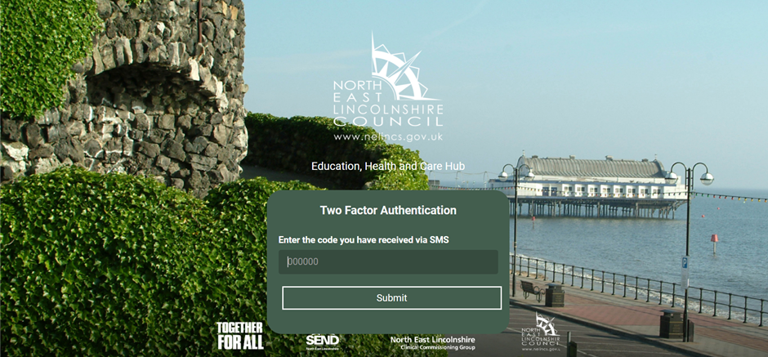
A code will be sent to the mobile number or authenticator app you set up when registering. Enter the code here

NAVIGATING THE HUB

Once you have successfully logged in you will be taken to the ‘My cases’ screen:
Search for cases using case reference or name
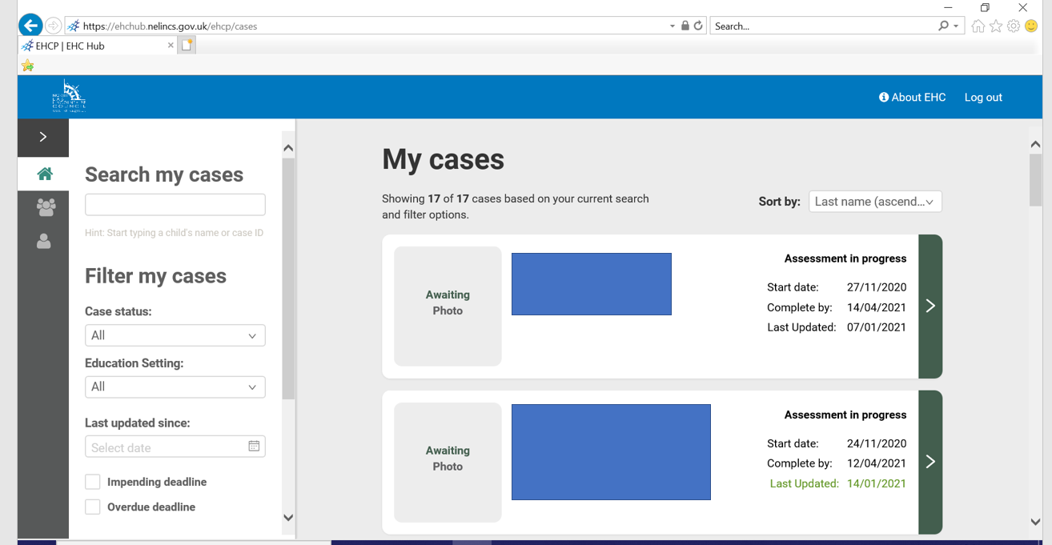
Users with manager level access can view all cases open to the team
Filter cases by case status, education setting, statutory process dates

Accessing case information

Within each individual case record on the hub, you can view information submitted at each stage of the assessment process by clicking on the coloured links at the top of the page. Here you will be able to read the information submitted in the assessment request including the child and parent concerns and wishes. Greyed areas mean the case has not yet progressed to this stage. Underlined sections indicate the current stage of the process.
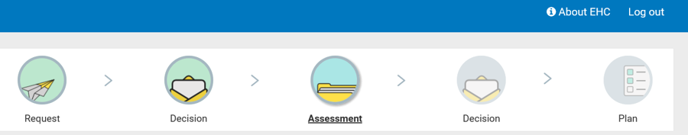

Allocating a case

All health teams have provided a central email address which allows for requests from EHCP Coordinators to be sent to the team via the hub. These are then allocated by a team member with managers level access permission (usually manager/admin staff) to a specific team member. This ensures that when individual team members are on leave requests can still be dealt with in a timely manner. Where a health team have multiple staff working on a duty system, multiple team members can be provided with manager level access permission if required.
- It is essential that these requests are actioned and allocated in a timely manner. All advice requests must be responded to and if appropriate, advice provided within the statutory 6 week timescale, which starts from the time the request is made to the team.
When a request is made by the local authority to a health team, an automated e mail request will be sent to the central team e mail address. No person identifiable data is contained within this e mail. The email contains a ‘case reference’ number. This is a unique identifier unique to the specific case within the hub. This is a security feature to ensure that only those with authorised access to the hub can view identifiable information.
- Please make sure you add the hub email address to your team and individual e mail contacts to avoid this being directed into your junk folder: no-reply@oohubmail.com

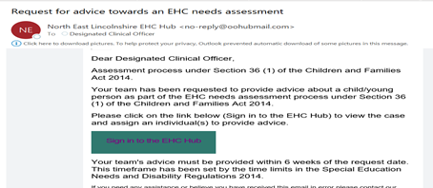
Click on the ‘sign in’ box in the email to take you to the EHC Hub

2. Start typing the case reference from the request email here
- Click on ‘Team Cases’
3. The case the request relates to will show here
4. Click on the arrow to open the case record

This will take you to the EHC Needs Assessment page:
Click the arrow to open the case
Find your team here
Click on ‘Assign to a professional’ in your team section

Click on ‘assign to a professional’

This will then take you to the ‘Request for Advice’ page. Choose the relevant option:
- Click on the relevant response box
4. Once you have completed your response, click ‘save changes’. You can then click ‘close’ to exit the case.
An e mail will be sent to the relevant team member, or the case will be automatically closed to the team.
This completes the allocation process.
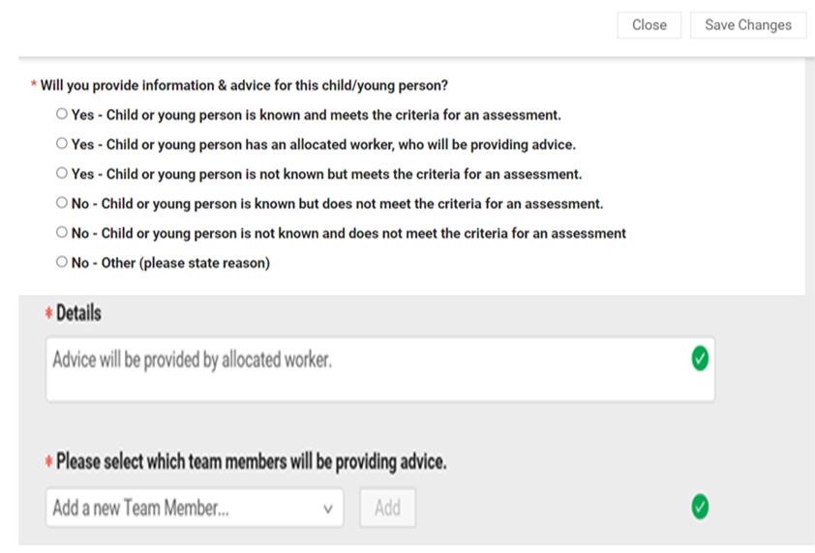
2. Explain your response here – i.e., ‘child not known’, ‘allocated to case worker’

3. If advice will be provided, choose the team member from the drop-down box and click ‘add’

PROVIDING ADVICE ON THE HUB

Once a case has been allocated to you, you will receive a request for advice email:
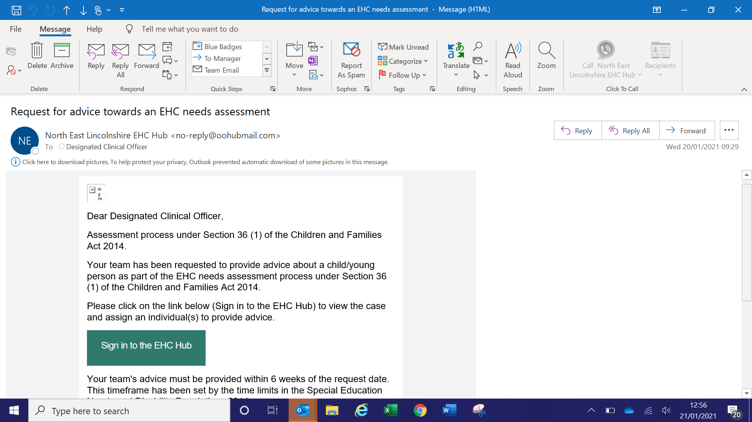
- Clicking on the link in the e mail will take you directly to the hub login page.
- Login to the hub as described in the earlier login section of this guidance.

2. The relevant case will show here, click on the arrow to open the case record
- On the ‘my cases’ page, start typing the case reference from the request e mail
The case the request relates to will display here.
Click on the arrow to open to the case record

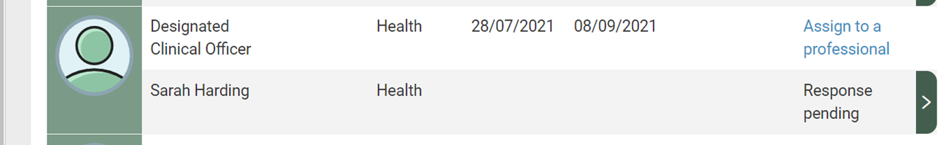
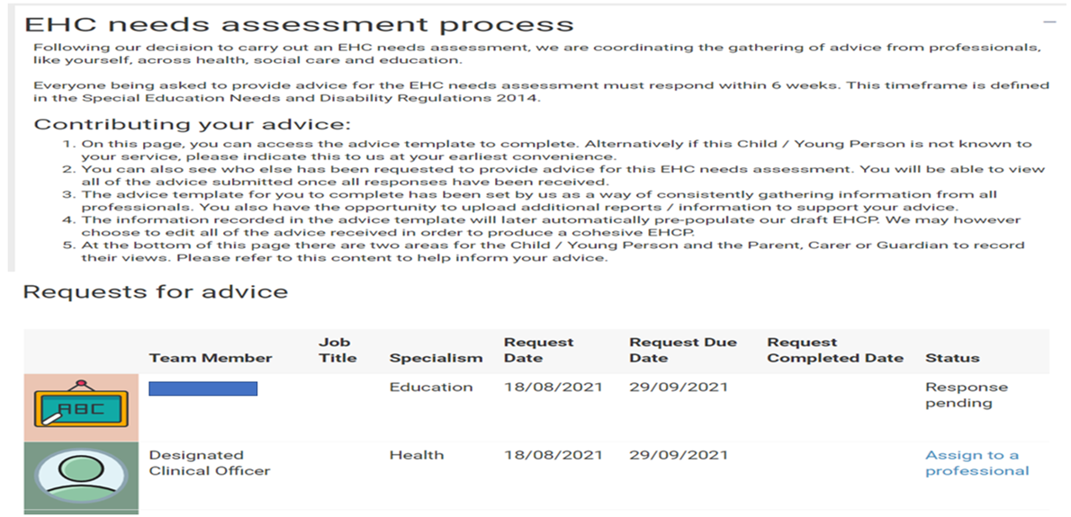
This will take you to the list of advice requests:
Find your team and click on ‘response pending’ next to your name

You will be taken to the Advice Template:
Find your name under ‘Requests for Advice’ and click on the arrow

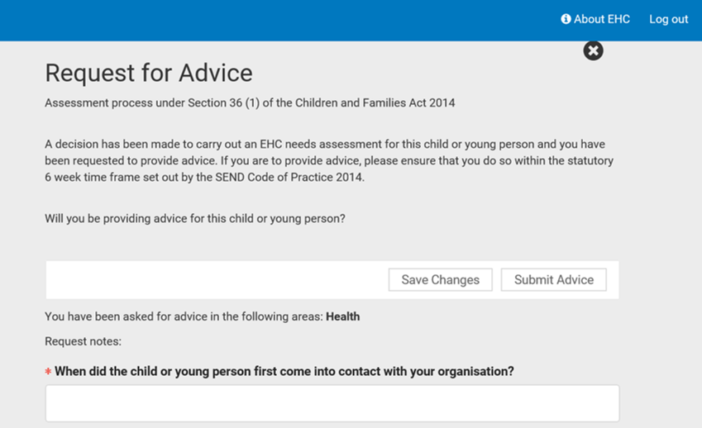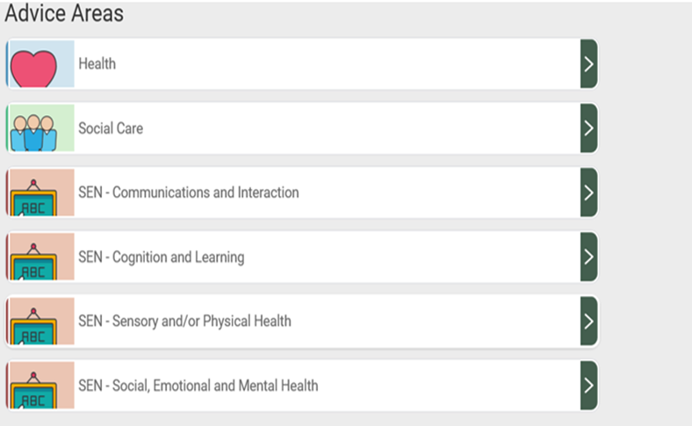
Clicking on ‘submit advice’ will publish your final advice on the hub. Changes cannot be made once you have clicked submit, only click this once you have completed all relevant sections
Click ‘save changes’ regularly to ensure your work saves. You can come back at a later date to complete the advice
All boxes marked with a * must be completed
Click on the arrows next to an area to provide advice. You can comment on any of the advice areas which are relevant to your area of professional practice/expertise. You do not have to complete every section.
.

For each of the advice areas you are asked to comment on the child’s strengths and special educational needs in that area

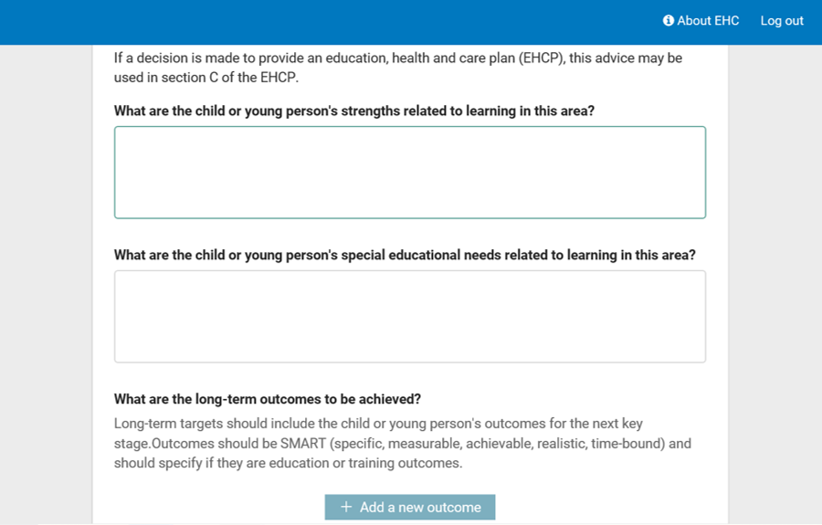
You can suggest outcomes for the areas of need you have identified. Click on ‘add a new outcome’
Explain how the health condition impacts on the child’s functioning, avoiding complex medical terms
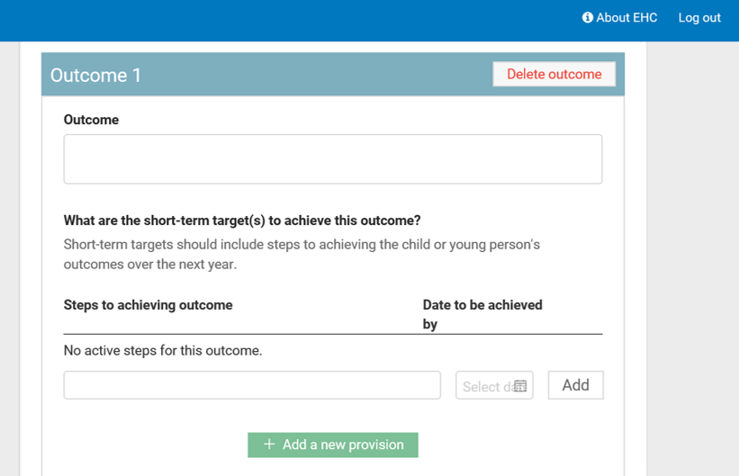
See ‘tips for advice writers’ in this document for support with writing outcomes

Click on ‘add new provision’ to detail what provision your service will provide to support the child in reaching their outcomes. Ensure this is quantified and specified clearly.

Uploading files to the hub

You can upload documents such as clinic letters and assessment reports to support the advice you are providing. Please ensure that you summarise the child’s needs in the relevant sections of the advice template. Clinical reports do not replace advice writing.

(Paediatric Secretaries only: you only need to upload the clinic letters. You are not required to provide written advice in the template).
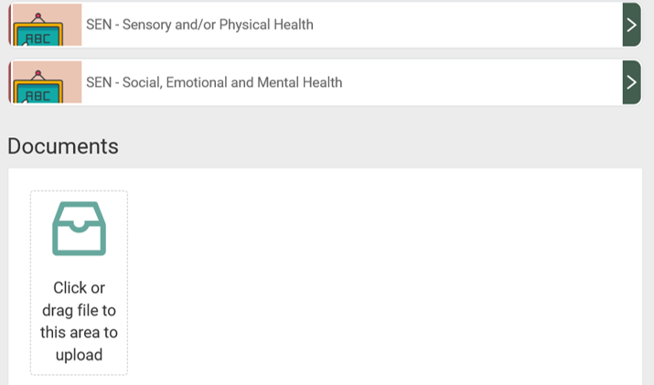

Saving and submitting your advice
The system allows for you to save advice and come back to it at a later date prior to submission and publication on the hub. This allows for the advice to be drafted over multiple sessions if needed or for professionals to seek supervision regarding the quality of their advice from a line manager/clinical supervisor prior to submission. To save draft advice click ‘save changes’.
- To access saved advice, go back into the case from the ‘my cases’ page
- Once you are ready to share your advice, save changes, then click on ‘submit advice’.
- A warning message will appear as a double check to ask if you are ready to submit.
- Once you have submitted the advice this is made available for the EHCP Coordinator, Parent/carer, and professionals registered to the case to view on the hub.
- A copy of your submitted advice can be downloaded and saved/printed off from the hub if required for clinical notes. This can be done by going into the case via ‘my cases’ and opening up the response you have submitted.

CONTRIBUTING TO ANNUAL REVIEWS

An annual review of the EHC plan must be undertaken as a minimum at least every 12 months, for children in the early years, this review is every 3-6 months.
The responsibility for ensuring the annual review is undertaken lies with the Local Authority, however in North East Lincolnshire, in common with many other areas, the responsibility is delegated to the education setting in the majority of cases.
The SENCO/EHCP Coordinator will invite all professionals involved with the child or young person to contribute to the review. The parent/young person must also be invited.
You may be asked to attend and/or contribute to an annual review. Whilst you may not always be able to attend in person, it is expected that you will provide updates regarding the child’s progress within your professional remit by identifying what is working well; providing evidence of targets met; and supporting with updating outcomes.
The annual review process is now undertaken via the EHC Hub in the majority of cases.

Invitation to an Annual Review

You will receive annual review invitations by email from the EHC Hub:
You can add the invitation to your outlook diary
Click here to log in to the hub
Once logged in to the EHC Hub, type in the case reference to identify the case

Once logged in to the individual case record you will be taken to the EHC Plan Review Consultation Screen:
Review meeting details can be found by clicking ‘Arrange’

Assign the request to the relevant team member in the same way as for the assessment process

On the EHC Review Consultation screen, find your name associated with your team and click on ‘response pending’. This will take you to the advice template:
When you have completed your advice, click ‘submit’. No further changes can be made following submission.
Saves changes as you go along
You can download your advice for your records once complete
Access the individual sections of the plan by clicking on the arrows

Current outcomes are shown in the template
Comment on what is working well – has provision in the plan relating to your service area been delivered, what is the impact?
Where you have relevant evidence/information, you are asked to comment on progress towards the outcomes
You can add new short-term targets towards meeting the outcome
Consider the current outcome – is this still relevant? Are any changes required?
Any changes to the provision which you will be providing, or your feel is needed can be added here.

Once you have completed your advice, save changes, and click ‘submit’ at the top of the template. Changes cannot be made once you have submitted.

Accepting/Declining a meeting invitation
Click on ‘Arrange’ to view the meeting invite and details

You can download a meeting invite letter here and find organiser contact details
Click here to provide your response. This response will be sent to the meeting organiser

TIPS FOR ADVICE WRITERS

- The advice which you provide will be part of several pieces of advice received by the local authority which will be used to produce a draft Education, Health and Care Plan.

- Completion of a needs assessment does not necessarily mean that a final plan will be issued. This decision is made by the Special Educational Needs Advisory Group (SENAG) after careful consideration of the information submitted and decisions are made in line with the SEND Code of Practice.

- When providing advice please only comment on things within your own area of professional expertise. Health professionals should not make recommendations regarding the type of educational setting, level of educational support or name a specific school.

- Advice must be returned by the date requested. The statutory timescale for health advice to be returned to the local authority is 6 weeks and this must be adhered to. All health advice is reviewed and additional information sought and/or provided by the Designated Clinical Officer where there are gaps in information.

- It is essential that the aspirations of the child/young person are central to your assessment and recommendations. It should be clear how the recommended provision will support the child to reach their aspirations.

- Preparation for Adulthood is a key element of the SEND reforms and should be clear in your advice for young people in Year 9 onwards. More information is available in the resources section of this guidance to support you with this.

Describing needs

- Needs are more than a diagnosis. A diagnostic label is not a sufficient description, you should clearly explain the impact of the condition on the child’s functioning across different areas of their life.

- Please ensure that you use ‘jargon free’ language, keeping it as simple as possible and explaining medical terms. Avoid lengthy historical information or complex medical information. Information needs to be accessible to parents/carers, plan writers and non-medical professionals.

- Where a child’s health condition is likely to fluctuate or effect attendance at school please explain how this may impact on the child/young person and how this is managed. If a health care plan is in place, please upload this to the hub.

Examples:

- Sian experiences multiple absence seizures a day, this may result in her missing information and impacts on her interactions with peers.

- Alex has cerebral palsy with a right sided weakness. He is independently mobile but requires a walking frame for longer distances.

- Dylan has Autistic Spectrum Disorder and experiences anxiety in response to changes in his routine.

Writing outcomes

- The development of outcomes must start with the child/young person themselves and come from their aspirations and hopes for the future. This can also include the parent/carers hopes for the child.

- Outcomes can build on something that is working well, change something that doesn’t work well, or help to move the child towards future aspirations.

- In order to be person centred, the outcome must clearly identify the benefit or difference made to the child/young person.

- Outcomes must be SMART – Specific, Measurable, Achievable, Realistic and Timely.

- Overarching outcomes are generally longer term, health professionals can support with identifying short term targets to help with working towards longer term outcomes.

- Consider outcomes which may support the child/young person towards preparation for adulthood through the development of functional and independence skills. This is a requirement for all children aged 14 years and onwards; but developing independence can start much earlier and should be considered at all ages. This might include developing independence in medication management or administration, understanding and knowledge regarding their health condition etc.

Example outcomes:

- Parents aspiration for the child: to be able to sleep through the night.

Health professional – consider what this would mean in terms of the child’s age, stage of development etc

Outcome: By the age of 11 years, Jessica will have 6 hours of uninterrupted sleep, at least 5 nights a week.

Steps towards (short term target): within the next 3 months Jessica will be able to get to sleep and reduce her waking by to up to 2 x per night.

- Child’s aspiration – to have a sleep over at a friend’s house

Health professional – how can you help in your role towards this? What short term targets can be put in place?

Outcome: By the end of key stage 3, Emma will be able to use and maintain her hearing aids independently so that she can enjoy an overnight stay with a friend.

Steps towards: Within the next half term Emma will have learnt to recognise the low battery signal and change her hearing aid battery.

Identifying provision

- Provision should enable the child to move towards their aspirations and goals. Consider what are the barriers to achieving these? What provision would support steps towards achieving aspirations?

- When describing provision explain exactly what is going to happen, who is going to do it, how often it is going to happen and when it will be reviewed.

Examples:

Within the first week of the school term training will be delivered to school staff by the Epilepsy Nurse on seizure management and refresher training will be offered annually.

Dylan will be offered a 6-week CBT group programme by a qualified CAMHS clinician, attending 1 hour per week followed by a review appointment with Dylan and his parents.

Lucy will be offered a 1-hour speech and language therapy session in school per week for 6 weeks. Resources to support ongoing practice of speech and language therapy skills will be supplied to school staff and parents. Progress will be reviewed by the Speech and Language Therapist 3 months following the start of therapy.

GOLDEN THREAD – THROUGHOUT YOUR HEALTH ADVICE CONSIDER THE CHILD’S ASPIRATIONS AS THE GOLDEN THREAD THAT WEAVES THE ADVICE TOGETHER. DO THE OUTCOMES AND PROVISION SUPPORT THE CHILD/YOUNG PERSON TOWARDS REACHING THEIR ASPIRATIONS?

RESOURCES

For more information regarding the EHCP process and EHC Hub please visit our Local Offer:
https://sendlocaloffer.nelincs.gov.uk/home/ehc-hub/

The Council for Disabled Children provide lots of information and resources for health professionals on their website:
https://councilfordisabledchildren.org.uk/resources-and-help/im-healthcare-professional

The SEND Code of Practice can be found on the Government website:
https://www.gov.uk/government/publications/send-code-of-practice-0-to-25

Free e learning for health professionals on health advice writing is available on the Council for Disabled Children website:
https://councilfordisabledchildren.org.uk/cdc-learning

For resources relating to Preparation for Adulthood including outcomes writing and the local transition pathway visit the SEND Local Offer:
https://sendlocaloffer.nelincs.gov.uk/preparing-for-adulthood-and-transition-to-adult-life/

If you would like training regarding the EHC Hub or any aspects of the education, health and care assessment and review process please contact the Designated Clinical Officer: designatedclinicalofficer@nelincs.gov.uk

I would like to credit the Council for Disabled Children for some of the information and examples provided in this guidance.

