North East Lincolnshire SEND Engagement Strategy
“Making things better together.”

- Introduction
In November 2019, the Council and the Clinical Commissioning Group approved a joint engagement strategy called “Talking, Listening and Working Together”. This includes a commitment to work together with partners and service users in the spirit of co-production to improve the education, health, care and life experiences of everyone living in North East Lincolnshire (see diagram below).
That commitment is of particular importance for children with Special Educational Needs and Disabilities (SEND) and their families. This SEND Engagement Strategy details how we aim to engage with our parents, carers and families around changes to services for children with SEND and their families. This is a key part of our statutory duty to “consult with children with SEN or disabilities, their parents and young people with SEN or disabilities in reviewing educational and training provision and social care provision and in preparing and reviewing the Local Offer” as detailed in the 2015 SEND Code of Practice.
Our Commitment
(Taken from ‘Talking, Listening and Working Together’)

This also fully supports our parent participation forum’s co-production charter which details our partnership commitment to making co-production work.

What are the principles and values of “Making things better together.”
Our ‘Making things better’ principles and values are:
- Co-operate, co-operate, co-operate
- Everyone has equal power
- Everyone should be treated with respect
- Everyone should be included
- Everyone should be listened to (even when it is challenging to hear what is being said)
- Everyone should be clear about the vision for the future, and have a common purpose
- Everyone should aspire to improve outcomes, but have realistic expectations
- Acknowledge that everyone brings their own strengths which we can build upon together
We will know that we are truly working together to make things better when these principles are followed consistently

- Levels of involvement/engagement
The Local Authority (LA) and Clinical Commissioning Group (CCG) recognise that sometimes they might just need to tell parents, carers and families something and sometimes parents, carers and families might want to get involved in working with the LA and CCG us make the best decisions we can for you and your families. The LA and CCG need to be clear on how they engage with parents, carers and families, enabling effective joint working.
These are the 4 levels of involvement/engagement we will use with our SEND community.
Inform | Discuss | Consult | Co-Produce*
This is how parents, carers and families will find out what is happening. | This is how all parties will get an understanding of one another’s views. | This is how all parties will be asked your views so they can be taken into account to make decisions upon. | This is how all parties work together as equals with shared responsibility.

*What do we mean by “Co-produce”?
Put simply, co-production means working together to make things better. People from all walks of life and backgrounds (children, adults, carers, staff, everyone) are the experts in their own lives. Co-production means that the LA and CCG seek solutions to problems together, in equal partnership with those people that the problems affect. It is a well-known fact, and it is the LA and CCG’s strongly held belief, that services designed and delivered with children and families are more effective and better value.
The LA and CCG have worked with children, adults, staff from different agencies in the development of this strategy and our principles. Our ambition is for all services for children and young people to adopt this approach.
Our initial ‘recipe’ for working together can be seen in Figure 1 overleaf. This is the first attempt at developing our approach so we plan to keep improving the ‘recipe’ over the coming years to make sure we keep making things better together.
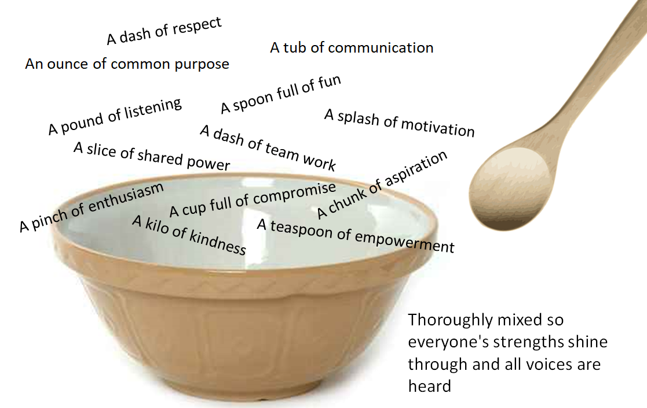

Figure 1 – Our Recipe for Working Together
Creating the environment for “Making things better together.”

We need to create a safe environment for open and honest communication so that we can build trusting relationships with service users. The Local Authority and Clinical Commissioning Group need to recognise that it takes time to build relationships and that everyone has a different starting point/experiences which will affect how they want to engage. This may mean going to the places where parents, carers and families tell us they are and may involve engaging through meaningful activity such as baking or bowling, enabling all involved to feel comfortable and bring their own views, strengths and ideas to the discussion.
Figure 2 details the kind of environment we want to create to help us work together.
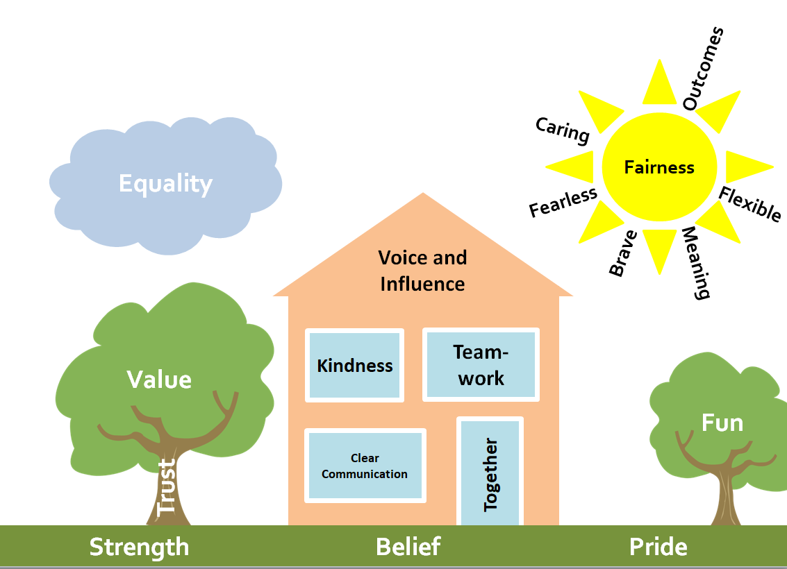
Figure 2 – Creating the Environment for Working Together

- How to Co-Produce Well?
To support commissioners and those working to develop services for children who have SEND and their families, the parent carer forum (NELPPF) and parent advice and support group (SENDIASS) have designed a request form (appendix 1) that professionals can use to outline their engagement and involvement plans for developing a service.
The model below shows the co-production process and how we will effectively co-produce.
This may have to be repeated several times before a final piece of work is produced
Be clear about what is possible and what is not
Remember to share as widely as possible
Not everyone has to meet at the same time
- How will we keep improving our ‘recipe’ for working together? What actions will we take?
Over the coming months and years we aim to keep improving how we work together. The following are some examples of where we plan to use this approach and principles to improve services and also to improve the approach to working together. This will help us build this approach into every day practice across the union.
We will test this approach and demonstrate our commitment by taking the following actions:

Appendix 1 – Parent Group Coproduction Request Form:
Request form for support to developing sections of the NE Lincs SEND Local Offer
Information for parents regarding SENDIASS /NELPFF coproduction opportunities
Why complete this form?
Parents want to know why you are seeking their views.
Completing this worksheet will support you to plan opportunities for their participation/coproduction; and it will help them to make well-informed decisions about becoming involved.
What is the purpose of the request?
[ ] To Inform
[ ] To Discuss
[ ] To Consult
[ ] To Co produce
Other (please explain) e.g.
[ ] Interviewing opportunity [ ] Task group opportunity [ ] Focus group opportunity
Why are parents’ views being sought?
Task 1 -

Task 2 -
What changes may be possible as a result of parents being involved?

What will be done with the information the parents provide?

What is the timescale for the parents’ involvement?

What skills, knowledge or resources will parents need?

How will you offer support to the parents in this role?

How and when will you give feedback to the parents on the impact of their contribution?

What expenses/recompense will be made available to the parents who get involved?
[ ] Travel expenses [ ] Token of thanks [ ] Payment/voucher [ ] Lunch
[ ] Other (please specify)

