**North East Lincolnshire**

**Joint Commissioning Strategy for Special Educational Needs and Disabilities**

**2020 – 2023**

|  |  |
| --- | --- |
| Internal Ref: | NELC/CCG Union Joint Commissioning Strategy for SEND |
| Review date | 2023 |
| Version No. | V0.02 FINAL |

**Background**

Commissioners in North East Lincolnshire have been developing integrated approaches to service design and delivery for more than a decade. We recognise the value of joint working and combining health and care resources together to design and deliver services which address people’s needs in a comprehensive and holistic way.

This document details how we will jointly deliver the improvements identified in the overarching joint SEND strategy which details the drivers for change and our vision for the future which is:

***“Our vision is for every young person in North East Lincolnshire with Special Educational Needs and Disabilities to be included in education and society; to develop their independence; and to achieve the outcomes that are important to them to lead successful and fulfilling lives.”***

We are further strengthening the relationship between North East Lincolnshire Council (NELC) and the North East Lincolnshire Clinical Commissioning Group (NELCCG) by building on the adoption of a ‘union’ model with the benefits of a joint approach to tackling the key challenges; this has included the appointment of a Joint Chief Executive over both organisations and agreement to a common commissioning approach and principles (see Figure 1 below).

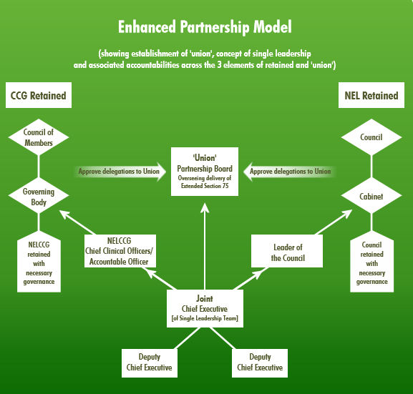

*Figure 1 – Our Union Model*

Both organisations share the vision of North East Lincolnshire as a *place*, working collaboratively to build stronger communities and a stronger economy for the benefit of all local residents.

The purpose of this document is to formalise and reinforce our approach to joint commissioning for Special Educational Needs and Disabilities (SEND) with NELC, NELCCG and other partner agencies to meet our duties in line with SEND code of practice 2014, providing value for money, driving efficiencies and ultimately improving the lives of children, young people and their families.

By supporting and developing joint commissioning practices, services will be able to keep pace with changing need and ensure that the best possible outcomes are achieved against a set of locally agreed priorities.

The Children and Families Act 2014 included reforms to the way that organisations work together to support children and young people aged 0-25 with SEND. These reforms place a duty on agencies to work together across education, health and care for joint outcomes.

Local authorities and clinical commissioning groups must make joint commissioning arrangements for education, health and care provision for children and young people with Special Educational Needs (SEN) or disabilities (Section 26 of the Act). Our intent is to foster a joined up and holistic approach to commissioning at a strategic, operational and individual level to meet need and ensure compliance with legislation, national guidance and recognised good practice.

This approach should be prioritised to ensure the best use of our shared resources aligned to actual need and provide value for money services in the face of increasing financial pressures. A long term, integrated commissioning plan, which includes robust forward planning and adopts the principles of prevention and early help, will help meet these financial pressures now and in the future.

Our Joint Commissioning Plan for SEND over the next 3 years can be found towards the end of this document. These actions have been informed by a number of sources (detailed in the SEND Strategy) and are based on a robust Joint Strategic Needs Assessment for Children and Young People.

**What do we mean by commissioning?**

Since the publication of the 2018 Joint Commissioning Strategy, we have been working together to develop a common approach to commissioning. In March 2019 this joint approach was agreed by the Union Board and the implementation of the SEND written statement of action (WSOA) plan was agreed as a union priority.

Our jointly agreed commissioning definition is:

***“Commissioning is the process by which we assess the needs of the population and ensure that appropriate responses are designed and delivered, to improve health, care and life experiences.”***

The National Audit Office defines successful commissioning as delivering the right outcomes at the right cost. Successful commissioning is, provision of a quality service which represents good value for money.

Commissioning activities include;

* assessing the needs of the people of North East Lincolnshire
* setting priorities and developing plans to meet those needs in line with local and national priorities
* securing sustainable solutions from providers (internal and external) to meet those needs
* monitoring and evaluating outcomes
* stakeholder engagement

Successful commissioning leads to good decision making, based on evidence and a thorough understanding of need which together set a path for delivering the right outcomes and value for money. It is an ongoing and inclusive process which determines where and how best to deploy the total resources available (see Figure 2)

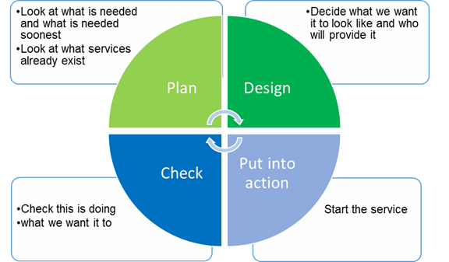

*Figure 2 – Our Commissioning Cycle*

**Our Joint Commissioning Principles for SEND:**

Our commissioning approach is underpinned by a set of union commissioning principles which are translated as follows for all work in relation to SEND. We will:

* have a single approach when we look at what impact any proposed change we are considering may have
* work with other organisations for the benefit of our children and families (for example, we will work with schools, academies, health providers and other partnerships)
* where possible make sure services we put in place are evidence-based and take into account what local children and families consider to be important
* ensure the services we put in place meet the needs of families and fit in with our wider plans for the neighbourhoods they live in and the difference we expect these plans to make
* make sure the children and families that use our services help us to plan, design and implement them
* ensure that everything we do supports young people to become as independent as possible and achieve their full potential
* actively promote innovation including the use of technology and digital approaches to support
* make sure that making a positive difference for children and families is at the heart of our commissioning process
* put a strong focus on delivering better-value, effective support, with quality and safety considered at each stage
* plan services that make the most of the skills and experience of all people working with our children and families so that the health, education and family support system works seamlessly for them
* support children and families to understand, and be able to ask for the support they have a right to
* take every opportunity to promote inclusion, wellbeing and independence

**Governance and decision making**

Roles and responsibilities for joint commissioning are clearly defined through the action plans documents relating to SEND following the Ofsted and CQC inspection and subsequent Written Statement of Action in 2018. These are as follows (see Figure 3):

*Figure 3 – SEND Governance Documentation*

All proposed changes in relation to SEND services and support will be reported and monitored by the SEND Executive Board and reported to the Union Leadership team with oversight from the Union Board. The union leadership team will recommend decisions to key decision making bodies such as the Union Partnership Board, NELC Cabinet and the CCG Governing Body.

Figure 4 below, details the monitoring and decision making process for all union activity in relation to SEND and the Written Statement of Action. The work streams to deliver this activity will be developed over the coming months.

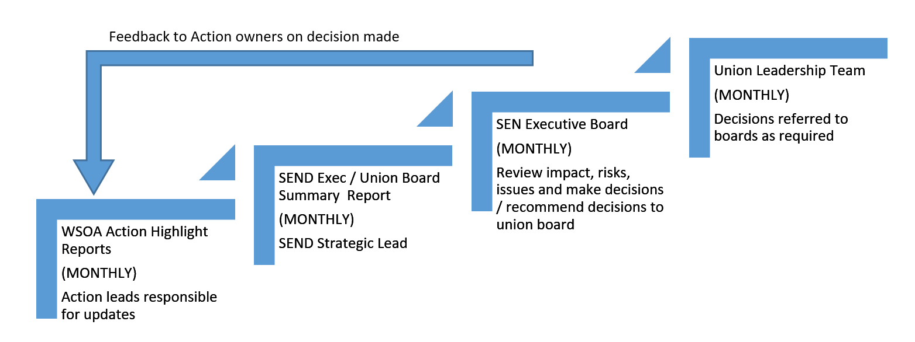

*Figure 4 – SEND Decision Making Process*

**Listening, Talking and Working Together**

In accordance with the Union’s Engagement Strategy, through the delivery of this strategy we will:

* Be clear and honest about how you can get involved
* Be clear and honest about what we are doing with what you have told us
* Hear your voice and what you have to say
* Use what you tell us to bring about change
* Be open to challenge on the way we do things
* Encourage all of our communities to take part
* Come to the places where you are
* Work together with you and others to make the best use of time and money

NELC and the CCG hereby commit to developing a full engagement plan with SENDIASS for each piece of joint commissioning activity we undertake in the following action plan.

**Joint Commissioning Plan – Our journey so far and our plan for the next 3 years**

Education Health and Care Plans

| **You Said…** | **We Did…** | **What next…** | **Impact measures** |
| --- | --- | --- | --- |
| “Never anyone from social care and health at the review process”  “One hour not long enough for an annual review meeting”  “Post 19 students want their EHC plan to continue to 25 but there’s not a consistent view of what is education”  “The SENCO didn’t know a plan could be requested for anything apart from cognition and learning.”  “Format of EHC plans vary across authorities, making them hard to understand and read”  “EHCP end result depends too much on who has written it” | Reviewed Audit process and updated Quality Assurance (QA) EHCP documentation.  QA Process now includes parent/carers as auditors.  As part of engagement workshops this has informed the development of the training programme  Parents/Carers, Children and Young People are developing a new EHCP Format  Reviewed and audited health input into EHCPs  Procured a new EHCP case management system  Significantly increased the number of EHCPs completed within statutory timescales | **In 2020/2021**  Explore the integration of EHCP review meetings with Children’s Social Care meetings where appropriate  Work with parents and carers to develop a new EHCP format  Continue to deliver training and implement the QA process  Test new EHCP Case Management System  **In 2021/2022**  Build the new EHCP case management system so parents, partners and carers can have direct access to their information | Numbers of EHCPs completed within statutory timescales will exceed the national average  The percentage of parents that say that their “family gets the social care/social worker support they need” will increase (baseline 29% in 2020)  The percentage of parents that say they “understand their EHCP” will increase (baseline 63% in 2020)  The percentage of parents reporting the “annual review process went well” will increase (baseline 61% in 2020)  The percentage of parents reporting that they “agree with EHCP outcome” will increase (baseline 60% in 2020) |

Voice, Influence and Change

|  |  |  |  |
| --- | --- | --- | --- |
| **You Said…** | **We Did…** | **What next…** | **Impact measures** |
| “The parental engagement and participation group does not work as it does not have wide enough representation”  “The voice of children with SEND in our local area is not captured and used to influence change”  “Young carers will not provide support without a diagnosis. This is really frustrating, My family needs help.”  “I have been looking for help for SEND issues for 4 years but I have not known where or who to turn to.” | Coproduction Event with professionals, children and young people, parents and carers has taken place.  The Voice, Influence and Change group has been revised and new terms of reference have been circulated.  Undertook an SEND survey with questions that have been co-produced with parents and carers  Young people’s advisory group (YPAG) set up and involved in service development work such as the sensory room etc…  Employed a local offer co-ordinator  The local offer is being accessed more frequently by families  New SEND logo developed by children and young people  Involved children and families in the interviews for the access pathway co-ordinator | **In 2020/2021**  Set up a siblings group to enable their voices to be heard  Build a new more accessible local offer website with co-produced content  Hold a SEND celebration and awards event with and for children and young people with SEND  Develop leaflets, booklets and video clips describing how to access the help people need (including the referral and assessment processes). Communications plan developed and implemented.  **In 2021/2022**  Trial new process which allows parent/ carer and self-referral for SEN support  **In 2022/2023**  Set up a process to enable continuous feedback through EHCP case management system | Families report that they know about the local offer website (SENDIASS Data)  The percentage of parents that say they have “confidence in their ability to access information about SEND” increases (baseline 50% 2020)  The percentage of parents that say they “knew where to get information about SEND” increases (baseline 62% 2020)  The percentage of parents that say they “found the local offer useful” increases (baseline 28% 2020)  First celebration event held and plan developed for an annual event  The percentage of parents that say they “get feedback about SEND developments in my area” increases (baseline 19% 2020) |

Transitions and Preparation for Adulthood

|  |  |  |  |
| --- | --- | --- | --- |
| **You Said…** | **We Did…** | **What next…** | **Impact measures** |
| “My school has a brilliant SENCO but the transition to secondary school is really worrying me.”  “There is not enough support available for young people to move into further education.”  “There is a gap between child and adult services.” | Developed a transitions good practice model and reviewed the health transition process too  EHCP co-coordinators attend all transition reviews  A SEND transition working group has been set up | **In 2020/2021**  Roll out good transitions protocol to schools and other settings  Implement a programme of supported internships for young people with SEND  All 16-18 year olds with an EHCP will be allocated an EET (Education, Employment and Training) practitioner  **In 2021/2022**  Audit the use of the transitions protocol in schools and other settings  Increase the number of supported internships offered for young people with SEND  **In 2022/2023**  Roll out of the SEND Charter Mark to local employers | Decrease in the number of SEND (SEN Support and EHCP) who are Not in Employment Education or Training (NEET) at age 17 (baseline 9.7% 2017/18)  Percentage of adults with learning disabilities in paid employment increases (baseline 11.3% 2018/19)  Percentage of 19 year olds with SEN support or EHCP qualified to level 2 in English and Maths increases (baseline 21.9% 2017/18)  The percentage of families that report they are talking about preparation for adulthood in Y9 or before increases (baseline 44% in 2020)  The percentage of parents that say that they are “confident that my child would like to access FE when they turn 16 that they will be supported to do so” increases (baseline 41% in 2020)  The percentage of parents that say “I am confident that my child will be supported to gain employment” increases (baseline 42% in 2020)  The percentage of parents that say “I am confident that my child will be supported to live independently” increases (baseline 42% in 2020) |

Health and Social Care

|  |  |  |  |
| --- | --- | --- | --- |
| **You Said…** | **We Did…** | **What next…** | **Impact measures** |
| “Young Minds Matter won’t accept a referral for my child, as they don’t meet the criteria. They have left us nowhere to go and we are desperate.”  “There is no understanding of selective mutism in NE Lincs. I have had to introduce professionals to this area of SEND and there is no specialist support or help.”  “Health services for young people aged 16 changes and there is nothing appropriate for them and no real transition at this point.” | Reviewed the healthy child programme to make sure that 2.5yr development checks were being done in a timely manner to allow early identification  Reviewed the health transition process  Carried out an audit of management of records by GP practices for adopted children and young people  Begun a review of all therapies (including speech and language therapy)  Reviewed the performance framework for the assisted living centre and made more equipment readily available from the community equipment store  Undertaken a Health Needs Assessment for vulnerable children including those with SEND so we better understand their needs. This has formed our Children’s Joint Strategic Needs Assessment (JSNA)  Appointed a Designated Clinical Officer for SEND to create capacity in relation to the health of children with SEND  Undertaken training with GPs on SEND | **In 2020/2021**  Exploring the integration of EHCP review meetings with Children’s Social Care meetings where appropriate  Develop the offer of Mental Health support teams in schools  Ensure effective transition processes are in place between children’s to adults’ community nursing  Ensuring the new referral and assessment process for SEND has health, education and social care involvement  Co-produce a new range of family training/support for SEND tackling useful subjects for families of children with SEND (e.g. time to sleep, helping your child reach their potential etc…)  Review therapies offer across speech and language, occupational therapy, nutrition/dietetics and physiotherapy  Combine the contract and performance monitoring arrangements for Speech and Language across the borough  **In 2021/2022**  Review Health Visiting service 2- 2.5yr developmental check to include advice, guidance and specific early identification of SEN in children born prematurely.  Undertake a review of the oral health of children and young people with SEND  Re-commission therapy services across NELC and CCG  Undertake a review of the short breaks service and co-produce a new offer  **In 2022/2023**  Review maternal health offer and develop commissioning plan to reduce local prevalence of prematurity. | The percentage of parents that say “our family gets the social care/social worker support they need” increases (baseline 29% in 2020)  The percentage of parents that say “our child gets the health care support they need” increases (baseline 43% in 2020)  The percentage of parents that say “our family gets the health care support we need” increases (baseline 37% in 2020)  Waiting times for assessment reduce year on year  The percentage of parents that say they know how to access therapy service increases year in year (baseline 35% 2020)  The average age of assessment is reduced year on year (baseline to be determined) |

Leadership and Governance

|  |  |  |  |
| --- | --- | --- | --- |
| **You Said…** | **We Did…** | **What next…** | **Impact measures** |
| “The voice of children with SEND in our local area is not captured and used to influence change.  “SEND is a low priority.” | Impower conducted a review of SEND education services  SEND has been identified as a priority for the union between North East Lincolnshire Council and North East Lincolnshire Clinical Commissioning Group  Undertaken phase 1 of a Health Needs Assessment for vulnerable children including those with SEND so we better understand their needs  Held a co-production event which fed into the development of the union’s Engagement Strategy.  Increased resources for SEND by recruiting, a strategic lead for SEND, a local offer co-ordinator, a designated clinical officer and additional EHCP co-ordinators  Set up a new governance process for reporting of progress on the written statement of action to the SEND Executive Board and the Union Leadership Team  Provided updates to the Children and Lifelong Learning Scrutiny Panel | **In 2020/2021**  Implement phases 2 (how well are we meeting children’s needs) and 3 (optimising resilience) of the Health Needs Assessment  Develop a live joint data dashboard to collate key health, social care and education data and inform service monitoring  Undertake an evaluation of SEND investment and outcomes for children and young people  Review SEND sufficiency and develop an action plan to ensure sufficiency of local places for children and young people with SEND  **In 2021/2022**  Update SEND Joint Strategic Needs Assessment  Review this joint commissioning plan based on intelligence gathered from phases 2 and 3 of the Health Needs Assessment and results of the annual SEND survey  Undertake a review of the possible causes of inequality in SEND (considering YOS, NEET, exclusions and attainment)  **In 2022/2023**  Review the Joint Commissioning Strategy based on intelligence gathered from above activity | Number of complaints received (across NELC, CCG, NLAG and LPFT) in relation to SEND reduced year on year  Number of EHCP mediations and tribunals reduced  Academic outcomes for CYP with SEND improved (KS1, KS2 and KS4)  The average age of initial issue of EHCP reduces year on year (baseline to be determined) |

Identification and Assessment of SEND

|  |  |  |  |
| --- | --- | --- | --- |
| **You Said…** | **We Did…** | **What next…** | **Impact measures** |
| “I have done 3 single assessments for the Access Pathway. They have all been lost or the person leading the referral has left. I have given up trying to get help.”  “I feel that parents are confused with what the pathway is actually for.”  “Parents believe that the panel was not looking at the history of the child as part of their decision-making. This led to the panel suggesting avenues that had already been used, or had already proved unsuitable.” | Asked Healthwatch to undertake an independent review of the Access Pathway process  Received and accepted a petition to remove the Access Pathway  Worked with families to develop a new approach to the identification, assessment of need and support. Gained cabinet approval to prototype the new process with families.  Developed a new feedback and complaints process  Recruited a new co-ordinator for the pathway  Co-produced a new referral form with families and a self-referral process with NELPFF and SENDIASS. | **In 2020/2021**  Undertake a prototype of the new process to help learn and grow the model with family journeys so that the new model is co-produced and can be effectively commissioned  Develop guidance and videos to explain the new process  Implement new complaints process  Re-shape SEN support services in schools for Autistic Spectrum Conditions and Physical Disabilities to ensure a consistent quality delivery model  **In 2021/2022**  Scale up staffing as required and implement the new approach  Make sure the new process allows parents to be involved in discussions with professionals about their child  Make sure that parents have access to a case co-ordinator / keyworker who can help them if they have a question  Develop a communication plan about the new pathway so everyone understands it  **In 2022/2023**  Healthwatch to undertake an independent review of the new process with families  Implement findings of independent review | Number of complaints about the assessment process reduce year on year.  Waiting times for assessment reduce year on year.  Parental feedback on the new approach improves year on year.  Gap between NELC and average numbers of cases of ASC closes. |

Early Years

|  |  |  |  |
| --- | --- | --- | --- |
| **You Said…** | **We Did…** | **What next…** | **Impact measures** |
| “Settings do not talk to each other about their children as the move from one to the other.”  “It took too long for the CDC to see my child; It was too late to get things in place in time for starting reception class.  “I am so stressed out because I don’t know where to get the help I really need.” | Developed an SEND Data Dashboard to inform service and improve outcomes for young children  Undertook a review of the Child Development Centre assessment processes including workshops, observations and parent interviews to help understand the journey  A review of the healthy child programme to improve early identification of SEND  Undertaken a mapping exercise to identify gaps in support for under 5s  Reviewed the early years (Portage) offer to ensure there is a full term of support following assessment at the CDC | **In 2020/2021**  Develop a business case to increase provision in the Child Development Centre, reduce waiting times and improve access to support for under 5s  **In 2021/2022**  Monitor improved CDC service, develop service specification and monitoring process.  Review Health Visiting ASQ3 so that SEN status is recorded age 2-2.5  Undertake an audit of SEND cases (including those that did not make a good level of development at EYFS) to identify opportunities for earlier identification, assessment and intervention  **In 2022/2023**  Re-commission the assessment offer for under 5s in line with Access Pathway actions above  Implement the SEND Charter Mark with early years settings  Implement findings from early intervention audit | The average age of initial issue of EHCP reduces year on year (baseline to be determined)  The average age of assessment is reduced year on year (baseline to be determined)  Waiting times for assessment reduce year on year. |

5-16 Education and Wider Outcomes

|  |  |  |  |
| --- | --- | --- | --- |
| **You Said…** | **We Did…** | **What Next…** | **Impact measures** |
| “If school don’t think your child has SEND needs all doors are shut to you.”  “My child is supposed to get SEN support but I don’t know what help he gets. I have never seen a “My plan” or anything.  “My son has had repeated fixed and permanent exclusions, displayed challenging and violent behaviour but I cannot get either professional or social care help.”  “Teachers do not have adequate training to deal with SEN effectively due to lack of understanding.”  “I have to retell my child’s story every year to a new teacher.”  “I don’t know what an ECP is. I go to my meetings with my mum and my teachers but I don’t know what an EHC plan is.” (Y8) | Co-produced and launch a new SEND Charter Mark to support a common vision of inclusion in our local areas services and education settings  Worked with schools and settings to develop a “Together For All” pledge which is a commitment between Children’s Services and Schools to improve outcomes for all students with a strand on SEND  Delivered training in schools on trauma informed practice | **In 2020/2021**  Roll out the SEND Charter toolkit  Undertake audits of the SEND Charter Mark to make sure schools and settings commit to inclusion of SEND  Develop a communications plan to share our successes and developments in SEND in the local area  **In 2021/2022**  Develop an SEND Charter Mark for local businesses to sign up to  Review inclusion work with the Primary and Secondary Behaviour and Attendance school Collaboratives (BAC)  Undertake a review of the possible causes of inequality in SEND (considering YOS, NEET, exclusions and attainment)  **In 2022/2023**  Implement findings of the inequality review  Develop a new School Nursing specification targeted (at those most at risk of poor outcomes) | Academic outcomes for CYP with SEND improved (KS1, KS2 and KS4)  The percentage of parents reporting that they “agree with EHCP outcome” will increase (baseline 60% in 2020)  Numbers of fixed term and permanent exclusions for SEND reduce year on year  Percentage of 19 year olds with SEN support or EHCP qualified to level 2 in English and Maths increases (baseline 21.9% 2017/18)  The percentage of parents that say “my child has been supposed to reach their goals (age 18)” increases year on year (baseline 61% 2020)  Number of SEND known to the YOS reduces year on year  Number of SEND that are classified as NEET age 17 reduces year on year |

## Supporting Documentation:

**Related North East Lincolnshire Strategies and Documents:**

* NELC’s Outcomes Framework
* The SEND Strategy
* The Local Offer
* Health and Wellbeing Strategy
* The Engagement Strategy
* The SEND Sufficiency Strategy
* Together for All pledge