Helping you to meet your mobility, health and well being goals, with the support of your therapist

[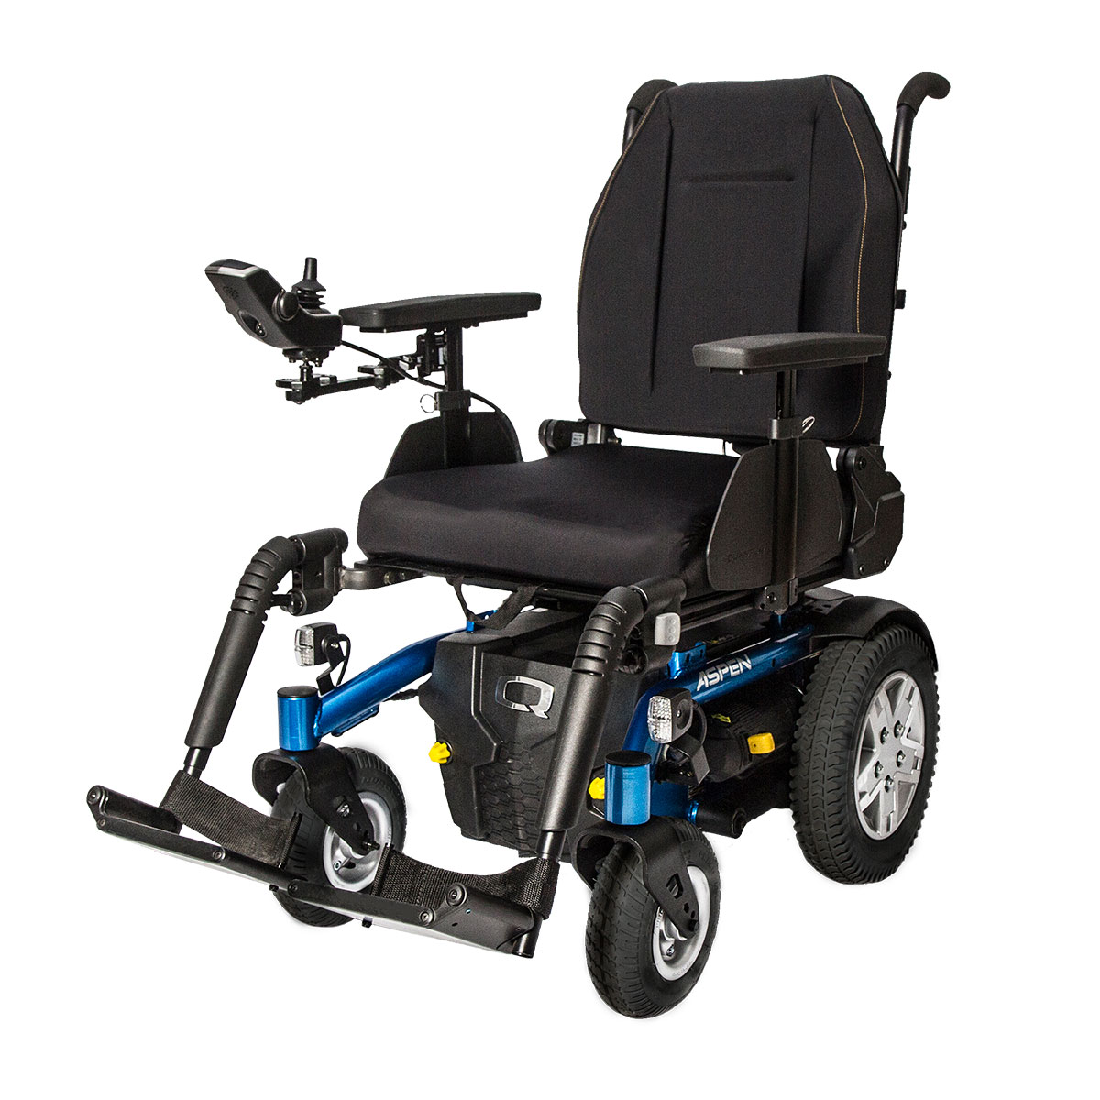](https://www.google.com/url?sa=i&rct=j&q=&esrc=s&source=images&cd=&cad=rja&uact=8&ved=2ahUKEwizi_vysunaAhVIWRQKHdfOCYcQjRx6BAgBEAU&url=https://www.activemob.co.uk/shop/electric-wheelchairs/rear-wheel-electric-wheelchairs/pride-quantum-aspen-electric-wheelchair/&psig=AOvVaw3BzAu0BFhG74dGFfgu0gaY&ust=1525431545781171)[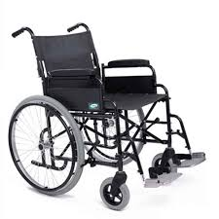](https://www.google.com/url?sa=i&rct=j&q=&esrc=s&source=images&cd=&cad=rja&uact=8&ved=2ahUKEwjJv6ejs-naAhUIWxQKHb3BDwYQjRx6BAgBEAU&url=https://www.nrshealthcare.co.uk/mobility-aids/wheelchairs/lomax-uni-8-self-propelled-wheelchair&psig=AOvVaw3BzAu0BFhG74dGFfgu0gaY&ust=1525431545781171)

Personal Wheelchair Budgets

(PWB)

Information for Patients and Visitors

**Joined up Planning**

For those wheelchair users who receive help and care from other agencies in the NHS, Social Services, Education and Charities consideration may be given to how the wheelchair will positively affect the level of care and support you currently receive

**Contact us**

Address

Hospital

Address

Postcode

Telephone:

# **Expected Longevity of Equipment & Insurance**

It is important to regularly maintain and repair your wheelchair. A typical adult wheelchair lasts 5 years. For children, changes are needed more often as they grow, typically every 2-3 years. This may also be the case with some medical conditions where wheelchair needs can change quickly.

Public Liability Insurance is strongly recommended if you are using your wheelchair in a public place particularly a powered wheelchair.

**A Personal Wheelchair Support Plan**

Before your wheelchair assessment you will be asked to think about the things that are important to you to by completing the personal wheelchair support plan which will help you and the therapist to find the most appropriate wheelchair/ seating solution.

***3) Outside NHS provision (this is called a Third Party PWB)***

In discussion with your NHS wheelchair therapist, if it is clinically appropriate, you can choose to use your PWB to contribute to buying a wheelchair from an Independent Provider outside of the NHS. Your choice will need to be agreed as clinically appropriate by your NHS wheelchair therapist . You can only use your PWB for the same category of chair. For example, a PWB for a manual wheelchair must only be used for purchase of a manual wheelchair.

The wheelchair therapist will be able to provide general advice if you choose this option, but will not accompany you to the assessment by alternative providers.

Your 3rd party PWB includes an allowance for Repairs & Maintenance as you will not have access to the NHS approved repair service. It will be your responsibility to arrange ongoing repairs.

***2) Notional with contribution for additional features***

This option allows you or another agency (eg. Voluntary or charitable organizations) to contribute to your PWB to add extra features to your wheelchair. For example, this could be a seat riser on a powered wheelchair or patterned spoke guards on a manual chair. The NHS wheelchair therapist will be able to advise and support your choice of additional features. The value of the PWB is still the cost to the NHS to provide a wheelchair to meet your identified needs.

By choosing additional features you or the supporting organisation will contribute to the overall cost of the wheelchair package. This will include VAT at 20% for the additional features which may be reclaimable privately.

With both notional options (1&2) the chair you chose remains NHS property and includes free NHS repair and maintenance but may not extend to include all additional features if option 2 is chosen.

**What Is a Personal Wheelchair Budget?**

The Northern Lincolnshire and Goole (NLAG) Wheelchair Service is now offering Personal Wheelchair Budgets (PWB). This is an individual resource available to help you meet your mobility and health and well being needs, with the support of your wheelchair therapist.

There are 3 ways that you can choose to use your PWB

**What are my Options?**

***1) Use within the NHS wheelchair range (this is called a Notional PWB)***

A notional wheelchair budget means that you can have a wheelchair from the NHS range through the wheelchair service. The value of the PWB is the cost to the NHS to provide a wheelchair to meet your identified needs.