Teams – How to Login
On any web browser, e.g. Google Chrome, Internet Explorer, Safari etc, go to www.office.com

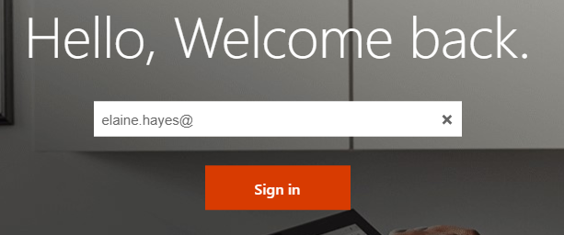
Click sign in and sign in with the username and password provided by your school.

Click on the Teams icon
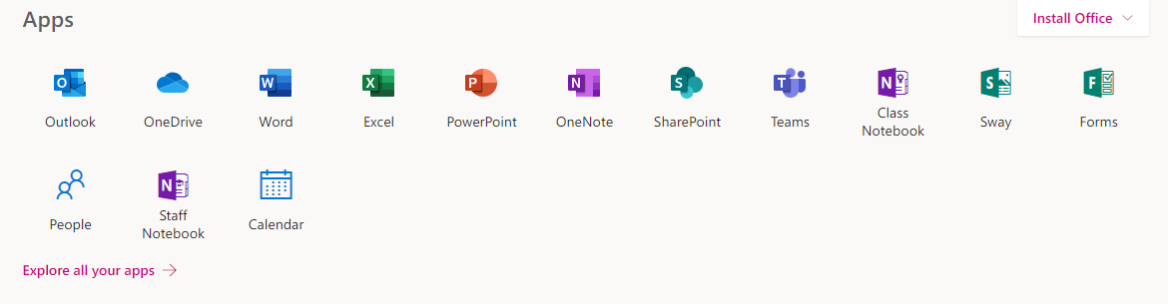
You should now see all the Teams if your teachers have already set them up for you, or you may have different codes to join your classes.

Teams – My teacher has given me a code to join a class
Your teacher will have given you a 7-character code, made up of letters and numbers – the letters are all lower case.

Log into Teams, in this example the student already has some of their teams. To put in the code, click join or create a team button in the top right hand corner, circled in red. 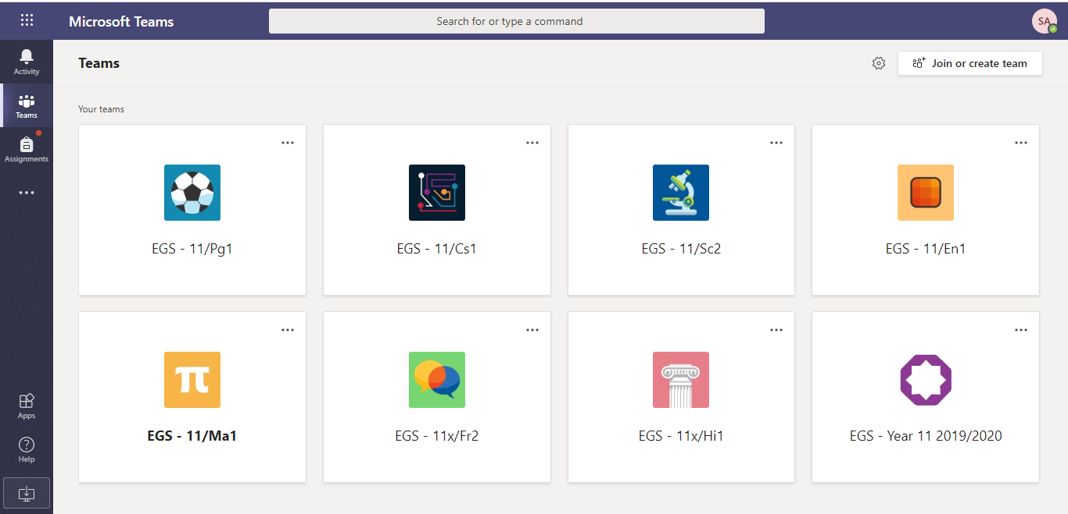

Once you click the button, this menu appears.
Put the code in that your teacher has given you and click the join team button circled. Be careful when inputting your team code as it is case sensitive.
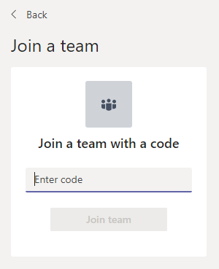

Teams – Joining a Virtual Classroom – Student
If your teacher has started a virtual classroom, you will see a blue notification in your Team. Your teacher will have told you what time your lesson starts, and you can join at any time by clicking the join button.
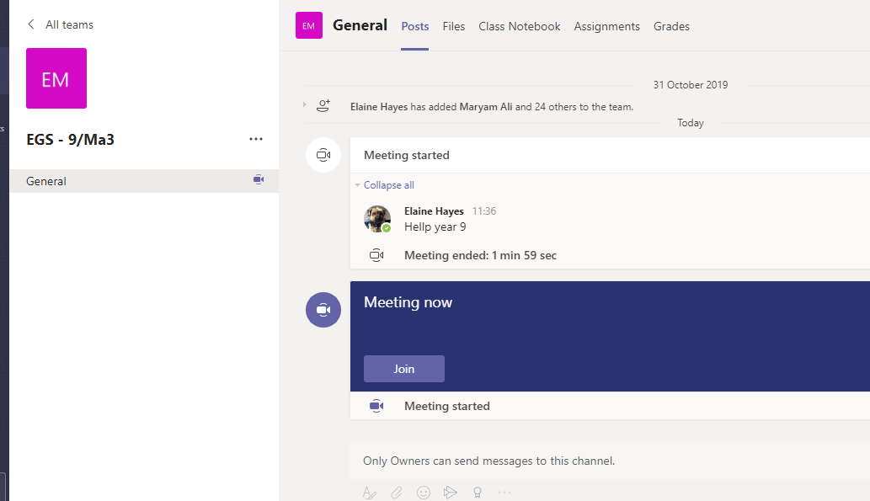

The make sure the camera function is switched off. Your teacher may have told you to keep your microphone on or off – in this meeting, the teacher has asked all students to keep their microphone off unless they are asking a question. You can ask a question of your teacher using the chat function. All questions are kept in the Team after the lesson is over.
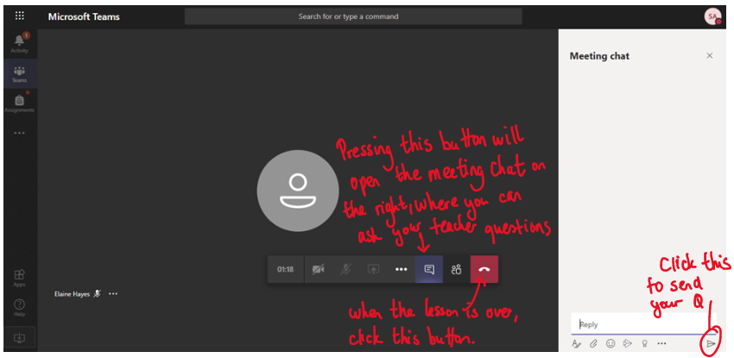

Teams – Uploading an assignment
Your teacher can set assignment for you to complete. You can access this is two different way. You can click the assignments button in the left-hand menu to see all the different assignments set by your teacher, or you can click into your class and click on the assignments button.
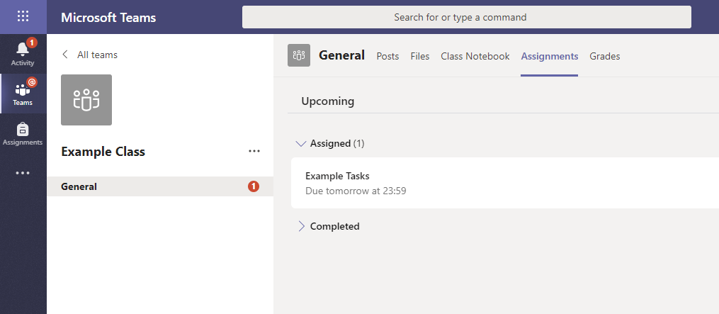

Click on the assignment to access the task.
To add your work, click on the add work. You can add a document that you have already been working on, or create a new one that you can do your work on. Your teacher will have given you some instructions on how to submit your work.
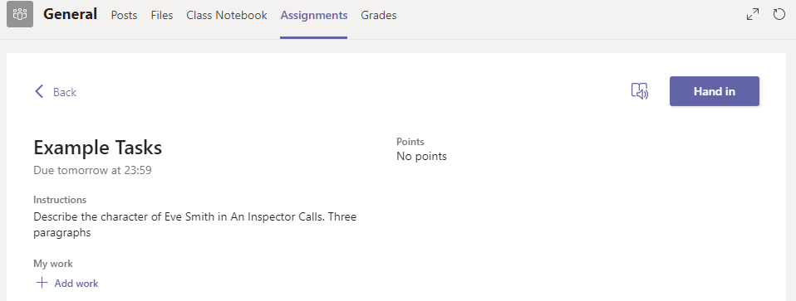

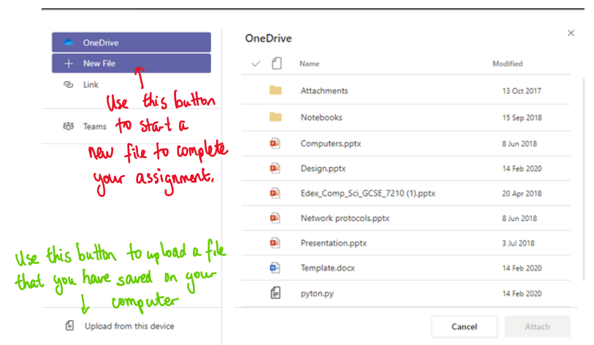
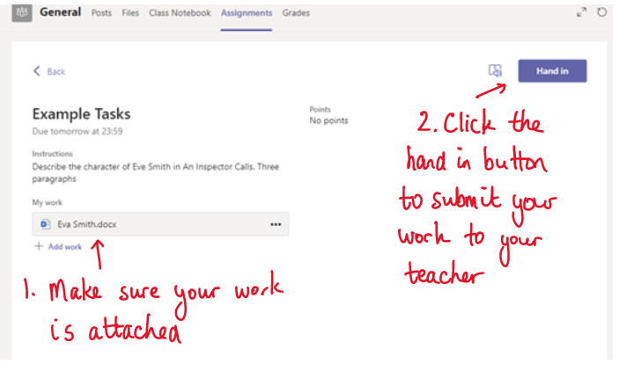

Make sure that you have your work attached. Click the hand in button. Your teacher can now look at your work and give you feedback if required.
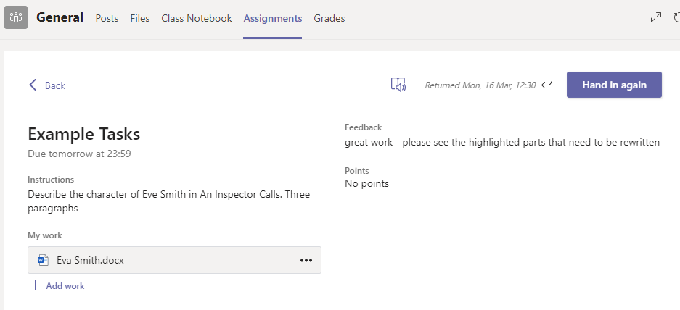
This piece of work has been looked at by this student’s teacher and been given some feedback. You can click on the file to open it and act on the feedback given to you by your teacher, before handing it in again.

Taken from TES 2020

