Google Classroom Pupil Guide

Logging In
1. Go to https://classroom.google.com and click on the “Sign In” button.
2. Having got to Google Classroom, to sign in, students must enter their school login credentials. This is their school e-mail address and their network password. These will be provided by your school.
3. Having logged in, students will be presented with all of the Classrooms that they have already been enrolled onto. For a student to enrol onto another Classroom, they must click on the "+" sign at the top of the screen, followed by "Join Class".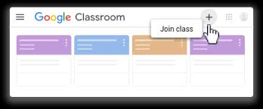
4. After clicking on "Join Class", students must then type in the code that was provided by their teacher. Note: They only need to do this once. After they have joined the class once, they will remain as a member of the Classroom for the rest of the academic year.
Viewing and Accessing Homework
- To view homework or tasks set, - once logged in to Google Classroom – students need to click on the class that they wish to view.
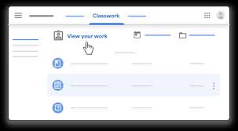
2. Having clicked on the appropriate classroom, the student will be in a Google Classroom. Here, they will have 3 tabs in front of them; "Stream", "Classmates" and "About".
The "Stream" Page
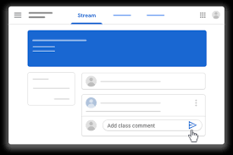
The stream works similarly to a social network page. The most recent post that a teacher has added to the Google Classroom will be at the top and the oldest will be at the bottom. Each post will be associated with the subject that the student is learning with that teacher.
When a teacher posts an assignment on their Google Classroom, it will contain the name of the task, a description of what the student has to do and possibly associated resources where possible. It will also have a due date for when the work needs to be completed by.
Students will be guided by their teacher on whether they complete their work online using Google Classroom or offline in another way.

Completing/Submitting Work Online
If students have to complete their work online, they will need to click on the name of the assignment followed by "Add +". A drop-down menu will appear where they can choose to create a Google document or upload a file from their computer or their online storage Google Drive.
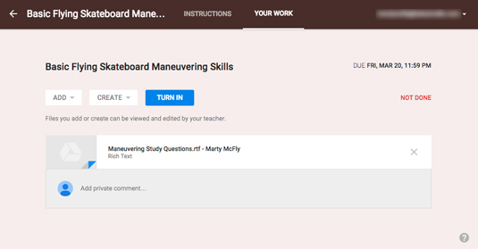
Having added their chosen document, it will appear in the white box just above the "Add +" button.

If a student has chosen to create a new document from the "Create" section, then they simply need to click on the file and then they can start their work. The file will open in a separate tab and will save automatically until closed. The student can go back to this document to work on it as many times as they wish until they need to submit it.
After the work has been completed or added to the assignment, then the student will need to press the "Hand In" button. See image below.
Completing work offline
Students who have been asked to complete the homework offline, will only need to access the information on Google Classroom. Once they have finished the homework, they will need to click on the assignment but then, just click "Mark As Done". This will notify their teacher that they have completed their work in time for the deadline.
The "Classmates" Page
If a student clicks on the "Classmates" page, they will be able to see all of the other students in their class.

The "About" Page
If a student clicks on the "About" Page, they are likely to find links to useful documents and websites associated with the course or subject that they are studying.

Mobile Apps
Students have the opportunity to download Google Apps for their handheld device. They are free but they must remember to use their school login details as mentioned at the top of the page as opposed to any other Google account that they use at home. Inside each app, they will give the user the choice on which to use.
The recommended apps are the following:
- Google Classroom
- Google Drive
- Google Docs (free alternative to MS Word)
- Google Slides (free alternative to MS PowerPoint)
- Google Sheets (free alternative to MS Excel)

