How to use Google Classroom on Xbox One & Xbox Series X/S 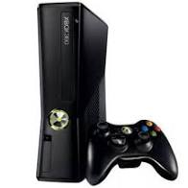
The Xbox consoles each have access to Microsoft Edge - the web browser that comes preinstalled as part of the Xbox user experience. This can be used to access Google Classroom (or another online education service approved by your child's school).

1. Plug a wired keyboard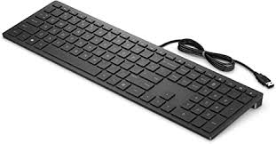 into your Xbox One, Xbox Series X or Xbox Series S via on of the USB ports on the front or back.
2. Press the Xbox button top-centre of a game controller and head to "My games & apps" in the side menu.
3. Click on "See all", scroll down to "Apps" and you will see Microsoft Edge in the icons on the right-hand side. Open it.
4. Type classroom.google.com into the URL bar at the top and log in as you would on a PC using your school Gmail account.
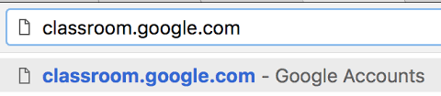
5. You can either use an Xbox controller to move the cursor or a separate USB mouse plugged into one of the other ports.
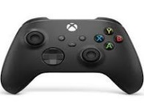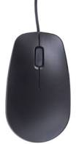

How to use Google Classroom on PS4 & PS5

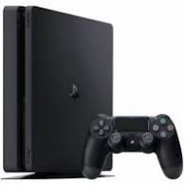
The PlayStation 4 has its own web browser that is easy to find on the PlayStation 4 (in the content menu as an icon with WWW written on it). However, it's currently a bit trickier on PS5, as there is no way to open the browser natively.
Instead, you can open the System Settings, then the User Guide. This will open up an online user manual inside a web browser page so you only have to change the URL at the top. Otherwise, the rest of the steps are the same.

- Plug a wired keyboard and/or mouse into the USB ports on the PS4 or PS5 - each console should recognise them.
- In the URL bar of the browser, type classroom.google.com and then log in using the details provided by your child's school.
3. You can now access Google Classroom.
In some cases you might not be able to do everything you can on a laptop or PC, but you can, at the very least, access Google Classroom and see what work your teacher has assigned for you to do.

