Accessing Microsoft Teams via

Xbox & PlayStation

1. Turn on and sign in (if required)
2. Access the internet browser on your console’s home page
(e.g. Microsoft Edge, Internet Explorer, Google etc.)
3. Search: Microsoft Teams
4. There is no need to download you can just sign in using your Candidate Number and password.
5. This will take you to the Microsoft Teams home page (which will look the same as it would on any other device)
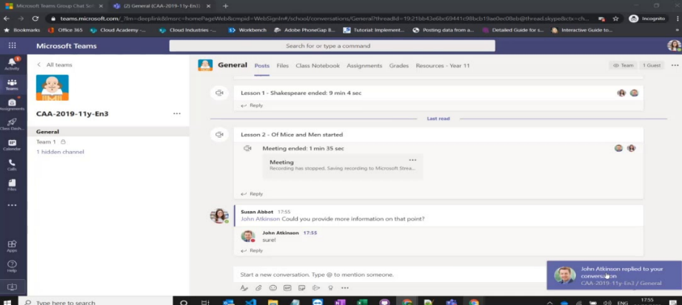
If you do not have a camera hooked up to your television (which is highly likely) then your child’s teacher/friends will not be able to see them. However, they will be able to see everybody who has a camera during the live chats and access all the work that has been posted for them.

