In this guide...

• What is transition?
• All about NE Lincs Transitions Best Practice Guidance
• Receiving settings —top tips
• Feeder settings —top tips
• How can parents/carers help?
• Early Years Transitions Best Practice Guidance
• Transitions Ideas during Covid https://sendlocaloffer.nelincs.gov.uk/school-transitions/

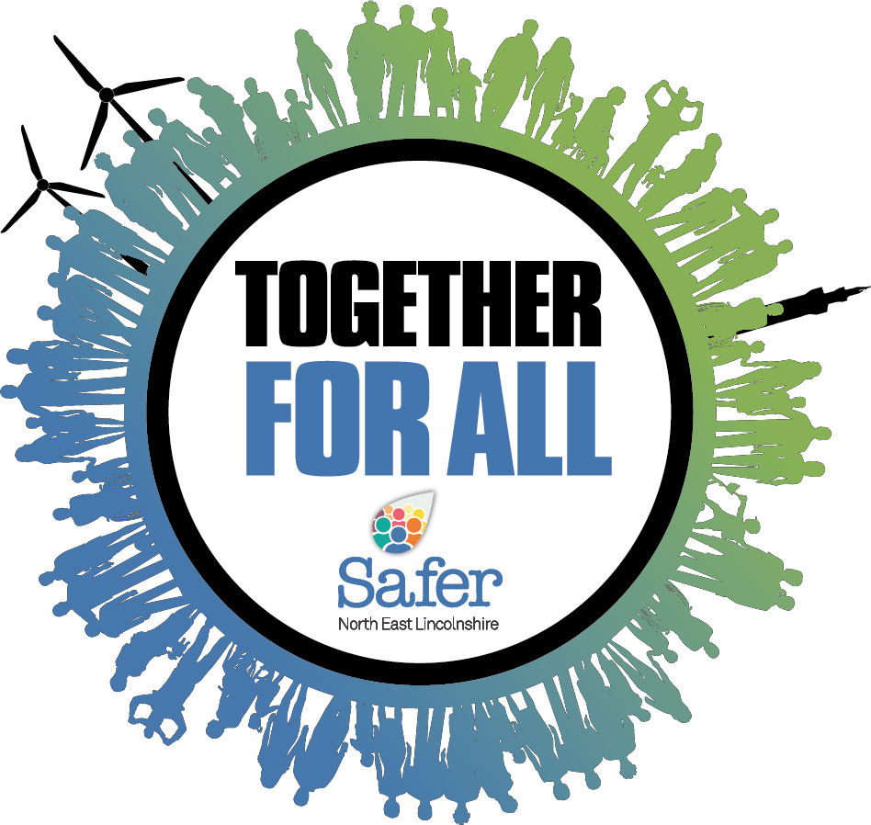SEND Transitions
Best Practice
guidance

2020-2021

1
TRANSITIONS
Best Practice guidance
What is transition?

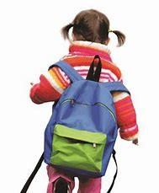• The term ‘transition’ is used to refer to life changes that child/young person and young people may go through.

• Some will be experienced by all child/young person, for example puberty or moving from one educational setting to another.

• Others will only be experienced by some child/young person and may not necessarily be understood by their peers, for example ill- ness or death in the family, family break-up, going into care, adoption, issues related to sexuality, teenage pregnancy, the asylum process or the consequences of crime.

TRANSITIONS
Best Practice guidance
What is transition?

This SEND Best Practice Guidance focuses on just one kind of transition – moving into, between and out of educational settings. In particular, it looks at three key transition points; the move from:

 Early years to primary setting

 Primary to secondary setting

 Secondary setting to work, college or university

Moving from one setting or setting to another can be stressful, and while all child/young person and young people benefit from positive experiences of transition, some require additional support. child/young person and young people with special educational needs and disabilities often find transition more challenging than their peers.

This SEND Transitions Best Practice Guidance
suggests what settings, families and children and young people can do to ensure that transition is as smooth as possible.

How and why was the NE Lincs
SEND Transitions Best Practice Guidance developed
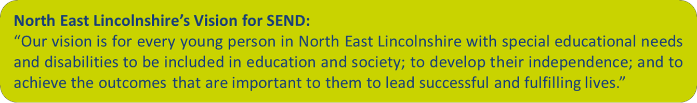

The NE Lincs SEND Transitions Best Practice Guidance has been developed to help give the best to support to the 3,500 children and young people in NE Lincs with Special Educational Needs and Disabilities when they move classes or settings.

It is intended that this guidance should be used alongside
Section 9 of the NE Lincs SEND Charter Mark.

What does the NE Lincs
SEND Transitions Best Practice Guidance aim to do?

• Suggest some practical approaches to supporting a smooth transition at different stages in the education process

• Identify what settings and child/young person and their families can do to smooth transition

• Improve educational attainment for child/young person and young people with SEND at the end of EYFS, Key Stage 1, 2 and 4 for learners in NE Lincs with Special Educational Needs both at SEN support and those with EHCPs

• Decrease the % of fix term and permanent exclusions for children with SEND

• Increase the % of learners with SEND in mainstream
provision

• Increase the % of Post 16 learners with SEND in education, employment, and training
Why is it important to support and promote
Best Practice Transition in NE Lincs?

• There is a need to create consistency in the approach to inclusion across North East Lincolnshire, particularly at
points of transition.

• In our local area too many parents/carers and teachers have worried that a child or young person with SEND will need an EHCP if they are to successfully manage transition.

“We worry about how children and young person will manage [in secondary setting] so we apply for an EHCP in year 5-6 as it is safer than risking transition

- Some educational professionals and parents/carers have also referenced using EHCPs as a way to ensure smoother transitions between primary and secondary for child/young person and young people with SEN support needs due to absence of trust in the transitions process.

• This trend suggests a greater focus of support is required to support smooth transitions into and between education providers with ongoing inclusion support to match individuals Special Educational Needs.

What have children and young
people said about transitions?

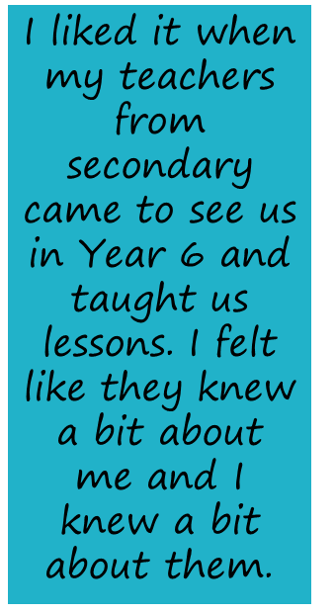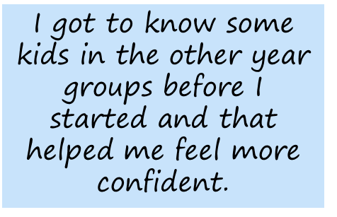Me and my

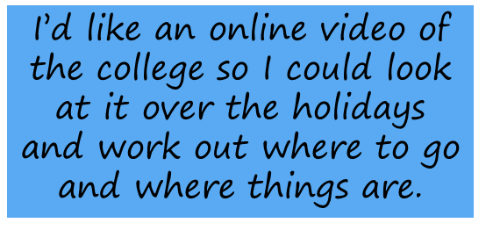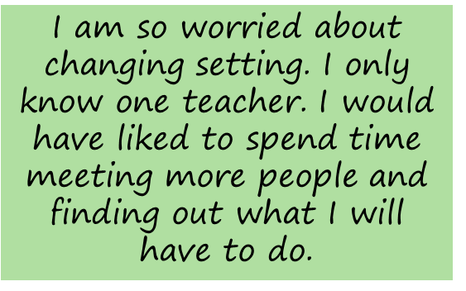Mum went to the new setting and I played and had dinner there. I had a book about my new class to take away.

What have parents and carers
said about transitions?

My child needs to know who he

can go to and when if he wants help. This needs to be consistent and all through the year not just at the beginning.

One or two visits to the new teacher with all the other pupils is not enough. My child needs a different approach to moving classes even though it is the same
setting.
Texts and communication from settings about my child/young person would reassure me. They go the secondary and you don’t know what is going on, it’s not like primary setting.

If I could meet my child’s teachers and build a relationship with them before my child/young person started their setting I would have more confidence

Knowing the teachers had

all the information they needed about my child would help me feel they really understood her needs.

What have teachers said about
transitions?

Identified individual visits to students from Y5 onwards would help build relationships

Sharing information about expectations might help everyone understand what is possible

Being able to read about a

child is Ok, but being able to work with them before they start setting is more important.

Support from parents is vital to making it work

Accurate assessment information and details about students needs are essential.

How can receiving settings
be prepared!

Make sure that the setting is accessible.
Educational settings are subject to the Equality Act 2010. This places duties on establishments not to treat disabled people less favorably and to make ‘reasonable adjustments’ where disabled students are placed at a ‘substantial disadvantage’. The duty is anticipatory, i.e., it does not only arise when a disabled pupil/student is about to join; instead, educational settings should anticipate the requirements of disabled learners/students and make, in advance, the adjustments they are likely to need.

Find out early if learners/students have particular needs and make the necessary adaptations and reasonable adjustments.
These should be in place when the learner joins the setting. You can find out a great deal from reading pupil profiles, relevant past re- ports and supporting documents, such as progress reports, provision maps, education, health and care (EHC) plans and attendance and behaviour data. However, it may be difficult to get a true picture of the capabilities and needs of an individual from paper or electronic records, so create opportunities to get to know the learners/ students better before they join you.

How can receiving settings
be prepared!

Prepare your staff.
All staff need to have a good understanding of the needs of those due to join the setting or setting. Make sure that staff briefings and training take place in good time, so that when learners or
students arrive everyone knows how to
make them welcome and secure, how to
help them settle in quickly, and can take
account of their needs.

Acknowledge it’s a big moment
Remember that families are likely to be at least as anxious about the first days of school as their children are – it marks a very big milestone in children’s lives. Anything you can do to ease that transition will make life better for everyone!

Think about ways in which families can be communicated with that acknowledges they will have questions and that the setting is there to support parent/carers anxieties too.

Please see NE Lincs Transitions Ideas during Covid for further support

https://sendlocaloffer.nelincs.gov.uk/school-transitions/

How can receiving settings
get practical?

Give children/young people an opportunity to visit their new setting, accompanied by a family member or a friend. Individuals with mobility or visual difficulties may wish to visit several times to familiarise themselves with the layout. Those with learning difficulties may like to take photographs to help them remember and think about their new setting.
Ask this year’s parents/cares what they wish they had known before their child started and collate that into information for the next incoming parents/carers. Make sure that the information is friendly and is easy to access – put it on your website and make it clear what and where it is. Provide opportunities for learners to visit and experience some classes in their new school.

Provide learners with a map of their new school building
– colour code rooms and highlight important areas such as the cafeteria, toilets, assembly hall and form rooms.

How can receiving settings
get practical? (2)

Creating a transition pack for each learner can be really helpful and reassuring . It could include information about:

• New environment - maps, locker, bells , break, lunchtimes, moving between classes ,

• New vocabulary - ‘tutor group’, ‘head of year’, subject-specific vocabulary,
• Key people - mentor, form tutor, SENCO, who/how to ask for help,

• Quiet area - library, allocated area for stress management ,

• Time timetable - how to use it, formatted for the individual’s under- standing.,

• Systems for organization - diary, checklists for materials and books,

• Homework – expectations and explanations,

Create daily checklists so that the correct items are taken to and from school for each day’s activities.

A personal Profile – written by pupil (with LSA/ parent/teacher support), including all the information new staff should know about the pupil

How can feeder settings
pave the way?
Share information with receiving settings.

Staff need to understand the implications of an individual’s SEND so that they can plan to meet those needs. Some set- tings compile a profile, which outlines key facts about an individual and highlights points to consider, for example: − mobility needs − how the individual communicates − special measures to support participation or learning, such as allowing additional processing time, breaking tasks down into manageable steps and using visual timetables − strategies that support positive behaviour, such as giving movement breaks and using ‘time out’ cards − care and/or support needs.

Prepare learners

It is important to listen to them and acknowledge and address any concerns they may have. Encourage visit s to the new set- ting to get to know the layout, experience the curriculum and meet staff and peers. Work with parents/carers. Remember, transition can also be a stressful time for the parents and carers of children and young people with SEND. Working closely with parent/carers will help them to feel confident that they have the right information and are well prepared for the process. Good communication and a consistent approach be- tween home and setting will help through transition.

How can feeder settings get
practical?

Share relevant documents and information during two-way transition visits, for example: − families visiting the setting − the new setting carrying out home visits − staff from new setting visiting old setting − staff from old settings visiting the new setting.

Give child/young person an opportunity to visit their new setting, accompanied by a familiar adult, and to join in a variety of sessions, including playtimes/break times and lunchtimes.

Make an ‘All about my new setting’ booklet for each child/young person with lots of pictures, and discuss it regularly. Use social stories to explain new situations.
Give child/young person opportunities to meet key staff, such as their teacher, teaching assistants and any other support staff who will work with them.

Top Transition Tips for parents and
carers

Have positive expectations
Research shows that if you expect your child to succeed, they are much more likely to do so.

Parents/carers who have positive expectations, clearly communicate those expectations, and encourage their child to meet those expectations tend to have children that are more motivated and achieve more .

If you let your child know that you believe they can get through this potentially difficult transition successfully, they will. Although transition can be rough, it doesn't need to be traumatic. With preparation and support, your child can navigate successfully and positively, strengthening their feelings about them- selves and their school.

Top Transition Tips for parents and carers (2)

Get to know the place
Settings should have a transitions event(s) you can get involved with before school officially begins. Doing a walk-through with your child and going through the class schedule may reassure your child that the building isn't as confusing as feared, teachers aren't as horrible as imagined, and some anxiety may abate.

Friends nearby
Research shows that children and young people who have had chance to make friends in their new school have smoother transitions. Do you know any children/young people in your community that may be willing to talk to your child or have play date or online chat? You may find that a conversation makes your child more relaxed about the thought of entering a new school.

Encourage positive relationships with teachers
Although your child may feel that building relationships with teachers is very uncool, research shows that having a good relationship with teachers can add to a smoother transition. Teachers can provide sup- port not only for learning but they can also provide social support and advice. Encourage your child to build a relationship with a teacher or two, by talking to the teachers before or after class and going to those teachers if they have a problem or a question.

Encourage involvement in encourage extracurricular activities
Look at all the possible activities. Encourage your child to find activities
that they are interested in and how to sign up.

Top Transition Tips for parents and carers (3)

Get involved and stay involved
There is nothing that you as a parent/carer can do to help your child in school more than getting involved and staying involved in her schooling. This involves: Being positive about change, meeting teachers and finding out what their expectations are, checking the homework web- sites to make sure homework is complete, finding out what services (e.g. counselling, tutoring, mentoring) are available at school, talking to your child about school and showing enthusiasm for her accomplishments and most importantly, listen to your child and look for any signs of distress. Don't let things go. If you suspect something is wrong, talk.

Help them learn time management
With more activities and more homework, there may be more stress and more potential for error. Time management skills are important but may children and young people with SEND haven't learned these skills yet. Help your child find a system that works for them. Do they
need one planner to write everything in or several planners to keep activities separate? Are they better with the calendar in the phone where they can set alarms to remind of important events and deadlines? Teach things like: Always plan extra time to complete homework, in
case it takes longer than she thinks, do the hardest, or least enjoyed, activity first when she has the most energy and concentration, break large goals into smaller goals so that she doesn't get overwhelmed,
study a little every day so that she doesn't wait until the last minute, re- ward yourself for getting work done before play, have different folders or binders for each subject, get materials ready the night before so her mornings aren't rushed.

Building Bridges

Setting the Scene

for Effective Transition in the Early Years

Compiled by Glenis Vessey

Cleethorpes Civic Offices, Knoll Street, Cleethorpes, North East Lincolnshire, DN35 8LN

Telephone 323077, Mobile 07741802680,

glenis.vessey@nelincs.gov.uk

Transition for all children

Transition should be seen as a process and not an event and should be anchored in the principles of the Early Years Foundation Stage (EYFS).

Transition should provide a secure foundation by being planned for around the needs and interests of each individual child.

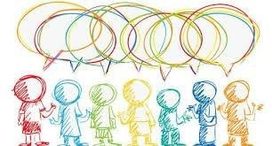Transitions should ensure a partnership working approach between practitioners and parents, which will secure quality and consistency of experience for the child.

Transition should underpin equality of
opportunity ensuring that every child is included and supported.

SEN support should include planning and preparation for transition, before a child moves into another setting or school. This can include
a review of the SEN support being provided or the EHC plan.

To support the transition, information should be share d by the current setting with the receiving setting or school .

DfE and DH (2015) SEN and disability code of practice: 0-25 years, para 5.47

Keystones of good transition practice

• Transition is made a priority-transition should be seen as an ongoing process throughout the year.

• Nominated person-there should be a nominated person who co- ordinates transition

• Respect-when relationships are respectful, it can lead to an open
dialogue which is more supportive of positive transitions

• Communication-key information is shared prior to the child starting in the setting. Recognising
and documenting the support
that is being put in place and sharing that information

• Planned-children and families
requiring a supported transition are identified and planned for as early as possible. -

• Tailored-individually around the needs of the child involving all organisations supporting the child. Personalised taking in to account the voice of the family, their priorities, hopes and concerns

• Children’s friendships are acknowledged—Consider how your groupings support children’s existing friendships

• Flexible-giving support through a change that takes as long as is individually appropriate over an extended period of time. Providing opportunities for repeated visits both for the child and for receiving setting practitioners to attend the current setting

• Continuous-maintaining an open link between settings in case further information is required and to provide opportunity for follow up and review

Top tips for feeder setting’s

• A regularly reviewed Transition Policy will help clarify the process of transition for all stakeholders and ensure that they are clear about the principles and practice.

• Plan regular transition meetings between settings and schools to enable important information to be shared and transition arrangements agreed.

• The key person has a significant role to play in sup- porting and preparing a child for transition; particularly any children who may experience feelings of sadness and resistance before leaving a setting, especially if he/she has been there for a very longtime.

• Use stories and resources (e.g. role play with uniforms, book bags, etc. to explore the new situations that the child will experience when he/she moves.

• Share information of children’s current friends/ relationships as having friends in the same group/ class may help children adjust to the demands of the new environment.

Enhanced transition practice

• Ensure any vital information with regard to EAL, LAC, medical needs, social care and SEN are communicated

• Arrange transition planning meetings for children with additional needs as soon as a setting /school placement is acknowledged. Consider virtual platforms should face to face meetings be impossible.

• Invite parents/carers and any agencies involved with he child (education, health, social)

• Establish a transition plan

• Arrange visits for future practitioners to observe child/
children in their current setting

• Arrange additional visits for child/children to become familiar with their new educational environment

• Transfer documentation relevant to the child’s needs

• Plan for the transfer of any specialised equipment that may need to move with the child

• Transfer familiar visual resources e.g. PECs, communication book, coat peg and drawer, labels, registration cards, etc.

• Familiarise child/children with relevant visual and auditory recordings for children to become familiar with people, places and routines

Top tips for receiving settings/schools

• A regularly reviewed Transition Policy will help clarify the process of transition for all stakeholders and ensure that they are clear
about the principles and practice.

• Offer a range of opportunities for parents/carers to access information about the transition process, e.g. website , power point presentation to share with families, open days, information events, consultations, newsletters.

• Establish close links with feeder settings/schools

• Gather vital information about children which could be important for the setting/school to know, such as allergies, health issues or additional needs.

• Visit homes and/or early years settings

• Consider how your groupings support children’s existing friend- ships

• Establish joint activities between yourselves and children’s cur- rent settings i.e. shared reading, trips, events.

• Create a display that incorporates children’s individual work from home or the previous setting

• Encourage families to make a memory box with their child and use this during the settling in process

• Recognise that a child needs time to settle and that a period of regression is quite normal, for a child to stand and watch before joining in is quite usual and appropriate.

Enhanced transition practice

• Arrange transition planning meetings for children with additional needs as soon as a setting /school placement is acknowledged. Consider virtual plat- forms should face to face meetings be impossible.

• Establish a transition plan and admission arrangements

• Engage with agencies involved the child (education, health, social)

• Identify and arrange for any specific training requirements (education, health, social)

• Identify and implement any documentation e.g.
Health Care and/or Education Plans

• Identify and arrange for any environment adaptations that may be required

• Identify and arrange for the purchase or transfer of any specialised equipment that may be required

• Provide visual and auditory recordings for children to become familiar with people, places and routines

• Provide timelines for children to become familiar
with expectations and routines

• Provide social stories for expectations and routines where relevant

Top tips for parents/carers

• Look out for Open Days to go and visit the schools you are interested in your child attending, or ask for an appointment if you can’t get along to the day.

• Find out about school visits so that you are able to attend

• Start to gather together all of the things your child will need for school, i.e. uniform, PE kit, lunch box, etc. and ensure all are clearly labelled and easily identified. Take your child along with you and help them chose items they can easily open and close themselves.

• Encourage your child to do things independently and build up their confidence.

• Get used to bedtime and morning routines that they will have when they start nursery/school

• Share books about going to nursery/school

• Familiarise your child with their new uniform, practice getting dressed in it (don’t purchase too early, remember children grow).

• Role play nursery/school

Enhanced transition

- Engage with transition planning meetings

- Share information about your child which could be important for the school to know, such as allergies, health issues or additional needs.

- Familiarise your child with the route to school as part of your daily walk. Take photographs of familiar landmarks on route
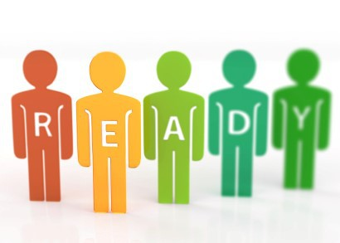and share these, get the child to look out for them on the
way/way back.

- Familiarise your child with rou-
tines and any new equipment/resources i.e. new lunch bag/box, drinks bottle, etc. Discuss foods they may take to school. Practice preparing and tasting different foods, making menus, etc.. Role play eating packed lunches. Some schools will not allow certain items in a lunch box. They should tell you this information be- fore your child starts school.

Activities that will help your child:

Reading together is fun and can also:
• improve listening skills; develop their imagination; increase knowledge of people and ideas from around the world; introduce them to new words, ide- as and information; improve their memory.

You can help improve your child’s language skills by:
• singing songs together; having fun with rhymes and jokes; asking them to follow simple instructions, for example how to pack their school bag; identifying pictures, letters and words in books, magazines, on television or the internet; talking to your child and giving them time to think about their reply.

Develop their thinking skills by:
• asking questions about characters, places and events; retelling stories together or creating a different ending;; making up sentences using a new or unusual word; drawing pictures about a story you’ve read.

Help develop their writing skills by:
• drawing, making marks with pencils, crayons or paintbrushes on paper, or with sticks in sand; praising your child’s efforts, even if that’s not how you would do it yourself; looking at numbers, letters and familiar words you see around you.

Develop their number skills by:
• encouraging your child to use words such as many, a lot, more or less; finding things in a group that are different, or the same, such as shapes or colours; finding opposites and patterns; involving your child in everyday activities that require counting, for example setting the table for three people.

You can help develop their personal and social skills by:
• arranging for them to play with other children so that they can learn to share and take turns; encouraging them to tidy up after playing - make
sure you join in too and praise their efforts; giving specific instructions. This
helps children to be clear about what they are being asked to do, for example “I’d like you to put all of the bricks in the box please.” talking about feelings and emotions; encouraging them to “have a go” and become more in- dependent, for example dressing themselves, pouring a drink or going to the toilet.

Help them to develop their physical skills by:
• using scissors, drawing, craft activities and play dough; finding opportunities to climb, run, skip, jump and lift; playing and exploring at the park; taking part in games and activities that make them out of breath.

Play is one of the most important needs children have, even once they go to school. Children learn a lot from times when things don’t go to plan, so under supervision let them have freedom to explore and take some risks.

