North East Lincolnshire – Education, Health and Care Hub
User Guide for Health Professionals

The Children and Families Act (2014) places a duty on health commissioning bodies and health professionals to cooperate with the local authority when undertaking needs assessments for children and young people with Special Educational Needs and Disabilities. Under this duty you may be asked to contribute to an assessment and/or review of a child or young person’s needs.

North East Lincolnshire has launched a new electronic EHC hub. Existing EHC plans will be gradually transferred to this system with the aim to be fully electronic by September 2021. Please be aware however that parents/carers are still able to make requests in an alternative format if they choose therefore you may still receive some requests via the paper/email process and must respond to these within the same statutory timescales.

This guidance aims to support health professionals with using the hub and responding to requests for advice.

If you have any queries regarding the EHC process or using the hub please contact :
Sarah Harding – Designated Clinical Officer – designatedclinicalofficer@nelincs.gov.uk
Or the SEN Service : SEN@nelincs.gov.uk

The Designated Clinical Officer is the health link professional for any queries relating to Special Educational Needs and Disabilities and the Education, Health and Care process.

To navigate to the section you require, hover mouse over contents heading and press Ctrl+click

Contents
ACCESS AND REGISTERING ON THE HUB 2
Access 3
Registering on the hub 3
Access Privileges 3
Resetting Password 3
Information in Other Languages 3
LOGGING IN TO THE HUB 4
NAVIGATING THE HUB 5
My Cases 5
Team Cases 6
Allocating a case 6
Accessing case information 10
PROVIDING ADVICE ON THE HUB 10
Uploading files to the hub 15
Saving and submitting your advice 16
TIPS FOR ADVICE WRITERS 17
Describing needs 17
Writing outcomes 18
Identifying provision 19
RESOURCES 20

Access

To access the hub, please visit https://ehchub.nelincs.gov.uk/

If you do not have login details for the hub contact: designatedclinicalofficer@nelincs.gov.uk

Registering on the hub

The following short video shows you how to register on the hub:

https://openobjects.vids.io/videos/a09dddb71f19e2c728/ehc-hub-account-registration

Access Permissions

The hub allows different access levels therefore you will be given the level of access required for your role. You will only have access to the areas of the Hub that are appropriate for you. Please only use your own log-in and password and do not share these with anyone else.

Resetting Password

In order to reset your password, there is a link at the bottom of the log-in screen. The password reset instructions will be sent to your registered e-mail address.

Information in Other Languages

The information on the Hub will be in English, but Google Translate could be used, as long as the content is in plain English. The Hub can also integrate with web accessibilities, such as Browsealoud.

LOGGING IN TO THE HUB

This is the login screen:

- Enter your email and password.

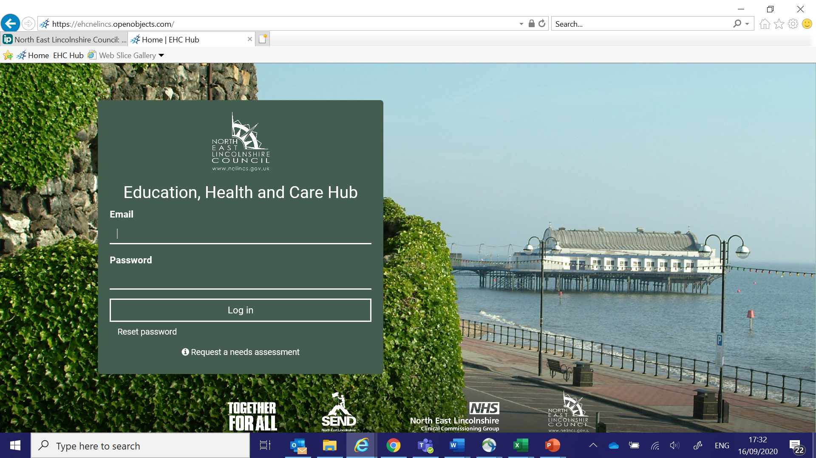

- You will then be asked to enter the authentication code sent to the mobile number you provided when you registered:
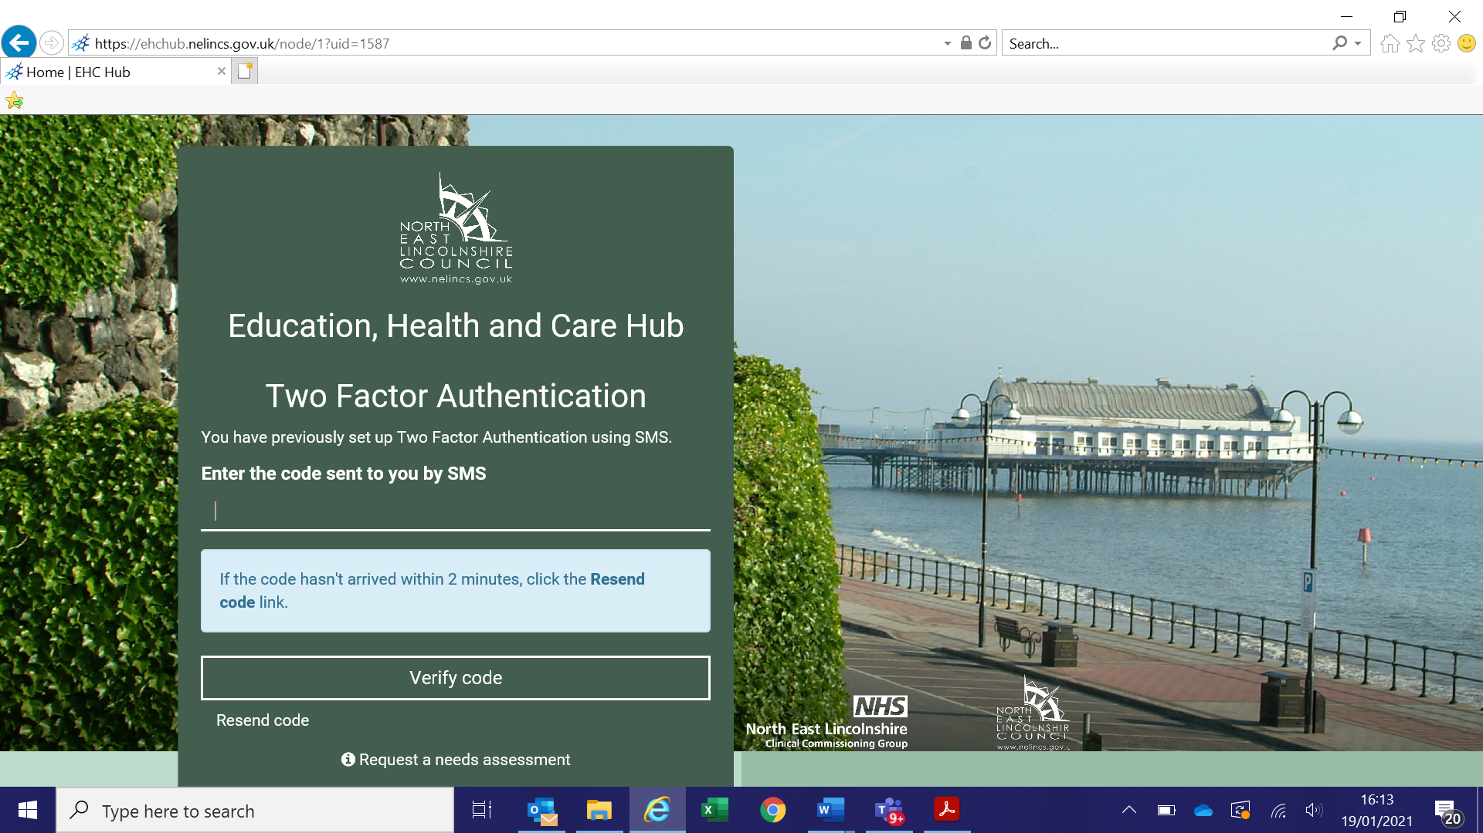

NAVIGATING THE HUB

Once you have successfully logged in you will be taken to the following screen:
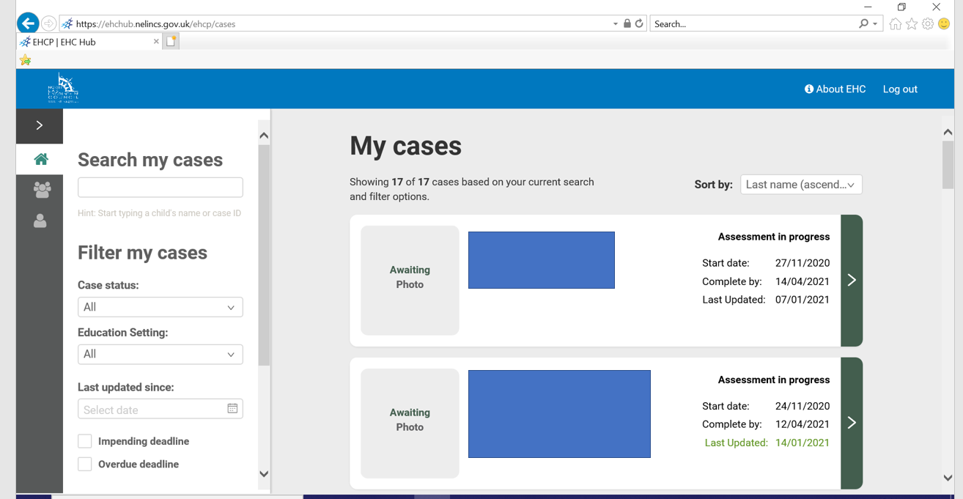

My Cases

- Within the ‘my cases’ page you can navigate through your cases by using the scroll bar, ‘search my cases’, or filter functions.
- You can filter cases by case status (stage in the assessment process), education setting, and those with impending or overdue deadlines

Team Cases

- Users with manager level access can also view all cases open to the team, requests sent and advice responses made. This is a helpful management tool to ensure statutory timescales are being met and reviewing the quality of health advice.
- Managers can use the filter functions to help with this

Allocating a case
All health teams have provided a central email address which allows for requests from EHCP Coordinators to be sent to the team via the hub. These are then allocated by a team member with managers level access permission (usually manager/admin staff) to a specific team member. This ensures that when individual team members are on leave requests can still be dealt with in a timely manner. Where a health team have multiple staff working on a duty system, multiple team members can be provided with manager level access permission if required.
- It is essential that these request are actioned and allocated in a timely manner. All advice requests must be responded to and if appropriate advice provided within the statutory 6 week timescale, which starts from the time the request is made to the team.
When a request is made by the local authority EHCP Coordinator to a health team, an automated e mail request will be sent to the central team e mail address. No case identifiable information is included in this e mail. This is a security feature to ensure that only those with authorised access to the hub can view this information.
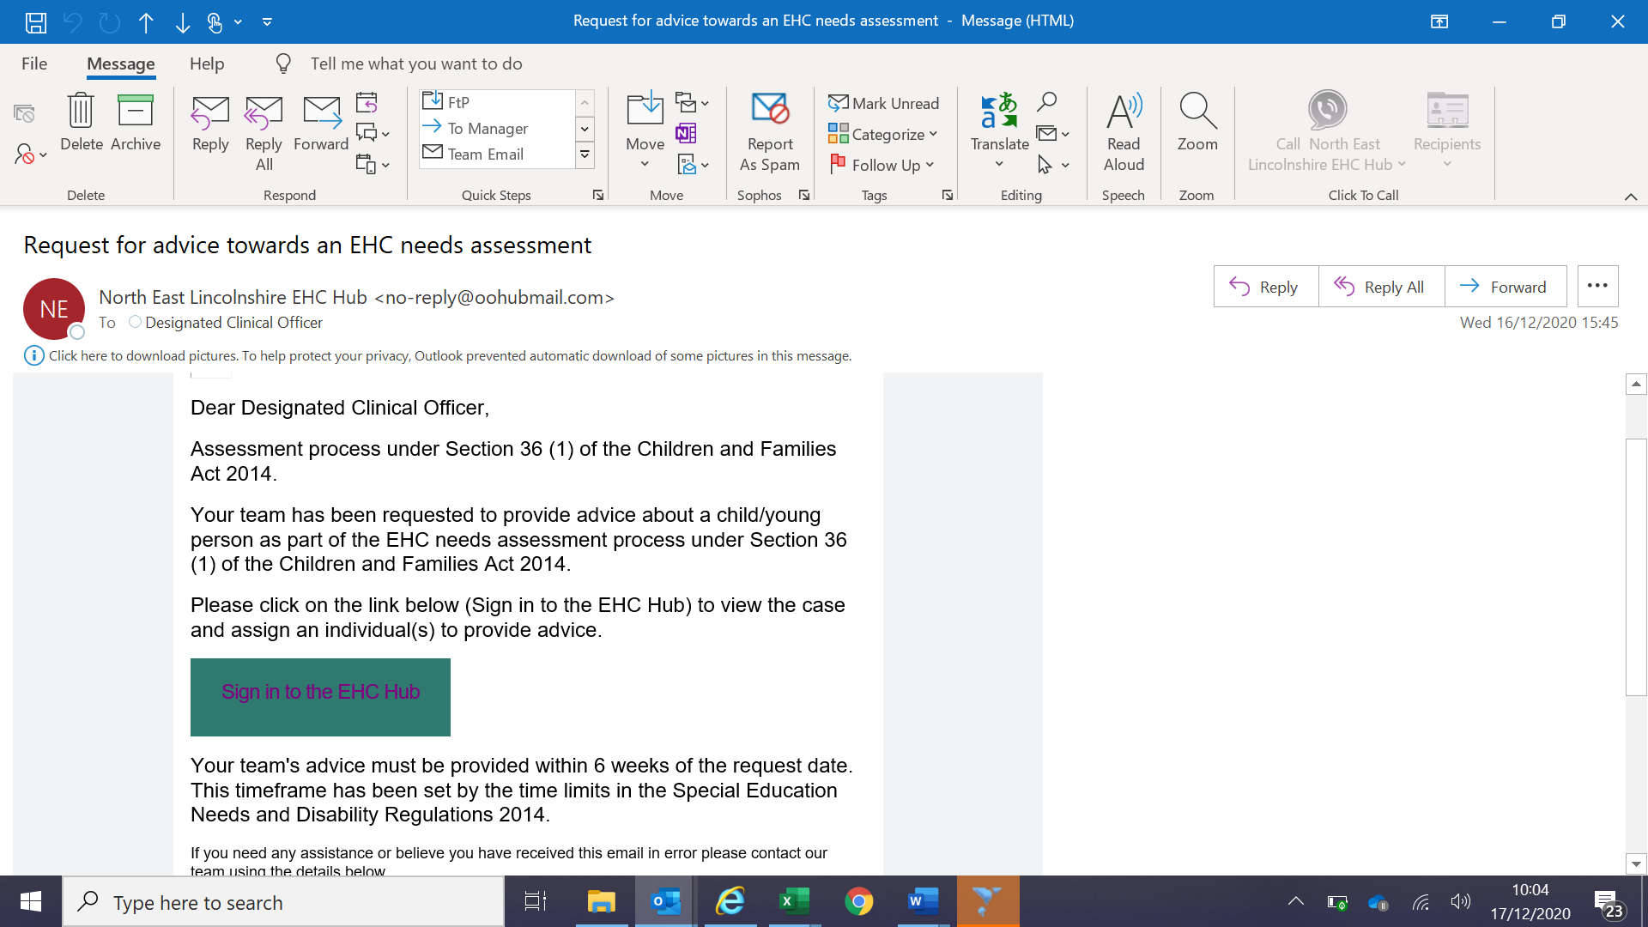

- Please make sure you add the hub email address to your team and individual e mail contacts to avoid this being directed into your junk folder: no-reply@oohubmail.com
- The ‘sign in to the EHC Hub’ link in the email will direct you to the hub login page.
- Login in as described in the previous section of this guidance.
- To access requests to your team - click on the ‘Team Cases’ icon:
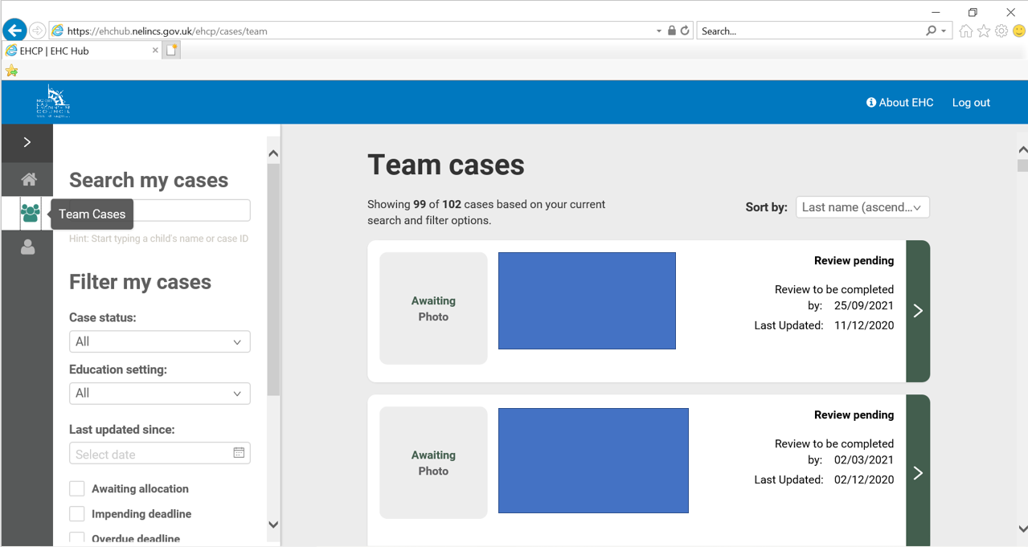
- To look for cases which need to be allocated to a team member, tick the ‘Awaiting allocation’ filter box.
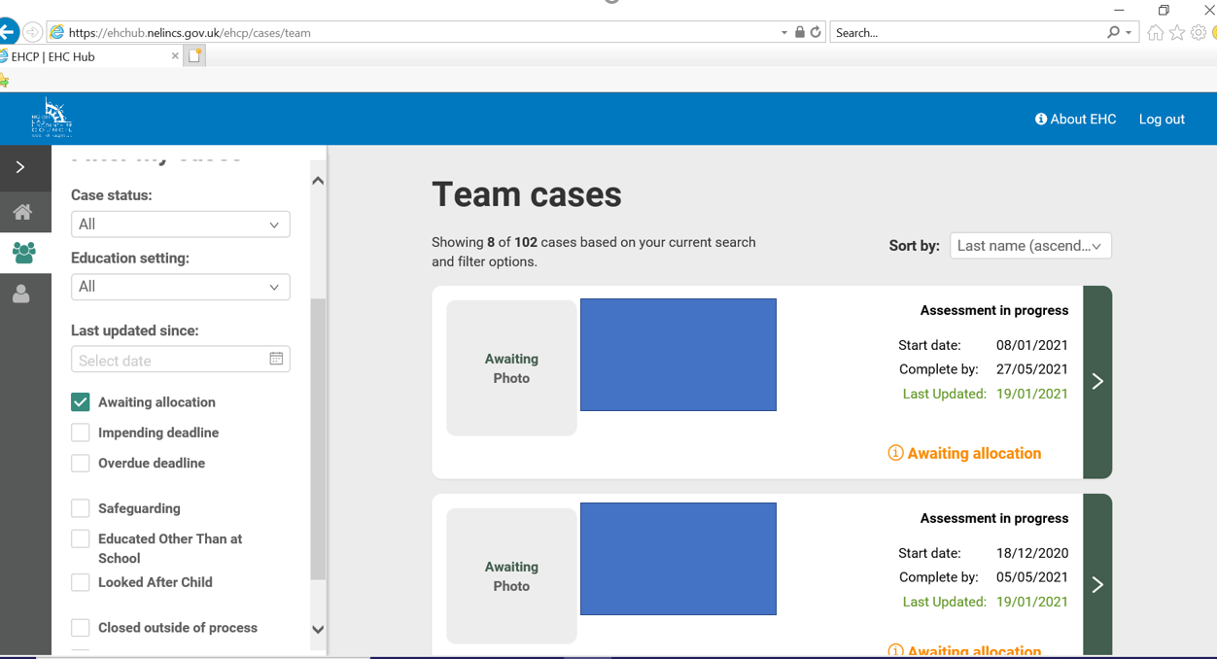
- Select a case to allocate by clicking on the arrow to the side of the case.

- You will be taken to the EHC needs assessment process page for the individual case selected:
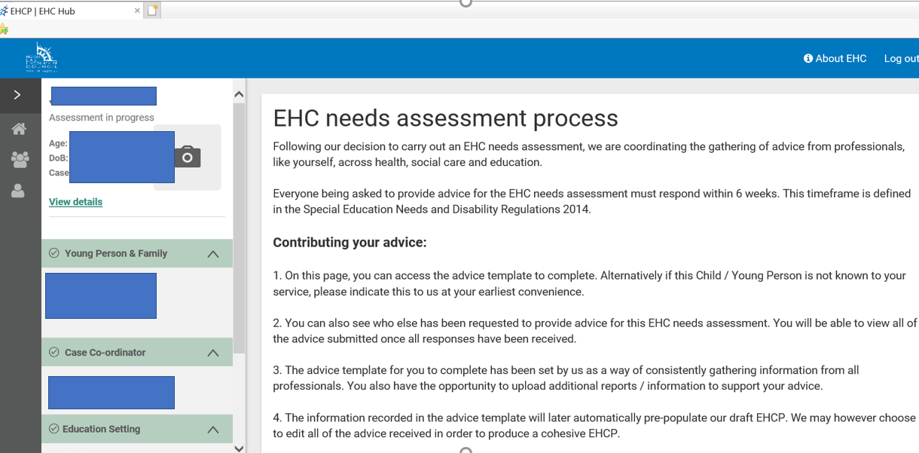
- Scroll down this page to find your team and click on ‘assign professional’.
- This will then take you to the ‘Request for Advice’ page. Choose the relevant option:
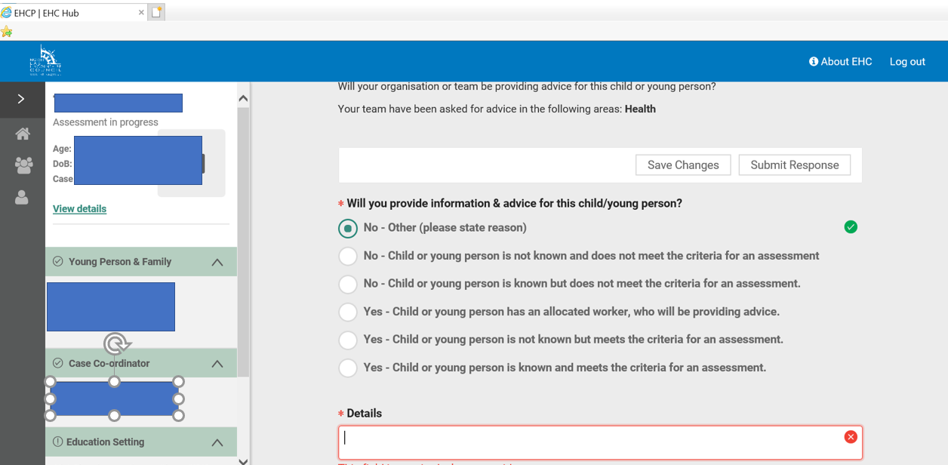
Child not known to service:
- If the child is not known to the service, select ‘no’ and advise ‘child is not known to the service’ in the details box. You can add additional information in this box as needed i.e previous discharge dates etc.
- Click on ‘submit response’ and this will close the service involvement for this case. You can then log out or repeat the process for further requests.

Child known to service:
- If the child is known to your service tick the relevant ‘yes’ option, select a team member name from the dropdown box, click on ‘add’.
If the team member does not appear in the dropdown box, you can type in their name or alternatively add the team members details. If the team member is not registered on the hub the system will send an automatic email requesting them to complete the registration process.
- Once you have added the team member you will see that their name shows below.
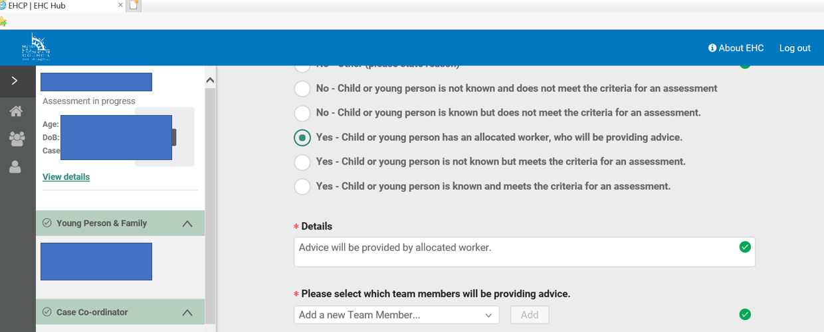
- Once a team member is added, click ‘save changes’. THIS COMPLETES THE ALLOCATION PROCESS.
The allocated team member will receive an e mail request to provide advice.

Accessing case information

Within each individual case record on the hub, you can view information submitted at each stage of the assessment process by clicking on the coloured links at the top of the page. Here you will be able to read the information submitted in the assessment request including the child and parent concerns and wishes. Greyed areas mean the case has not yet progressed to this stage.
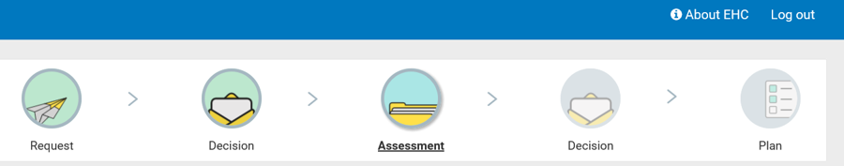

PROVIDING ADVICE ON THE HUB

Once a case has been allocated to you, you will receive a request for advice email:
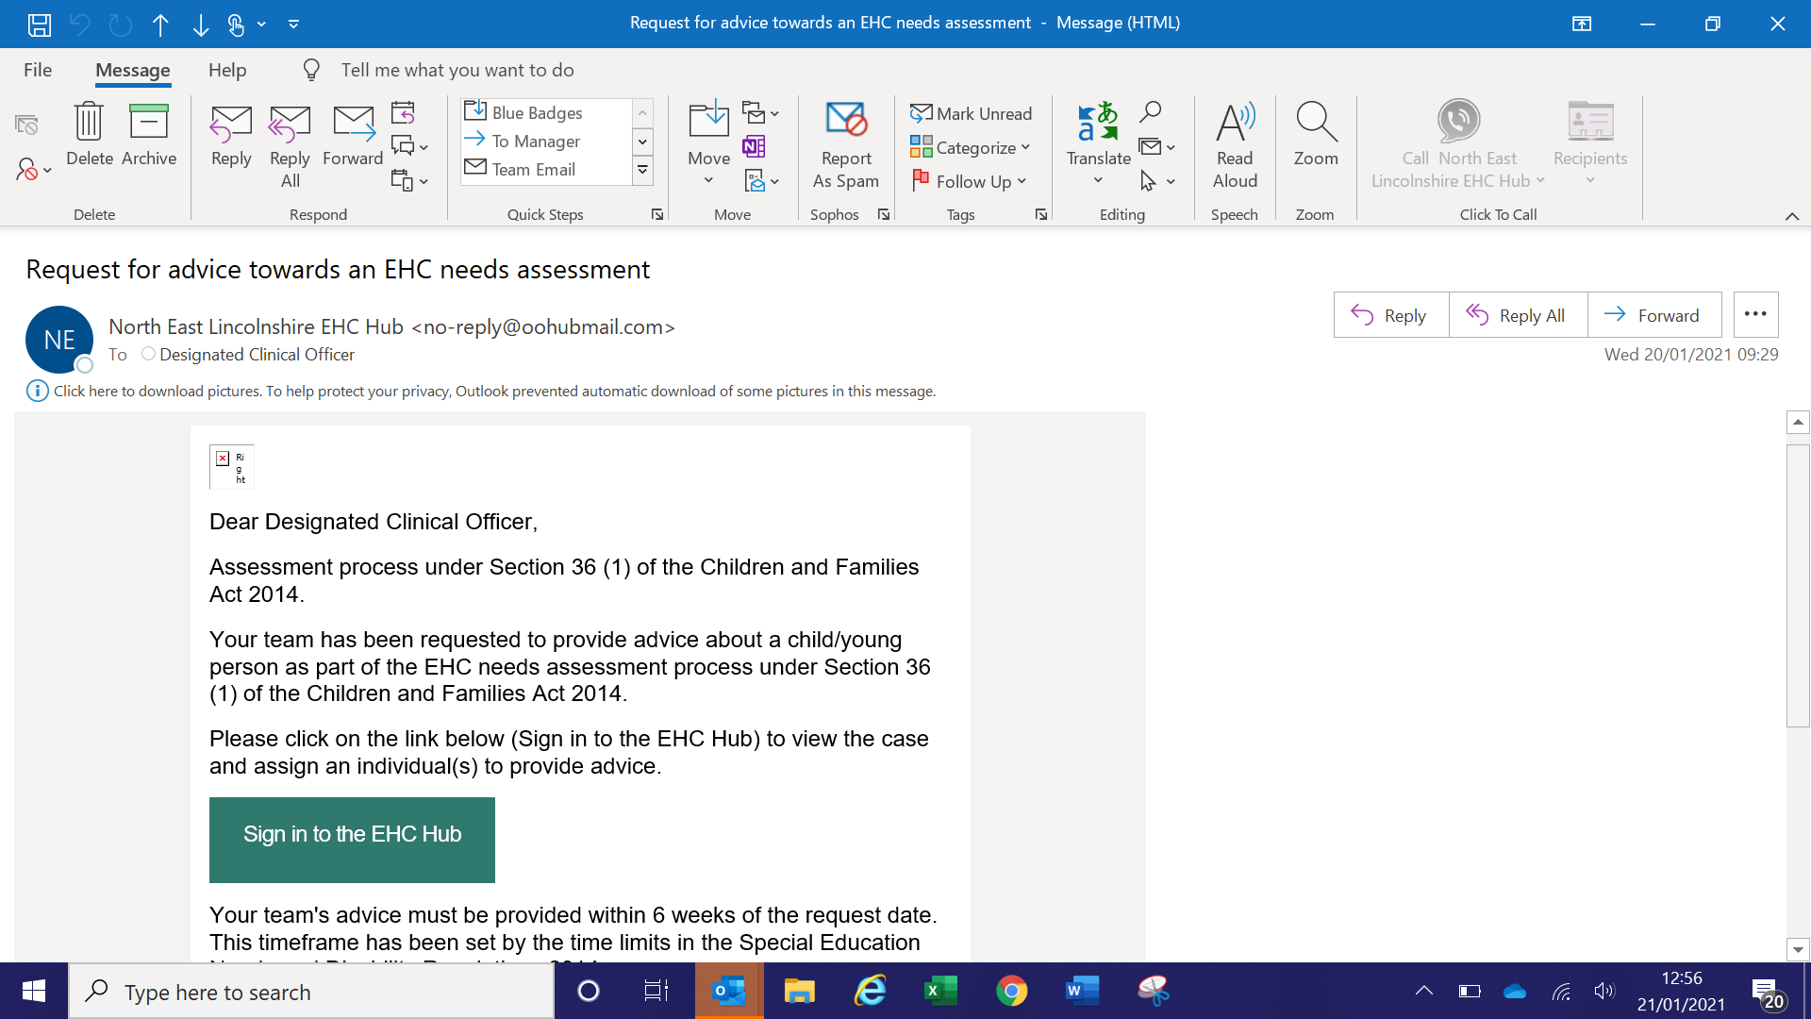
- Clicking on the link in the e mail will take you directly to the hub login page.
- Login to the hub as described in the earlier login section of this guidance.
- Open the individual case required by clicking on the arrow

This will take you to the EHC needs assessment process page:

- Scroll down this page to find your team and your name.

- Click open next to your name to access the advice template. On this page you will also be able to see who else has been asked to provide advice.

Advice template:

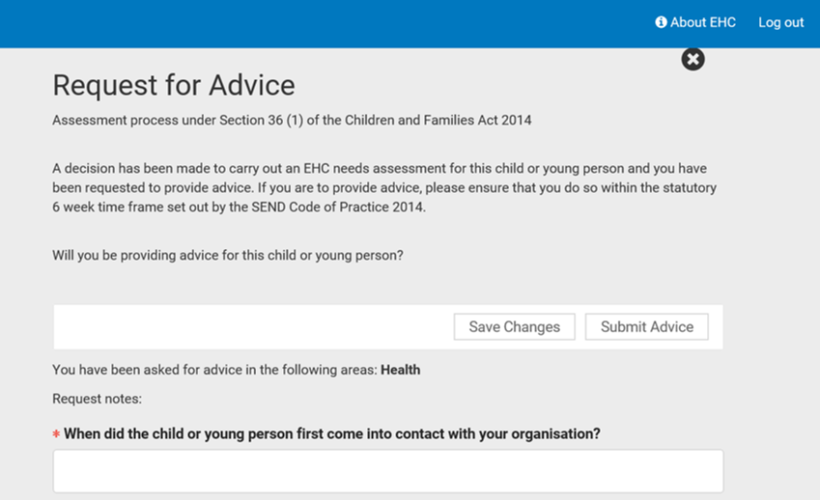
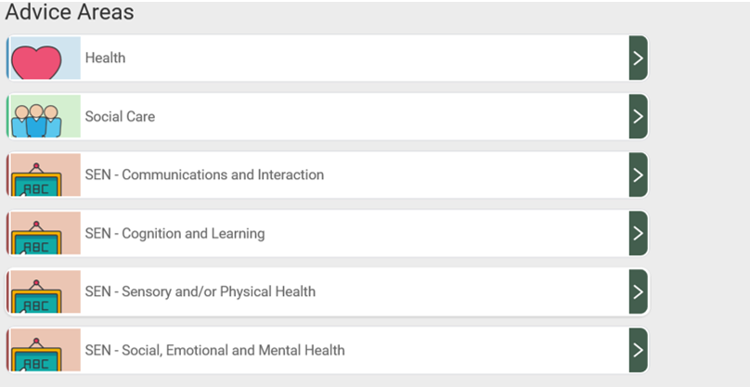
You can provide advice on any of the advice areas however please only comment on those areas which are within your own area of professional expertise.

- For each of the advice areas you are asked to comment on the child’s strength’s and special educational needs in that area:
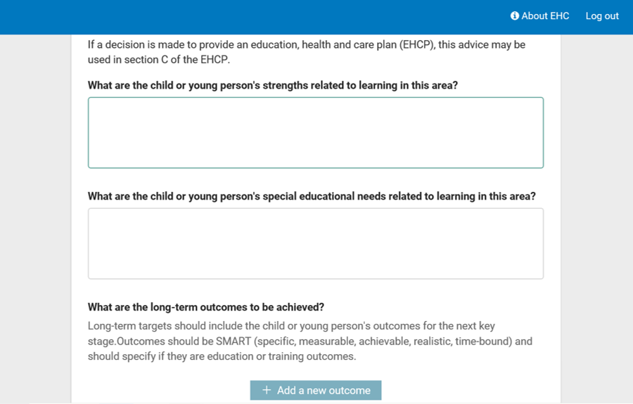

- 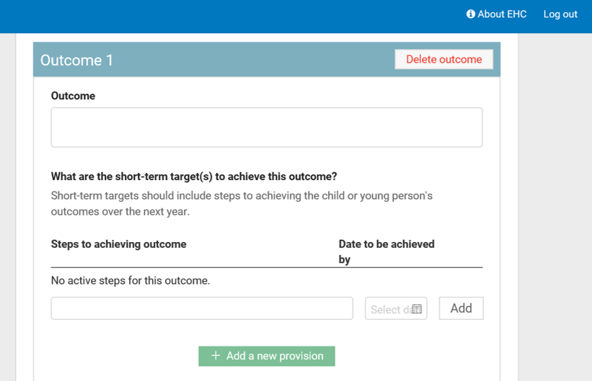 You can suggest outcomes for each area of need you have identified. Click on ‘add a new outcome’.

- You can also suggest short term steps to achieving this outcome.

- For can add the provision you feel the child requires to support achievement of the outcome. This must be within your own area of service provision or expertise.

- To add a new provision, click on ‘add new provision’.

Uploading files to the hub

You can upload documents such as clinic letters and assessment reports to support the advice you are providing. Please ensure that you summarise the child’s needs in the relevant sections of the advice template.

(Paediatric Secretaries only: you only need to upload the clinic letters. You are not required to provide written advice in the template).
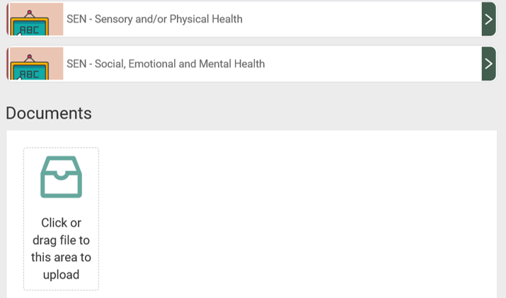

Saving and submitting your advice

The system allows for you to save advice and come back to it at a later date prior to submission and publication on the hub. This allows for the advice to be drafted over multiple sessions if needed or for professionals to seek supervision regarding the quality of their advice from a line manager/clinical supervisor prior to submission. To save draft advice click ‘save changes’.

- To access saved advice, go back into the case from the ‘my cases’ page

- Once you are ready to share your advice, save changes, then click on ‘submit advice’.
- A warning message will appear as a double check to ask if you are ready to submit.
- Once you have submitted the advice this is made available for the EHCP Coordinator, Parent/carer, and professionals registered to the case to view on the hub.
- A copy of your submitted advice can be downloaded and saved/printed off from the hub if required for clinical notes. This can be done by going into the case via ‘my cases’ and opening up the response you have submitted.

TIPS FOR ADVICE WRITERS

- The advice which you provide will be part of several pieces of advice received by the local authority which will be used to produce a draft Education, Health and Care Plan. Completion of a need assessment does not necessarily mean that a final plan will be issued. This decision is made by the Special Educational Needs Advisory Group (SENAG) after careful consideration of the information submitted and decisions are made in line with the SEND Code of Practice.

- When providing advice please only comment on things within your own area of professional expertise. Health professionals should not make recommendations regarding the type of educational setting, level of educational support or name a specific school.

- Advice must be returned by the date requested. The statutory timescale for health advice to be returned to the local authority is 6 weeks and this must legally be adhered to. All health advice is checked and collated by the Designated Clinical Officer prior to submission to the Local Authority.

- It is essential that the aspirations of the child/young person are central to your assessment and recommendations. It should be clear how the recommended provision will support the child to reach their aspirations.

Describing needs

- A list of diagnoses is not a sufficient description of need, you should clearly explain the impact of the condition on the child’s functioning across different areas of their life.

- Please ensure that you use ‘jargon free’ language, keeping it as simple as possible and explaining medical terms. Avoid lengthy historical information or complex medical information.

- Where a child’s health condition is likely to fluctuate or effect attendance at school please explain how this may impact on the child/young person and how this is managed. If a health care plan is in place, please upload this to the hub.

Examples:

- Sian experiences multiple absence seizures a day, this may result in her missing information and impacts on her interactions with peers.

- Alex has cerebral palsy with a right sided weakness. He is independently mobile but requires a walking frame for longer distances.

- Dylan has Autistic Spectrum Disorder and experiences anxiety in response to changes in his routine.

Writing outcomes

- The development of outcomes must start with the child/young person themselves and come from their aspirations and hopes for the future. This can also include the parent/carers hopes for the child.

- Outcomes can build on something that is working well, change something that doesn’t work well, or help to move the child towards future aspirations.

- In order to be person centred, the outcome must clearly identify the benefit or difference made to the child/young person.

- Outcomes must be SMART – Specific, Measurable, Achievable, Realistic and Timely.

- Overarching outcomes are generally longer term, you can also add smaller steps towards achieving these.

- Consider outcomes which may support the child/young person towards preparation for adulthood through the development of functional and independence skills. This is a requirement for all children aged 14 years and onwards; but developing independence can start much earlier and should be considered at all ages. This might include developing independence in medication management or administration, understanding and knowledge regarding their health condition etc.

Example outcomes:

By the end of key stage…Emma will be able to use and maintain her hearing aids independently so that she can enjoy overnight stays with friends.

Steps towards: Within the next half term Emma will have learnt to recognise the low battery signal and change her hearing aid battery.

Within the next academic term Bobby will be able to identify and use at least two coping strategies to manage anxiety so that he can attend youth club once a week without his parents.

Identifying provision

- Provision should enable the child to move towards their aspirations and goals. Consider what are the barriers to achieving these? What provision would support steps towards achieving aspirations?

- When describing provision explain exactly what is going to happen, who is going to do it, how often it is going to happen and when it will be reviewed.

Examples:

Within the first week of the school term training will be delivered to school staff by the Epilepsy Nurse on seizure management and refresher training will be offered annually.

Dylan will be offered a 6-week CBT group programme by a qualified CAMHS clinician, attending 1 hour per week followed by a review appointment with Dylan and his parents.

Lucy will be offered a 1-hour speech and language therapy session in school per week for 6 weeks. Resources to support ongoing practice of speech and language therapy skills will be supplied to school staff and parents. Progress will be reviewed by the Speech and Language Therapist 3 months following the start of therapy.

RESOURCES

The Council for Disabled Children provide lots of information and resources for health professionals on their website:
https://councilfordisabledchildren.org.uk/resources-and-help/im-healthcare-professional

The SEND Code of Practice can be found on the Government website:
https://www.gov.uk/government/publications/send-code-of-practice-0-to-25

Free holistic outcomes e learning is available on the Council for Disabled Children website:
https://councilfordisabledchildren.org.uk/cdc-learning

If you would like training regarding the EHC Hub or any aspects of the education, health and care assessment and review process please contact the Designated Clinical Officer: designatedclinicalofficer@nelincs.gov.uk

